Programmer's Guide
for
Algae Count Estimator
Version 1.0
Prepared by Algae Counting Team
Institute for Watershed Studies
12/10/2014
Table of Contents

Contents
Contents ii

1. Development Environment 1

2. Code Structure 2

3. Important Classes 2

4. Windows Deployment 4

Revision History

Name | Revision | Description | Date
Andrew Young | 1.0 | Initial Document | 12/21/2014

Development Environment

Windows
Windows development requires the following dependencies:

Name | Version | Download | Note
msysGit | 1.9.4 | https://msysgit.github.io/ | Git source control for Windows
Python | 2.7.9 32bit | https://www.python.org/downloads/ | Python 2.7 development for Windows
PyQt | PyQt4-4.11.3-gpl-Py2.7-Qt4.8.6-x32.exe | http://www.riverbankcomputing.com/software/pyqt/download | PyQt Python 2.7 wrapper for Qt 4.8.6
py2exe | py2exe-0.6.9.win32-py2.7.exe | http://sourceforge.net/projects/py2exe/files/py2exe/0.6.9/ | Python deployment tool
Microsoft Visual C++ 2008 Redistributable Package | 9.0.21022.8 | http://www.microsoft.com/en-us/download/details.aspx?id=29 | Requires file msvcp90.dll to be placed in the source directory

Git for Windows is only required if you would like to continue development from the github repository.

- Install the Python 2.7.9
- Install PyQt
- Install msysGit (Optional, required to clone of github project)
- Install py2exe (Optional, required to build executable for distribution)
- Install Microsoft Visual C++ 2008 redistributable package (Optional, required for py2exe)

Linux
Linux development requires the following dependencies:

Instruction for Ubuntu using apt-get package manager:

- Install Python 2.7 for your version of Ubuntu
- RUN: sudo apt-get install python-qt4
- OPTIONAL Docs: sudo apt-get install python-qt4-doc

Editors
Recommended editors for python development:

Name | Version | Download | Note
Spyder | 2.3.2 | https://bitbucket.org/spyder-ide/spyderlib/downloads | Advanced code editor with debugging and introspection features
Sublime Text | 2.0.2 | http://www.sublimetext.com/2 | Best all-around editor

Both Spyder and Sublime Text are available in Windows, Linux, and Mac versions.

Code Structure

Class Diagram
See Diagram 2.1

General Notes
The Ace program is composed of a QMainWindow with a QStackedWidget to change between different parts of the program. Each sub part of the program are represented in code as QWidget items. Any Qt object used must be a in the child tree of QmainWindow so that it can be cleaned up properly by Qt (if the application crashes on exit after you've added new Qt objects, the issue is most likely that the new objects are not parented correctly). The source code is commented to explain individual sections.

Class Descriptions

SlideGen Class
Stores the functions for storing, saving, and generating a new slide. The number of colonies in selected uniformly between either the number of cells if there is less than 15, or a triangular distribution between 1 and 15. The algae colonies are simulated by picking a center point, and then plotting cells around it randomly throughout a circle which has a radius somewhere in the uniform distribution between opt_r (which is based on the number of cells in that colony, and max_r, which is the width of the screen over 2. To plot anywhere within a circle of radius r, a radius is chosen uniformly between 0 and the radius of the outer circle. X is then chosen to be between the center point's x coordinate plus or minus r. Y is then calculated by using the equation for a circle solved for y, which simplifies to the positive or negative square root of r^2 – x^2.

SpriteFactory Class
The SpriteFactory class job is walk the directory structure of the img/sprites/ folder and locate sprites. These sprites are formatted so that the program can utilized the sprite that is the closes match to the specified depth and rotation.

The sprites directory structure is organized as the following:

type (sub folder) | depth (sub folder) | filename | note
t0 | d1 | r0.png | type 0, depth 1, rotation 0
 | d2 | r0.png | type 0, depth 2, rotation 0
 | d3 | r0.png | type 0, depth 3, rotation 0

Depth
Directory of d0, d1, d2, d3, d4 are used to represent the depth of the sprite. The depth concept is a simulated depth fields. The camera is focused at depth 2.0. The ones too closes and too far away from the “camera” are slightly out of focus. This illusion is to simulate the rough focus controls you would find on a microscope. When these sprites are used in the view that they will be contained it is assumed that a z-value of 2.0 is considered in focus. Z-values are each slide are chosen at random from 0.0 to 4.0. The sprite that is chosen to represent the parameters is based on the sprite that has the closest fit.

Rotation
The rotation values are represented by the file names themselves. For example r0.png represents a cell image that has a rotation of 0 degrees. Degree measures can be an integer from 0 to 359. The best selection code in the SpriteFactory will choose the sprite that will require the least amount of additional rotation to match the requested rotation specified. Having many sprites rendered at different rotation may be most useful when creating a image of a cell that has a light source that casts a shadow from one side. If the shadow was not considered the simulated rotation would display the shadow incorrectly.

Here are some examples of two types of cells who all have the file name r0.png

type | d1 | d2 | d3
Aphanothece Outline
Aphanothece Rendered

The premise behind having different images for each depth and rotation is we are making the assumption that the rough focus and rough rotation. This gives us the best simulation of a 3d image possible without the use of additional 3d libraries or tools.

The Rendered sample does have a light source slightly askew. Here is example of the rotation.

 | r0.png | r45.png | r90.png
Looking at all d2 images
 |  |  | notice the shadown on the right side

This slight variation between the images gives a slightly more realistic version of the cell being displayed at a minimal cost. All detailed rendering can be done ahead of time. All sample rendered cells for this demo where created in Rhino 3D. Any suitable 3d software with lighting controls would be able to produce the desired effect.

Adding New Sprites
In order to add additional sprites you must create at least directories d1, d2, d3 depths and have each contain one rotation with the file name r0.png. You will also need to update the COUNT variable in the SpriteType class. This class maintains ratio of sprite types in a given SpriteType set. This allows for more control over how given sprites will be displayed, if there are multiple types of cells. By adding your own sprites you can get a feel for how to expand this tool.

Windows Deployment

Prerequisites
Python 2.7, PyQt4 and py2exe are required to be installed on the Windows system you are interested in deploying on. If the VSC++ redistributable msvcp90.dll is not on your PATH, it must be placed in the source directory containing the setup.py file.

Building the executable
To build a distributable executable package navigate to the source directory that contains the setup.py file. Run the following code:

python setup.py py2exe

This will create a build and dist directory. The dist folder is the one that contains the binary files necessary to run the program. The setup.py does not include code to copy the required img folder. This can be accomplished manually by making a full copy of the img folder and all of its content into the dist folder. Once all the files are copied ace.exe can be run and should execute appropriately. You may be required to install the VSC++ redistributable package on the Windows system you plan to deploy the software.

Packaging
The current release using a zip compressed archive of the build directory for our distribution method. A more preferable method would be to use an installer tool like Inno Setup.

Documentation & Tutorials
The main reference for PyQt4 is found at http://pyqt.sourceforge.net/Docs/PyQt4/classes.html. Unfortunately, it's just a big dump of the attributes and methods of every Qt object, but if you know what you're looking for it can be very helpful.

If you're completely new to PyQt, I would recommend going through the tutorials found on Zetcode. Try building some smaller test applications to learn PyQt.

If you have any questions about PyQt, or have any issues understanding or expanding our code, please feel free to email me at joshminor@live.com.

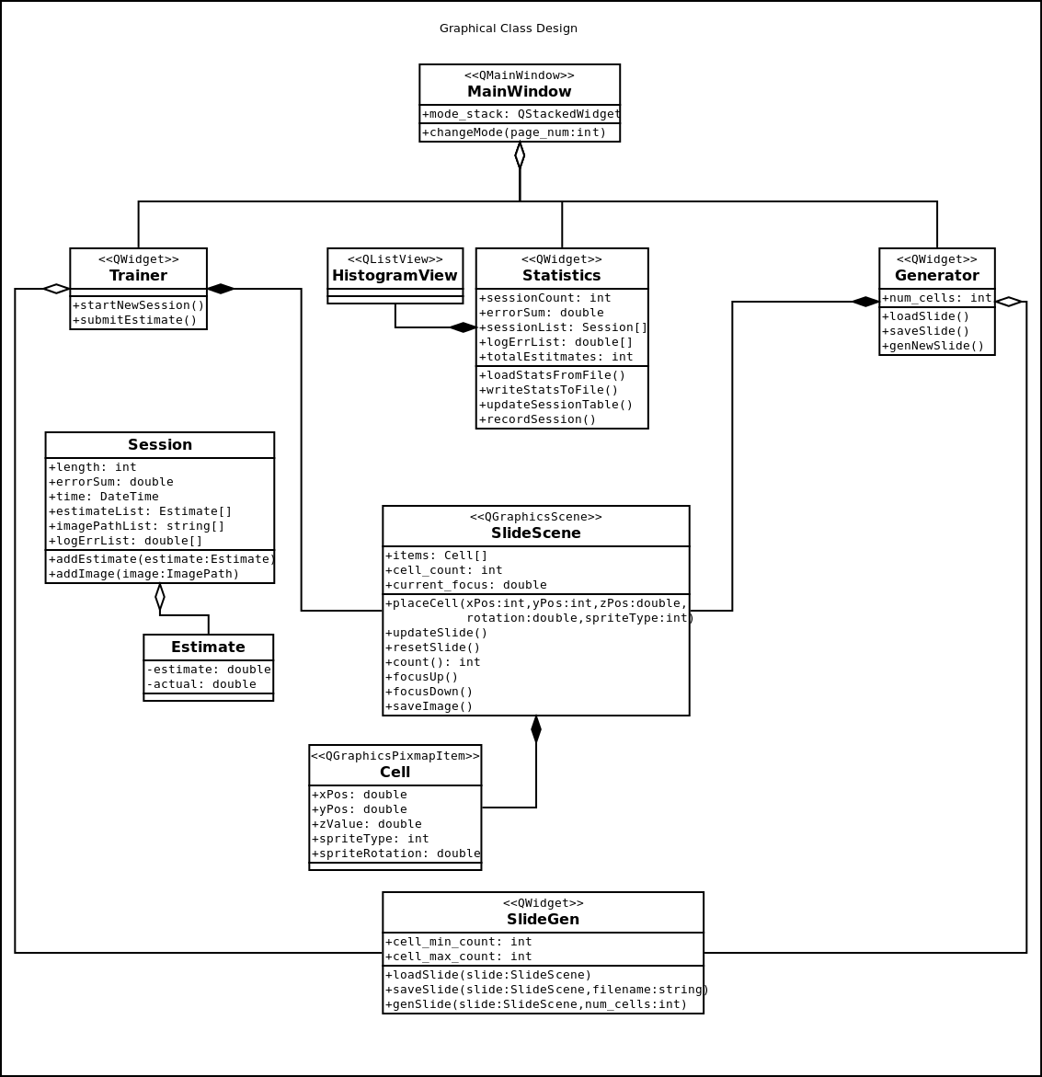
Diagram 2.1

