ENCRYPTION PROJECT

SOFTWARE REQUIREMENTS SPECIFICATION

26 March 2002

Levi D. Smith and Christopher Ingram

CS4235 Section A

Professor Nelson-Palmer
Spring Semester 2002
Georgia Institute of Technology

Section 1: Introduction

  - Purpose
The purpose of this project is to demonstrate how some of the more popular encrypting algorithms work their “magic”. The system will allow the user to enter a message, select an encryption method, and then view the message encrypted by the selected algorithm. When an encryption method is selected, options pertaining to that specific algorithm will be displayed for the user to customize. When the user presses the "Encrypt" button, the algorithm will then begin encrypting the message. After each calculation, a message will be displayed to the user relating to the operation that has just been performed. These messages will allow the user to understand the method used in the encryption algorithm. When the algorithm is finished, the user will have the message encrypted according to the method selected and options selected.

  - Scope
The scope of this project is limited to factors incorporated by the program itself. In the future, additional components may be added.

  - Definitions, acronyms, and Abbreviations
Caesar Cipher – a cipher in which each letter is translated to the letter a fixed number of letters after it in the alphabet.

Polyalphabetic Substitution Cipher – a cipher that uses two separate encryption alphabets, the first for all the characters in odd positions of the plaintext message, the second for all the characters in even positions.

Vernam Cipher- cipher which utilizes a one-time pad that involves an arbitrarily long nonrepeating sequence of numbers that are combined with the plaintext.

Columnar Transposition Cipher - cipher that uses a rearrangement of the characters of the plaintext into columns.

Data Encryption Standard (DES) – a system developed for the US government for use by the general public. The algorithm itself is rather complex, but involves a combination of permutations and substitutions.

El Gamal Algorithm – algorithm used to generate a key pair. Similar to the US Digital Signature Algorithm.

  - References
Pfleeger, Charles P. Security in Computing. New Jersey: Prentice Hall, 2000.
Oaks, Scott. Java Security. California. O’Reilly, 2001.

  - Overview
This introduction is intended to give a brief overview of the Encryption Project for this term. The following section will give background information that is necessary to fully understand the functional and non-functional requirements of the system. All of the requirements of the system will be stated, and each requirement must be testable.

Section 2: Overall Description

2.1 Product Perspective
The Encryption Project shall run as a java applet embedded inside a web page or HTML page. If the user chooses to do so, the software will also run as a standalone application.
While the software is running, the user shall be able to select which component to input values. This incorporates the selection of a cryptographic algorithm and any plaintext.

2.1.1 System Interfaces
The system is intended to interface with a single user at any given time. The user is able to interact with the system using a graphical user interface.

2.1.2 User Interfaces
The user interface must provide the user an understandable and effective way for entering attributes into the system. Java will be used to create the graphical user interface for the system. At the top of the GUI is a drop-down panel that will display each of the encryption algorithms that may be used (including the Caesar cipher, Vernam cipher, a Polyalphabetic substitution, columnar transposition, DES algorithm, and the El Gamal Digital Signature Algorithm. Below that is a text field that allows the user to enter the plaintext that is to be encrypted. Depending on the type of algorithm chosen, the user will also be given the option of choosing various options such as the various key or substitutions. At the bottom of the interface is a text area that displays the result of the cryptographic scheme or cipher text. Occupying the right side is a console area that displays any output that will attempt to give the user some insight into how the encryption schemes work.

Section 3: Specific Requirements for Proposed System

3.1 Overview
These requirements will allow the user to gain knowledge in how different encryption schemes do their “magic”.

3.1 Functional Requirements

3.2.1 Encryption Algorithms
The system must be able to allow the user to select from the following encryption schemes: a Caesar Cipher, Vernam Cipher, a Polyalphabetic Substitution, columnar transposition, DES algorithm, and the El Gamal algorithm.

3.2.1.1 Caesar Cipher
The user must be allowed to select the extent to which the alphabet will be shifted.

3.2.1.2 Vernam Cipher
The user will not have any options here since the cipher text is dependent on a padding with a random binary sequence.

3.2.1.3 Polyalphabetic Substitution
The user must be allowed to select the character mappings for each letter of the alphabet for each character that appears in the plain text. There must also be two different mappings depending on where the character appears in the plain text, one mapping for odd characters and another for even characters.

3.2.1.4 Columnar Transposition
The user must be allowed to select the number of columns that are to be used in creating the ciphertext.

3.2.1.5 Data Encryption Standard (DES)
Each user will be allowed to enter in their own 64-bit key that will be used.

3.2.1.6 El Gamal / Digital Signature Algorithm
The user will be allowed to input the prime number to be used as well as the two integers that are needed to produce the ciphertext.

3.2.2 Plaintext Input
The user must be able to enter a plaintext message that will be encoded by our software.

3.2.3 Encryption Algorithm Selection
The user must be able to select the encryption mechanism to be used to create the ciphertext.

3.2.4 Viewing Messages

3.2.4.1 Plaintext
The user must be able to view the plaintext message that he or she has input.

3.2.4.2 Ciphertext
The user must be allowed to view the encoded ciphertext in one of a variety of forms that are used in encodings today, mainly the ASCII standard, decimal, hexadecimal, and binary.

3.2.5 View Console
The user must be able to view any messages that will give them insight into the inner workings of the particular encryption algorithm.

3.3 Nonfunctional Requirements

3.3.1 User Interface and Human Factors
Depending on how the user chooses to access the system, either via an applet embedded inside an HTML page, or via a standalone application, our system will still function independently of how the user chooses to execute it. All input fields will be aligned in the center of any panel that contains the component for ease of use reasons.

3.3.2 Documentation and Manuals
The system should be self-explanatory to anyone that is familiar to the encryption algorithms employed. If not, a web page will be included which will serve as a reference to beginners and help them understand the functionality of the algorithm.

3.3.3 Deployment Platform

3.3.3.1 Software
If run as an applet, the applet will run on any java capable browser that supports Java2. If run as a standalone application, the user must have a recent version of Java2 installed on their system.

3.3.3.1.1 Operating System
Because Java is used, the operating system will be irrelevant. The system will run on any OS that supports Java2, including, but not limited to, Windows, Linux, and MacOS.

3.3.3.1.2 Graphics
A graphical user interface is used to enhance usability and must be able to run on any display that supports 640x480 resolution or higher.

3.3.3.2 Hardware
The system must run on all systems that support Java2.

3.3.4 Error Handling
The system must check to ensure that all values in fields are valid (if an input field expects a letter of the alphabet, then great pains must be taken to ensure that the user does not input a non-alphabetic character), and that numerical fields have values that lie within the specified range.

3.3.5 Quality Issues
The program should not halt or crash during execution. The program must not alter the state of the user’s system after closing. As far as security issues are concerned, no files on the user’s system are read or otherwise modified.

3.4 System Models

3.4.1 Scenarios
<not yet included>

3.4.2 Use Cases
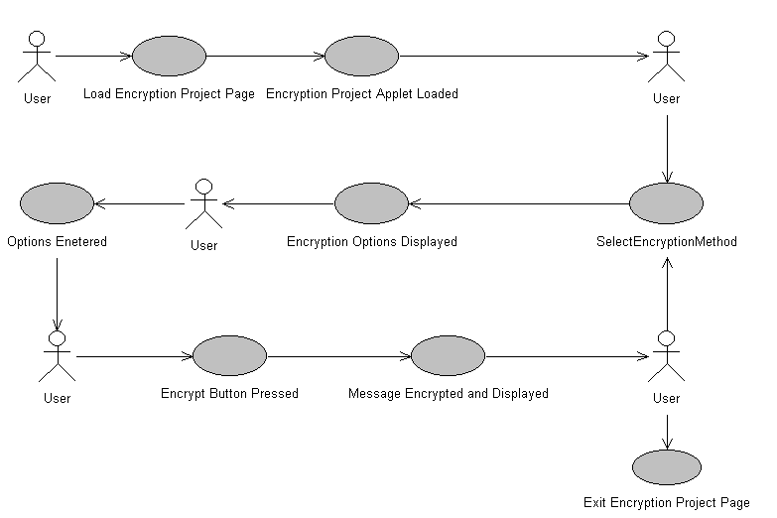

3.5 Software System Characteristics
Availability
The software is available to any party wishing to access it and will be accessible via the products home page (http://www.prism.gatech.edu/~gte187k/cs4235/project/EncryptionProject.html).

Security
There are no known security flaws at this time.

Maintainability
The source code should be properly documented, so that new developers will be able to understand the code as easily as possible.

Portability
Since Java is used as the development language, there should be few problems porting the software to new platforms. As an added bonus, as long as the platform contains a java-capable browser, the system will run as an applet.

