ENCRYPTION PROJECT

SOFTWARE DESIGN DOCUMENT

26 March 2002

Levi D. Smith and Christopher Ingram

CS4235 Section A

Professor Nelson-Palmer
Spring Semester 2002

Georgia Institute of Technology
Section 1: Introduction

  - Purpose of the System
The purpose of the system is to allow users to generate encoded messages depending on a user’s input. The system will also enlighten the user as to what goes on behind the scenes when an encryption algorithm is implemented.

  - Design Goals
The design is intended to give complete descriptions of the system so that the developers can implement the component with little confusion.

  - Definitions, Acronyms, and Abbreviations

  - References
Refer to the CS4235A Spring 2002 Software Requirements Specification

Section 2: Detailed Design

2.1 UML Diagram

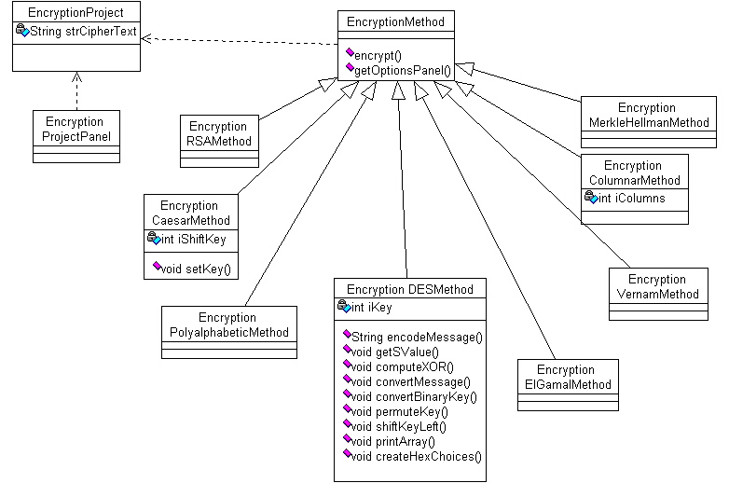

Section 3: Detailed Design Rationale
The Encryption Method class is abstract to give the various encryption algorithms a standard set of methods to use when interacting with the main class, EncryptionProject. The Encryption Project Panel class is implemented by each Encryption method to allow the user to specify the attributes of the encryption. The Encryption Project class is the manager for all the other classes and holds instances of all the Encryption methods.

Section 4: User Interface

4.1 Screen Shots
All screen shots and documentation can be found online at http://www.prism.gatech.edu/~gte187k/cs4235/project/EncryptionProject.html

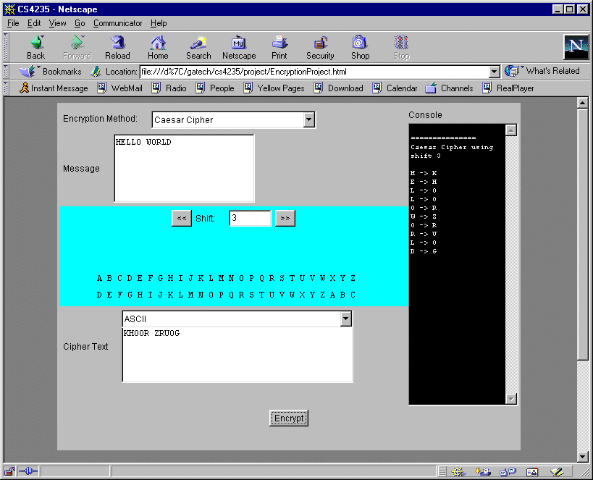

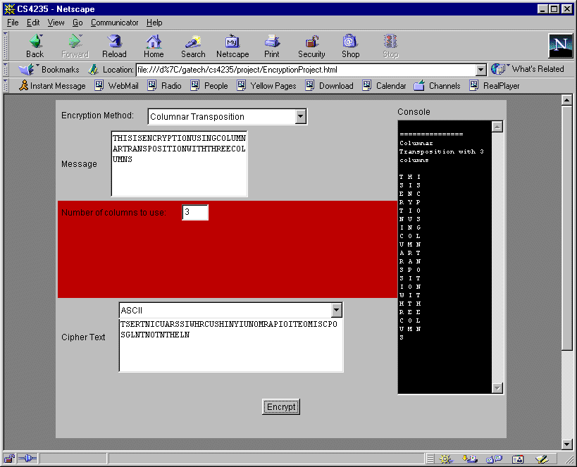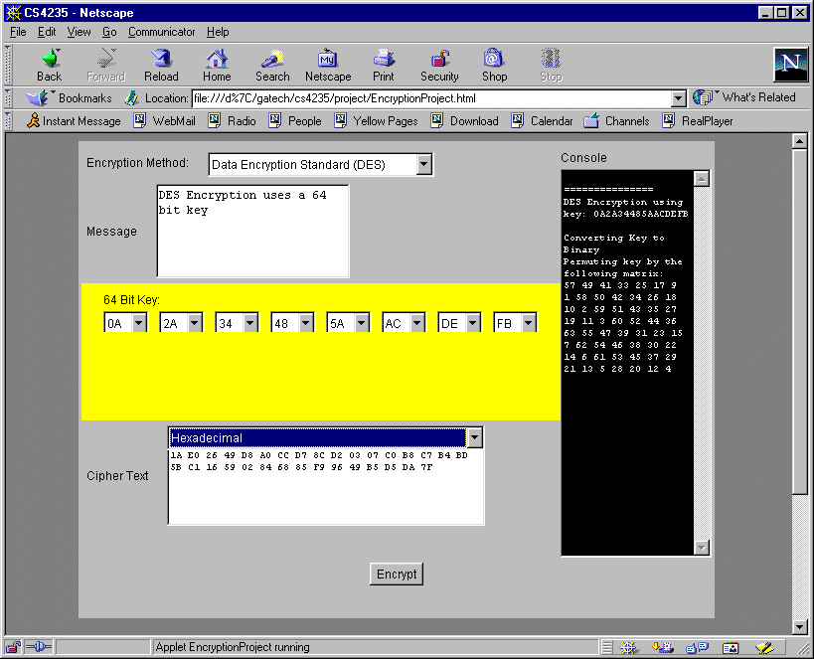

4.2 Interaction Description
The user will interact with four major areas: the plaintext text area, the algorithm selection area, the algorithm options area, and the encrypt button. The user will input the plaintext via the keyboard and select an encryption algorithm as well as selecting any options (and in some cases, input information via the keyboard) that are required by the encryption scheme, followed by clicking on the encrypt button. After this, the encryption algorithm will execute and display the cipher text in the cipher text area. Any relevant information that will provide insight into the inner workings of the algorithm will be displayed in the console to the right.

