


Universal Proxy User Manual

Summary

This document describes installation and maintenance of the Mona Lisa Universal Proxy Application (UniProxy).

Dokument Information
Website | http://www.gatehouse.dk
Filename | uniproxy-manual.odt
Copyright | GateHouse © 2012-2019
License | Creative Commons (CC BY-NC-SA 3.0)  http://creativecommons.org/licenses/by-nc-sa/3.0/

Revision History
Revision | Date | Author | Description
1.8 | 9/5-2023 | Poul Bondo | Added accept_short_certificate and min_tls_protocol
1.5 | 22/3-2019 | Poul Bondo | Added auto_reconnect parameter for version 1.5
1.3 | 12/9-2017 | Poul Bondo | Add Docker and general updates to match latest version 1.3.
0.3 | 15/10-2015 | Morten C. Larsen | Added details regarding timeout and keep-alive
0.2 | 28/09-2015 | Morten C. Larsen | Updated manual to reflect changes made to the uniproxy
0.1 | 10/05-2014 | Poul Bondo | Initial Revision

Table of Contents
1 Introduction 3
2 Installation 3
2.1 Windows 4
2.2 Linux 5
2.3 Docker 5
3 Configuration 6
3.1 Client configuration 6
3.2 Host Configuration 10
3.3 Configuration files 16
3.4 Windows Firewall (Windows and Windows Server ) 17

Introduction
The Uniproxy application is a simple VPN like application specifically developed for exchange of data between maritime authorities, although it can be used for a lot of other use cases.

A simplified description is visualised below. Both the host (data provider) and the client (data consumer) install a proxy. The proxy can be configured as either host or client (or a combination).

The basic principle is the standard one of public/private keys, where public keys are exchanged via a certificate. The security is based on the standard openssl package.

On initial connection the host and the client must be have established a separate communication channel (typically phone). Simultaneously they allow the uniproxy application to exchange certificates with each other. Once this exchange has been performed successfully any subsequent communication will be handled automatically.



Proxy
Proxy
Proxy
Proxy
Data
Consumer
Data
Provider
A more thorough description of the security is available in the document uniproxy-design.

Installation
The software is packaged by GateHouse for Windows and Linux (Ubuntu .deb and docker).

Windows
The application is tested with Windows 10 and Windows Server 2016 / 2019 all in 64 Bit only.
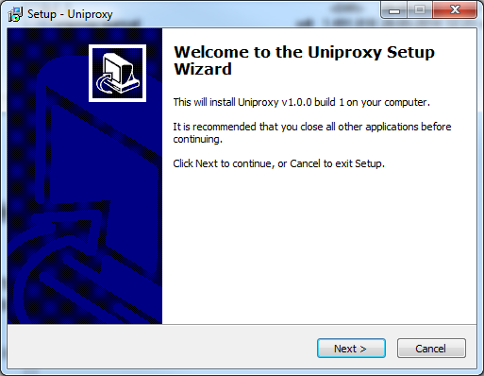

The application is intended to be run as a service but can also be run as a normal application.
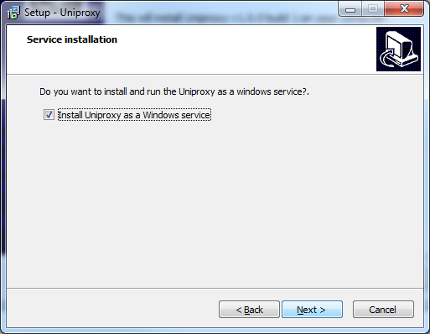
Press Next and finally press Install.

Linux
The Uniproxy application is bundled as a debian package tested with the latest Ubuntu LTS server, currently 18.04 Bionic.

The application is intended to be run as a daemon but can also be run as a normal application.

Installation is simply by double clicking the uniproxy-x.y.deb file and follow the instructions. On ubuntu server gdebi or dpkg can be used for installation.

The installation will create a uniproxy user with a home directory in /var/lib/uniproxy/.

Docker

Load image
gunzip -c uniproxy_v1.x.x.tar.gz | sudo docker load (import saved image from disk)

Create a Container From an Image And Run It The First Time
sudo docker run -d -p 1240:1240 -p 8085:8085 --name uniproxy_v1.3.0 uniproxy

-d run in the background
-p forward these ports from docker container to host machine

Subsequent Runs of the Container
sudo docker start uniproxy_v1.3.0
sudo docker stop uniproxy_v1.3.0

Uniproxy Setup / Configuration / Logs
connect to http://IP_OF_DOCKER_HOST:8085

Connect for data:
TCP connection to IP_OF_DOCKER_HOST port 1240

Configuration

Client configuration
Open a browser and bring up the uniproxy web page by default on port 8085 on the installed computer (typically localhost).

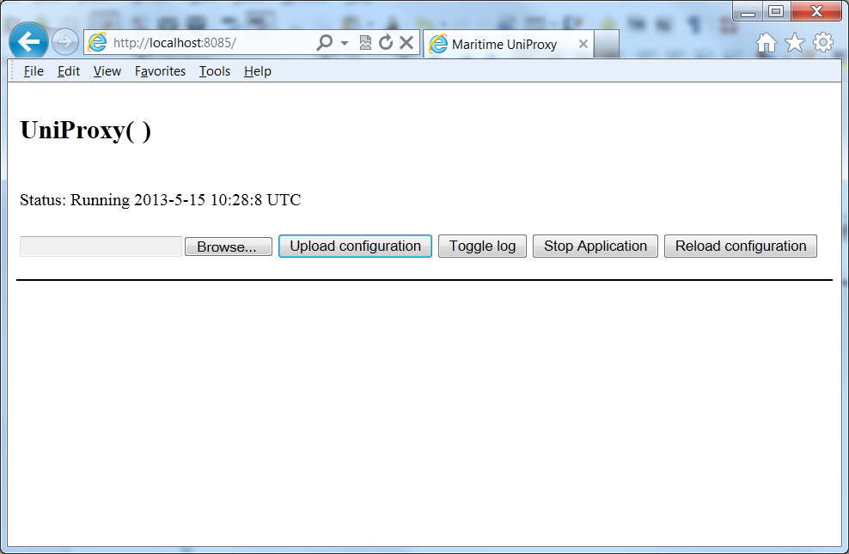
Verify that the uniproxy is running, i.e. Status: Running and a recent timestamp (updated about every 5 seconds)

The next step is to upload the configuration file supplied by the host master.

Press “Browse” to select a file and then press “upload configuration” to actually load the configuration.

After a few seconds the browser should change to something like:

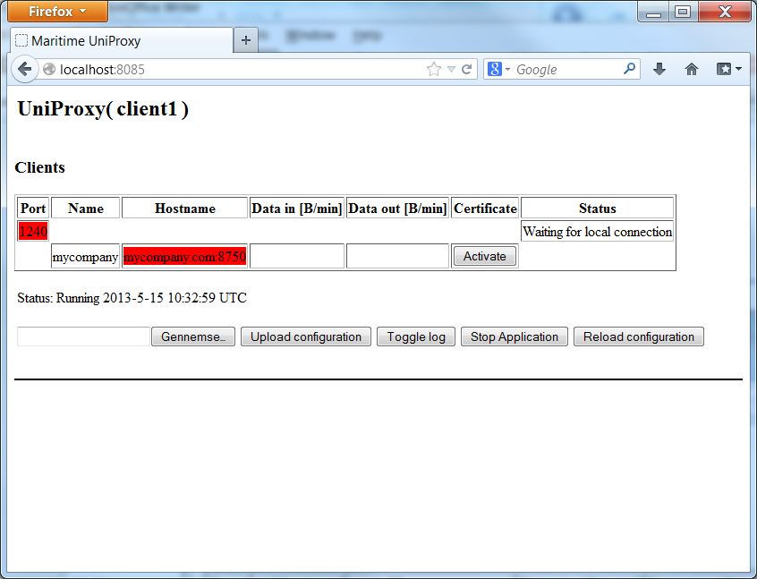
The important part is client name “client1” in the header Uniproxy(client1). This will be name of your local secure certificate.

The next step is to exchange the public part of the certificate with the host master.

Now call the host master on the phone (or any other means). When the host master say go you shall press the Certificate Activate button.

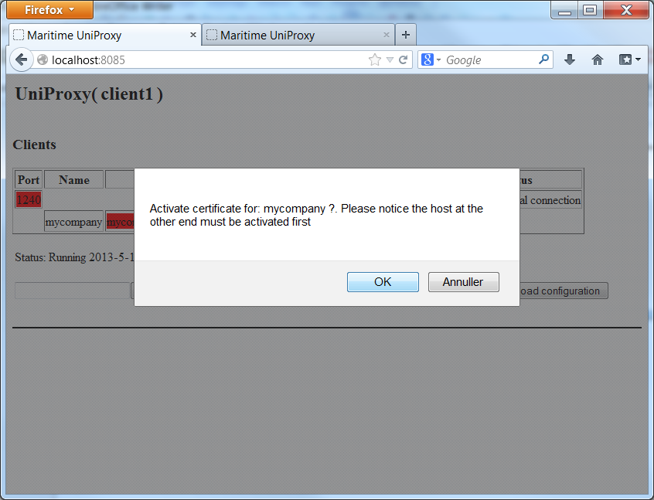
If successful the certificates are exchanged and the Activate button should now read “Delete”.

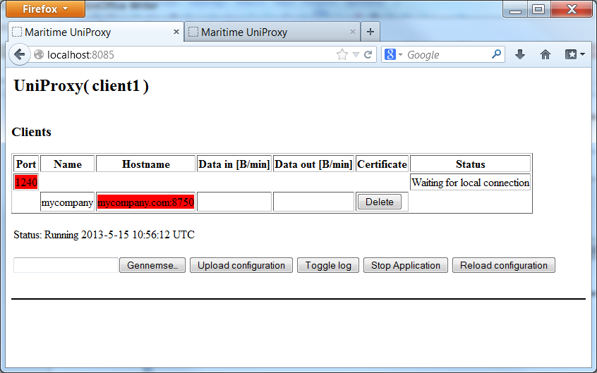
The client and the host have now exchanged the certificates are they are now ready for use with the intended applications

One of the simple tests that can be performed is using nc or telnet.

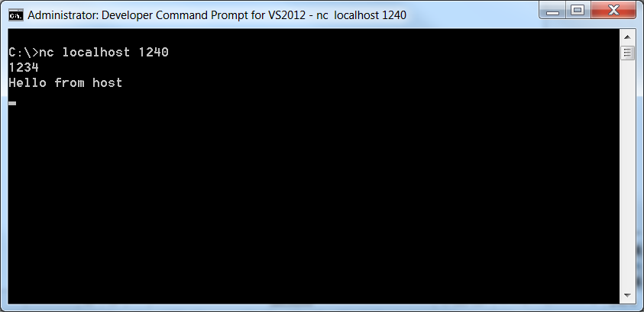

The browser should now change the color of the connection to green to indicate the connection is open.

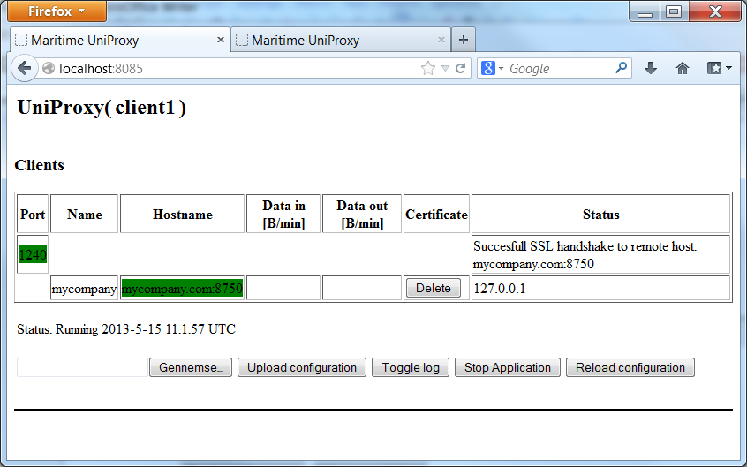

Host Configuration
Please see the next section for the format of the configuration file. The configuration file should be prepared for both the host and the attached clients.

The configuration file can either be managed externally and uploaded to Uniproxy the same way as for the client or it can be maintained in place with the name: uniproxy.json

After each edit, simply press “Reload configuration”.

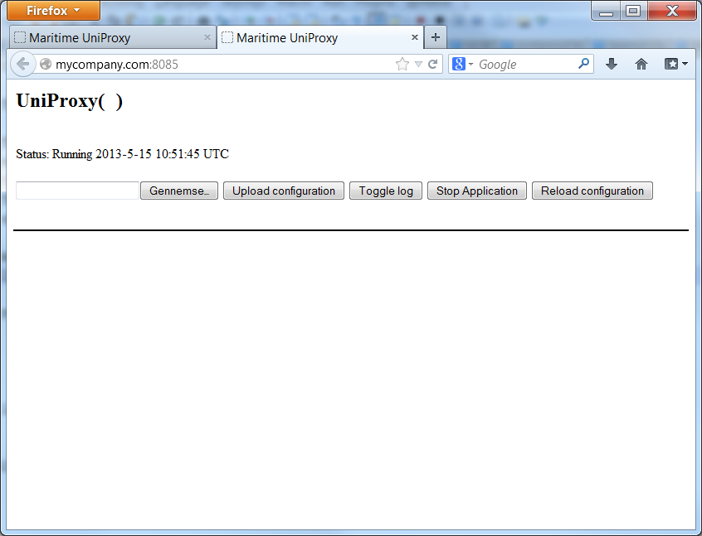
Verify the application is running Status: Running and a recent timestamp. Updated about every 5 seconds.

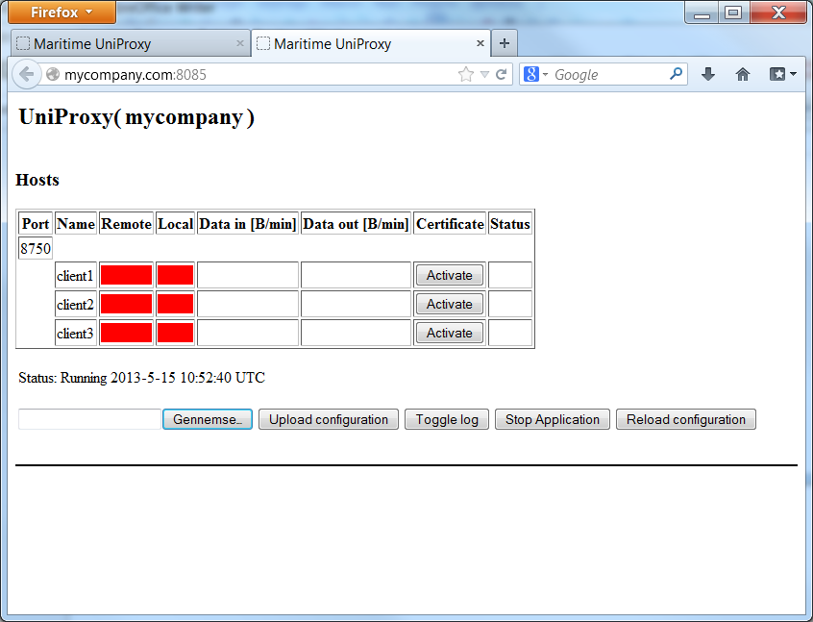
In the example here the proxy is prepared for 3 external clients.

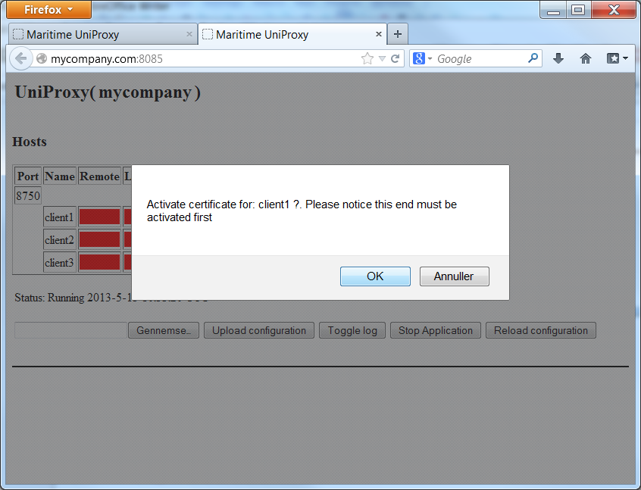
Call (whatever online means) the client and make sure his system is running and that he has loaded his configuration file, i.e. he has a Client section.

When you and the client are ready you press the Activate button for the client and then press ok. The client now has a default of 1 minute to also press the Activate and ok button. The timeout is configurable on the server end.

A piece of advice is to try out locally with a test setup, since it can be a little confusing when dealing with external clients.

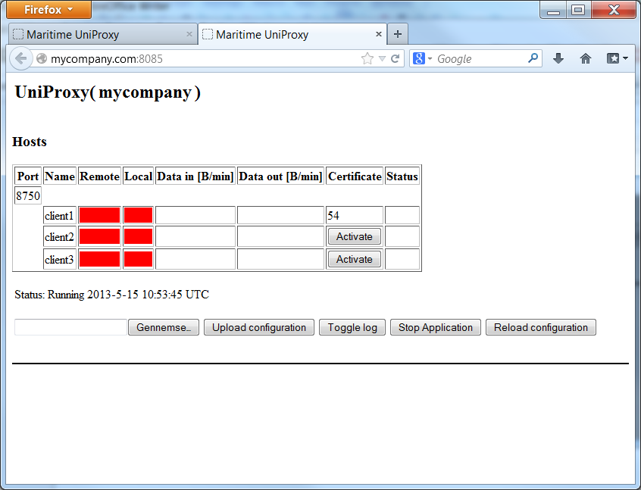
For the duration of 1 minute the counter will tick down. If the operation fails, then after 1 minute you can try again.

The most common problem is firewall issues. The uniproxy will fail silently for security reasons. Using netcat or similar can be an easy way to establish whether there are any firewall issues.

If/when all goes well the Activate button on both the Client and the Host will change to Delete.

The client can now test the connection by connecting with the client application or netcat to the client port.

If all goes well the connection will change color to green on both the client and the host.

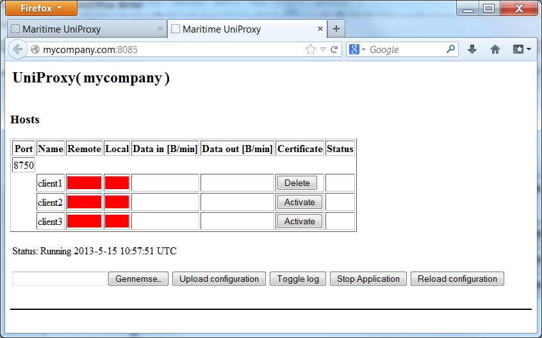

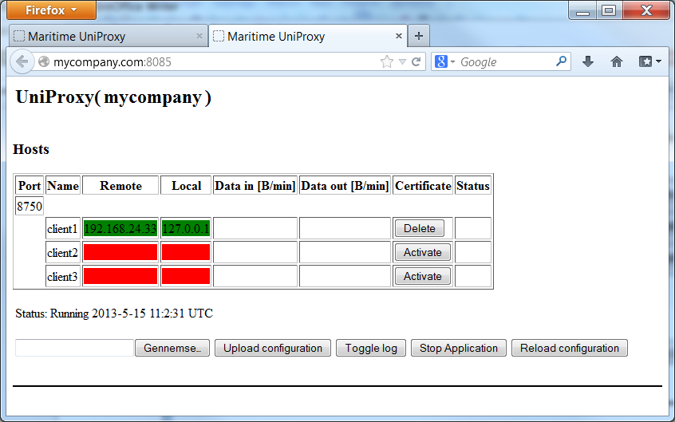
Some issues may be resolved by looking at the log. Press the “Toggle log” or look for the uniproxy.log file.

Configuration files

In the Uniproxy, “TCP Keep Alive" is enabled by default at 20 seconds, on both the host and client side.

Sample simple client configuration file:

{
"clients":[
{
"port" : 1240,
"remotes" : [
{ "name" : "mycompany", "hostname" : "mycompany.com","port":8750 }
]
}
],
"config" : { "name" : "client1" }
}
Slightly more complex client configuration showing the various options:

{
"clients":[
{
"port" : 1240,
"read_timeout" : "00:05:00",
"auto_reconnect" : false,
"max_connections" : 1,
"active" : true,
"provider" : false,
"remotes" : [
{ "name" : "mycompany", "hostname" : "mycompany.com","port":8750 }
]
}
],
"config" : {
"name" : "client1",
"accept_short_certificates" : 1,
"min_tls_protocol" : 12
}
}
Please notice that the client side does not require any special configuration, but the following options are available:

- "read_timeout" : "00:05:00" indicates the client shall disconnect if no data is received in 5 minutes. This can be needed if the data transferred is sent in chunks, or if the data is only received periodically.
- "auto_reconnect" : false indicates the client should not attempt to reconnect if any problems are detected. Notice setting this to true is an experimental feature.
- "max_connection" : 1 indicates only one client application is allowed to connect to the client uniproxy. Notice setting this > 1 is experimental and has some known problems. Such as if one client application is slow in retrieving the data this will affect all connections.
- "Provider" : false Indicates if the client shall act as a data provider, not as a data consumer. See below.

Additional Configuration Parameters

- "accept_short_certificates" : 1 indicates that the client will accept server certificates issued before ca. 2018. This is in relation to older server installations where the issued certificates are no longer considered fully safe. Notice this should not be used on the server end to accept short client certificates.
- "min_tls_protocol" : 12 indicates the minimum accepted TLS protocol: 12 = version 1.2 and 13 = version 1.3. From Uniproxy version 1.8.1 the TLS version 1.3 is used by default, but to allow usage with other uniproxies since version 1.7 the configuration can be set to 12.

Provider example:

{
"clients":[
{
"port" : 1240,
"provider" : true,
"locals" : [ { "hostname" : "192.168.1.1", "port" : 26473 } ],
"remotes" : [
{ "name" : "mycompany", "hostname" : "mycompany.com","port":8750 }
]
}
],
"config" : { "name" : "client1" }
}
The difference will be that the client will first connect to a local system connection. And if successful will then connect to the remote host uniproxy. It will then read data from the local system and deliver the data to the remote Uniproxy.

Sample simple host configuration file:

{
"hosts" : [
{ "port" : 8750,
"locals" : [ { "hostname" : "localhost", "port" : 2000 } ],
"remotes" : [
{ "name" : "client1" }, { "name" : "client2" }, { "name" : "client3" }
]
}
],
"config" : { "name" : "mycompany" }
}
Sample simple host configuration file for access to a GateHouse AIS System:

{
"hosts" : [
{ "port" : 8750, “type” : “GHP”,
"locals" : [ { "hostname" : "ais03", "port" : 26472 } ],
"remotes" : [
{ "name" : "client1", “username” : “client1”, “password” : “pw1” },
{ "name" : "client2", “username” : “client2”, “password” : “pw2” },
{ "name" : "client3", “username” : “client3”, “password” : “pw3” }
]
}
],
"config" : { "name" : "mycompany" }
}
{
"hosts" : [
{ "port" : 8750, “type” : “GHP”,
"locals" : [ { "hostname" : "ais03", "port" : 26472 } ],
"remotes" : [
{ "name" : "client1", “username” : “client1”, “password” : “pw1” },
{ "name" : "client2", “username” : “client2”, “password” : “pw2” },
{ "name" : "client3", “username” : “client3”, “password” : “pw3” }
]
}
],
"config" : { "name" : "mycompany" }
}
A more thorough example with multiple access and both client and host access is provided below.

{
"clients":[
{
"port" : 1240,
"remotes" : [
{ "name" : "mycompany", "hostname" : "mycompany.com","port":8750 }
{ "name" : "mycompany", "hostname" : "mycompany.com","port":8750 }
]
}
],
"hosts" : [
{ "port" : 8750, “type” : “GHP”,
"locals" : [ { "hostname" : "ais03", "port" : 26472 } ],
"remotes" : [
{ "name" : "client1", “username” : “client1”, “password” : “pw” },
{ "name" : "client2", “username” : “client2”, “password” : “pw” },
{ "name" : "client3", “username” : “client3”, “password” : “pw” }
]
}
],
"config" : { "name" : "mycompany" }
}

Windows Firewall (Windows and Windows Server )
It is of utmost importance that the firewall is open at the relevant ports, otherwise the application will fail and due to security it is designed to fail silently.

During the installation the application opens the relevant web port 8085. However other ports that should be open depends on the configuration.

On the workstation or server where the Uniproxy application is running the local firewall should be set up to allow incoming on “clients.port” and “hosts.port”.

External firewalls should allow incoming on “hosts.port” and it should be forwarded to the Uniproxy computer.

Simple Mode
In the simple mode we simply allow the uniproxy application to open and access all the required ports.

Choose Control Panel / Windows Firewall.

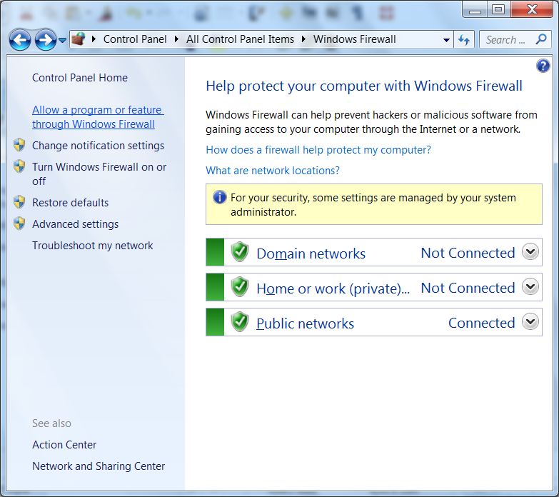
Select the link “Allow a program or feature through Windows firewall”.

If the uniproxy application is not already on the list add it through the “Allow another program”.

Then browse to and select “c:\program files (x86)\uniproxy\uniproxy.exe”.

You may need to press the “Change Settings” button at the top.

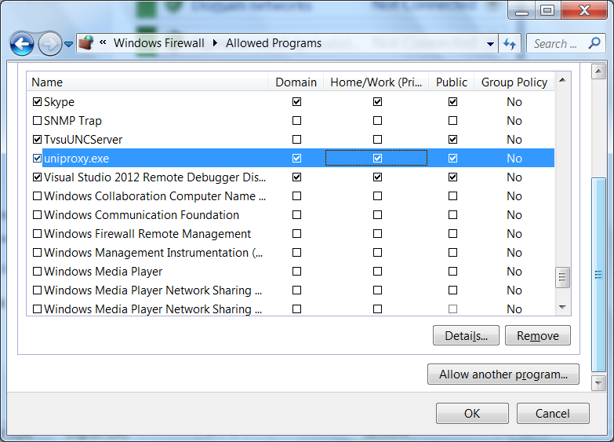
Enable all the relevant modes (Domain / Home / Public).

Finally press the “OK” button.

Advanced Mode

To open the necessary ports in Windows Firewall, open the option in Control Panel:

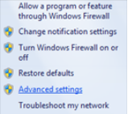

In the left menu choose “Advanced settings”

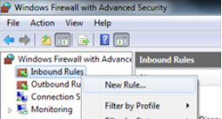
In ”Windows Firewall with Advanced Security” right-click on “Inbound Rules” and select “New Rule…”
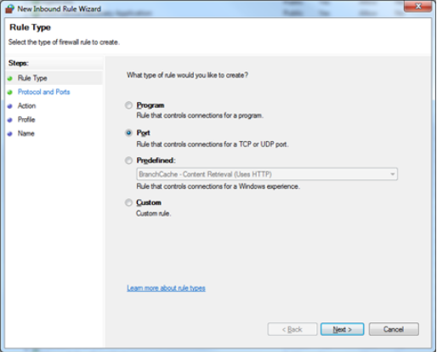
Select ”Port”
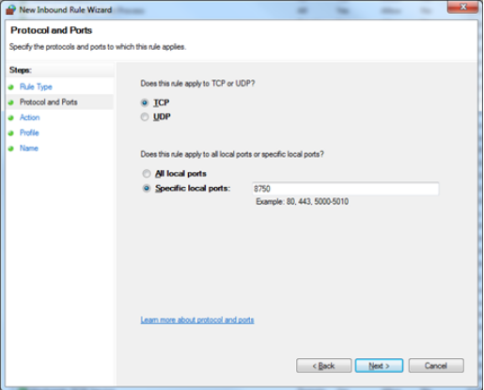

Choose ”TCP” and ”Specific local ports”, and enter the specific port or range.
- For UniProxy open port 8750 and optional port 8085 if it is desire to connect through a browser. Make one rule for each port.
Allow connection through the specific port.
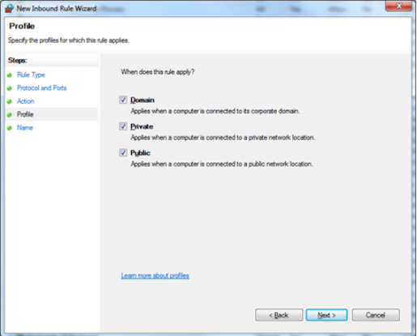

Choose which firewall profiles the rule should be applied too.
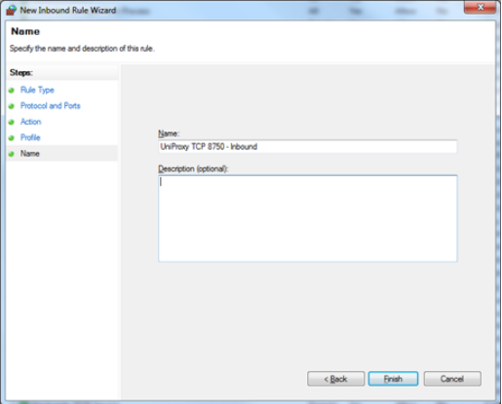
Finish by giving the rule a proper name.

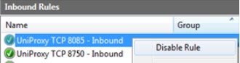
A rule can be disabled/re-enabled by right clicking on the rule in the “Inbound Rules”-list and choosing the first option.

