Cassy Gates

Design and Functionality: Grocery Item Tracker

This is a description of the Grocery Item Tracker Program and its functionality. The program loads an external file with a list of grocery items and saves a new file with each of the items and their frequencies listed neatly in pairs. After that, the program will give the users a menu of 4 options to search for an item and its frequency, print all items and their frequencies, print a histogram of frequencies, or exit the program. The program validates user input and successfully carries out all menu options. Please see the following documentation for photos and a more in-depth description of the functionality.

1. File Loading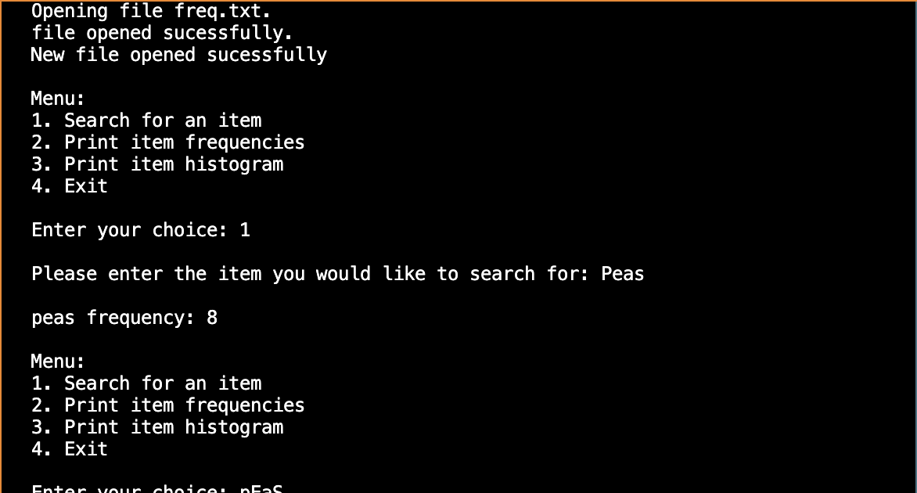

Fig 1: The program displays while the input file and the output file are opened. A message will appear telling the user that the files are either opened successfully or unsuccessfully.

2. Menu Printing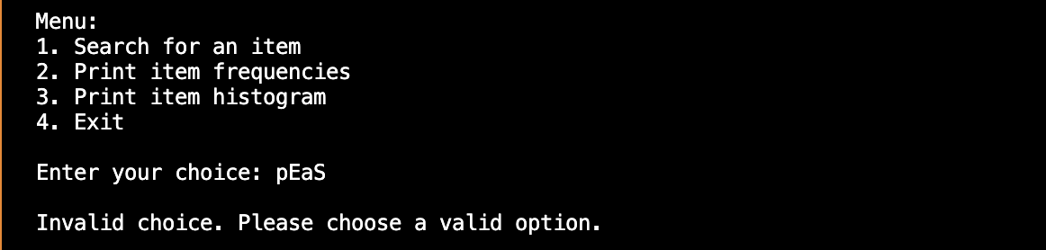

Fig 2: Once the files have loaded, a Menu will appear listing the 4 options. The program will validate the user input and prompt the user for a new input if an invalid entry is made.

3. Item Search Button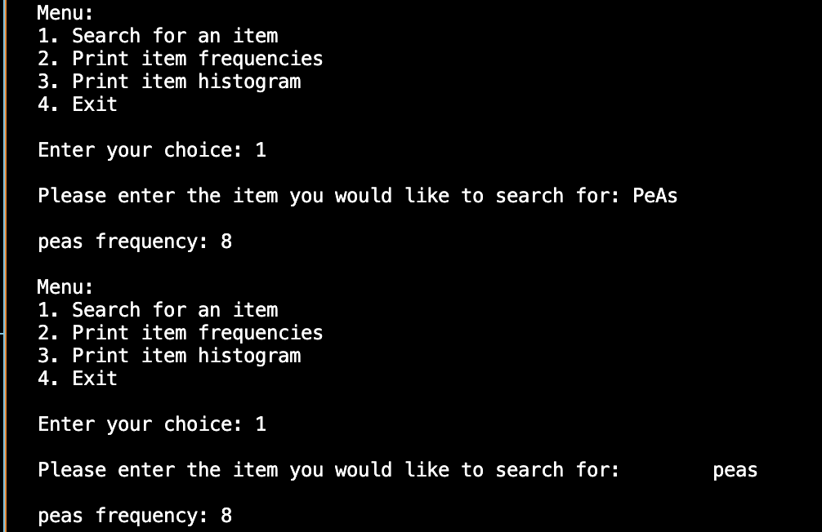

Fig 3: If the user selects 1, the program will allow the user to search for an item and its frequency. The program will perform a case-insensitive search that will remove spaces from the user input.

4. Frequency Printing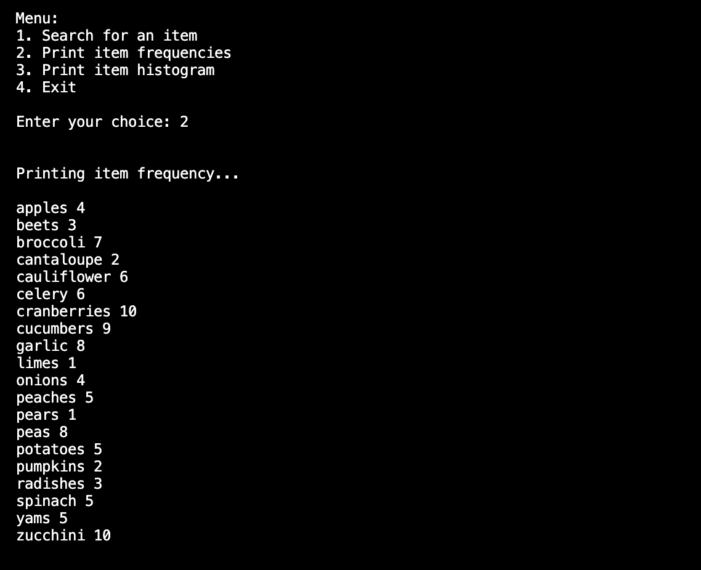

Fig 4: If the user selects 2, the program will print a list of all of the items and their frequencies in pairs.

5. Histogram 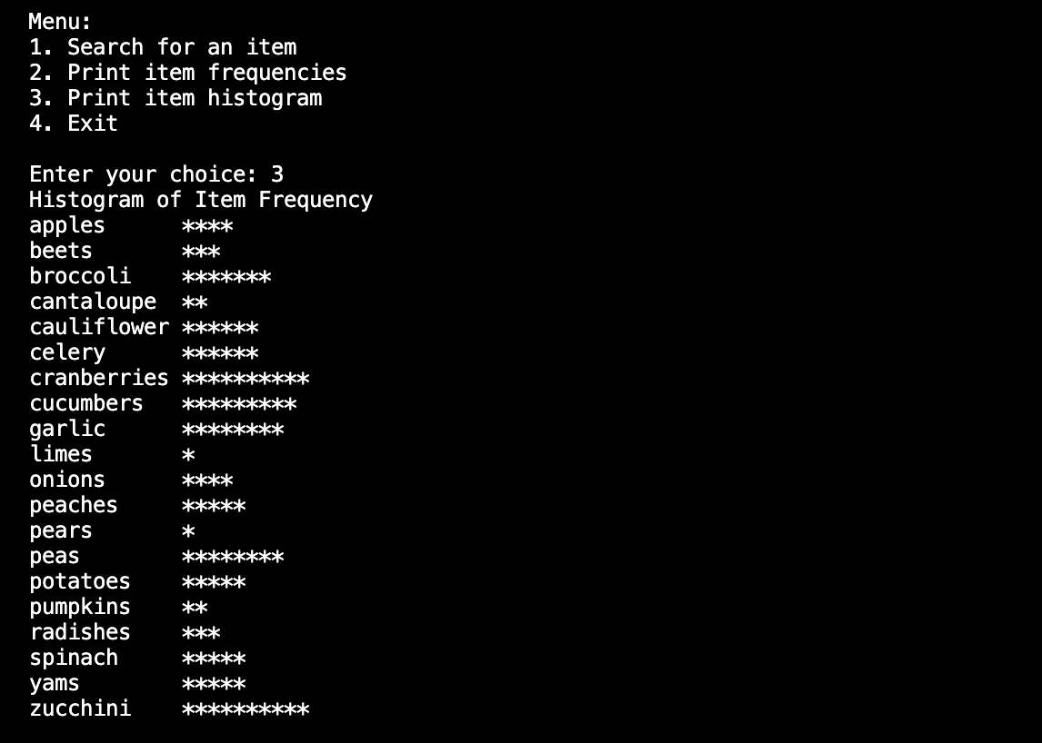

Fig 5: If the user selects 3, the program will print a histogram of the items and their frequencies represented by repeating the symbol “\*”.

6. Exit Program 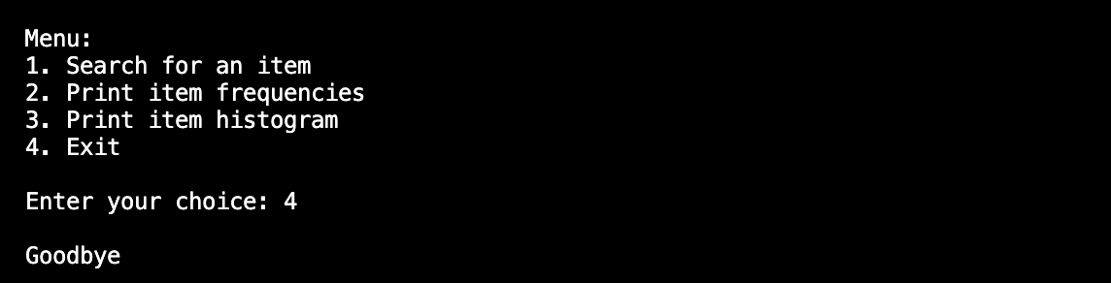

Fig 6: If the user selects 4, the program will exit and say “goodbye”.