PL/SQL JOINs & Window Functions Project Assignment
Name: GATESI Eddy-guerra
Course: Database Development with PL/SQL (INSY 8311) Group: D
Instructor: Eric Maniraguha
Submission Date: 8 February 2026
Step 1: Problem Definition
Businesss context
A university institution managing multiple academic departments records student progress and course enrollments. The administration wants to analyze academic performance and curriculum dependencies to improve course scheduling and graduation outcomes.
Data Challenges
The system maintain strict referential integrity between grades, student identifiers, and specific section records to ensure transcript accuracy. It also faces the complexity of managing recursive prerequisite relationships and tracking courses offerings across different years and semesters.
Expected outcome
Analysis will enable the administration to optimize faculty assignments based n section performance and identity curriculum bottlenecks to streamline student graduation paths.
Step 2: Success Criteria
- Top 5 students by GPA per major RANK()
- Running total credit hours per semester SUM() OVER()
- Year over year grade improvement per student LAG() / LEAD()
- Student performance quartile segmentation NTILE(4)
- Three years moving average of department enrollment AVG() OVER()

Step 3: Database Schema Design

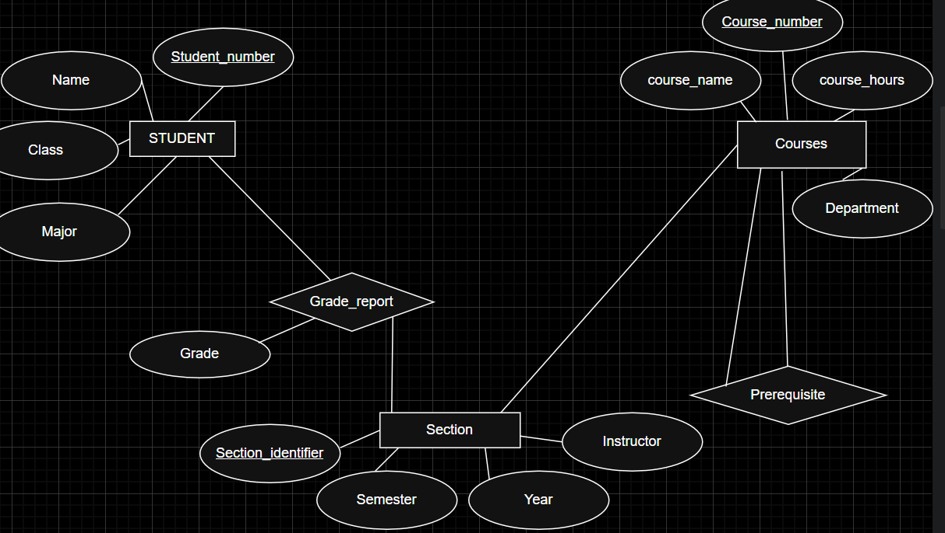
Table creation and insertion; 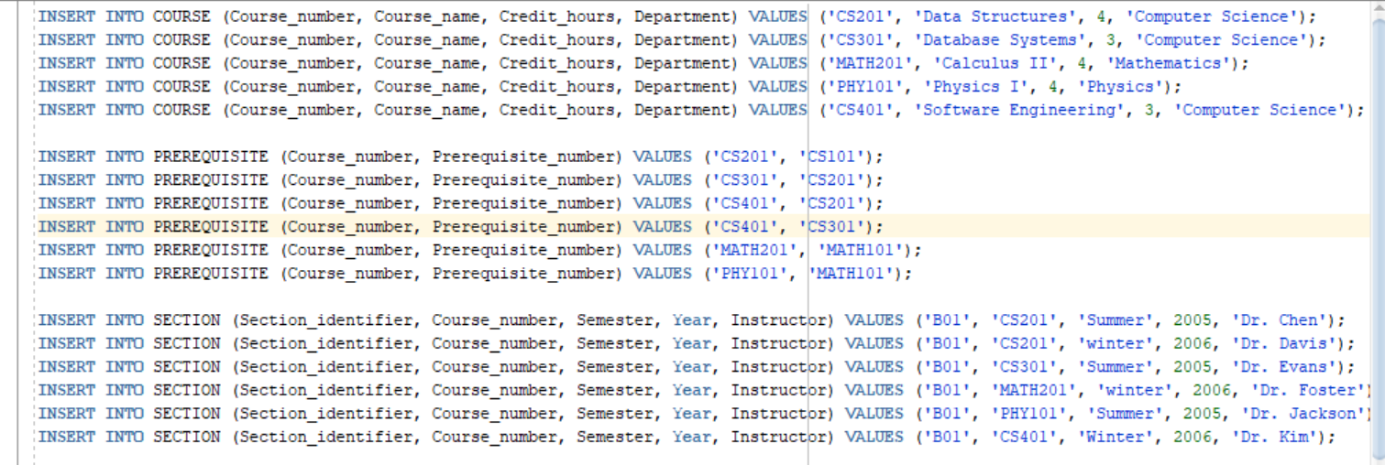
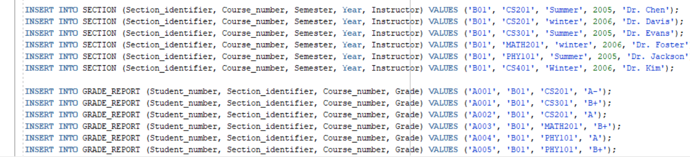

Out put;
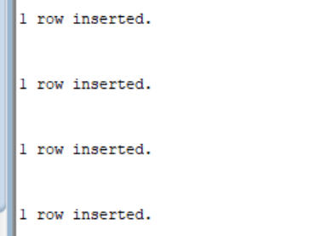

Step 4: Part A — SQL JOINs Implementation
INNER JOIN:
Retrieve transaction with valid customer and product
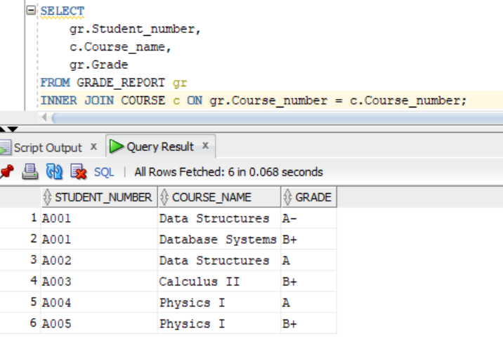
Business Interpretation: This query identifies completed enrollments where both a registered student and a valid course exist. It ensures the report only reflects verified academic records.
2. LEFT JOIN
Identify customers who have never made a transaction
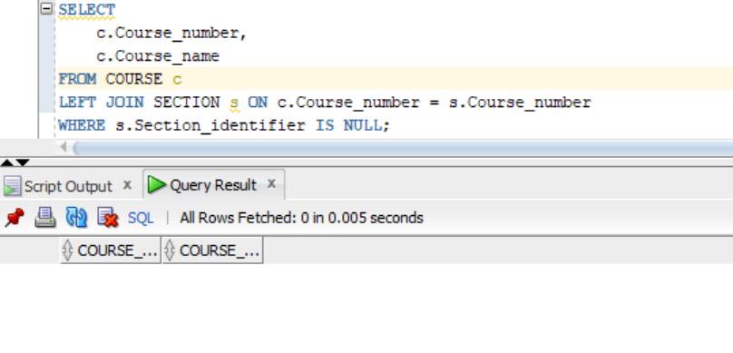
Business Interpretation: This query identifies dormant courses that are part of the curriculum but haven't been scheduled for a semester yet. It helps administrators decide if these courses should be archived or if a new instructor needs to be assigned to teach them.
3. RIGHT JOIN
Detect products with no sales activity

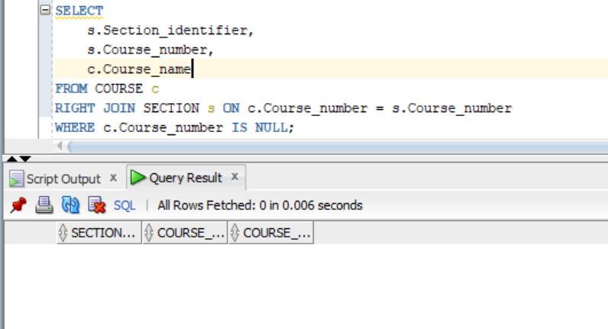
Business Interpretation: This is a data-quality query used to find sections. If a section is scheduled but the course doesn't exist in the main catalog, it indicates a database error that could prevent students from seeing the course details during registration.
4. FULL OUTER JOIN
Compare customers and products including unmatched records
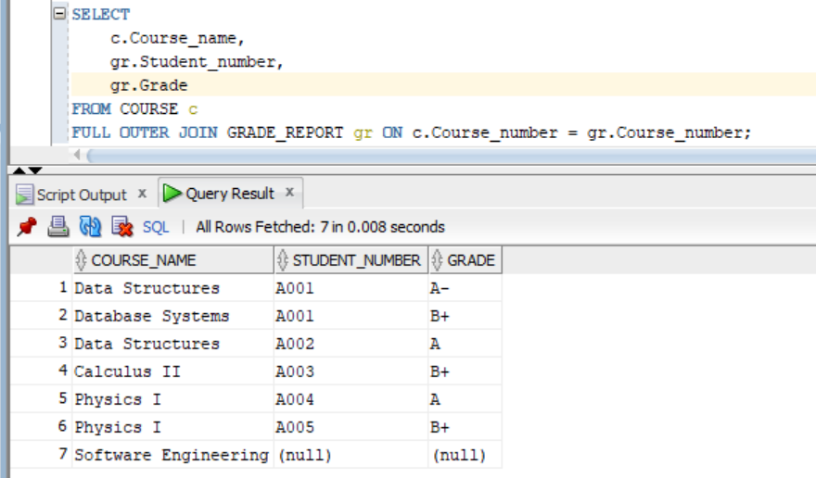
Business Interpretation: This provides a bird's-eye view of academic activity. It highlights both highly popular courses and specialized courses that currently have zero enrollment, assisting in long-term departmental planning.

5. SELF JOIN
Compare customers within the same region or transactions within the same time period
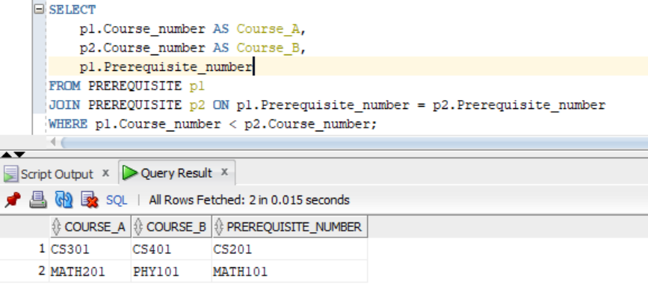
Business Interpretation: This identifies courses that require the same foundational knowledge. This is useful for academic advisors when suggesting alternative paths for students who have completed a specific prerequisite but find one of the advanced courses full.
Step 5: Part B — Window Functions Implementation
- Ranking Functions ROW_NUMBER (), RANK (), DENSE_RANK (), PERCENT_RANK ()
Use case: Top N customers or products by revenue
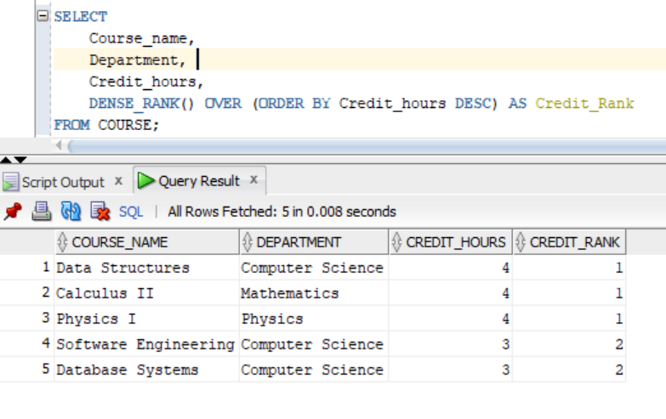
Interpretation: This query ranks the curriculum by difficulty or workload based on credit hours. It helps students quickly identify the most intensive courses versus lighter electives.
- Aggregate Window Functions SUM (), AVG (), MIN (), MAX () Use both ROWS and RANGE frames
Use case: Running totals and trends
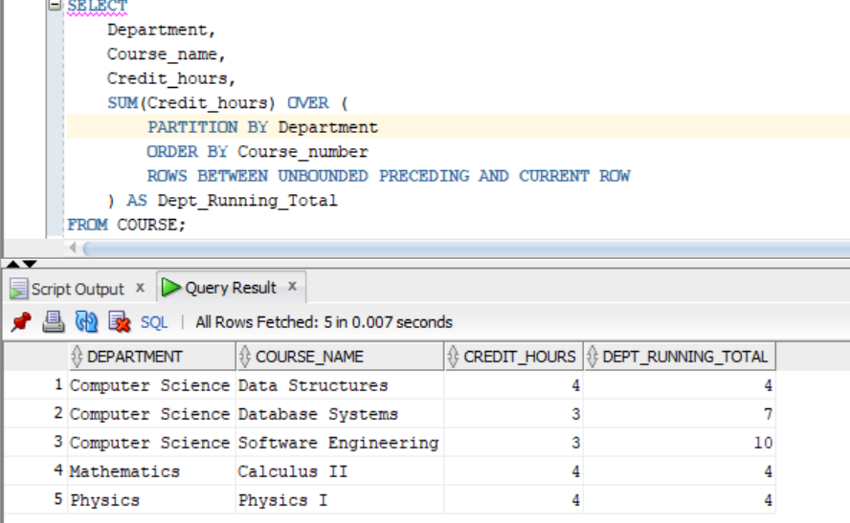
Interpretation: This query shows the cumulative weight of the curriculum within a specific department. It is useful for department heads to see how credits accumulate as students’ progress through course numbers.
- Navigation Functions LAG (), LEAD()
Use case: Period-to-period comparison and growth
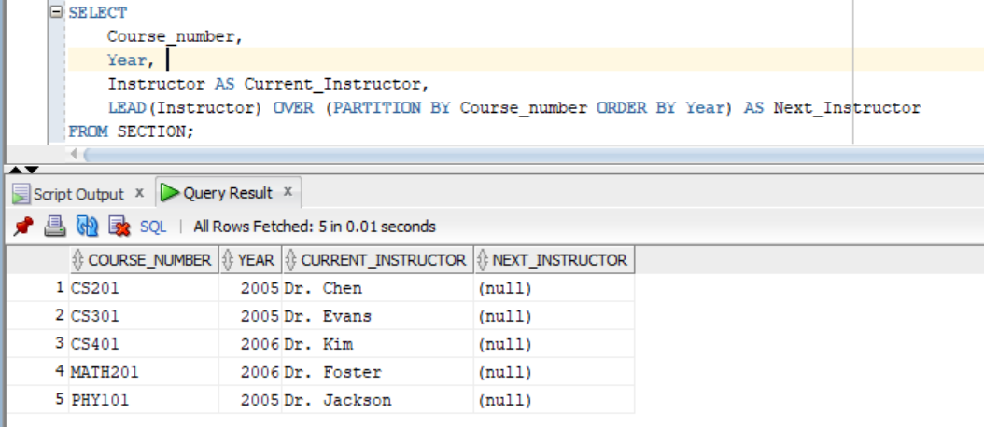
Interpretation: This identifies staffing changes over time for specific courses. It allows the administration to track instructor turnover or verify if a specific professor is scheduled to take over a course in the following year.
- Distribution Functions NTILE (4), CUME_DIST ()
Use case: Customer segmentation
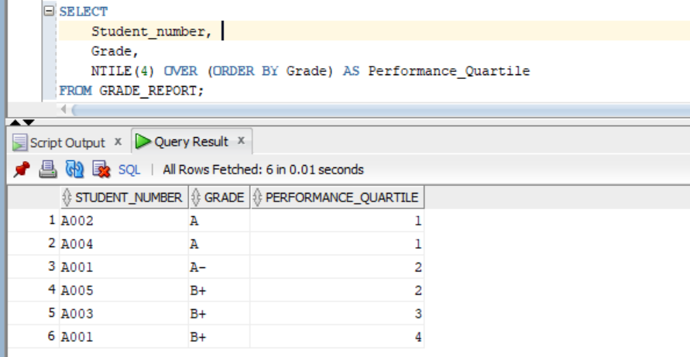
Interpretation: This identifies staffing changes over time for specific courses. It allows the administration to track instructor turnover or verify if a specific professor is scheduled to take over a course in the following year.

