ANM 1 – HW Set 1

PR 1

```

x = [1 2 3 4]

y = [2 1 -2 3]

x.\*y

x./y

x.^y

x+y

x-y

```

x =

1 2 3 4

y =

2 1 -2 3

ans =

2 2 -6 12

ans =

0.5000 2.0000 -1.5000 1.3333

ans =

1.0000 2.0000 0.1111 64.0000

ans =

3 3 1 7

ans =

-1 1 5 1

~~~~~~~~~~~~~~~~~~~~~~~~~~~~~~~~~~~~~~~~~~~~~~~~~

PR 2

```

h = 1;

x = 5:h:10;

y = sqrt((x.^3) + 1) .\* sin(x);

figure(1)

plot(x,y)

h = .01;

x = 5:h:10;

y = sqrt((x.^3) + 1) .\* sin(x);

figure(2)

plot(x,y)

```

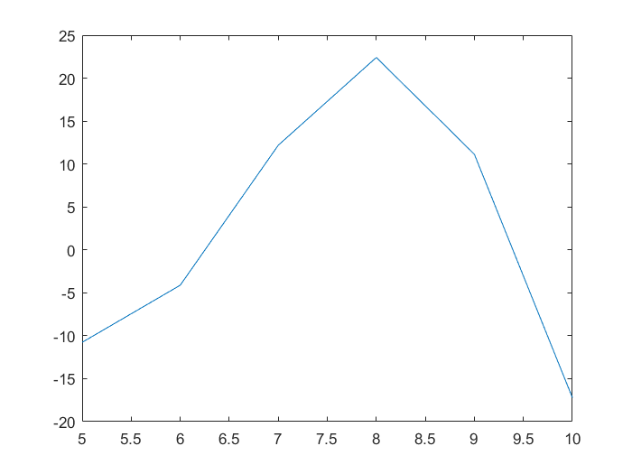

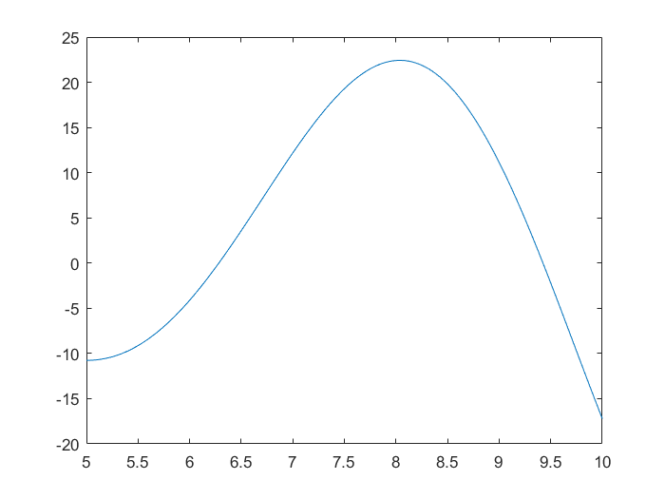

~~~~~~~~~~~~~~~~~~~~~~~~~~~~~~~~~~~~~~~~~~~~~~~~~

PR 3

```

% the 'o' is an optional third parameter

% that formats the graph of x1,y1

% Second approach

x = 5:1:10;

y = sqrt((x.^3) + 1) .\* sin(x);

figure(1)

hold on

plot(x,y,'o')

x = 5:.01:10;

y = sqrt((x.^3) + 1) .\* sin(x);

plot(x,y)

```

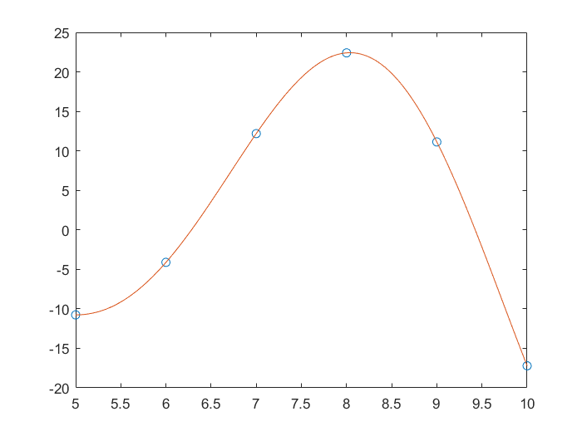

~~~~~~~~~~~~~~~~~~~~~~~~~~~~~~~~~~~~~~~~~~~~~~~~~

PR 4

```

f = @(x) ((exp(x)) .\* sin(x) ) ./ ((x.^2) + 1)

h = 1;

x1 = 3:h:7;

y1 = f(x1);

figure(1)

h = .01;

x2 = 3:h:7;

y2 = f(x2);

plot(x1,y1, 'o', x2, y2)

```

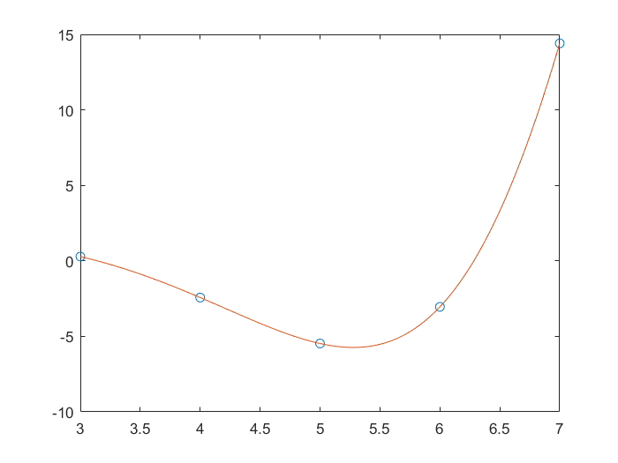

f =

@(x)((exp(x)).\*sin(x))./((x.^2)+1)

~~~~~~~~~~~~~~~~~~~~~~~~~~~~~~~~~~~~~~~~~~~~~~~~~

PR 5

```

f = @(x) (sin(x.^3));

x=5.201;

fprintf('f(%.8f) = %.10e \n',x,f(x))

x= -8323.6;

fprintf('f(%.8f) = %.10e \n',x,f(x))

x= 0.0003;

fprintf('f(%.8f) = %.10e \n',x,f(x))

```

f(5.20100000) = 6.3076122538e-01

f(-8323.60000000) = -5.2794696417e-01

f(0.00030000) = 2.7000000000e-11

~~~~~~~~~~~~~~~~~~~~~~~~~~~~~~~~~~~~~~~~~~~~~~~~~

PR6

```

[x1, x2] = quadform(1, 1.8, -.740)

[x1, x2] = quadform(1, -12.00035802468123, 36.00214817704637)

% fprintf('The approximate derivative at %f using h=%f is %e\n',x,h1,d1)

% fprintf('The approximate derivative at %f using h=%f is %e\n',x,h2,d2)

```

x1 =

6.0001

x2 =

6.0002