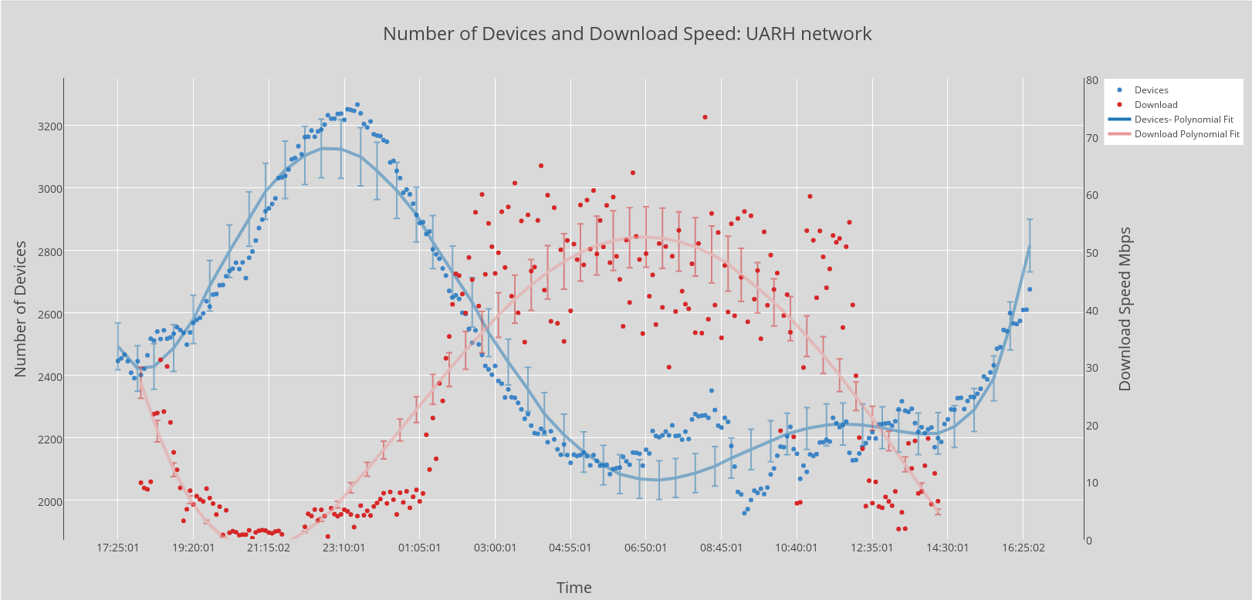

I noticed, after living on campus, that the WiFi speeds varied greatly depending on the time of day. I suspected it had to do with how many devices were connected at a time. I wanted to put this to the test. With a Raspberry Pi connected to the internet for 24 hours I was able to monitor the download speed and number of connected devices every 5 minutes. The results are shown above.