CODVEDA BUSINESS ANALYTICS INTERNSHIP
PROJECT 1
Social Media Sentiment and Engagement Analysis
Final Project Report
Dataset: Sentiment dataset.csv - 732 supplied records
September 2026

1. Project Overview
This project analyzes the supplied social media dataset to understand sentiment, engagement, platform use, country patterns and time trends. The work was completed using Excel, Jupyter Notebook with Python, Power BI and MySQL. The same cleaned data and headline figures were used across the deliverables so that the results stay consistent.

Business questions
- What is the overall sentiment distribution in the supplied records?
- Which platforms have the highest post volume and average engagement?
- How are Likes and Retweets related?
- Which countries and posting hours appear most often?
- Are the observed differences in average Likes statistically significant?

Internship task alignment
The project demonstrates data cleaning and exploratory analysis, descriptive statistics, statistical testing, SQL aggregation and joins, and an interactive Power BI dashboard. These activities support the business analytics tasks in the internship guide.

Dataset summary
Item | Result
Records | 732
Raw columns | 15
Missing values | 0
Full duplicate rows | 0
Platforms | 3
Countries | 33
Date range | 2010 to 2023

2. Data Preparation and Method
The two redundant index columns were removed. Leading and trailing spaces were cleaned from text fields, including Country and Sentiment. The original sentiment field was kept, and a separate Sentiment_Group field was created for Positive, Negative and Neutral analysis. Before trimming spaces, the Sentiment column contained 279 distinct stored strings; after normalization there were 191 unique labels.
The IQR check flagged 18 Likes values and 18 Retweets values as potential outliers. The values were still inside the observed valid ranges of the dataset, so they were retained rather than removed automatically.

Main methods used
- Descriptive statistics: count, mean, median, mode, standard deviation, minimum and maximum.
- Exploratory analysis by sentiment, platform, country, year and hour.
- Pearson correlation and simple linear regression for Likes and Retweets.
- One-way ANOVA for Likes across platforms and a Welch t-test for Positive versus Negative Likes.
- SQL aggregation, conditional aggregation, an INNER JOIN, indexes and EXPLAIN.
- Power BI measures and interactive dashboard views.

Descriptive statistics
Statistic | Likes | Retweets
Count | 732 | 732
Mean | 42.90 | 21.51
Median | 43 | 22
Mode | 45 | 22
Std. deviation | 14.09 | 7.06
Min / Max | 10 / 80 | 5 / 40

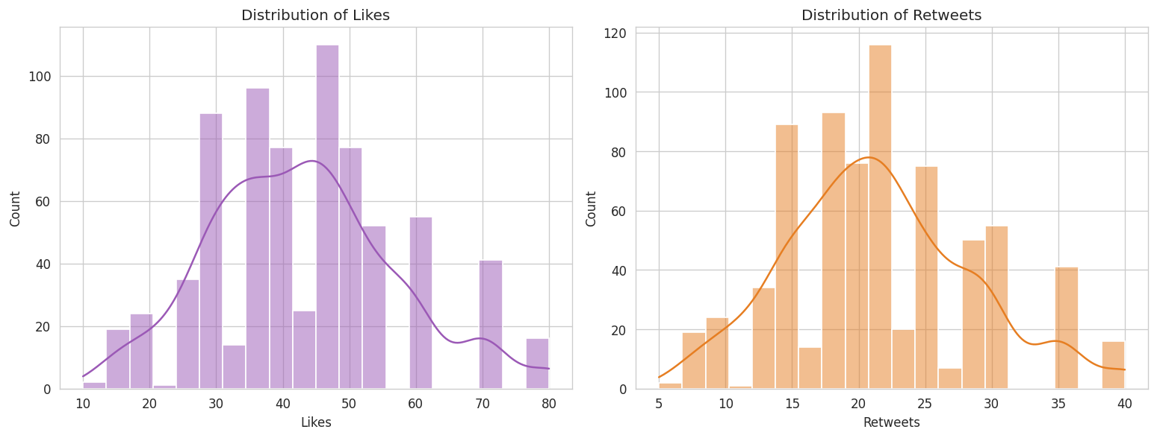
Figure 1. Distribution of Likes and Retweets from the executed notebook.

3. Sentiment and Platform Results
Positive sentiment is the largest group in the dataset. It represents 474 of 732 posts, or 64.75%. Negative sentiment represents 195 posts (26.64%), while Neutral represents 63 posts (8.61%).
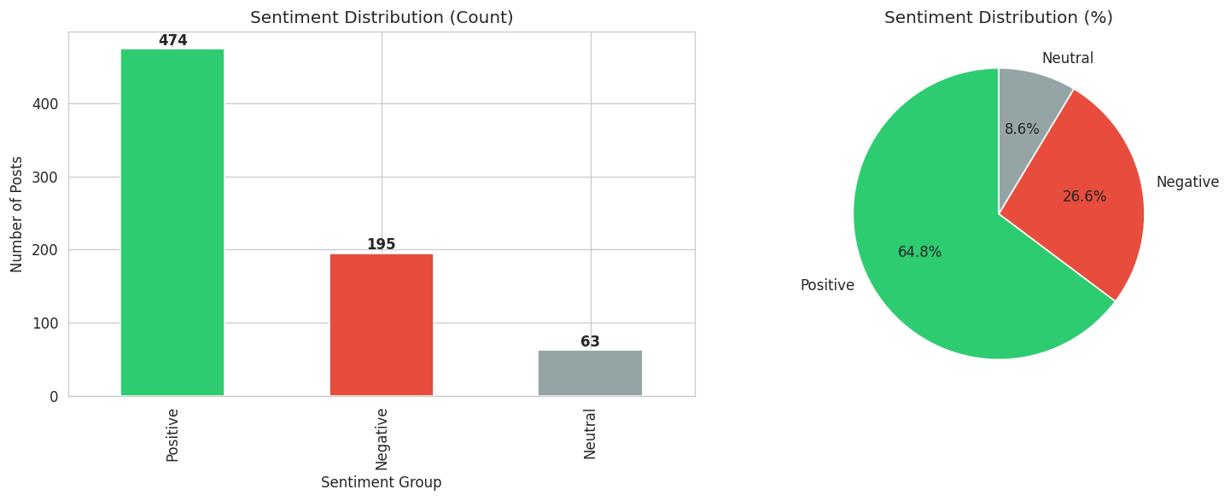
Figure 2. Sentiment distribution from the executed notebook.
Sentiment | Posts | Share | Avg Likes | Avg Retweets
Positive | 474 | 64.75% | 45.97 | 23.04
Negative | 195 | 26.64% | 35.97 | 18.03
Neutral | 63 | 8.61% | 41.29 | 20.76

Platform volume is fairly balanced. Instagram has 258 posts, Twitter 243 and Facebook 231. Instagram also has the highest average Likes and Retweets in this sample.
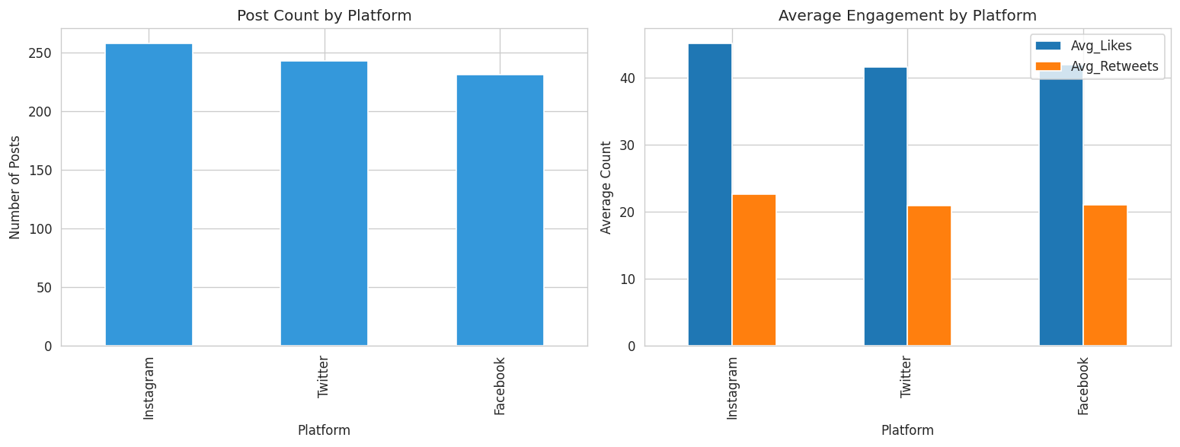
Figure 3. Platform volume and average engagement from the executed notebook.

4. Country, Time and Power BI Dashboard
The dataset covers 33 countries. The largest five groups are USA (188 posts), UK (143), Canada (135), Australia (75) and India (70). Together they account for more than 83% of the supplied records.
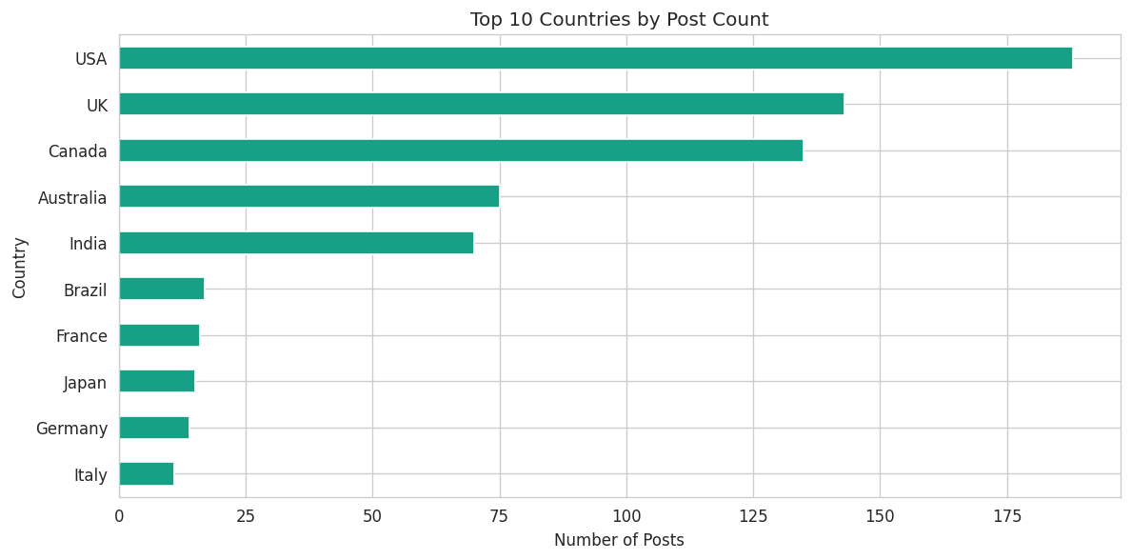
Figure 4. Top 10 countries by post count from the executed notebook.
The records cover 2010 to 2023. Hour 14 is the most frequent posting hour with 94 posts. The year 2023 has the highest number of records in the dataset.
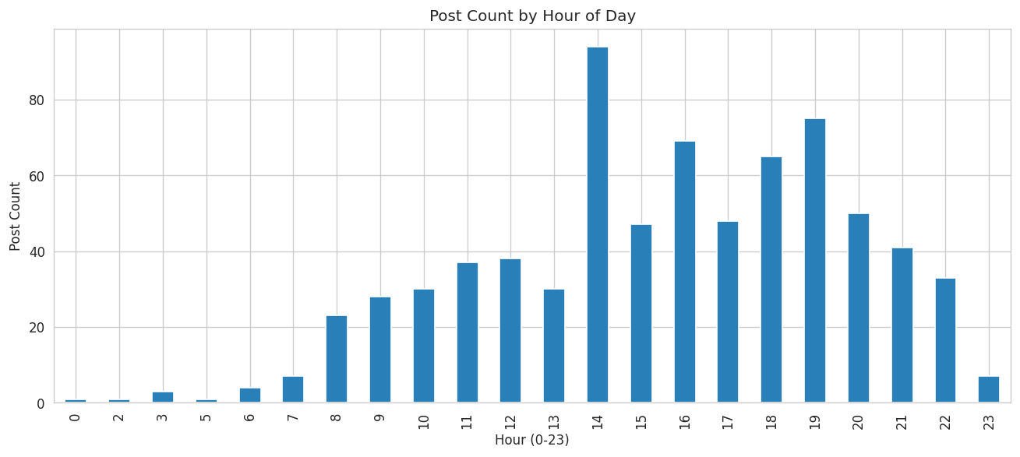
Figure 5. Post count by hour of day from the executed notebook.

Power BI deliverable
The Power BI file was built from the cleaned dataset and uses the same main KPIs as Excel, Python and MySQL. The dashboard includes Total Posts, Total Likes, Total Retweets, Average Likes and Average Retweets, together with sentiment, platform, country and time analysis.
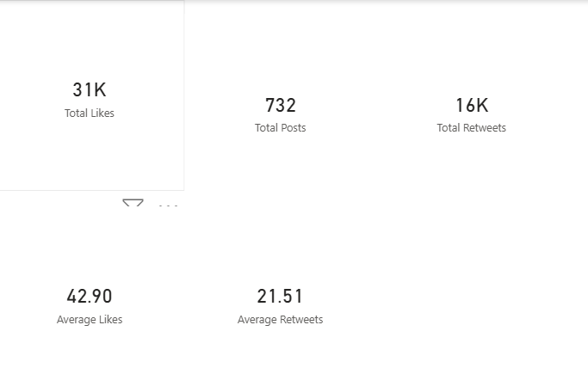
Figure 6. Power BI KPI view from the actual dashboard work.

5. Correlation and Statistical Testing
Likes and Retweets have a Pearson correlation of r = 0.998. The fitted regression is approximately Likes = 1.992 x Retweets + 0.050, with R-squared = 0.997. This is an unusually strong relationship, so it is treated as a feature of the supplied dataset and should be checked again on independent or newer data before being generalized.
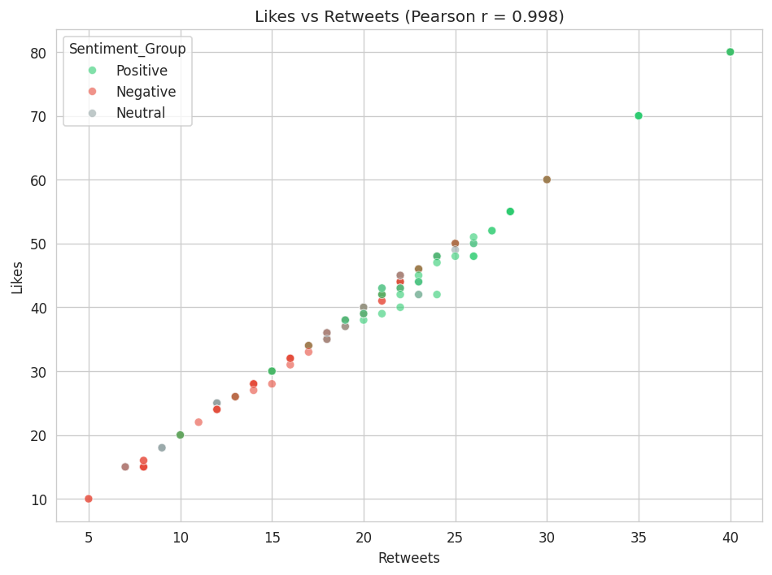
Figure 7. Likes versus Retweets from the executed notebook.
Test | Result | Interpretation
ANOVA: Likes by platform | F = 4.8819, p = 0.0078 | Significant at 5% level
Welch t-test: Positive vs Negative Likes | t = 8.6011, p < 0.000001 | Significant at 5% level

The tests show statistical association in this sample. They do not prove that platform or sentiment causes the engagement difference.

6. MySQL Analysis and Execution Evidence
The MySQL work was executed in WAMPserver64 through phpMyAdmin. The final database contained 732 records. The SQL analysis included COUNT, SUM, AVG, GROUP BY, conditional aggregation, an INNER JOIN, indexes and EXPLAIN. These steps were used to support the SQL for Business Analytics requirement.
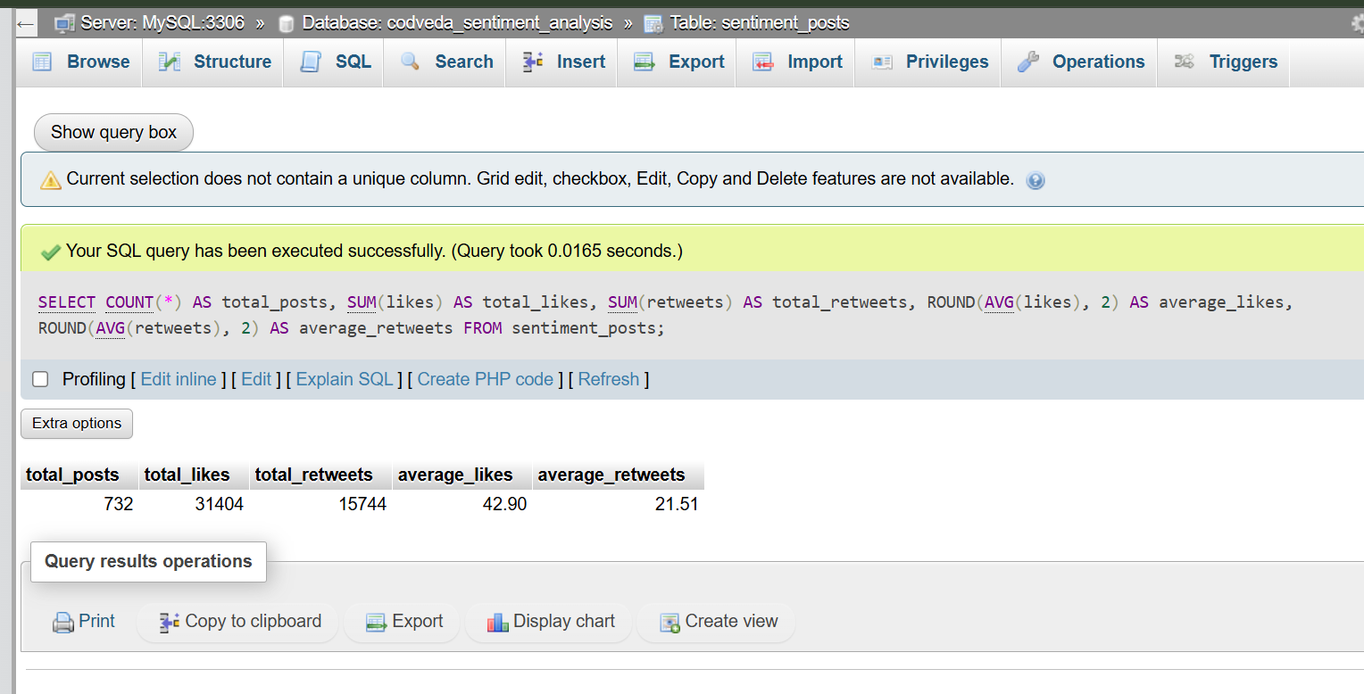
Figure 8. Actual phpMyAdmin result showing the main SQL engagement totals.
The SQL totals match the other deliverables: 732 posts, 31,404 Likes, 15,744 Retweets, average Likes 42.90 and average Retweets 21.51.
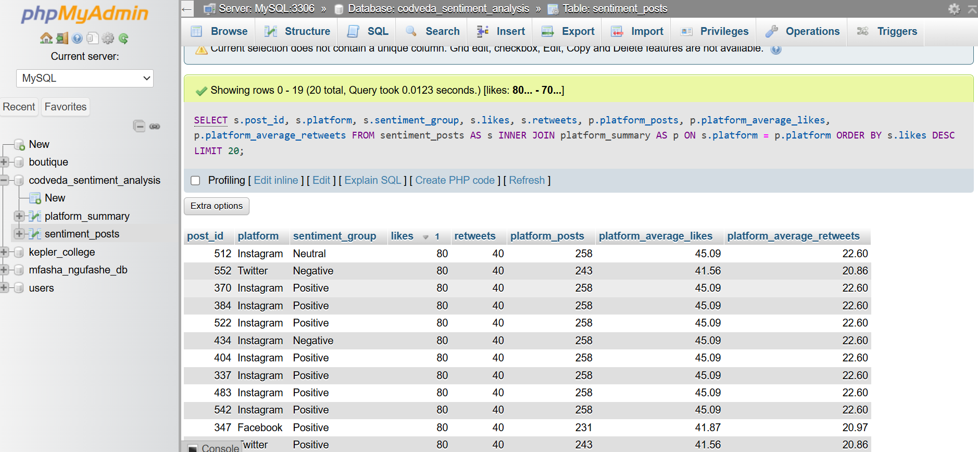
Figure 9. Actual INNER JOIN execution in phpMyAdmin.

7. Main Findings and Recommendations

Main findings
- Positive sentiment is the largest group at 64.75% of the supplied records.
- Instagram has the highest post volume and the highest average engagement, although the three platforms are relatively close in volume.
- Average engagement is 42.90 Likes and 21.51 Retweets per post.
- Likes and Retweets move almost together in this dataset (r = 0.998), which should be rechecked on independent data.
- The five largest country groups account for more than 83% of the records.
- ANOVA and the Positive-versus-Negative t-test both show statistically significant differences in average Likes.

Recommendations
- Review Negative-sentiment posts to identify repeated topics or complaints that need attention.
- Give Instagram slightly more attention while maintaining a multi-platform approach.
- Use the country analysis to prioritize deeper review of the largest geographic groups.
- Do not treat Likes and Retweets as fully independent signals in this dataset because the relationship is unusually strong.
- Repeat the same KPIs on newer data before making long-term marketing decisions.

Limitations
- The 732 records are a supplied sample and may not represent all social media activity.
- Sentiment grouping required analyst judgment after text normalization.
- The very high Likes-Retweets correlation may reflect how the dataset was sampled or constructed.
- The analysis is observational and does not establish causal relationships.

Deliverables used
- Excel workbook: Codveda_Project1_Sentiment_Analysis_FINAL.xlsx
- Jupyter Notebook: Codveda_Project1_Sentiment_Analysis_FINAL.ipynb
- Power BI dashboard: Codveda_Project1_Dashboard.pbix
- MySQL analysis: Codveda_Project1_MySQL_FINAL_SUBMISSION.sql
- SQL execution screenshots from WAMP/phpMyAdmin

Conclusion
The project provides a consistent view of sentiment and engagement across Excel, Python, Power BI and MySQL. The main figures match across the deliverables, and the work covers data preparation, exploration, statistical analysis, dashboard reporting and SQL business analysis using the supplied dataset.

