CODVEDA BUSINESS ANALYTICS INTERNSHIP
PROJECT 2
Customer Churn Prediction
Final Project Report
Dataset: churn-bigml-80.csv and churn-bigml-20.csv - 3,333 supplied records
September 2026

1. Project Overview
This project uses the supplied telecom churn datasets to predict whether a customer will churn. The main purpose is to compare classification models and identify useful churn signals that can support customer-retention decisions.

Business questions
- What is the churn rate in the supplied customer data?
- Which customer characteristics are associated with higher churn?
- Which classification model performs best on the supplied test set?
- Which features are most useful for predicting churn?
- How can the model results support a practical retention process?

Internship task alignment
This project directly supports the Predictive Analytics and Machine Learning task by using classification models for customer churn prediction and evaluating them on a separate supplied test set.

Dataset summary
Item | Training | Testing | Combined
Rows | 2,666 | 667 | 3,333
Columns | 20 | 20 | 20
Missing values | 0 | 0 | 0
Duplicate rows | 0 | 0 | -
Churned customers | 388 | 95 | 483
Churn rate | 14.55% | 14.24% | 14.49%

2. Data Preparation and Method
The supplied 80% training file and 20% testing file were kept as the train/test split. International plan and Voice mail plan were encoded as 0/1. Churn was converted from True/False to 1/0. State was label-encoded using the training data, and Area code was excluded from the model feature set because it is a location code rather than an ordered numeric measure. Numeric predictors were standardized for Logistic Regression only.

Models compared
- Logistic Regression with standardized predictors.
- Decision Tree with max_depth = 6.
- Random Forest with 200 trees and max_depth = 10.

Evaluation measures
Because churn is only 14.49% of the combined data, Accuracy alone can be misleading. The models were compared using Accuracy, Precision, Recall, F1-score and ROC-AUC. Confusion matrices were also reviewed to see how many churners each model correctly identified or missed.
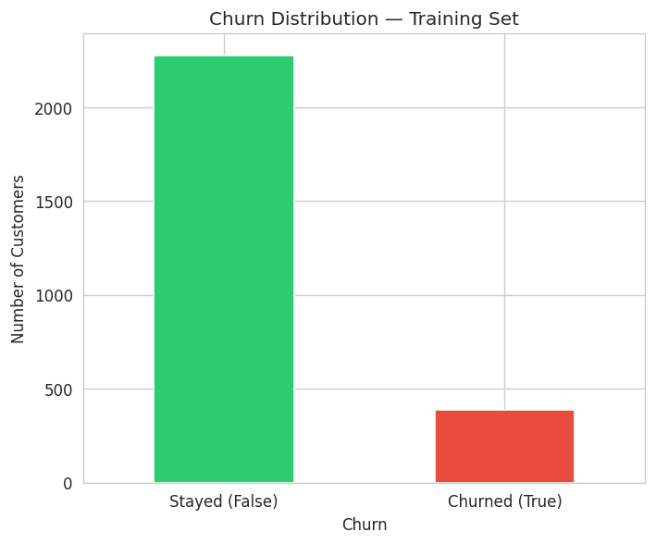
Figure 1. Churn distribution in the supplied training set.

3. Churn Patterns in the Data
The combined churn rate is 14.49%, equal to 483 churned customers out of 3,333 records. International plan customers have a much higher observed churn rate at 43.70%, compared with 11.27% among customers without the plan. Voice mail plan customers have a lower observed churn rate at 8.87%, compared with 16.71% among customers without it.
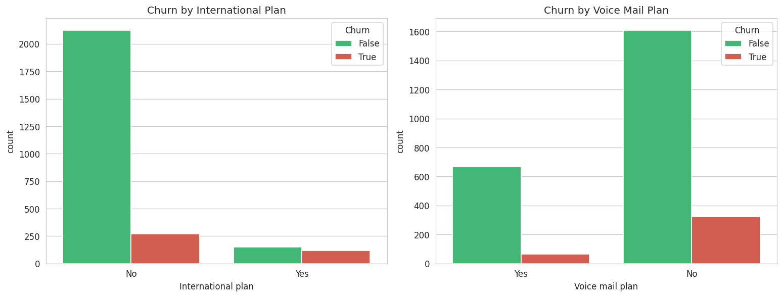
Figure 2. Churn by International Plan and Voice Mail Plan from the executed notebook.
Segment | Churn rate
International plan = Yes | 43.70%
International plan = No | 11.27%
Voice mail plan = Yes | 8.87%
Voice mail plan = No | 16.71%

Churned customers also average more customer service calls (2.21 versus 1.45) and more total day minutes (205.18 versus 175.10) than customers who stayed. These are associations in the supplied data and should not be treated as proof of causation.
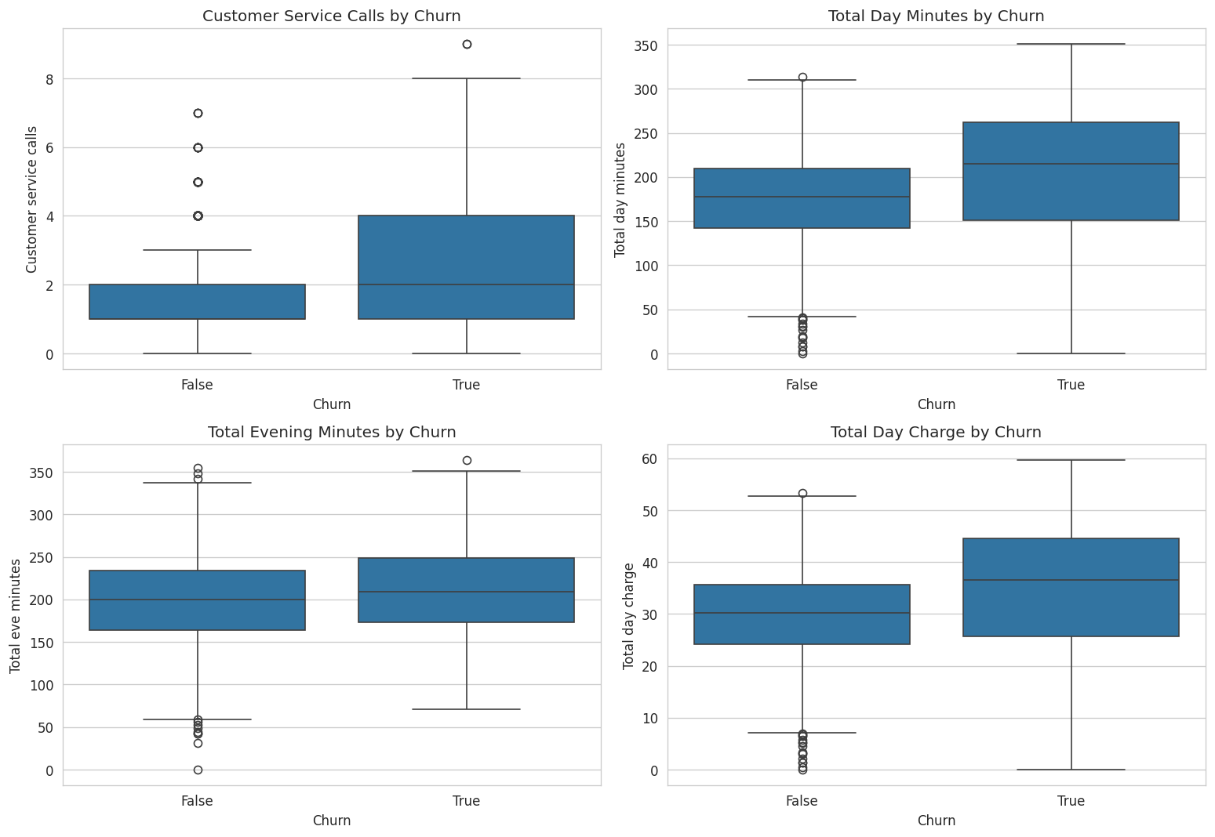
Figure 3. Usage patterns by churn status from the executed notebook.

4. Model Performance
Model | Accuracy | Precision | Recall | F1 | ROC-AUC
Logistic Regression | 85.46% | 47.37% | 18.95% | 0.2707 | 0.8265
Decision Tree | 95.35% | 88.10% | 77.89% | 0.8268 | 0.8799
Random Forest | 94.90% | 92.96% | 69.47% | 0.7952 | 0.9266

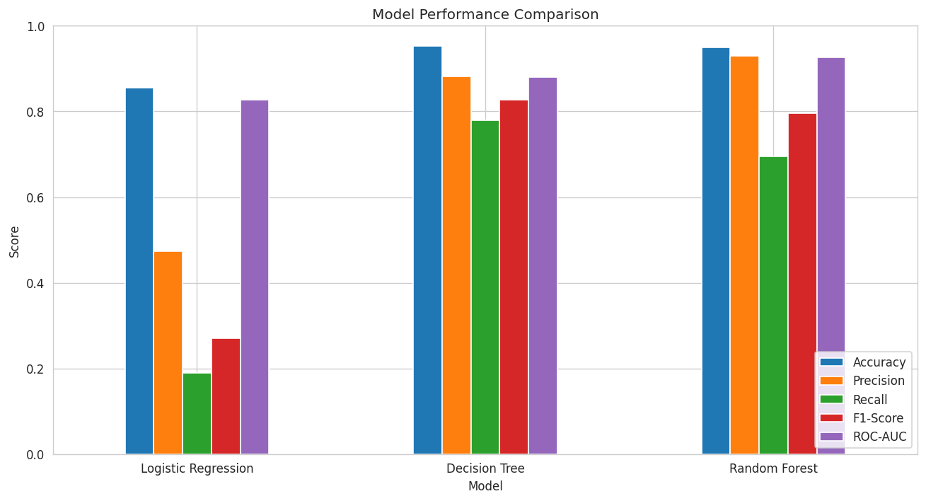
Figure 4. Model metric comparison from the executed notebook.
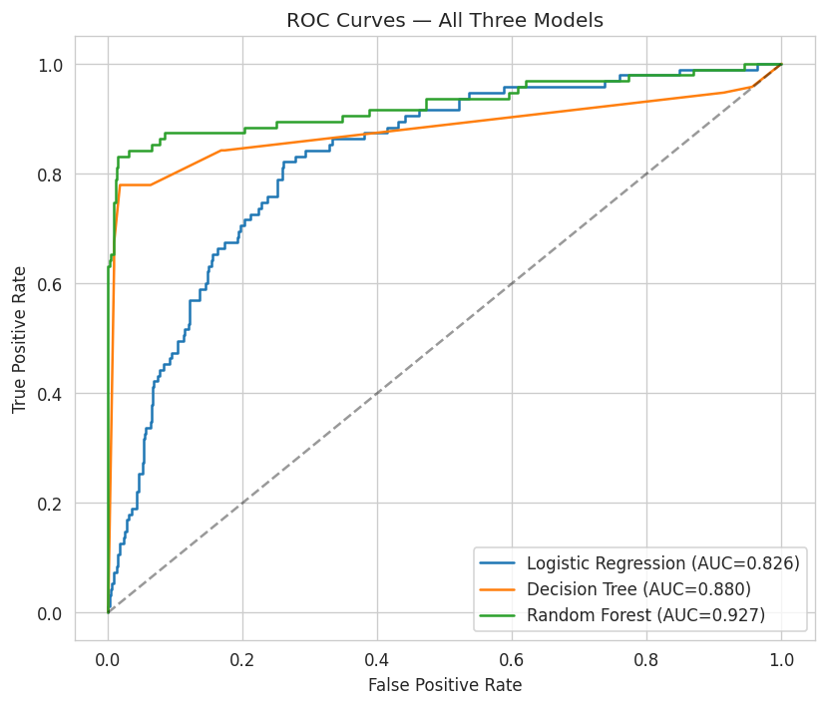
Figure 5. ROC curves for the three models from the executed notebook.
The Decision Tree has the highest F1-score and higher Recall than the Random Forest, so it is selected as the main retention model for this analysis. Random Forest has the highest Precision and ROC-AUC, making it a reasonable alternative when reducing false-positive retention contacts is the priority.

5. Confusion Matrices and Model Selection
Model | TN | FP | FN | TP
Logistic Regression | 552 | 20 | 77 | 18
Decision Tree | 562 | 10 | 21 | 74
Random Forest | 567 | 5 | 29 | 66

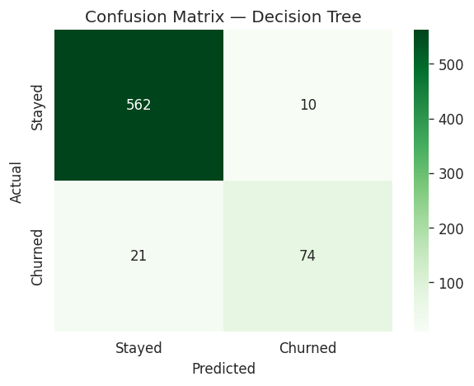
Figure 6. Decision Tree confusion matrix on the 667-customer test set.
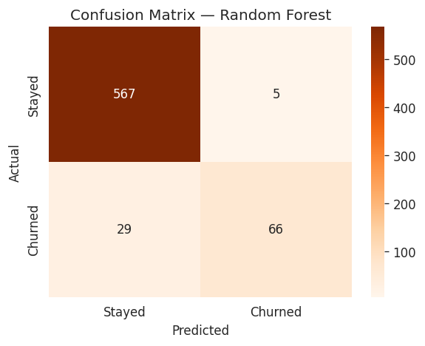
Figure 7. Random Forest confusion matrix on the 667-customer test set.
The Decision Tree correctly identifies 74 of the 95 actual churners in the test set, which gives 77.89% Recall. Random Forest correctly identifies fewer churners (66) but produces only 5 false positives, which explains its higher Precision.

6. Feature Importance and Business Use
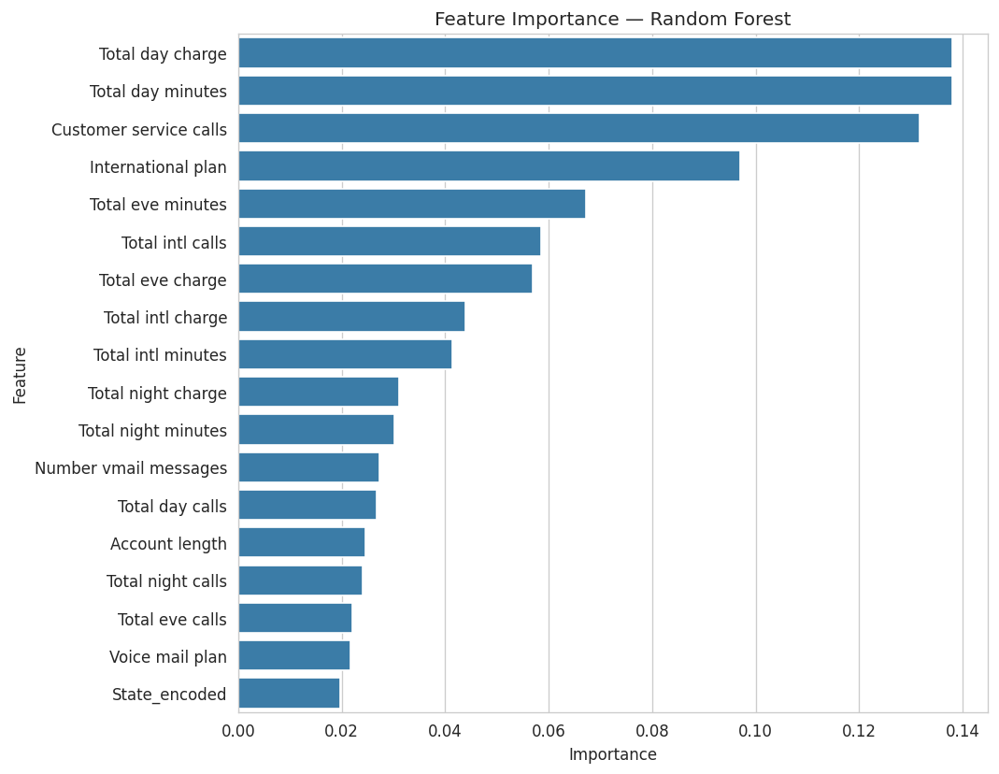
Figure 8. Random Forest feature importance from the executed notebook.
The strongest Random Forest features are Total day charge (0.138), Total day minutes (0.138), Customer service calls (0.132) and International plan (0.097). Logistic Regression also gives positive coefficients for Customer service calls and International plan. These are predictive signals, not proof that the variables cause churn.

Recommended business actions
- Review the International plan segment because its observed churn rate is much higher in this dataset.
- Use repeated customer service calls as an early warning signal for retention follow-up.
- Use the Decision Tree as the main churn-risk scoring model for this project because it gives the best F1-score and stronger Recall.
- Use Random Forest as a comparison model when higher Precision is preferred.
- Re-evaluate model performance when newer customer data become available.

7. Limitations, Deliverables and Conclusion

Limitations
- The 3,333 records are a supplied historical dataset and may not reflect another company or a later period.
- Churn is imbalanced at 14.49%, so Accuracy should not be used alone.
- The analysis identifies predictive associations and does not establish causal effects.
- State is label-encoded for this comparison; other categorical encoding methods could be tested in a future version.
- The results depend on the supplied 80/20 split and should be validated on newer operational data before deployment.

Deliverables used
- Jupyter Notebook: Codveda_Project2_Customer_Churn_FINAL.ipynb
- Training dataset: churn-bigml-80.csv
- Testing dataset: churn-bigml-20.csv
- Executed model charts, ROC curves, confusion matrices and feature-importance output included in this report

Conclusion
The churn analysis compares three classification models using 2,666 training records and 667 test records. The Decision Tree gives the best F1-score (0.8268) and identifies 77.89% of the actual churners, while Random Forest gives the highest ROC-AUC (0.9266) and Precision (92.96%). International plan status, customer service calls and day-time usage are important predictive signals in this dataset. The results can support customer-retention prioritization, but they should be rechecked on newer business data before operational deployment.

