Careem e-Movers

Technical Design Document

TABLE OF CONTENTS
0 Preface 1
0.1 Purpose of this document 1
0.2 Use of this document 1
0.3 Overview 2
0.4 Basis of this Document 2
0.5 A Reference Architecture for the IDA Programme 3
0.6 Specific Design Considerations 3
1 Introduction 5
1.1 Purpose 5
1.2 Scope 5
1.3 Definitions, Acronyms and Abbreviations 5
1.4 References 6
1.5 Overview 6
2 System Overview 7
2.1 System Characteristics 7
2.2 System Architecture 7
2.3 Infrastructure Services 9
3 System Context 10
4 System Design 11
4.1 Design Method and Standards 11
4.2 Documentation Standards 12
4.3 Naming conventions 13
4.4 Programming Standards 13
4.5 Software development tools 13
4.6 Outstanding Issues 14
4.7 Decomposition Description 14
5 Component Description 15
5.1 Component Identifier 16
6 Software Requirements Traceability Matrix 19
Document Control 20
Document Signoff 20
Document Change Record 20

Actors:
1. User
2. Admin
User Stories shipment delivery service:
----------------------------------------------------
As an Application user I should be able to
- Login to the Application
- See My details in my profile
3. Get optimal Cost Effective suggestions for my shipments
4. Track my shipment details

As Application:
1. Should be able to provide transportation resources
2. Find the most cost-effective and reliable way to deliver shipments based on user input
3. Calculate cost (Flexible- adaptable)
4. able to do dead line management. ETA
6. Tracking
As an Admin:
1. Add or delete partners
2. Upload cost and discount details to db.

Architecture:
High level Diagram:
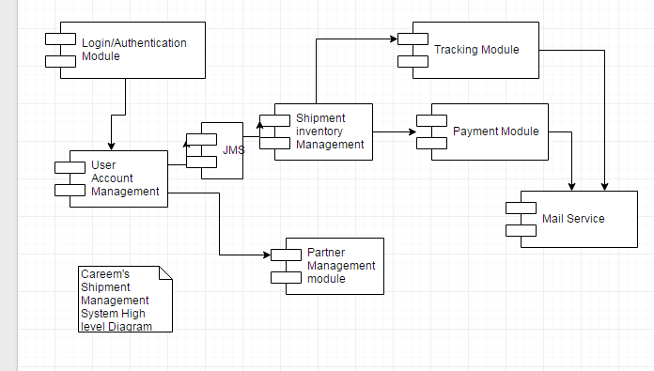

Class diagram:
