int main(int argc, char* argv []) {

//FUNDAMENTAL CONSTANTS

//CGS UNITS (Centimetre, Gram, Second)

const double gravitational_constant = 6.67 * pow(10, -8);

const double speed_of_light = 3.0 * pow(10, 10);

const double radiation_density_constant = 7.56 * pow(10, -15);

const double hydrogen_fraction = 0.34;

const double helium_fraction = 0.64;

const double heavy_fraction = 0.02;

const double boltzmann_constant = 1.38 * pow(10, -16);

const double proton_mass = 1.67 * pow(10, -24);

const double pi = 3.14159;

//DERIVED CONSTANTS

double mu_reciprocal = 2.0 * hydrogen_fraction + 0.75 * helium_fraction + 0.5 * heavy_fraction;

double mu = 1.0 / mu_reciprocal; //Schwarszchild equation 8.2

const double Central_Pressure = 6.0 * pow(10, 15);

const double Central_Temperature = 1.56 * pow(10, 7);

const double central_density = 4;

const double Total_Mass = 2.0 * pow(10, 33); //Wikipedia (grams)

const double Radius = 7.0 * pow(10, 10); //Wikipedia (cms)

const double Total_Luminosity = 6.0 * pow(10, 33); //Schwarzschild page 42

const double t_over_tentosix = 17.0; //Schwarzschild page 83, Table 10.1

const double epsilon1 = 0.0001; //Schwarzschild page 83, Table 10.1

const double nu = 4.0; //Schwarzschild page 83, Table 10.1

**C++ CODE FOR STELLAR STRUCTURE CALCULATIONS**

**For Main Sequence Stars**

double r = 0.0, from_surface;

double rfactor, temperature_constants_factor;

double pressure_fundamental_factors, pressure_stellar_factors, pressure_all_factors;

double pressure, mass, luminosity, temperature;

double zero_pressure_distance = 0.0;

bool zero_pressure_reached = false;

**PREFACE**

This paper is the third in a series of three papers that look, respectively, at the physics of main sequence stars, techniques of numerical integration and, this part III, the application of numerical integration techniques to the calculation of the internal structure of stars. Internal structure means the profile of pressure, temperature, density and other physical quantities from the centre of the star to the surface. This paper does not describe the evolution of stars.

**Contents**

**1.** **INTRODUCTION** 7

**2.** **SCHWARSZCHILD CALCULATIONS** 8

2.1 Calculations With Untransformed Variables 8

2.1.1 Calculations at the Centre 8

2.1.2 Constant Density Approximation 9

2.1.3 Linear Density Approximation 12

2.1.4 Application of Numerical Techniques 14

2.1.5 Choice of Algorithm for Initial Outward Integration 19

2.1.6 Calculations at the Surface 19

2.1.6.1 Analytic Solutions 19

2.1.7 Outward and Inward Integration 21

2.1.8 Searching for a Solution 21

2.1.9 The Radiative Convective Transition 22

2.2 Calculations with Transformed Variables 22

2.2.1 Initial Transformation 23

2.2.2 Supplementary Transformation 23

2.2.2.1 Derivation of the Constants 23

2.2.2.2 Estimates of the Range of the Variables 23

2.2.3 The Integration Algorithm 23

2.2.3.1 Calculation of the Derivatives 23

2.2.3.2 The Outgoing Solution 24

2.2.3.3 The Inward Solution 24

2.3 Calculations with Mass as Independent Variable 24

**3.** **HENYEY CALCULATIONS** 25

3.1 The Linear Algebra of the Solution 25

**4.** **PHYSICAL CONSTANTS** 26

4.1 Universal Physical Constants 26

4.2 Solar Characteristics 27

**5.** **WORKINGS** 28

5.1 Taylor Series Expansion 28

5.2 Backward Euler and Heun Methods 29

5.3 Heun’s Method With Varying Density 30

5.4 Choosing Pressure and Composition 31

5.5 Instability at the Surface 32

5.5.1 What are Givens and what are Calculated Values ? 33

5.5.2 Schwarzschild’s Initial Sun Model 33

5.5.3 Schwarzschild’s Present Sun Model 34

**6.** **C++ CODE FOR STELLAR STRUCTURE CALCULATION** 36

6.1 What the Code Does 36

6.2 The Structure of the Code 36

6.3 How to Use the Code Outputs 37

6.4 The Location of the Code 37

# **INTRODUCTION**

The problem to be solved in stellar structure calculations is finding the *next* value of a variable given previous values of the variable. *Next* will often mean further out from the centre of the star than the previous values, with the distance between the values constant. Here, distance from the centre of the star is the *independent* variable, the variable that does not depend on anything else. The independent variable could also be a fraction of the mass of the star - the fraction of the mass of the star within a distance from the centre of the star (this will depend on the density).

As mentioned in Part I of this series, most of the physics and a lot of the mathematics in this project is taken from Schwarszchild’s 1965 book “Structure and Evolution of The Stars”. This is repeated and extended to more exotic stars in “Stellar Structure and Evolution” of 2012.

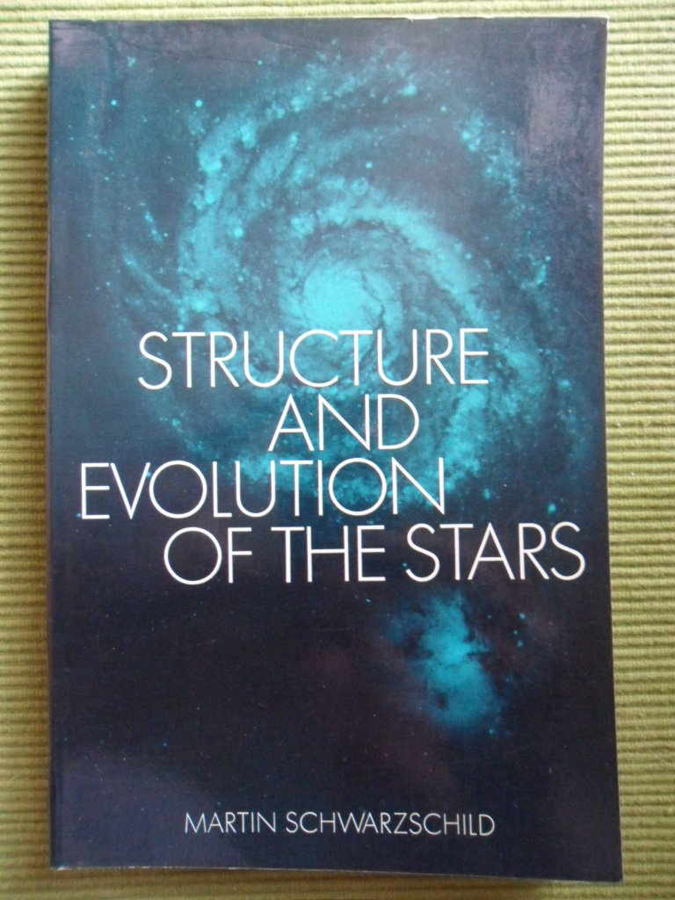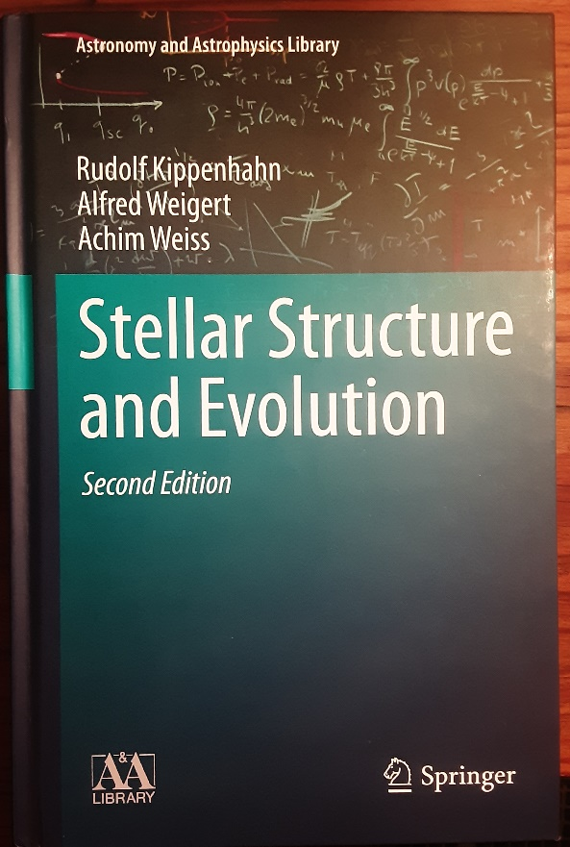

# **SCHWARZSCHILD CALCULATIONS**

In his 1965 book Schwarzschild defines a transformation of the physical variables (i.e pressure, temperature etc) into a set of dimensionless variables in order to reduce the amount of calculations required for a stellar model. Computational speed is now no longer relevant so the calculations can be done with real physical variables anyway. However, calculations with transformed variables are considered below, as well as with the physical variables, just to fill in some of the details that Schwarszchild did not include in his book.

## Calculations With Untransformed Variables

This section examines the details of the mathematics using actual physical values – metres, degrees, Pascals etc.

### Calculations at the Centre

The basic physical equations governing the stellar structure of main sequence stars are, as derived in Part I :

**Figure 1 : The Basic Equations of Stellar Structure**

**Source :** [The Structure and Evolution of the Stars: Amazon.co.uks](https://www.amazon.co.uk/Structure-Evolution-Stars-M-Schwarzschild/dp/0486614794)

The first temperature equation is for radiative heat transfer. The second temperature equation is for convective heat transfer. Only one of these two equations is used at any one time but which one may vary. So only four equations are active at any one time. The two modes are described in Part I of this series. The variables are :

: pressure at radius r

: mass fraction within radius r

: luminosity at radius r

: temperature at radius r

: density at radius r

: energy production

: opacity

### Constant Density Approximation

In the equations above, the density can be seen to be a complicating factor, with opacity and energy production further complicating factors. In fact, if the density, energy generation and opacity are considered to be constant for small values of then approximations for the physical variables can be derived. For example, the and / equations above can be integrated and solved for and . Thus, if the density, energy generation and opacity near the centre are constants ,, then :

For and , there is a complication because appears on the right-hand side of the equation whereas, for and , does not appear on the right-hand side :

so the above cannot be integrated easily because, more exactly :

However, if the approximation is made that , then :

In fact, Schwarszchild gives the equations below in figure 2 as approximate solutions but with the description *“if one develops the solution at the center in powers of , if one ignores terms of fourth or higher order, and if one designates all quantities at the centre with the subscript c”.* It can be seen that they are the same as the equations developed above. This is probably because if one were to use approximate expressions such as (in particular) :

these would produce the higher order terms Schwarszchild refers to. For example, the equation would become :

which could be modified by using the power series expression :

which would give, for (with a constant) :

]

Ignoring “terms of fourth or higher order” leads to the expression in figure 2. This dependence of on also causes complications in the use of Heun’s method and the Runge-Kutta method in section 2.1.1.3 below.

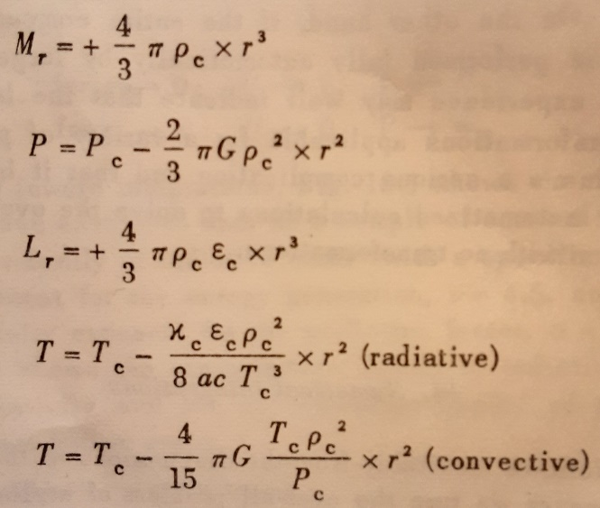

**Figure 2 : Schwarzschild approximate solutions (he does *not* call them constant density solutions)**

**Source :** [The Structure and Evolution of the Stars: Amazon.co.uks](https://www.amazon.co.uk/Structure-Evolution-Stars-M-Schwarzschild/dp/0486614794)

Putting numbers into the equations above with a step size of cms (one hundredth of the stellar radius) and yields :

where

where

These results qualitatively suggest the possibility that an initial set of, say, 5 values can be successfully extended with an Adams-Bashforth algorithm to a realistic solution. For the temperature equation :

For numbers used see sections 5.4.2 on Schwarzschild’s initial sun model where .

### Linear Density Approximation

There is a small refinement that involves approximating the density near the centre as a linear function. Whether this makes a significant difference is a difficult question, perhaps only answered by looking at model outputs.

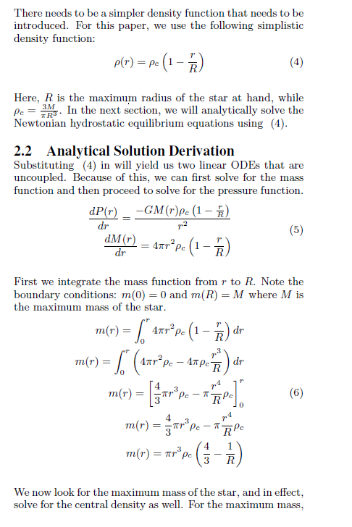

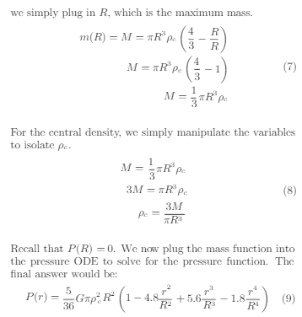

**Figure 3 : Linear Density Approximation**

**source :** A Comparative Analysis of Numerical Solutions for Solving Stellar Structure Equations

### Application of Numerical Techniques

In Part II a number of numerical integration techniques were described, namely, in order of presentation in Part II :

* Taylor series expansion
* Euler’s method
* Heun’s method
* Runge-Kutta methods
* Adams-Bashforth and Adams-Moulton methods

The next few sections explore where each of these techniques leads.

**Taylor Series Expansion**

A Maclaurin series (a Taylor series centred on ) for and can be employed, starting at the centre of the star, with the pressure at the centre being or .

The term  initially looks to be a problem because it has a dependency. However, it also has  in the numerator. From physical reality must be zero. Mathematically, this just means that the  term “wins” against the dependency. After all, the term has an dependency. Hence :

The Maclaurin expansion for is done in much the same way :

In fact, since can be integrated directly, it is not surprising that the Maclaurin series terminates and gives the same result as the constant density approximation (see section 5.1).

The Maclaurin expansion for is similar to that for :

and for :

These lead to (see section 5.1) :

Again, the Maclaurin series gives the same result as the constant density approximation.

**Euler’s Method**

The forward Euler method seems very unpromising since the first derivatives at the centre are all (assumed to be) zero. Section 5.2 shows that the backward Euler method gives the following values for and with the density assumed to be a constant.

and for and :

**Heun’s Method**

In this method the average of the gradient at the centre (zero) and the gradient at is used. This gives the following values for and with the density assumed to be a constant.

and for and :

**Comparison of Taylor, Euler, and Heun Results**

The following table summarises the expressions found for the three methods.

|  |  |  |  |  |
| --- | --- | --- | --- | --- |
|  |  |  |  |  |
| Taylor**1** |  |  |  |  |
| Euler**2** |  |  |  |  |
| Heun**2** |  |  |  |  |

**Figure 4 :**

1. The Taylor series uses (by definition) the exact values (with constant density assumed) for and i.e the spherical volume term . Hence all values in green.
2. The Euler and Heun methods, if taken literally, use inexact values for and . Hence values in red. Also, the values given involve an additional approximation that is approximately

The naïve values for and (the values in red) for the Euler and Heun methods mean the table is not really very helpful. Instead, if the “correct” values (that is, where is assumed) are used the following table results, where the Taylor values are unchanged.

|  |  |  |  |  |
| --- | --- | --- | --- | --- |
|  |  |  |  |  |
| Taylor |  |  |  |  |
| Euler |  |  |  |  |
| Heun |  |  |  |  |

**Figure 5 :**

**Heun’s Method With Varying Density**

It is possible to derive an inelegant semi-solution using Heun’s method and assuming the ideal gas equation for the density :

Section 5.3 looks at the derivation of the equation which appears to be a 12th order polynomial in T with and in among the coefficients. Its solution for and would require some guessing of the latter and the numeric solution of the polynomial. However, it seems intuitively unlikely that any great benefit would arise from such a complex equation.

**Runge-Kutta Methods**

Using the algorithm described in section 6.2.2.1 of part II :

= + + 2 + 2 + )  
  
and :

= , )

= +

= +

= + )

In this case, for the pressure, and with :

=

=

=

=

Using :

gives :

which is the same value as for the Taylor series method.

The Runge-Kutta method now gets more complex for the and pair because of the value.

=

**Adams-Bashforth and Adams-Moulton Methods**

These are basically sophisticated extrapolation methods and are considered as the method(s) to take over once a core set of values has been developed by one of the methods mentioned above so far. They are therefore used as described in section 2.1.7 where the initial centre and surface values are then integrated towards each other.

### Choice of Algorithm for Initial Outward Integration

For the initial outward integration the choice must be the constant density equations of 2.1.2. This is an intuitive choice based on the apparent crudity of Euler/Heun/Runge-Kutta algorithms and the appreciation that there is far more actual physical information in the constant density equations.

After the accumulation of, say, five or ten points around the centre using the constant density approximation one of the Adams-Bashforth (or Adams-Moulton) methods can take over, using derivatives at the successively generated points. After each iteration the newly generated (integrated) values are swapped to the other differential equations to generate the new derivatives. Additionally, the density itself can be calculated from the gas equation (as long as the ideal gas equation applies).

In practice, even the constant density approximation can be modified so that the density is recalculated at each step.

### Calculations at the Surface

In the same way as an approximation is used to get a small number of central values, a different approximation is used to get a small number of surface values. The surface values are then used to start an Adams-Bashforth integration using the standard equations as given in figure 1 for the calculation of the derivatives at each point.

#### Analytic Solutions

On the basis that, at the surface :

and

Schwarzschild derives the following for the calculation of and near the surface, for the radiative case :

.

where :

: pressure

: temperature

: total mass

: total luminosity

: radius of the star

: gravitational constant

: mass of the proton

: Boltzmann’s constant

: radiation density constant

: speed of light

: distance from centre

with the fractional abundances of hydrogen, helium and heavier elements by weight:

and, for the opacity, as given in Part 1 of this series :

### Outward and Inward Integration

The outward and inward integrations are carried out with a third order Adams-Bashforth method. This method calculates the value of a variable from the value of the variable and the derivatives of the variable at the and points. Hence, for the pressure, for example :

where is the step size. As new values are calculated at a new point they are used to calculate the derivatives at the new point.

Adams-Bashforth methods are described in [Linear multistep method - Wikipedia](https://en.wikipedia.org/wiki/Linear_multistep_method), see Figure 6 and also Paper 2.

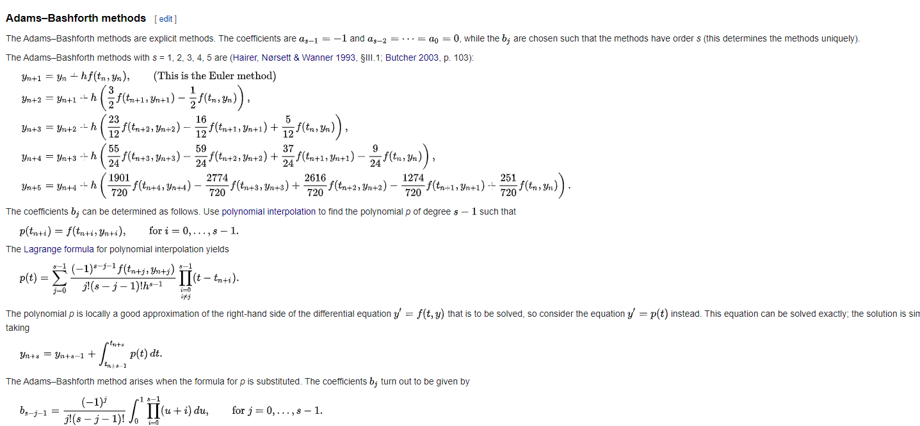

**Figure 6 : Adams-Bashforth Equations up to Fifth Order**

**Source :** [Linear multistep method - Wikipedia](https://en.wikipedia.org/wiki/Linear_multistep_method)

### Searching for a Solution

The overall search for a solution needs defining more closely. The initial assumed parameters of the star are its mass and chemical composition (hydrogen, helium, and heavier elements). Only broad assumptions are made about the pressure or temperature at the stellar centre, about the radius of the star, about the luminosity (energy generation) of the star. It is assumed, however, that the pressure and temperature at the surface can be taken to be zero.

Any solution will provide the following :

* The values of from the centre to the surface of the star, without any discontinuities.
* The radius and luminosity of the star.

A well-founded solution will be taken to have these characteristics :

* The temperature and pressure will both fall to zero at the surface
* The mass fraction and luminosity will both fall to zero at the centre

The star is initially assumed to be 100% hydrogen. The density is assumed to be given by the ideal gas law. Energy generation is assumed to be by the proton-proton reaction i.e hydrogen fusion to form helium (the central temperature is therefore considered to be <108K, where helium fusion begins). The opacity (see section X.X in Paper I) is assumed to be from free-free electron interactions for a 100% hydrogen star and then free-free plus bound-free for cases where helium and heavier elements are present.

This means that the density is dependent on pressure and temperature, energy generation is dependent on density and temperature, opacity is also dependent on density and temperature. The initial values depend only on pressure and temperature at the centre, and (apart from constants and ).Thus, ostensibly, one could get a complete solution by just integrating to the surface. However, as Schwarzschild describes and as experience developing the code showed, this is not practical. As the algorithm approaches the surface the equations become unstable because of the division of density by the temperature. This approaches a term at the surface. See section 5.4.

It can also be seen that any solution started at the surface and integrated to the centre will also encounter an instability but this time because of the term.

In fact, the solution of the equations in Figure 1 must be done by calculating an outward solution from the centre and an inward solution from the surface and joining them together. For the outward calculation, the and values are free to be varied. For the inward calculation, the  and values are available to be varied. Schwarzschild developed special transformations to reduce the amount of calculation required, but this paper shows that, with current computers, the amount of calculation is not a problem.

The search for a solution consists in principle of generating a set of curves going towards the surface for pairs and also generating a set of curves for and looking for the pair that join smoothly at the same point. The most general search, however, consists of also including the composition as a variable. One can imagine generating a large number of curves in a three-dimensional space consisting of composition and and keeping these as a library for searching. See section 6.3 for more.

### The Radiative Convective Transition

## Calculations with Transformed Variables

Schwarszchild explained in his book that the number of calculations needed to solve the differential equations in section 2.1.1 is very large due to the necessity of fitting together an outward integration (from the centre) and an inward integration (from the surface) coupled with the fact that the values of total luminosity , and radius , must be varied to get the fit. He therefore introduced a transformation of the variables to variables. He thought that that might not be necessary if the calculations could be done by a computer :

“When all the numerical work is to be performed by a large electronic computing machine, the most efficient way to attack our problem may be by following the general formulation discussed above, in spite of the large number of integrations necessary. When, however, the numerical work has to be performed by more modest means – as has been the case for most of the investigations which we will review in the following chapters – it appears necessary for efficiency’s sake to apply all methods which reduce the number of necessary integrations, even though the miscellany of these labor-saving methods spoils the simplicity of the general formulation”.

However, given the prospect of searching a four-dimensional space of and , it might be necessary to use the transformations anyway, unless perhaps some optimising search algorithm is available.

### Initial Transformation

Schwarszchild introduced, first, an initial transformation and then a supplementary transformation on the initial set of transformations. The initial transformation is :

Why these particular transformations ?

### Supplementary Transformation

#### Derivation of the Constants

#### Estimates of the Range of the Variables

### The Integration Algorithm

#### Calculation of the Derivatives

#### The Outgoing Solution

#### The Inward Solution

## Calculations with Mass as Independent Variable

# **HENYEY CALCULATIONS**

<TBD>

## The Linear Algebra of the Solution

# **PHYSICAL CONSTANTS**

## Universal Physical Constants

Schwarszchild’s book used CGS cvalues throughout, so this paper also uses CGS values.

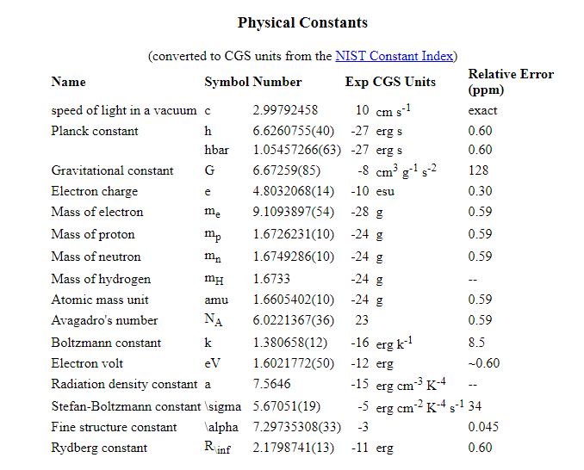

**Figure (7) : Universal Physical Constants**

## Solar Characteristics

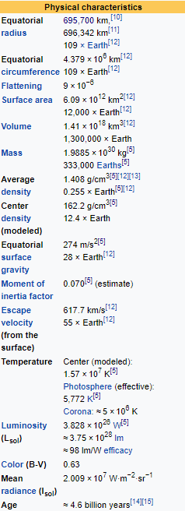

**Figure (8) : Solar Values**

**Source :** [**Sun - Wikipedia**](https://en.wikipedia.org/wiki/Sun)

# **WORKINGS**

## Taylor Series Expansion

The density in the derivatives is the central density since the derivatives are evaluated at .

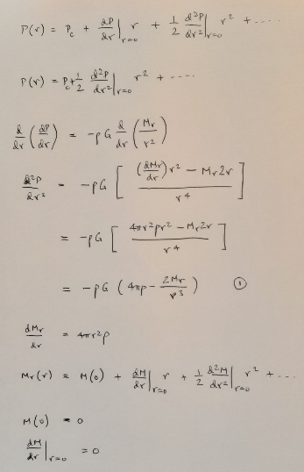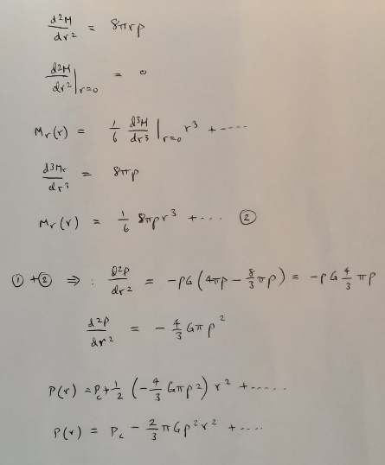

The third derivative of is zero since the second derivative does not depend on . So the series terminates.

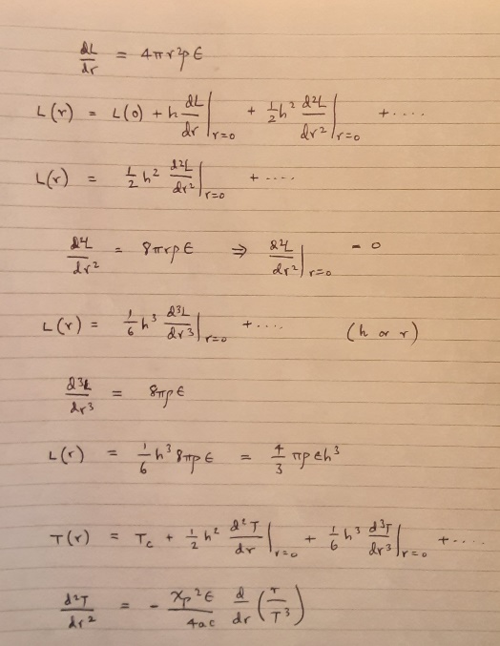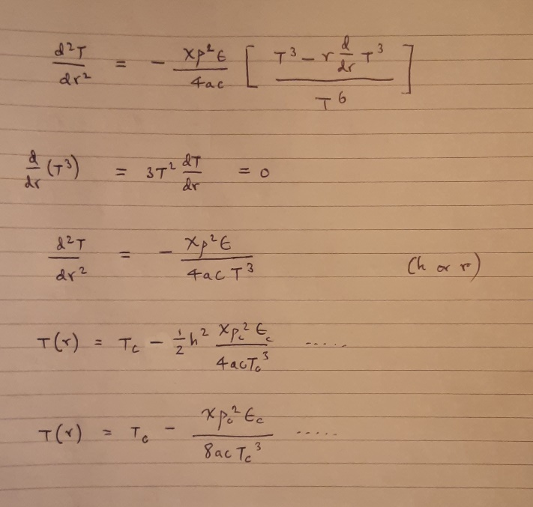

## Backward Euler and Heun Methods

Pressure and mass fraction :

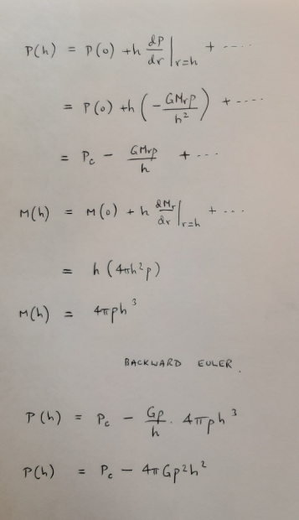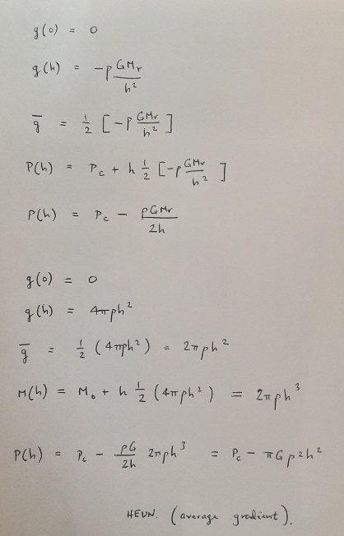

Temperature and Luminosity :

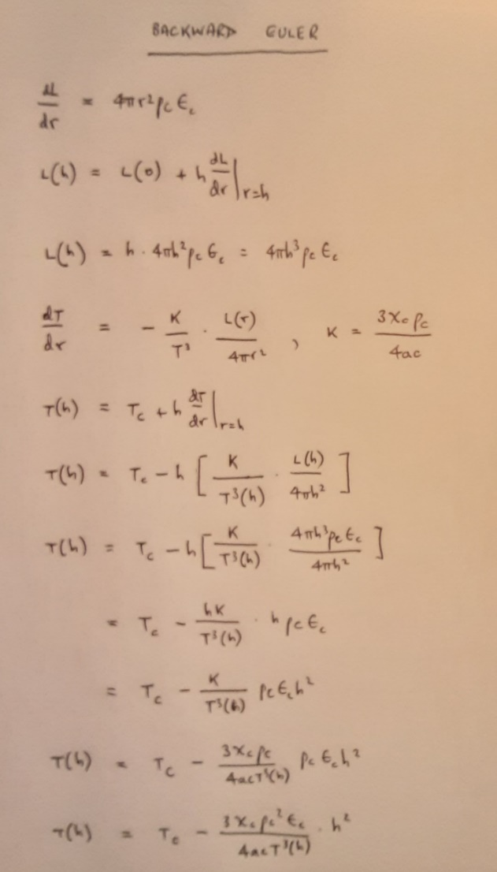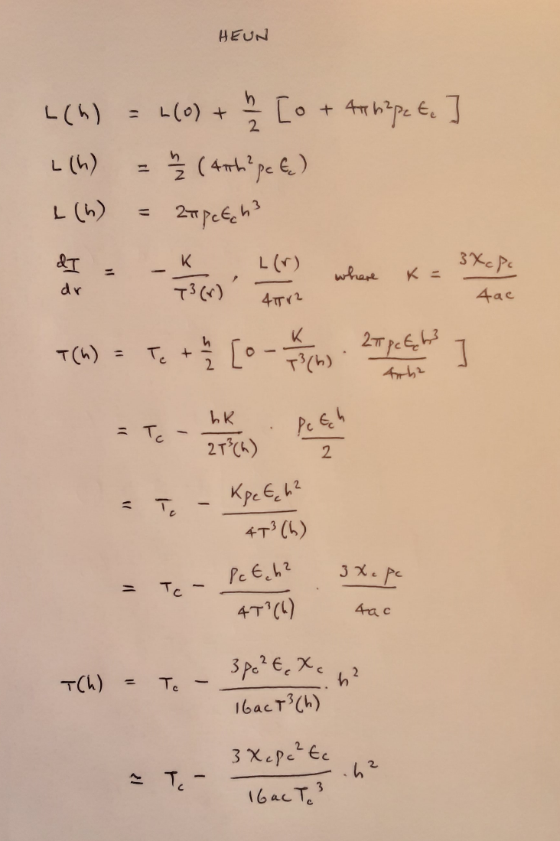

## Heun’s Method With Varying Density

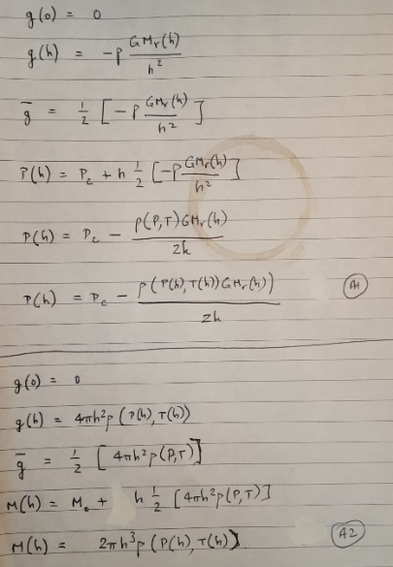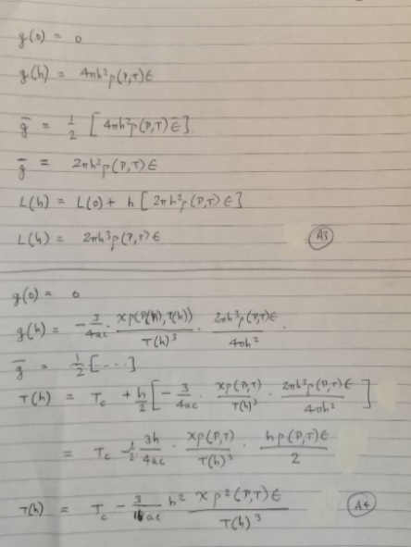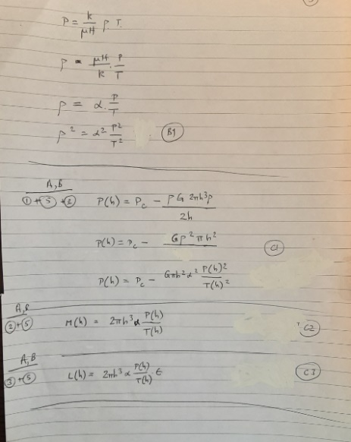

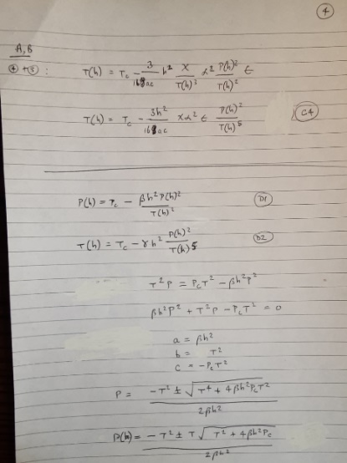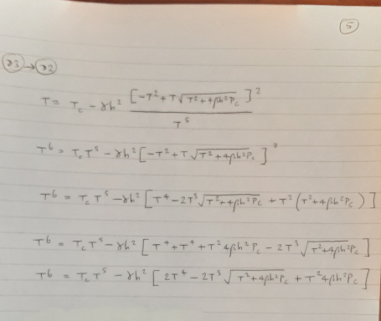

## Choosing Pressure and Composition

The two tables below were generated by the C++ code. One calculates opacity with free-free electron scattering only. The second calculates opacity with free-free and bound-free electron scattering. Each table has results (in bold) for the density in of the initial sun and the present-day sun. Columns such as (15.13)(7.093) list the logarithms of pressure and density, respectively. Figures such as (0.70, 0.28, 0.02) are fractions of hydrogen (X), helium (Y) and heavier elements (Z).

Schwarzschild’s Table 28.3 is for the initial sun and Table 28.6 is for the present-day sun. The tables give the densities as 77 and 134 respectively, as calculated (presumably) from the pressure and temperature given in the tables and using the ideal gas equation.

The densities below were calculated by the C++ code using the ideal gas equation. It can be seen, therefore, that the pressure must go up to around 1017 in order to get a density in the right area. However, the initial assumption that the composition is (1.0, 0.0, 0.0) gives a density of 66 for the initial sun, which is significantly less than the 77 given in Schwarzschild’s initial sun model (17.13)(7.093). It seems that the initial sun may not have been (1.0, 0.0, 0.0). Figure X below shows Table 23.2 from Schwarzschild’s book where the initial composition is given as more like (0.70, 0.26, 0.04). Figure X shows that this composition gives a density of 82 which is close to the figure in Table 28.3. For the present day sun the value of 136 is basically the same as the Schwarzschild value.

|  |  |  |  |  |
| --- | --- | --- | --- | --- |
| Initial sun | (1.0, 0.0, 0.0)  0.5 | (0.70, 0.26, 0.04)  0.62 | Present day sun | (0.50, 0.46, 0.04)  0.73 |
| (15.13) (7.093) | **0.66** | **0.82** | (15.35) (7.165) | **1.36** |
| (16.13) (7.093) | **6.6** | **8.2** | (16.35) (7.165) | **13.6** |
| (17.13) (7.093) | **66** | **82** | (17.35) (7.165) | **136** |

**Figure (X) : Calculations with Opacity Determined by Only**

However, the values of table X were calculated with only whereas, since there is helium present, it seems that the opacity should be calculated from . In this case the results are as given in figure X. Those for (1.0, 0.0, 0.0) are unchanged because X = 1.0. For the other two columns the third row indicates that the Adams-Bashforth results diverged with the density actually rapidly increasing leading to the temperature quickly becoming negative.

|  |  |  |  |  |
| --- | --- | --- | --- | --- |
| Initial sun | (1.0, 0.0, 0.0)  0.5 | (0.70, 0.26, 0.04)  0.62 | Present day sun | (0.50, 0.48, 0.04)  0.73 |
| (15.13) (7.093) | **0.66** | **0.82** | (15.35) (7.165) | **1.36** |
| (16.13) (7.093) | **6.6** | **8.2** | (16.35) (7.165) | **13.6** |
| (17.13) (7.093) | **66** | **82 🡪 500 (fail)** | (17.35) (7.165) | **136 🡪 500 (fail)** |

**Figure (X) : Calculations with Opacity Determined by**

This possibly idicates that the inclusion of the term introduces inaccuracies.

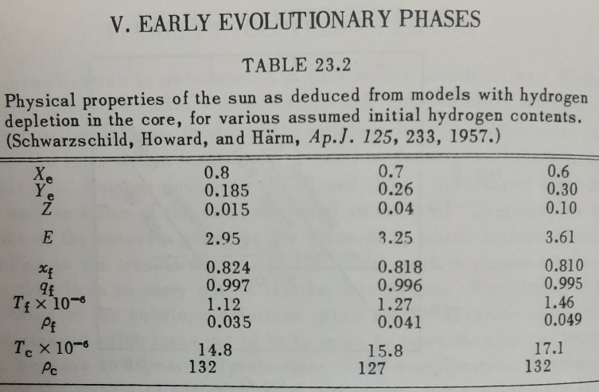

**Figure (X) : Table 23.2 from Schwarzschild’s book.**

## Instability at the Surface

|  |  |  |  |  |
| --- | --- | --- | --- | --- |
|  |  |  |  |  |
|  |  |  |  |  |
| 17.266 | 7.093 | 2.03 x 1010 | 6.00 x 1015 | 367163 🡪 -ve |
| 17.266 | 7.094 | 2.53 x 1010 | 1.08 x 1015 🡪 -ve | 53661 |
| 17.266 | 7.0941 | 2.72 x 1010 | 6.25 x 1014 | 456423 |
| 17.266 | 7.09415 | 2.89 x 1010 | 2.97 x 1014 | 693770 |
| 17.266 | 7.09417 | 3.02 x 1010 | 1.63 x 1014 | 319035 |
| 17.266 | 7.09419 | 3.28 x 1010 | 4.81 x 1013 | 337957 |
| 17.266 | 7.094195 | 3.45 x 1010 | 1.98 x 1013 🡪 -ve | 422232 |
| 17.266 | 7.094197 | 3.62 x 1010 | 6.39 x 1012 | 256846 |
| 17.266 | 7.094198 | 3.95 x 1010 | 2.97 x 1011 | 127447 🡪 -ve |
| 17.266 | 7.09419805 | 4.16 x 1010 | 5.87 x 109 | 18000 |
| 17.266 | 7.09419806 | L | 6.65 x 10-11 | 200580 |
| 17.266 | 7.09419807 | L | 2.61 x 10-7 | 241150 |
| 17.266 | 7.0941981 | L | 0.001 | 305162 |
| 17.266 | 7.0941982 | L | 6 | 6 |
| 17.266 | 7.0941985 | L | 3950 | 530524 |
| 17.266 | 7.094199 | L | 148684 | 639646 |
| 17.266 | 7.0942 | L | 3.05 x 106 | 765712 |
| 17.266 | 7.0945 | L | 1.62 x 1012 | 2.7 x 106 (C) |
| 17.266 | 7.095 | L | 7.36 x 1012 | 3.45 x 106 |
| 17.267 | 7.094 | 2.15 x 1010 | 4.62 x 1015 | 1.73 x 106 |
| 17.265 | 7.094 | L | 2.48 x 1012 | 2.88 x 106 |

“L” means the limit of 1.009e+11.

At the blue-shaded result, the density is 10-24 and the energy generation is 10-42. That is, they are both effectively zero. This makes the pressure, mass fraction and luminosity derivatives basically zero while the temperature derivative is unstable because of a zero-divide-by-zero quotient. See figure (x) below. The density is the 10-24 number. The distance from the centre is 1.009e+11. The four rows at the same distance are the pressure, mass fraction, luminosity, and temperature. Thus, pressure is 6.64777e-11 and temperature is 200580. Columns 3, 4, and 5 are the derivatives in the Adams-Bashforth algorithm. Column 6 is the next value, after application of the algorithm.

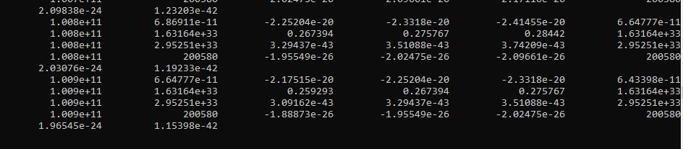

**Figure (9) : Cause of Instability.**

### What are Givens and what are Calculated Values ?

The only givens are the mass and chemical composition. For the case of an initial main sequence star, the chemical composition is taken to be constant as the star will be composed entirely of hydrogen. The radius and total luminosity will be calculated values, along with the central pressure and central temperature. Pressure and temperature will be assumed to be zero at the surface.

### Schwarzschild’s Initial Sun Model

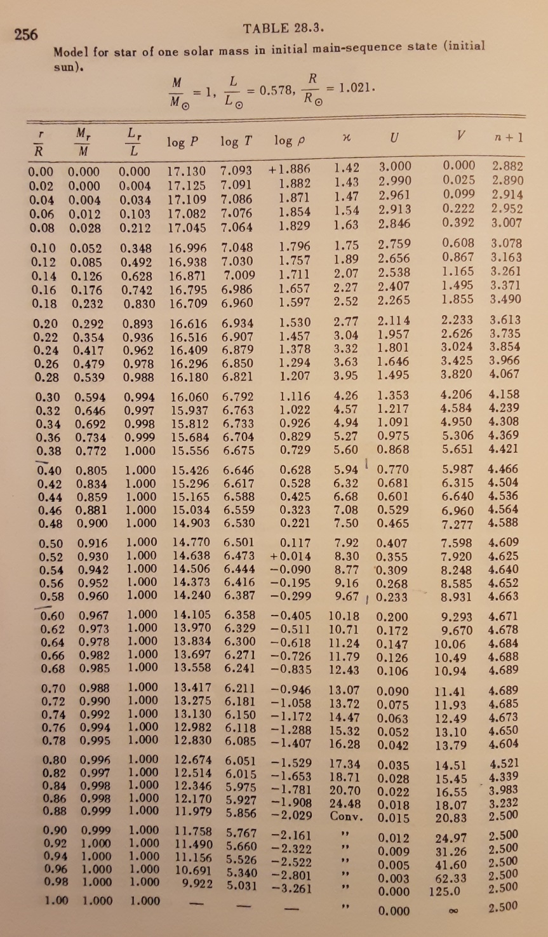

### Schwarzschild’s Present Sun Model

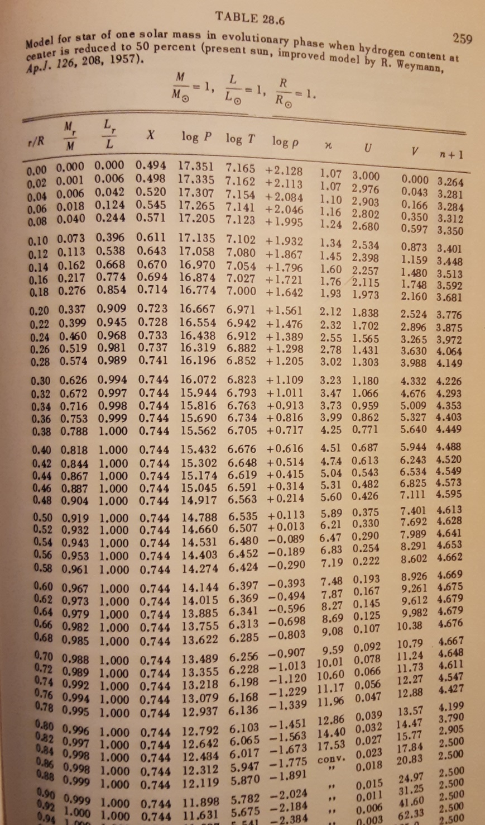

# **C++ CODE FOR STELLAR STRUCTURE CALCULATION**

## What the Code Does

Comments copied from the program :

// The code does essentially four things:

// Calculates a few starting values at the stellar centre using a modified //constant density approximation

//Inputs these starting values into an Adams-Bashforth integration algorithm //and calculates outwards towards the surface of the star

// Calculates a few starting values at the stellar surface using an //approximation where mass and luminosity are assumed constant and at their //full values

// Inputs these starting values into the same Adams-Bashforth integration //algorithm and calculates inwards towards the centre of the star

// There is some undeveloped code for calculations in transformed variables. //This needs completion.

// The code is C++ and was developed under VisualStudio v16.8.4

//

// Figure 1 in Paper 3 gives the basic differential equations

// Figure 2 in Paper 3 gives the constant density approximation equations for //the stellar centre

// Section 2.1.2 in Paper 3 gives the constant mass and luminosity //approximation equations for the stellar surface

// Section 2.1.3 in Paper 3 describes the Adams-Bashforth integration algorithm

//

// The code below does not :

// Attempt to join the outward and inward solutions to get a full solution

// Do calculations for convective energy transfer

// Do evolutionary calculations where the star develops in time and its //chemical composition changes

// Apply the Henyey method of stellar structure calculation

// Do calculations with the stellar mass (instead of distance) as the //independent variable.

## The Structure of the Code

Comments copied from the program :

//This program contains, at the top level, two independent loops.

//A "pctc" loop codes the outward calculation (i.e from the stellar centre).

//It has the central pressure and central temperature as the two parameters

//of the calculation - see section 2.1.1 of TechnicalNote_CplusplusCode.docx.

//A solution is calculated for a range of central pressures and central

//temperatures. The range and step sizes are easily changed by editing

//the variables pressure_exponent, pressure_multiplier, temperature_exponent

//and temperature_multiplier.

//An "mrl" loop codes the inward calculation (i.e from the stellar surface).

//It has Model_Mass, Model_Radius, and Model_Luminosity as the

//three parameters of the calculation - see section 2.1.2 of

//TechnicalNote_CplusplusCode.docx. A solution is calculated for a range

//of Model_Radius and Model_Luminosity. The range and step sizes are

//easily changed by editing the variables radius_exponent, radius_

//multiplier, luminosity_exponent and luminosity_multiplier.

//There is currently no loop for the mass.

## How to Use the Code Outputs

The code outputs two files : OutResults_File_pctc.txt and OutResults_File_mrl.txt. These contain the outputs from the pctc loop and mrl loop respectively. These are for the outward and inward calculations and ( and and are independent of each other : changes to the ( of the pctc loop do not affect the results from the mrl loop, and vice versa.

To get a full solution an outward integration must be matched to an inward integration. To do this, a joining point needs to be decided on. The two integrations each cover more than half of the radius, so there is overlap where a point can be chosen. Given that the radius is specified in the mrl calculations then when the joining part is at some distance from the surface, then the point will be at distance from the centre in the pctc calculation. At this point the integration results * must be equal (to within a sensible tolerance and the gradients should also join smoothly.

*They are marked with (for historical reasons) in order to help in searching the files for particular values.

## The Location of the Code

The code can be found on Github, here :

[gatica651/Stellar_Untransformed_Variables (github.com)](https://github.com/gatica651/Stellar_Untransformed_Variables)

It can be downloaded and modified. This paper and the Part II paper on numerical integration are also on the site.

METHODS

From MRL to PCTC :

1. Choose the desired mass of the star (NB. Below a certain mass the solution is unrealistic ? eg. 4.0x1031 gave a midrange temperature of 50000K).
2. Generate pctc and mrl files.
3. In the mrl file, choose a midpoint by halving the radius.
4. For the pressure at the midpoint generate a pctc file by suitably setting the pressure loop parameters.
5. Search the pctc file with the nearest halfway point value with the “T” postfix (to be able to get all 4 values displayed) and check the pressure values.
6. Generate new pctc files as appropriate to get closer to the right pressure values.
7. When the right pressure values are met, check the Q value above after each search of the midpoint distance value. This will give the maximum Q value.
8. Change the M value in the MRL solution if necessary.

From PCTC to MRL :

There is an outgoing solution in PcTc that has P,Q,F,T values at terminating distance r. Search in the MRL file for the right strings.