Certificate of Donation
${subtitle}

${date}

Shipment paid for:
Partners In Health
888 Commonwealth Ave; 3rd Floor
Boston, MA 02215
EIN#04-3567502

Consignee:
Zanmi Lasante
Attn: Loune Viaud
6, rue Mayard
Christ Roi
Port au Prince, HAITI
509-3687-7382

Contents: Humanitarian relief supplies

Total shipment value, provided for customs purposes only, is ${value}.

The items contained in this shipment constitute a humanitarian donation to Zanmi Lasante, and are not for resale. These commodities were from the United States. In accordance with the export administration regulations diversion contrary to United States Laws is prohibited.
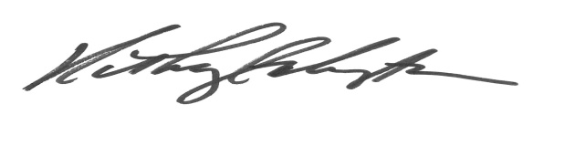
Kathryn G. Kempton
Director of Procurement

Packing List
${date}

Shipment paid for:
Partners In Health
888 Commonwealth Ave; 3rd Floor
Boston, MA 02215
EIN#04-3567502

Consignee:
Zanmi Lasante
Attn: Loune Viaud
6, rue Mayard
Christ Roi
Port au Prince, HAITI
509-3687-7382

Contents:

