One-Way ANOVA — Part B
Within & Between Group Variability Student Worksheet
Name: | Date: April _____, 2026

Context: This section builds conceptual understanding of the two sources of variability that one-way ANOVA uses to compare group means: within-group variability (noise) and between-group variability (signal). The response variable (y) is plotted vertically in all dot-plots.

1 Within-Group Variability
Within-group variability measures how spread out individual response variable values are around their own group mean y_i. It is the noise in ANOVA — variation that exists even within groups receiving the same treatment.

The dot-plots below show the response variable (y = exam score) on the vertical axis and groups (A, B, C) on the horizontal axis.

High Within-Group Variability  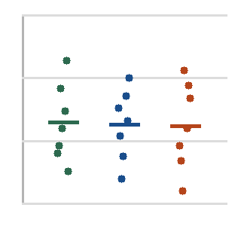  Dots spread far within each group | Low Within-Group Variability  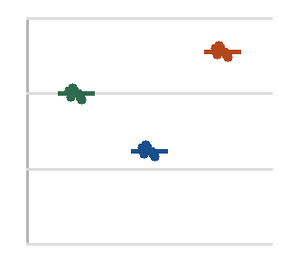  Dots tight within each group

1a Fill in the blanks
When within-group variability is large, individual response values are spread from their group mean y_i. This makes it for ANOVA to detect real differences between groups, because the grows larger.

1b Identify which plot shows larger within-group variability and explain why it matters

2 Between-Group Variability
Between-group variability measures how far apart the group means ${\overline{y}}_{i}$ are from the overall mean$\overline{\overline{y}}$ (the grand mean across all observations). It is the signal — evidence that the groups actually differ.

Using the data from the study: group means are ${\overline{y}}_{A}$ = 72, ${\overline{y}}_{B}$ = 85, ${\overline{y}}_{C}$ = 91, and the overall mean is $\overline{\overline{y}}$ = 83.

2a Calculate deviations
Group | Group Mean ${\overline{y}}_{i}$ | Overall Mean $\overline{\overline{y}}$ | Deviation ${\overline{y}}_{i}$ – $\overline{\overline{y}}$
Group A | 72 | 83
Group B | 85 | 83
Group C | 91 | 83

2b Interpretation
The group with the largest deviation from the overall mean is contributing most to between-group variability. Which group is it, and what does this suggest about the effectiveness of that study method?

3 The F-Ratio: Signal Over Noise
The F-statistic is computed as:
F = Between-Group Variability / Within-Group Variability = MSB / MSW

3a Fill in the blanks
When F >> 1, the between-group signal is relative to within-group noise. This the alternative hypothesis that at least one group mean y_i differs from the others.

When F ≈ 1, the between-group signal is to within-group noise. This is consistent

with .

Can F be negative? Reason:

3b Interpret F = 9.14 (from the ANOVA output table in Part A)

4 Equal Variance Condition
ANOVA assumes that within-group variability is roughly equal across all groups — this is called homoscedasticity. If violated, the pooled MSW (denominator of F) is distorted.
4a Check the condition
Group | Scores | Std Dev (approx.)
A | 78, 80, 79, 81, 77 | ~1.6
B | 42, 65, 88, 91, 55 | ~21.1
C | 72, 74, 73, 75, 71 | ~1.6

Ratio of largest to smallest SD: Is the condition met (rule: largest SD ≤ ~2× smallest)?

Explain what this violation means for interpreting the F-statistic.

