One-Way ANOVA — Part B
Within & Between Group Variability Instructor Edition
Name: | Date: April — (Instructor Key)

Context: This section builds conceptual understanding of the two sources of variability that one-way ANOVA uses to compare group means: within-group variability (noise) and between-group variability (signal). The response variable (y) is plotted vertically in all dot-plots.

1 Within-Group Variability
Within-group variability measures how spread out individual response variable values are around their own group mean y_i. It is the noise in ANOVA — variation that exists even within groups receiving the same treatment.

The dot-plots below show the response variable (y = exam score) on the vertical axis and groups (A, B, C) on the horizontal axis.

High Within-Group Variability  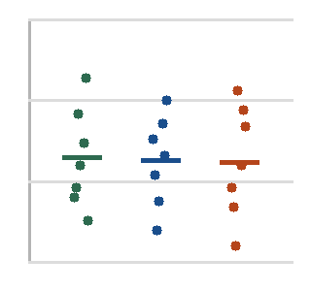  Dots spread far within each group | Low Within-Group Variability  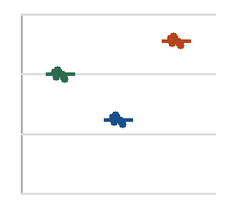  Dots tight within each group

1a Fill in the blanks
When within-group variability is large, individual response values are spread far from their group mean y_i. This makes it harder for ANOVA to detect real differences between groups, because the noise (denominator of F) grows larger.

1b Identify which plot shows larger within-group variability and explain why it matters
✓ The LEFT plot (High Within-Group Variability) shows larger within-group variability.
✓ Dots within each group span a wide range of y-values. When within-group spread
✓ is large, the denominator of the F-statistic (MSW) is large, making it harder to
✓ detect real differences between group means y_i.

2 Between-Group Variability
Between-group variability measures how far apart the group means y_i are from the overall mean y_bar (the grand mean across all observations). It is the signal — evidence that the groups actually differ.

Using the data from the study: group means are y_A = 72, y_B = 85, y_C = 91, and the overall mean is y_bar = 83.

2a Calculate deviations
Group | Group Mean y_i | Overall Mean y_bar | Deviation y_i − y_bar
Group A | 72 | 83 | -11 points
Group B | 85 | 83 | 2 points
Group C | 91 | 83 | 8 points

2b Interpretation
The group with the largest deviation from the overall mean is contributing most to between-group variability. Which group is it, and what does this suggest about the effectiveness of that study method?

✓ Group C (y_C = 91) has the largest deviation: 91 − 83 = +8 points.
✓ This suggests students using AI-assisted study with structured prompting scored
✓ substantially higher on average. However, we need the F-statistic and p-value to
✓ determine whether this difference is statistically meaningful.

3 The F-Ratio: Signal Over Noise
The F-statistic is computed as:
F = Between-Group Variability / Within-Group Variability = MSB / MSW

3a Fill in the blanks
When F >> 1, the between-group signal is large relative to within-group noise. This supports the alternative hypothesis that at least one group mean y_i differs from the others.

When F ≈ 1, the between-group signal is similar in size to within-group noise. This is consistent with H₀ (no difference in group means).

Can F be negative? No. Reason: F is a ratio of mean squares. Mean squares are computed from squared deviations, which are always ≥ 0. So F ≥ 0 always.

3b Interpret F = 9.14 (from the ANOVA output table in Part A)
✓ F = 9.14 means the between-group variability (MSB) is approximately 9 times
✓ larger than the within-group variability (MSW). This is a strong signal relative
✓ to noise, providing evidence that the group means are not all equal.

4 Equal Variance Condition
ANOVA assumes that within-group variability is roughly equal across all groups — this is called homoscedasticity. If violated, the pooled MSW (denominator of F) is distorted.

4a Check the condition
Group | Scores | Std Dev (approx.)
A | 78, 80, 79, 81, 77 | ~1.6
B | 42, 65, 88, 91, 55 | ~21.1
C | 72, 74, 73, 75, 71 | ~1.6

Ratio of largest to smallest SD: 21.1 / 1.6 ≈ 13.2 Is the condition met (rule: largest SD ≤ ~2× smallest)? No — clearly violated.

Explain what this violation means for interpreting the F-statistic.
✓ The equal variance condition is severely violated (Group B has SD ~13× larger
✓ than Groups A and C). This distorts the pooled MSW (denominator of F), making
✓ the F-statistic and p-value unreliable. A Welch ANOVA or data transformation
✓ would be more appropriate for this dataset.

