One-Way ANOVA — Part B
Within & Between Group Variability Student Worksheet
Name: | Date: April _____, 2026

Context: This section builds conceptual understanding of the two sources of variability that one-way ANOVA uses to compare group means: within-group variability (noise) and between-group variability (signal). The response variable (y) is plotted vertically in all dot-plots.
1 Within-Group Variability
Within-group variability measures how spread-out individual response variable values are around their own group mean ${\overline{y}}_{i}$. It is the noise in ANOVA — variation that exists even within groups receiving the same treatment.

The dot-plots below show the response variable (y = exam score) on the vertical axis and groups (A, B, C) on the horizontal axis.

High Within-Group Variability  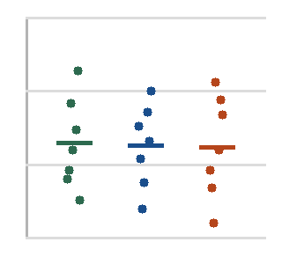  Dots spread far within each group | Low Within-Group Variability  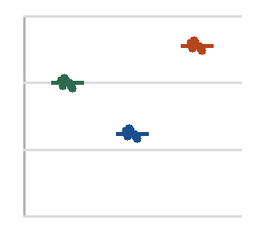  Dots tight within each group
1a Fill in the blanks
When within-group variability is large, individual response values are spread far from their group mean ${\overline{y}}_{i}$.
This makes it HARD for ANOVA to detect real differences between groups, because
the noise grows larger.
1b Identify which plot shows larger within-group variability and explain why it matters
The left plot has the higher within group variability because the points dramatically deviate from each groups mean. When the within group variability spread is large, the one-way ANOVA cannot detect the real differences between the groups means.

2 Between-Group Variability
Between-group variability measures how far apart the group means ${\overline{y}}_{i}$ are from the overall mean$\overline{\overline{y}}$ (the grand mean across all observations). It is the signal — evidence that the groups actually differ.

Using the data from the study: group means are ${\overline{y}}_{A}$ = 72, ${\overline{y}}_{B}$ = 85, ${\overline{y}}_{C}$ = 91, and the overall mean is $\overline{\overline{y}}$ = 83.

2a Calculate deviations
Group | Group Mean ${\overline{y}}_{i}$ | Overall Mean $\overline{\overline{y}}$ | Deviation ${\overline{y}}_{i}$ – $\overline{\overline{y}}$
Group A | 72 | 83 | 72 – 83 = -11 points
Group B | 85 | 83 | 85 – 83 = 2 points
Group C | 91 | 83 | 91 – 83 = 8 points

2b Interpretation
The group with the largest deviation from the overall mean is contributing most to between-group variability. Which group is it, and what does this suggest about the effectiveness of that study method?
Group A is deviating the most from the overall mean with 11 point below and group C is 8 points above. The lowest performing group is re-reading.

3 The F-Ratio: Signal Over Noise
The F-statistic is computed as:
F = Between-Group Variability / Within-Group Variability = MSB / MSW
Mean Square Between / Mean Square Within
Squared Deviations on average
3a Fill in the blanks

When F >> 1, the between-group signal is large relative to within-group noise. This supports the
alternative hypothesis that at least one group mean ${\overline{y}}_{i}$ differs from the others.

When F ≈ 1, the between-group signal is similar in size to within-group noise. This is consistent

with the null hypothesis that the populations means are the same.

Can F be negative? No, Reason: Since we are square the deviations, the F statistic has to be 0 or more.
3b Interpret F = 9.14 (from the ANOVA output table in Part A) means that the between group variability is approximately 9 times larger than within group variability. The strong signal relative to the noise is apparen providing evidence against the null hypothesis.

4 Equal Variance Condition
ANOVA assumes that within-group variability is roughly equal across all groups — this is called homoscedasticity. If violated, the pooled MSW (denominator of F) is distorted.
4a Check the condition
Group | Scores | Std Dev (approx.)
A | 78, 80, 79, 81, 77 | ~1.6
B | 42, 65, 88, 91, 55 | ~21.1
C | 72, 74, 73, 75, 71 | ~1.6

Ratio of largest to smallest SD: 21.1/1.6 =13 Is the condition met (rule: largest SD ≤ ~2×
smallest)? No, the assumption has been clearly violated
Explain what this violation means for interpreting the F-statistic. -

