Homework 5

## Description

The Auto dataset from the ISLR2 package contains information on various automobile models from the 1970s and 1980s, providing a useful context for exploring relationships between vehicle characteristics and fuel efficiency. It includes **392 observations** on **nine variables**, such as mpg (miles per gallon), horsepower, weight, acceleration, displacement, cylinders, and year. These variables are a mix of quantitative and categorical data, with the name column identifying each car model. The dataset is particularly valuable for regression analysis due to its real-world relevance and the presence of nonlinear relationships, multicollinearity, and opportunities for transformation—making it ideal for studying how predictor variables influence fuel efficiency.

library(here) ## File Path Management  
library(ISLR2) ## Data Extraction  
library(dplyr) ## Data Transformation  
library(tidyr) ## Data Transformation  
library(ggplot2) ## Data Visualization  
library(broom) ## Data Analysis  
source(here("R","assessment_regression.R"))

**Question:** *Fit a linear regression model to predict mpg using horsepower. How well does the model fit the data, and what does the residual plot suggest about the relationship between the two variables?*

## Summary Statistics

auto_df <- Auto %>% drop_na()  
  
# Summary statistics: mean, sd, min, max  
summary_stats <- auto_df %>%  
 select(mpg, horsepower) %>%  
 summarise(across(everything(), list(  
 mean = mean,  
 sd = sd,  
 min = min,  
 max = max  
 ), .names = "{.col}_{.fn}")) %>%  
 pivot_longer(  
 everything(),  
 names_to = c("variable", "statistic"),  
 names_sep = "_",  
 values_to = "value"  
 )   
  
summary_stats

# A tibble: 8 × 3  
 variable statistic value  
 <chr> <chr> <dbl>  
1 mpg mean 23.4   
2 mpg sd 7.81  
3 mpg min 9   
4 mpg max 46.6   
5 horsepower mean 104.   
6 horsepower sd 38.5   
7 horsepower min 46   
8 horsepower max 230

[Summarize information about these numbers]

# Compute correlation  
cor_val <- auto_df %>%  
 summarise(correlation = cor(mpg, horsepower))  
  
cor_val

correlation  
1 -0.7784268

[Summarize information about the correlation being negative]

## Visualization

ggplot(auto_df, aes(x = horsepower, y = mpg)) +  
 geom_point(alpha = 0.6) +  
 geom_smooth(method = "lm", se = FALSE, color = "steelblue", linewidth = 1.2) +  
 labs(  
 title = "Relationship Between Horsepower and MPG",  
 x = "Horsepower",  
 y = "Miles Per Gallon (MPG)"  
 ) +  
 theme_minimal(base_size = 14) +  
 theme(plot.title = element_text(hjust = 0.5))

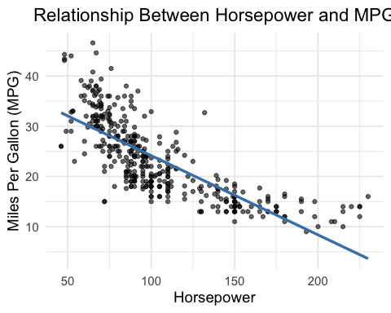

[Based on the graphic we should transform y but we should transform x, say this in a well provided manner]

## Analysis

### Regular Model

model_0 <- lm(mpg ~ horsepower, data = auto_df)  
summary(model_0)

Call:  
lm(formula = mpg ~ horsepower, data = auto_df)  
  
Residuals:  
 Min 1Q Median 3Q Max   
-13.5710 -3.2592 -0.3435 2.7630 16.9240   
  
Coefficients:  
 Estimate Std. Error t value Pr(>|t|)   
(Intercept) 39.935861 0.717499 55.66 <2e-16 ***  
horsepower -0.157845 0.006446 -24.49 <2e-16 ***  
---  
Signif. codes: 0 '***' 0.001 '**' 0.01 '*' 0.05 '.' 0.1 ' ' 1  
  
Residual standard error: 4.906 on 390 degrees of freedom  
Multiple R-squared: 0.6059, Adjusted R-squared: 0.6049   
F-statistic: 599.7 on 1 and 390 DF, p-value: < 2.2e-16

[Interpretation of regressions coefficients, both y-intercept and slope and make sure to say expected value or on average]

plot_scatter_resid(model_0,auto_df ,"Original")

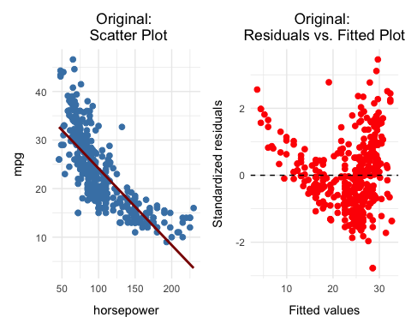

[Interpretation of Plots (scatter and residual) ]

### Transformations

mod_1_auto_df <- auto_df %>%  
 mutate(  
 log_hp = log(horsepower),  
 sqrt_hp = sqrt(horsepower)  
 )

[Mention How we adhoc selected these transformations and we could have done power transformation but we decided not to since we did not learn them]

#### Square Root of *hp*

# Linear model with sqrt(horsepower)  
model_2 <- lm(mpg ~ sqrt_hp, data = mod_1_auto_df)  
summary(model_2)

Call:  
lm(formula = mpg ~ sqrt_hp, data = mod_1_auto_df)  
  
Residuals:  
 Min 1Q Median 3Q Max   
-13.9768 -3.2239 -0.2252 2.6881 16.1411   
  
Coefficients:  
 Estimate Std. Error t value Pr(>|t|)   
(Intercept) 58.705 1.349 43.52 <2e-16 ***  
sqrt_hp -3.503 0.132 -26.54 <2e-16 ***  
---  
Signif. codes: 0 '***' 0.001 '**' 0.01 '*' 0.05 '.' 0.1 ' ' 1  
  
Residual standard error: 4.665 on 390 degrees of freedom  
Multiple R-squared: 0.6437, Adjusted R-squared: 0.6428   
F-statistic: 704.6 on 1 and 390 DF, p-value: < 2.2e-16

[Interpretation of regressions coefficients, noting a square root has been applied, both y-intercept and slope and make sure to say expected value or on average]

plot_scatter_resid(model_2,mod_1_auto_df ,"Square Root")

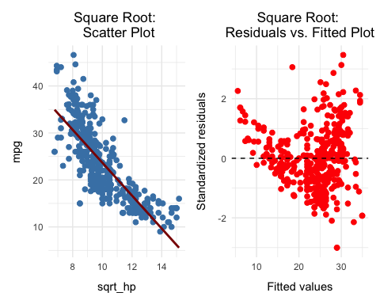

[Interpretation of Plots (scatter and residual) regarding transformation ]

#### Natural Log of *hp*

# Linear model with log10(horsepower)  
model_1 <- lm(mpg ~ log_hp, data = mod_1_auto_df)  
summary(model_1)

Call:  
lm(formula = mpg ~ log_hp, data = mod_1_auto_df)  
  
Residuals:  
 Min 1Q Median 3Q Max   
-14.2299 -2.7818 -0.2322 2.6661 15.4695   
  
Coefficients:  
 Estimate Std. Error t value Pr(>|t|)   
(Intercept) 108.6997 3.0496 35.64 <2e-16 ***  
log_hp -18.5822 0.6629 -28.03 <2e-16 ***  
---  
Signif. codes: 0 '***' 0.001 '**' 0.01 '*' 0.05 '.' 0.1 ' ' 1  
  
Residual standard error: 4.501 on 390 degrees of freedom  
Multiple R-squared: 0.6683, Adjusted R-squared: 0.6675   
F-statistic: 785.9 on 1 and 390 DF, p-value: < 2.2e-16

[Interpretation of regressions coeffcients, noting a natural log has been applied, both y-intercept and slope and make sure to say expected value or on average]

plot_scatter_resid(model_1,mod_1_auto_df ,"Natural Log")

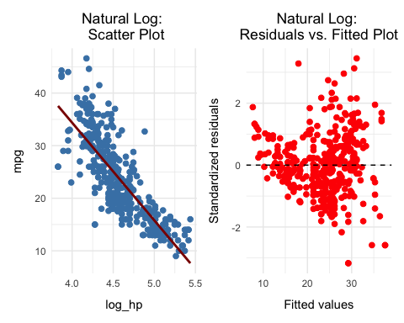

[Interpretation of Plots (scatter and residual) regarding transformation ]

### Interpretation of Results

summary_model_0 <- summarize_reg_model(model_0,'original')  
summary_model_1 <- summarize_reg_model(model_1,'log_hp')  
summary_model_2 <- summarize_reg_model(model_2,'sqrt_hp')  
  
  
bind_rows(  
 summary_model_0,  
 summary_model_1,  
 summary_model_2  
)

type RSS RSE R2 Adj_R2 AIC BIC  
1 original 9385.92 4.91 0.61 0.60 1246.88 1250.85  
2 log_hp 7899.93 4.50 0.67 0.67 1179.31 1183.28  
3 sqrt_hp 8486.62 4.66 0.64 0.64 1207.39 1211.37

[Interpretation of best model]

### Box-Cox Transformation

A Box-Cox transformation should not be used here because it is only applicable to the **response variable** (y), and horsepower is the **predictor**. Applying Box-Cox to x violates its assumptions and intended use.