Skalch 0.03 – Developing
Nicholas Tung, June 2010
The software_documentation file covers how to check out the source code, and build Skalch. This document is dedicated to how the compiler is organized, and how to write graph transformations. The graph transformations software, GrGen, contains an excellent, detailed manual (in that repository's doc folder).
Table of Contents
Compilation stages 1
Overview 1
Compiler Plugin 1
GrGen stages 1
Stage details 2
Adding function blocks and retyping Scala blocks 3
Example graph transformations 4
Set enclosing links 4

Compilation stages

Overview
Several stages are executed during compilation. First, the Scala source is processed using the Scala compiler and Skalch's compiler plugin, which (among other things) dumps the source to the gxl graph format. This is then imported by GrGen, lowered (removing Scala AST explosion), and saved. Then, a Scala tool performs a discrete union of that graph with graphs for any library classes. Final GrGen stages are run. The graph is then imported by Java code, which initialize the SKETCH AST. The Java code in the last stage is generated by Python.

Compiler Plugin
- Save annotations, since they are discarded by further lowering stages

GrGen stages
- Delete classes marked as ignore, warn if any unsupported features are encountered.
- Convert $this variables to explicit function parameters.
- Annotate symbol types, and make SKETCH constructs (assert, ??, !!) special nodes.
- Convert function bodies to blocks, and add return statements to non-unit-type functions.
- List modernization
- Array lowering
- Write list of required libraries, run external discrete union script, and restart.
- Convert Scala-style nodes (e.g. if statements, blocks as expressions) to C-style nodes
- Final cleanup for SKETCH import (changing nodes to their base type, like ScalaSymbol --> Symbol)

Stage details
Stages are detailed below.

Adding function blocks and retyping Scala blocks
First, we want to ensure all functions have blocks as bodies, i.e. change the Scala syntax of “def f(x) = x” into “def f(x) = { x }”. The rewrite production looks like this:
insert scan here
Scala blocks have an expression value, so “{ x ; y }” will return the latest value of “y” at the end. SKETCH, by contrast, has C-style blocks. At the top level
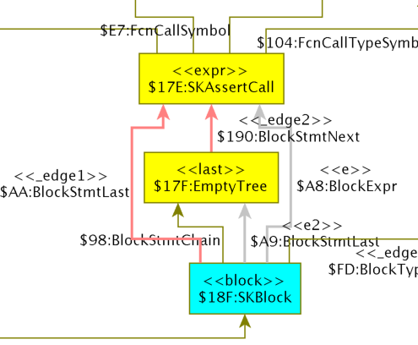

Example graph transformations

Set enclosing links
In order to build a call graph, we want links from any node to its enclosing function.
This rule uses GrGen's new recursive subpattern matching to match all subnodes in one shot (no recursive exec or negative statements required).
// === set enclosing function ===
rule setEnclosingFunctionInitial {
x:FcnDef;
ise:iteratedSetEnclosing(x, x);
modify { ise(); }
}

pattern iteratedSetEnclosing(x:ScAstNode, fcn:FcnDef) {
hom(x, fcn);
iterated {
x -:Subtree-> y:ScAstNode;
ise:iteratedSetEnclosing(y, fcn);
modify { ise(); }
}
iterated {
x -:Subtree-> lst:List;
iterated {
lst -:ListElt-> :ListNode -:ListValue-> y:ScAstNode;
ise:iteratedSetEnclosing(y, fcn);
modify { ise(); }
}
modify { }
}
modify { x -:EnclosingFcn-> fcn; }
}

