Biologically Informed Machine Learning for Malaria Incidence Forecasting: Integrating Mechanistic Vector Traits with Environmental and Epidemiological Predictors
Ewli Kodjo Gato Didier
Pan African University Institute for Basic Sciences, Technology and Innovation (PAUSTI), Juja, Kenya
Corresponding author: [confirm preferred email address]
Article type: Research | Target journal: Parasites & Vectors

Abstract
Background. Malaria incidence forecasting commonly uses epidemiological history and environmental covariates, whereas temperature-dependent mosquito–parasite processes are rarely represented explicitly in country-level prediction models. We evaluated whether selected mechanistically derived biological predictors improved one-year-ahead forecasts.
Methods. World Health Organization annual malaria incidence per 1,000 population at risk was combined with environmental and historical variables. Temperature-dependent biological features derived from a computationally reproduced mechanistic framework were evaluated in matched conventional Gradient Boosting (GB), BIML-Full and BIML-Reduced models. Expanding-window rolling-origin evaluation covered 29 African countries in 2019–2022 (116 paired country-year predictions). Generalized additive models (GAMs), feature ablations, country-clustered bootstrap resampling and country-exclusion sensitivity analyses provided complementary assessments.
Results. Pooled MAE was 14.7153 for conventional GB, 14.5300 for BIML-Full and 14.4935 for BIML-Reduced; corresponding RMSE values were 25.9808, 25.8620 and 25.8298. BIML-Reduced improved country-specific MAE in 22/29 countries. Its mean-annual MAE improvement was 0.2217 (country-clustered bootstrap 95% CI 0.1070–0.3529); RMSE and R² improvement intervals included zero. Recalculation after excluding each country’s existing predictions preserved positive differences in all three metrics for all 29 exclusions, without retraining.
Conclusions. Selected mechanistically motivated temperature transformations provided a small additional predictive benefit, most clearly for MAE. These retrospective findings require independent biological validation, nested feature selection and external temporal and geographical evaluation before operational interpretation.
Keywords: malaria; incidence forecasting; biologically informed machine learning; vector competence; extrinsic incubation period; gradient boosting; rolling-origin evaluation

Background
Malaria transmission reflects interactions between infectious humans, mosquito vectors, parasite development, interventions and local environmental conditions. Country-level incidence estimates summarize this complex system but do not directly observe its entomological processes. Predictive models often use previous incidence and climate-related variables because these inputs are available at broad geographic scales; however, a raw temperature variable may not efficiently represent nonlinear thermal constraints on parasite development and mosquito survival [1–4].
Mechanistic transmission research links temperature to vector competence, the extrinsic incubation period (EIP), survival and biting behaviour. These relationships are biologically meaningful but depend on mosquito species, experimental context and model assumptions. Computationally derived quantities must not be mistaken for independent observations of mosquito abundance or realized transmission [3–6].
Recent Parasites & Vectors studies have applied interpretable machine learning to environmental determinants of mosquito biting in Burkina Faso, investigated thermal influences on parasite EIP in India and examined the importance of estimating vector life-history parameters [7–9]. Their endpoints and spatial scales differ from annual malaria incidence forecasting. The present study addresses the narrower question of whether a small set of mechanistically motivated transformations improves prediction when the historical and environmental inputs and evaluation design are held constant.
We developed and evaluated a biologically informed machine-learning (BIML) representation using temperature-dependent competence, EIP, biting activity and a composite B2 index. The primary comparison was conventional GB versus matched full and reduced biological configurations. We additionally evaluated year-specific performance, feature ablations, geographical heterogeneity, bootstrap uncertainty and the sensitivity of aggregate results to excluding individual countries.

Methods

Study setting, observations and outcome
The environmental data development domain contained 32 African countries with monthly observations from January 2013 through December 2024 (4,608 country-month records). The final rolling-origin forecasting evaluation comprised 29 eligible African countries and four target years (2019–2022), yielding 116 country-year predictions. These counts describe different stages of the pipeline and must not be conflated with the size of the fitting data in each expanding window.
The forecasting target was WHO annual malaria incidence, indicator incidence_b, expressed as cases per 1,000 population at risk [1,10]. For country c and year t, let Y(c,t) denote the reported incidence. A one-year-ahead forecast at origin t targets Y(c,t+1). The outcome is an annual population-level estimate rather than an individual clinical diagnosis or a directly observed entomological transmission measure.

Environmental and epidemiological predictors
The original environmental processing used ERA5-Land two-metre air temperature, temperature and dew point for relative humidity, CHIRPS rainfall, Landsat 8 Collection 2 Level 2 vegetation/water indices and surface temperature, and MODIS Aqua MYD11A2.061 nighttime land-surface temperature. Rainfall totals were summed over months; other annual environmental summaries used the mean of available valid monthly values. Missing or invalid satellite observations affect coverage. Exact cloud masks, spatial reductions and extraction dates should be checked against the archived acquisition scripts before final submission [11–15].
The epidemiological predictor family included historical WHO incidence; additional intervention-related indicators were considered in the wider BIML research pipeline. The evaluated matched GB comparison should be understood as a comparison of the common history/environment feature set with and without the biological additions. The biological-coverage variable was included consistently across matched configurations to avoid making missingness information an unintended difference between models.

Mechanistic model reproduction and biological representation
Temperature-dependent biological functions were derived from a computational reproduction of the published mSOS framework of Suh et al. [4]. The pooled Stan model was fitted using four chains with 5,500 iterations per chain (3,000 warmup; 10,000 post-warmup draws overall), random seed 12345, adapt_delta 0.99 and maximum tree depth 12. The source benchmark at 17.5 °C returned a fixed-EIP reference of 0.02573695 and an mSOS expected-infectious-bites reference of 0.3779795. These numerical checks assess reproduction of the source computation; they do not validate vector ecology in each African country.
Let δ(T) and δS(T) denote the two temperature-dependent components used to construct vector competence, E(T) the mean EIP, A(T) biting-related activity and S(0,e;T) survival through duration e from infection at age zero. The derived predictors were:
C(T) = δ(T) × δS(T) (1)
EIP(T) = E(T) (2)
I_B2(T) = A(T) × C(T) × S(0, E(T); T) (3)
The B2 quantity is a deliberately simplified composite biological index. It is not the original mSOS age-integrated infectious-bite expectation, not a complete vectorial capacity formula and not a direct estimate of observed transmission. The biting-related response incorporates assumptions from an Anopheles stephensi context, while the source mSOS parasite–vector experiment involves a different vector setting; this species transfer is a substantive biological limitation.
Monthly functions were evaluated using the available monthly temperature summaries and aggregated over supported months M(c,y), retaining the number of supported months as coverage metadata:
B̄(c,y) = [1 / |M(c,y)|] × Σ[m ∈ M(c,y)] B(T(c,y,m)) (4)
Because biological functions are nonlinear, the mean of monthly evaluations generally differs from evaluation at annual mean temperature. Monthly averaging nevertheless does not resolve diurnal thermal variation, subnational heterogeneity or unmeasured mosquito population density.

Prediction task, models and rolling-origin evaluation
The supervised models predicted the annual incidence change ΔY(c,t+1) = Y(c,t+1) − Y(c,t). Incidence forecasts were reconstructed from the incidence available at the forecast origin and clipped to nonnegative values:
Ŷ(c,t+1) = max{0, Y(c,t) + ΔŶ(c,t+1)} (5)
Three matched Gradient Boosting configurations were compared: conventional GB (historical and environmental predictors); BIML-Full (the common predictors plus competence, EIP, biting activity and B2 index); and BIML-Reduced (the common predictors plus competence and B2 index). The recorded common Gradient Boosting settings were 100 estimators, learning rate 0.02, maximum depth 1, minimum leaf size 15 and subsample 0.8. GAM provided an additional non-GB benchmark [16,17].
Retrospective expanding-window rolling-origin predictions were evaluated for 2019, 2020, 2021 and 2022, with 29 countries in each target year. All three GB configurations used the same target observations and matched forecasting origins. The reduced biological subset was selected through the evaluated ablation comparisons; consequently, its performance may reflect selection on the evaluation period and must be regarded as exploratory rather than a fully nested confirmatory comparison.

Evaluation metrics and sensitivity analyses
For observed incidences yᵢ, forecasts ŷᵢ and N evaluation records, the following metrics were calculated:
MAE = (1/N) Σᵢ |yᵢ − ŷᵢ| (6)
RMSE = √[(1/N) Σᵢ (yᵢ − ŷᵢ)²] (7)
R² = 1 − [Σᵢ (yᵢ − ŷᵢ)² / Σᵢ (yᵢ − ȳ)²] (8)
Pooled metrics use all 116 predictions in a single calculation. Mean-annual metrics are the arithmetic mean of four separately calculated annual metrics. In particular, mean-annual RMSE and R² are not identical to pooled RMSE and R². For improvements, positive ΔMAE and ΔRMSE indicate lower error for BIML, while positive ΔR² indicates higher R².
The country-clustered bootstrap resampled countries with replacement, retaining each country’s four-year trajectory, and recalculated mean-annual differences. Country-exclusion sensitivity was a separate deterministic calculation: each country c was removed from the already generated prediction table, metrics were recalculated on the remaining 28 countries and four years, and the two models were compared. Models were not retrained. The exclusion difference for metric Q is ΔQ(−c) = Q_GB(D\{c}) − Q_BIML(D\{c}) for MAE/RMSE, and ΔR²(−c) = R²_BIML(D\{c}) − R²_GB(D\{c}).

Results

Pooled and mean-annual forecasting performance
The supplied 116-row paired prediction export was independently rescored for all three GB configurations. It reproduced the previously reported pooled results to four decimal places (Table 1). Relative to conventional GB, BIML-Reduced reduced pooled MAE by 0.2218 (1.51%) and RMSE by 0.1510 (0.58%); R² increased by approximately 0.0008. These differences are small in absolute and relative terms.
Table 1. Pooled forecasting performance across 116 country-year predictions. MAE and RMSE: cases per 1,000 population at risk.
Model | MAE | RMSE | R²
Conventional GB | 14.7153 | 25.9808 | 0.9322
BIML-Reduced | 14.4935 | 25.8298 | 0.9330
BIML-Full | 14.5300 | 25.8620 | 0.9328

The mean-annual comparison retained the same model ordering, but with different RMSE and R² values due to annual averaging. BIML-Reduced had mean-annual RMSE 24.6631 versus 24.7717 for conventional GB; corresponding mean-annual R² values were 0.9299 and 0.9291. GAM was weaker overall (mean-annual MAE 16.2337, RMSE 25.7894, R² 0.9221).
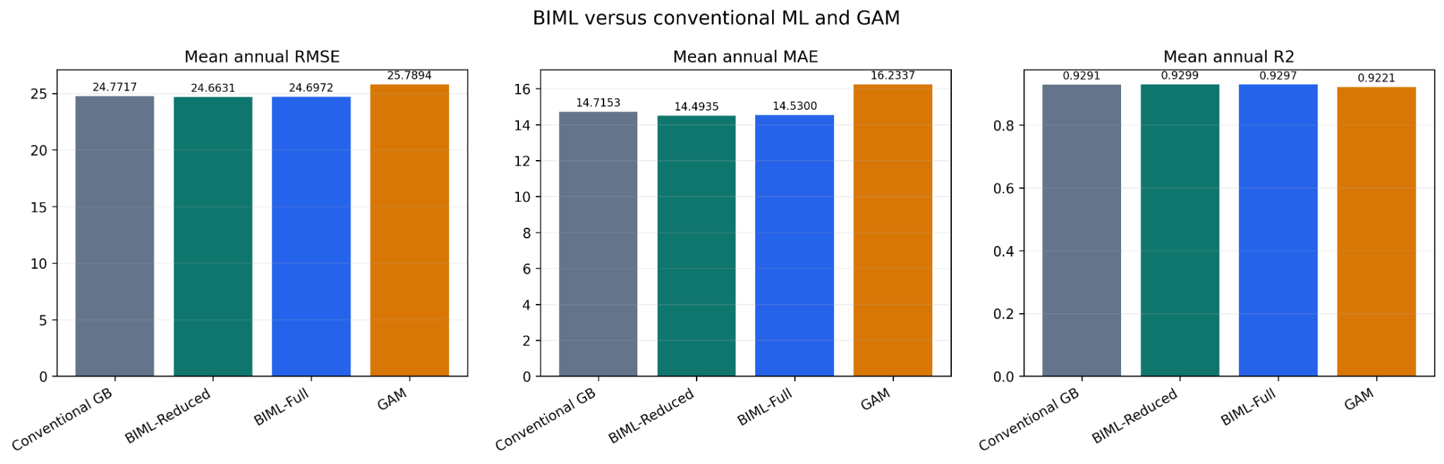
Figure 1. Mean annual MAE, RMSE and R² by model (source: mean_performance.png).

Year-specific performance
The advantage was not uniform across evaluation years. BIML-Reduced improved both MAE and RMSE in 2019 and 2021; conventional GB had lower MAE in 2020 and lower RMSE in 2022. GAM had the best MAE, RMSE and R² in 2021. Table 2 reports all 16 annual comparisons.
Table 2. Rolling-origin performance by target year (29 country predictions per year).
Year | Model | MAE | RMSE | R²
2019 | Conventional GB | 15.0633 | 22.9149 | 0.9531
2019 | BIML-Reduced | 14.7597 | 22.8946 | 0.9532
2019 | BIML-Full | 14.7850 | 22.9120 | 0.9531
2019 | GAM | 17.0303 | 24.9983 | 0.9442
2020 | Conventional GB | 18.9435 | 36.7482 | 0.8472
2020 | BIML-Reduced | 18.9912 | 36.4887 | 0.8493
2020 | BIML-Full | 19.0137 | 36.5236 | 0.8490
2020 | GAM | 22.0104 | 39.7904 | 0.8208
2021 | Conventional GB | 15.2042 | 24.5783 | 0.9386
2021 | BIML-Reduced | 14.8202 | 24.2222 | 0.9404
2021 | BIML-Full | 14.8885 | 24.2650 | 0.9402
2021 | GAM | 14.6708 | 22.1092 | 0.9503
2022 | Conventional GB | 9.6501 | 14.8455 | 0.9774
2022 | BIML-Reduced | 9.4030 | 15.0468 | 0.9768
2022 | BIML-Full | 9.4328 | 15.0883 | 0.9767
2022 | GAM | 11.2233 | 16.2596 | 0.9729

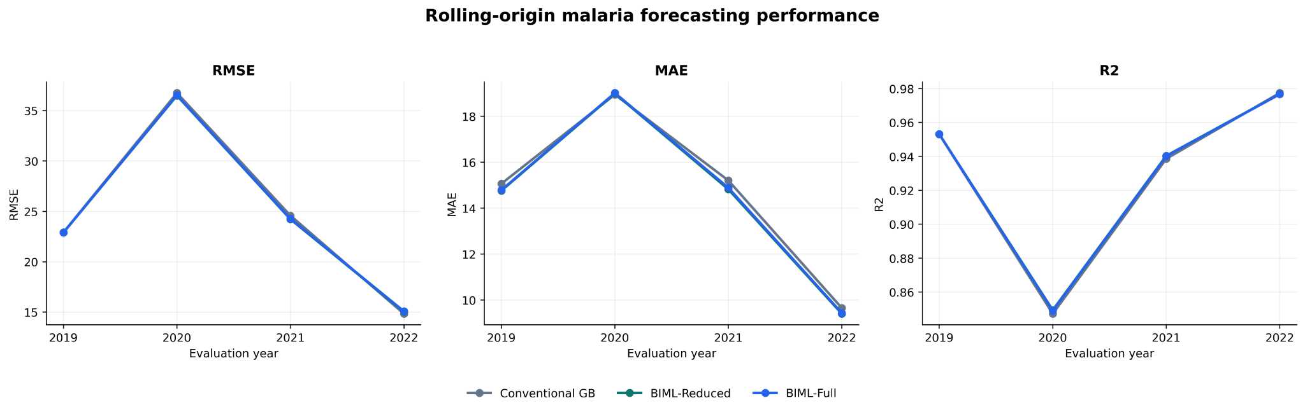
Figure 2. Annual model performance comparison (source: figure10_annual_model_performance.png).

Biological ablation and model interpretation
The competence-only feature set achieved mean-annual RMSE 24.6736; competence plus B2 achieved 24.6631, compared with 24.7717 for conventional GB and 24.6972 for BIML-Full. Adding all biologically motivated features did not produce the strongest result. This is consistent with possible redundancy among temperature-derived predictors, although the analysis cannot identify a causal explanation.
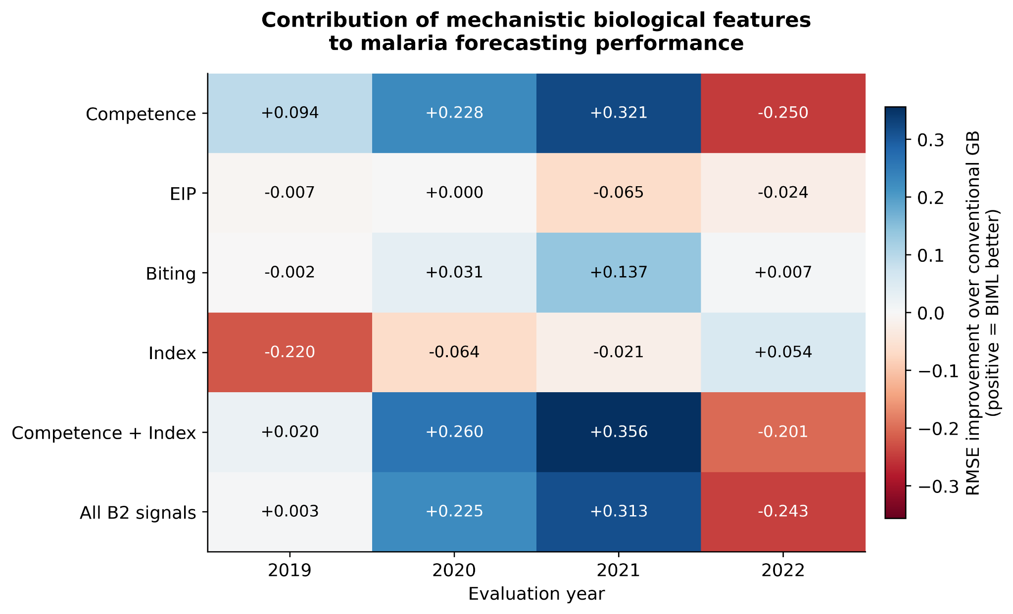
Figure 3. Biological feature-ablation results (source: figure1_biological_ablation.png).
Grouped impurity-based feature importance attributed approximately 49.87% to historical predictors, 39.01% to environmental predictors, 11.04% to biological features and 0.07% to coverage. Importance is descriptive and can be redistributed among correlated predictors; it is not a measure of causal effect.
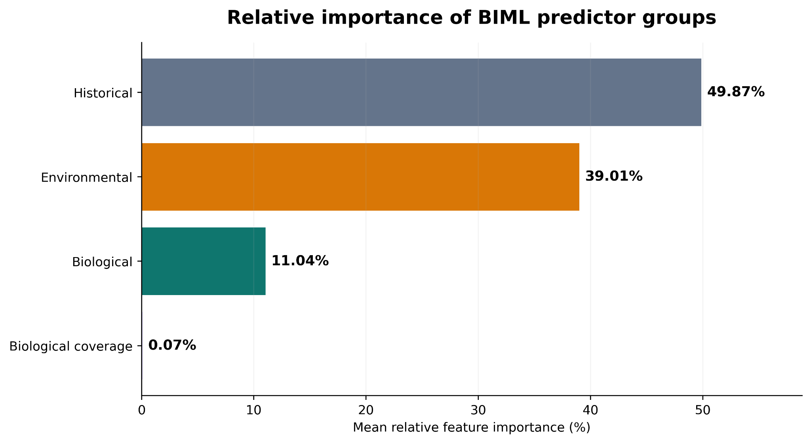
Figure 4. Mean grouped predictor importance (source: figure14_mean_group_importance.png).

Country-level performance and country-exclusion sensitivity
Country-level MAE was lower for BIML-Reduced in 22 of the 29 evaluated countries. This is distinct from the country-exclusion sensitivity result: a country may not individually benefit from BIML even when removing it leaves a positive aggregate advantage.
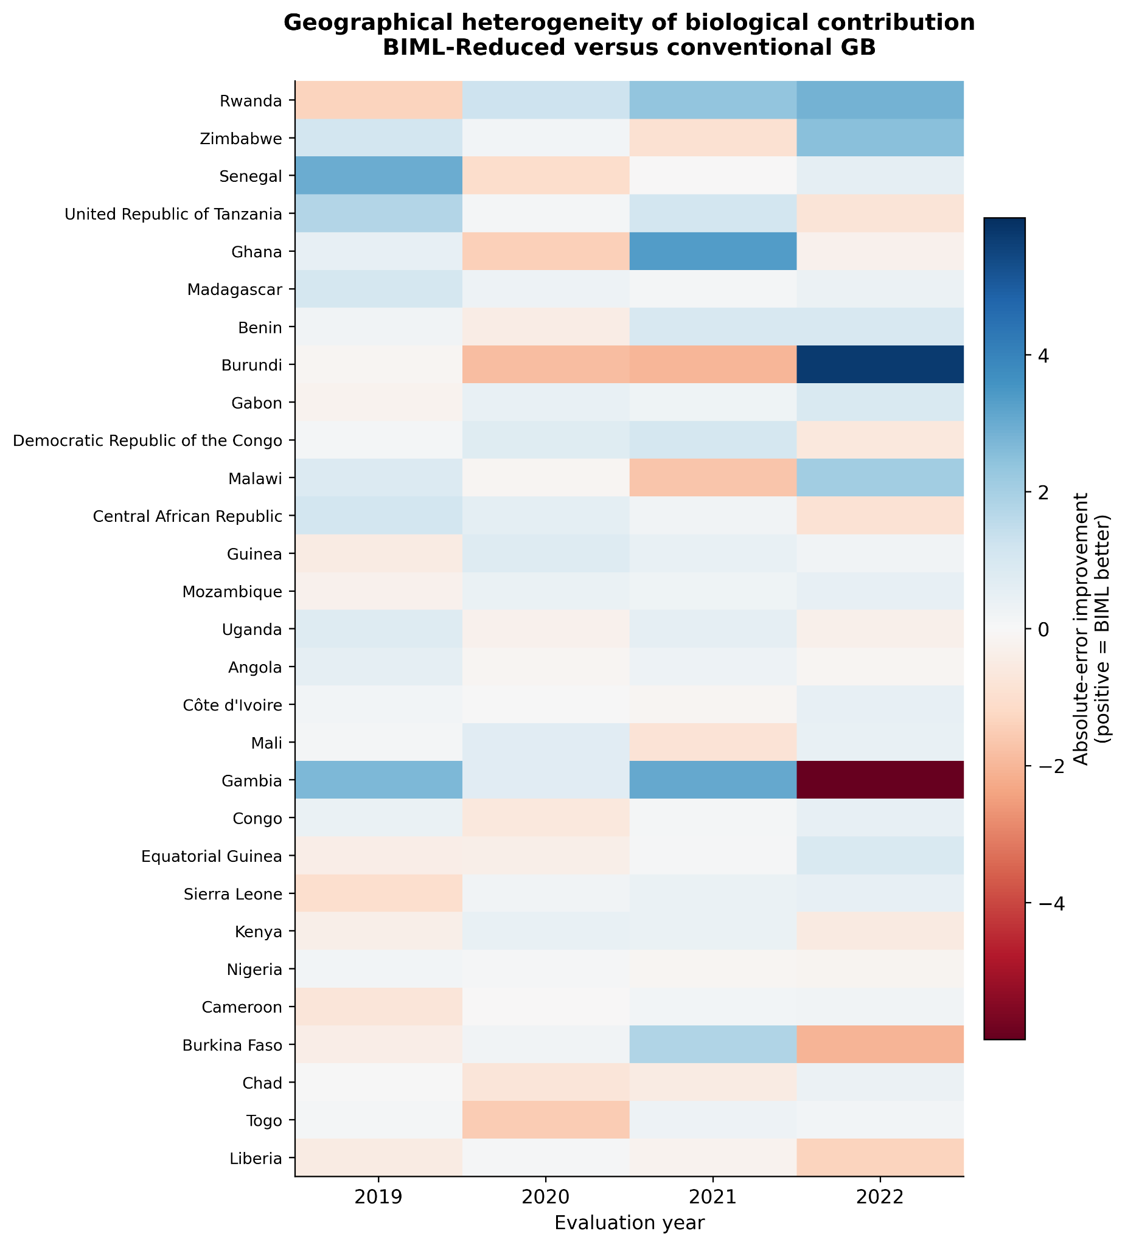
Figure 5. Country-level biological contribution to MAE improvement (source: figure3_country_biological_contribution.png).
Recalculation after removing each country’s existing predictions retained positive mean-annual ΔMAE, ΔRMSE and ΔR² in all 29 cases (Table 3; full values in Supplementary Table S1). For BIML-Reduced, ΔMAE ranged from 0.183453 to 0.247096 (median 0.222774), ΔRMSE from 0.044411 to 0.193782 (median 0.109360), and ΔR² from 0.000203 to 0.001045 (median 0.000853). The minimum RMSE advantage occurred when Rwanda was excluded; the maximum when Gambia was excluded. The result demonstrates insensitivity of the aggregate comparison to removal of a single country’s evaluation records, not generalization to unseen countries.
Table 3. Summary of country-exclusion sensitivity. Positive differences favour BIML; no models were retrained.
Model | Metric | Minimum | Median | Maximum | Positive
BIML-Reduced | ΔMAE | 0.183453 | 0.222774 | 0.247096 | 29/29
BIML-Reduced | ΔRMSE | 0.044411 | 0.109360 | 0.193782 | 29/29
BIML-Reduced | ΔR² | 0.000203 | 0.000853 | 0.001045 | 29/29
BIML-Full | ΔMAE | 0.146680 | 0.186296 | 0.210861 | 29/29
BIML-Full | ΔRMSE | 0.015951 | 0.075090 | 0.160367 | 29/29
BIML-Full | ΔR² | 0.000102 | 0.000679 | 0.000862 | 29/29

Country-clustered bootstrap uncertainty
The country-clustered bootstrap indicated a positive mean-annual MAE difference for BIML-Reduced (0.221724; 95% CI 0.107044–0.352939). In contrast, its RMSE difference (0.108666; 95% CI −0.083201 to 0.359986) and R² difference (0.000846; 95% CI −0.000201 to 0.002826) had intervals crossing zero. These intervals characterize resampling uncertainty conditional on the fitted and compared configurations; they do not correct for possible feature-selection reuse.
Table 4. Country-clustered bootstrap improvements for mean-annual metrics.
Configuration | Metric | Estimate | 95% CI lower | 95% CI upper
BIML-Reduced | RMSE | 0.108666 | -0.083201 | 0.359986
BIML-Reduced | MAE | 0.221724 | 0.107044 | 0.352939
BIML-Reduced | R2 | 0.000846 | -0.000201 | 0.002826
BIML-Full | RMSE | 0.074520 | -0.111655 | 0.333013
BIML-Full | MAE | 0.185297 | 0.066107 | 0.319773
BIML-Full | R2 | 0.000671 | -0.000331 | 0.002383

Discussion

Principal interpretation
The central result is a modest, reproducible reduction in absolute forecasting error when competence and the B2 index are added to the matched GB framework. The 116 paired prediction records now independently reproduce pooled MAE, RMSE and R², strengthening numerical traceability. The country-exclusion analysis demonstrates that no single evaluated country is solely responsible for the positive aggregate differences. Nevertheless, the absolute improvement is small, and the clustered RMSE and R² intervals include zero. The study therefore supports a limited incremental predictive contribution rather than broad claims of biological superiority.

Comparison with previous studies
The study extends mechanistic thermal modelling into a supervised incidence forecasting comparison. Suh et al. [4] address temperature-dependent mosquito–parasite processes; Taconet et al. [7] examine environmental predictors of biting, Kripa et al. [8] focus on EIP and Morris et al. [9] address vector life-history parameter estimation. Those studies justify biological feature construction but cannot be used as direct benchmarks for annual country-level incidence prediction. The present results show that biologically interpretable transformations can sometimes help, not that their inclusion necessarily improves prediction in every year or country.

Heterogeneity, interpretation and generalizability
Performance varied across years, and GAM was strongest in 2021. Biological predictors were constructed from temperature inputs already available to the conventional models; they therefore add a representation rather than independent biological measurements. Correlation among competence, EIP, biting activity and the B2 index can also complicate interpretation of impurity-based importance. The country-exclusion analysis does not test generalization to countries absent during model fitting; that requires retraining with geographical holdouts.

Limitations and future research
The original mechanistic framework was computationally reproduced, but country-specific mosquito and parasite traits were not measured. The biting-related component introduces cross-species assumptions. Country-level annual incidence and aggregated temperature obscure local seasonality and diurnal fluctuations. WHO incidence estimates and environmental products contain uncertainty that was not fully propagated into prediction intervals. Four retrospective target years provide limited evidence of future stability. Most importantly, the reduced biological subset was chosen using the evaluated ablation results; selection optimism cannot be excluded. Country-clustered bootstrap intervals should not be treated as independently confirmatory after this selection.
Further work should evaluate training-fold-only feature selection, independently held-out future years, geographically withheld countries with model refitting, mosquito species-specific parameter uncertainty and locally measured entomological outcomes. Higher-frequency incidence and environmental data would enable more direct alignment between mechanistic thermal processes and forecast horizons. Operational early-warning deployment is not justified by the current evaluation alone.

Conclusions
In a matched retrospective evaluation across 29 African countries, a reduced set of temperature-dependent biological predictors improved annual malaria incidence forecasts modestly relative to conventional Gradient Boosting. The strongest support concerned MAE; RMSE and R² differences remained uncertain under country-clustered bootstrap resampling. The recovered 116 predictions and full 29-country exclusion table make the evaluation more reproducible. Independent biological, temporal and geographical validation remains necessary.

Declarations
Ethics approval and consent to participate. This analysis uses secondary country-level data; confirm the applicable institutional ethics determination before submission.
Consent for publication. [Author to confirm.]
Availability of data and materials. WHO and environmental sources are identified in the Methods. The 116 paired evaluation predictions and country-exclusion sensitivity tables are available as study-generated CSV outputs. [Insert public repository URL, license and source access dates once deposited.]
Competing interests. [Author to confirm.]
Funding. [Insert verified institutional or grant funding statement.]
Authors’ contributions. [Confirm final author list and contributions.]
Acknowledgements. [Confirm supervisory, institutional and technical acknowledgements.]

References
1. World Health Organization. World malaria report 2025. Geneva: WHO; 2025. [Verify exact edition cited in the original analysis.]
2. Mordecai EA, et al. Optimal temperature for malaria transmission is dramatically lower than previously predicted. Ecology Letters. 2013.
3. Mordecai EA, et al. Thermal biology of mosquito-borne disease. Ecology Letters. 2019. [Verify complete bibliographic details.]
4. Suh E, et al. Temperature-dependent malaria transmission mechanistic study. Nature Communications. 2024. doi:10.1038/s41467-024-47265-w. [Verify full published title and author list.]
5. Paaijmans KP, et al. Influence of climate on malaria transmission depends on daily temperature variation. Proceedings of the National Academy of Sciences. 2010. [Verify volume/pages.]
6. Macdonald G. The Epidemiology and Control of Malaria. Oxford University Press; 1957.
7. Taconet P, et al. Data-driven and interpretable machine-learning modeling to explore the fine-scale environmental determinants of malaria vectors biting rates in rural Burkina Faso. Parasites & Vectors. 2021. doi:10.1186/s13071-021-04851-x.
8. Kripa, et al. Impact of climate change on temperature variations and extrinsic incubation period of malaria parasites in Chennai, India: implications for its disease transmission potential. Parasites & Vectors. 2024. doi:10.1186/s13071-024-06165-0.
9. Morris A, Ghani AC, Ferguson NM. Fine-scale estimation of key life-history parameters of malaria vectors: implications for next-generation vector control technologies. Parasites & Vectors. 2021. doi:10.1186/s13071-021-04789-0.
10. World Health Organization. Global Health Observatory: malaria incidence (incidence_b). [Insert access date and dataset URL.]
11. Hersbach H, et al. The ERA5 global reanalysis. Quarterly Journal of the Royal Meteorological Society. 2020. [ERA5-Land product documentation should be cited separately.]
12. Funk C, et al. The climate hazards infrared precipitation with stations—a new environmental record for monitoring extremes. Scientific Data. 2015. [Verify CHIRPS citation details.]
13. US Geological Survey. Landsat Collection 2 Level-2 Science Products. [Insert access date.]
14. NASA LP DAAC. MYD11A2 Version 6.1 MODIS/Aqua Land Surface Temperature and Emissivity 8-Day L3 Global 1 km. [Insert access date.]
15. Gao BC. NDWI—A normalized difference water index for remote sensing of vegetation liquid water from space. Remote Sensing of Environment. 1996.
16. Friedman JH. Greedy function approximation: a gradient boosting machine. Annals of Statistics. 2001;29:1189–1232.
17. Hastie T, Tibshirani R. Generalized additive models. Statistical Science. 1986;1:297–310.
18. Carpenter B, et al. Stan: A probabilistic programming language. Journal of Statistical Software. 2017;76(1).
19. Vehtari A, et al. Rank-normalization, folding, and localization: An improved R-hat for assessing convergence of MCMC. Bayesian Analysis. 2021.

Supplementary information
Supplementary Table S1 provides the complete 29-country exclusion results for BIML-Reduced. The 116 country-year paired prediction records and full-model exclusion table are provided as separate machine-readable CSV files. Full mechanistic derivations, Stan posterior diagnostics, detailed extraction scripts and additional figures should be deposited as a separate methods supplement after verification against the original implementation.
Supplementary Table S1. BIML-Reduced country-exclusion sensitivity: mean-annual improvement after removal of each country’s four existing predictions; 28 countries and 112 predictions remain for each exclusion. Positive differences favour BIML.
Excluded country | ΔMAE(−c) | ΔRMSE(−c) | ΔR²(−c)
Angola | 0.224103 | 0.109360 | 0.000840
Benin | 0.214034 | 0.091046 | 0.000826
Burkina Faso | 0.233381 | 0.107555 | 0.000870
Burundi | 0.214040 | 0.106256 | 0.000897
Cameroon | 0.232786 | 0.112738 | 0.000857
Central African Republic | 0.220266 | 0.111986 | 0.000903
Chad | 0.236805 | 0.110464 | 0.000853
Congo | 0.226565 | 0.105273 | 0.000834
Côte d'Ivoire | 0.224797 | 0.110573 | 0.000852
Democratic Republic of the Congo | 0.218470 | 0.111564 | 0.000873
Equatorial Guinea | 0.227329 | 0.113104 | 0.000859
Gabon | 0.217146 | 0.107333 | 0.000845
Gambia | 0.225765 | 0.193782 | 0.001045
Ghana | 0.210580 | 0.104627 | 0.000832
Guinea | 0.220966 | 0.110909 | 0.000851
Kenya | 0.229956 | 0.110997 | 0.000927
Liberia | 0.247096 | 0.149737 | 0.000947
Madagascar | 0.213449 | 0.081807 | 0.000795
Malawi | 0.219697 | 0.102219 | 0.000828
Mali | 0.225325 | 0.102850 | 0.000813
Mozambique | 0.221505 | 0.107389 | 0.000852
Nigeria | 0.230192 | 0.110652 | 0.000855
Rwanda | 0.183453 | 0.044411 | 0.000203
Senegal | 0.207927 | 0.087939 | 0.000916
Sierra Leone | 0.228775 | 0.111640 | 0.000866
Togo | 0.238360 | 0.110086 | 0.000850
Uganda | 0.222774 | 0.105730 | 0.000826
United Republic of Tanzania | 0.210246 | 0.103016 | 0.000859
Zimbabwe | 0.204219 | 0.140559 | 0.001035

Supplementary files: paired_predictions_116.csv; country_exclusion_reduced_29.csv; country_exclusion_all_models.csv; country_exclusion_summary.csv.

