hw3

Avinash Ramu

September 25, 2016

## Q11.4

t1 <- read.table("dat/allvar.csv", head = T, sep = ",")  
t1$time <- t1$visage - t1$baseage  
plot(t1$time, t1$CD4PCT, xlab = "Time (Visage - Baseage)", ylab = "CD4PCT")

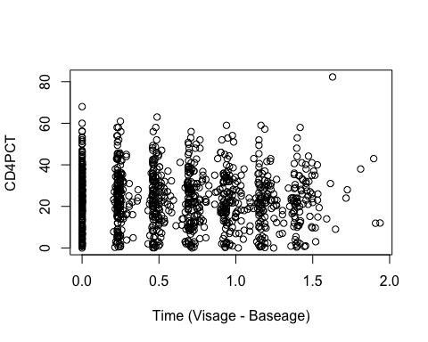 ## Q12.2

## Q12.5