StepCat
Payout Calculator
Quick Start Guide
App and Profitability Workbook v252

Estimate payouts, record completed results, and copy exact rows into the matching workbook.

Release note
v252 includes the corrected Entry Mode/Membership sequence, visible drawer controls, protected clear/start actions, SC Record IDs, stricter Free Game validation, safer draft recovery, and updated Help & Resources links.

This guide is for StepCat users. It explains the current app and workbook workflow without developer-facing implementation notes.

Contents
1. Start with Entry Mode, then Membership Type
2. Enter required calculation fields
3. Use Additional Details only when needed
4. Calculate, save, and understand the result
5. Use Saved History and SC Record IDs
6. Finalize an Estimate in place
7. Copy records into the workbook
8. Review workbook reports
9. Personalize Settings safely
10. Find Help & Resources
11. Install StepCat or create a shortcut
12. Send feedback
13. Migrate old workbook data
14. Troubleshooting and rules
Fastest workflow
Choose Entry Mode (Step 1), confirm Membership Type (Step 2), enter the required calculation fields, then tap Calculate & Save. Open Additional Details only for names, dates, payment labels, or notes.

1. Start with Entry Mode, then Membership Type
Entry Mode is the first required choice. Choose Estimate for a projection or Finalized for a completed challenge. Membership Type is the second required choice. Confirm Member or Non-Member after choosing the mode.
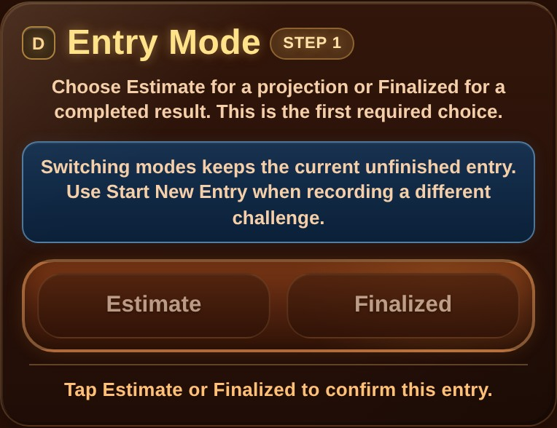 | 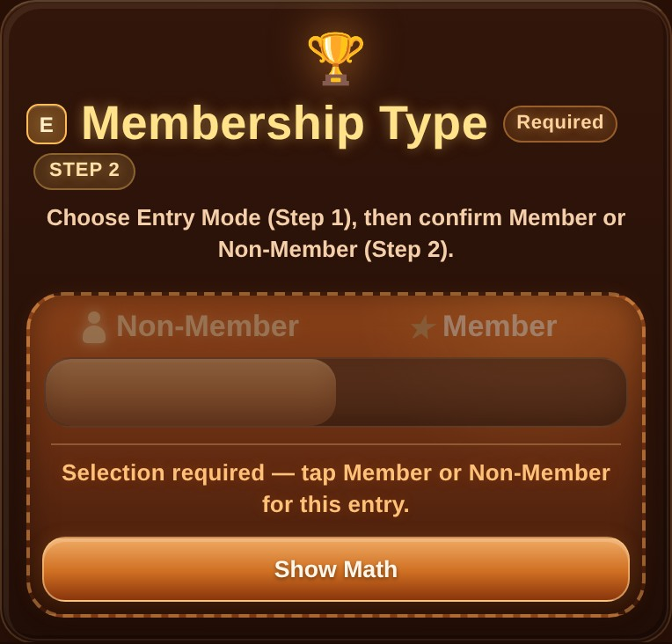
Entry Mode is Step 1 and begins the workflow. | Membership Type is Step 2 and is required before calculation.

Membership math
Member uses the full Gross Pot. Non-Member uses the adjusted pot after the 15% deduction. Show Math explains the active calculation.

Remember Entry Mode and Remember Membership are optional Settings. When either is off, StepCat intentionally asks for a fresh selection after refresh or reopening.

2. Enter required calculation fields

Estimate
- Gross Pot / Chips
- Entry Fee
- Eligible Players
Total Players is optional. When entered, it supports eliminated-player and elimination-rate calculations.

Finalized
- Entry Fee
- Final Earned / Chips
Disqualified / Lost Entry Fee appears immediately before Final Earned. Turning it on sets Final Earned to zero and locks the field for the current result.
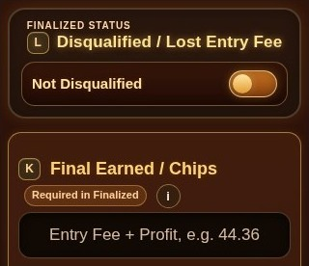 | 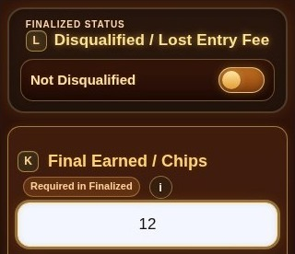
Disqualified is off and Final Earned remains available. | Final Earned records the total returned, not profit alone.

Free Game rule
A Free Game must have a $0 Entry Fee. StepCat blocks a Free Game with a paid fee in both Estimate and Finalized modes. A $0 entry is recorded as Free Game.

3. Use Additional Details only when needed
Game Entry contains the calculation fields. Additional Details contains optional game and workbook information. Both are visibly styled as drawers and include manual expand/collapse controls.
- Game Name
- Game Start Date and Game End Date
- Date Format
- Payment / Record Type
- Optional statistics when available
- Notes
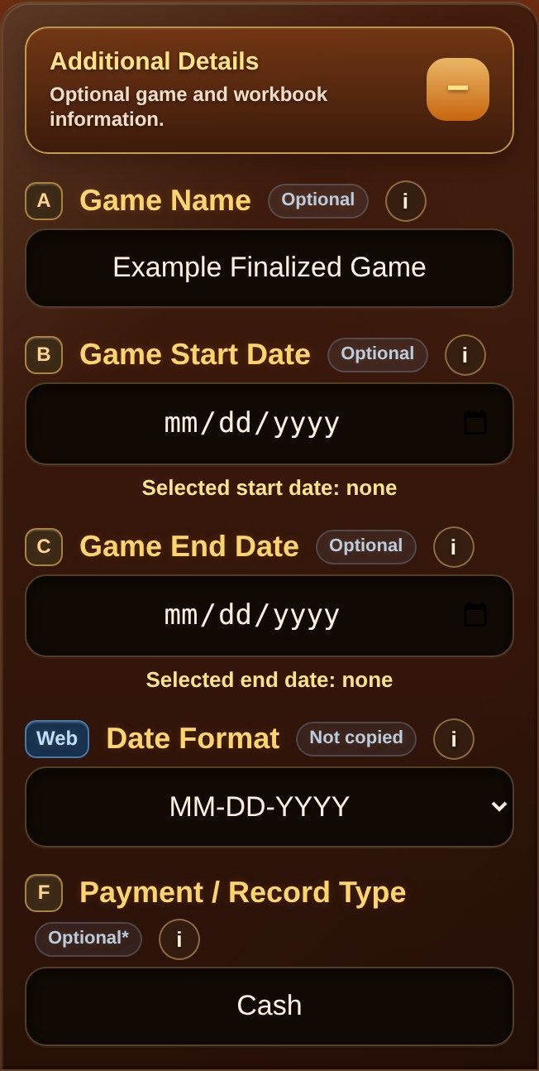 | 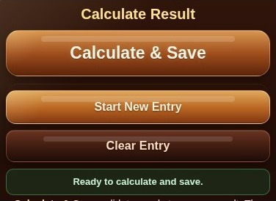
Additional Details opened with example record information. | Calculate & Save validates and stores one result.

Notes can store unusual entry details or a cash-and-points breakdown.
Drawer behavior
Default-open Settings apply when StepCat loads or refreshes. They do not override a drawer that you manually opened or closed during the current session.

4. Calculate, save, and understand the result
Tap Calculate & Save after the required fields are complete. StepCat scrolls to the first invalid field when correction is needed. A successful save clears the completed draft so it does not return as unfinished work.
Result | Meaning
Profit | Final Earned is greater than Entry Fee. Profit is the difference.
Draw | A normal completed return at or below Entry Fee. Net Profit is $0.00.
Disqualified | A paid entry loses the full Entry Fee. Free Games record the status without a monetary loss.
Free Game | Return is recorded as chips or game credit. Cash Net Profit is $0.00 and ROI is N/A.
Estimate | Projection only. Accounting Result and ROI remain N/A until finalized.

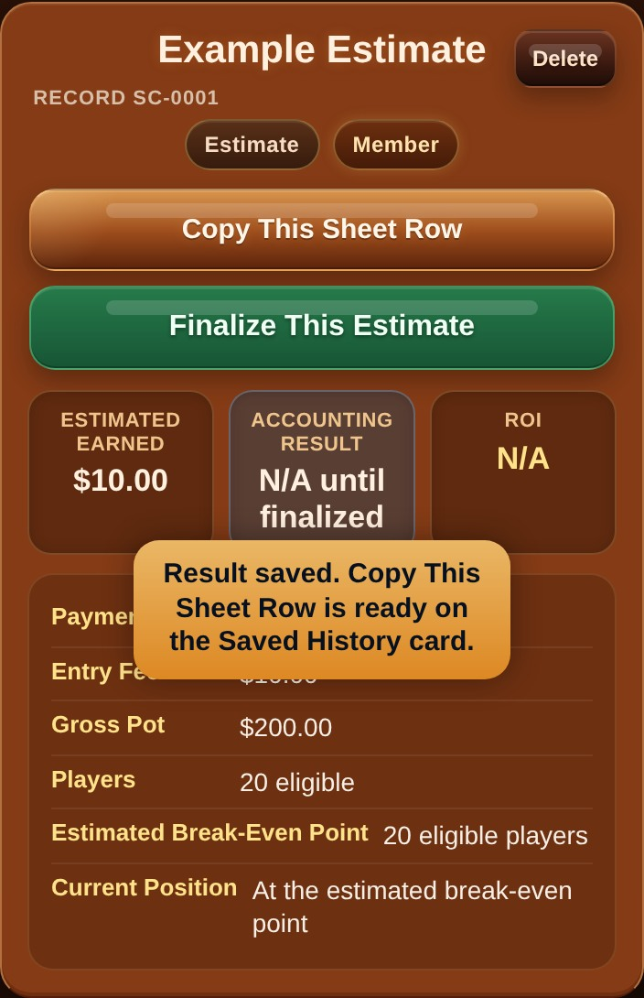 | 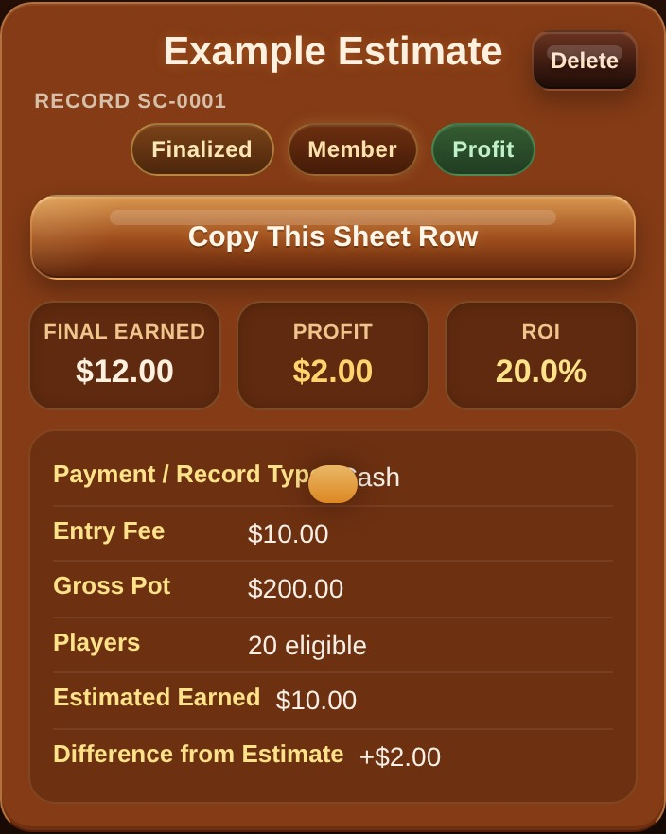
Newest saved Estimate with a Finalize This Estimate action. | Finalized Saved History card with result and accounting values.

5. Use Saved History and SC Record IDs
Saved History persists on the device. Each record receives a permanent, non-editable SC Record ID such as SC-0023. The ID identifies the app record; it is not a workbook row number.
- Named records display the SC ID as small secondary text.
- An unnamed record uses a fallback such as Unnamed Game - SC-0023.
- The same ID remains through Estimate finalization, editing, deletion Undo, and restoration.
- Deleted IDs are not reused or renumbered.
- Copy This Sheet Row copies one record; Copy All Sheet Rows copies all saved records without headers.
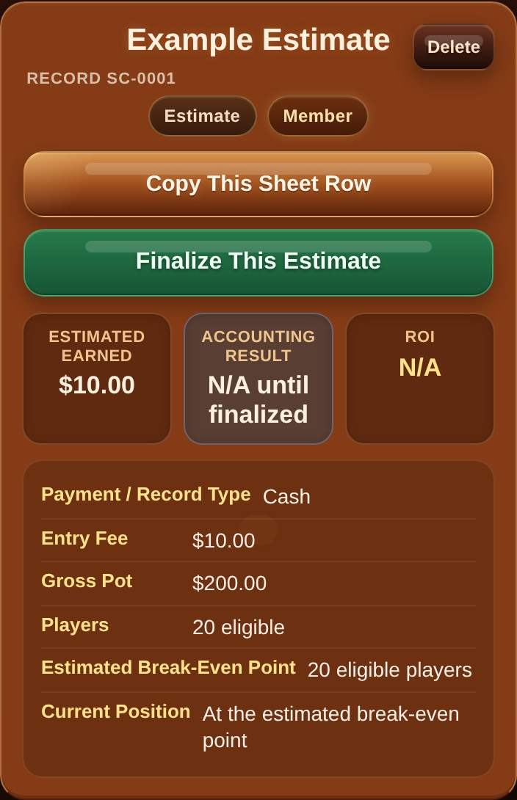
Copy This Sheet Row prepares the exact A-M record values.
Deletion and restoration
Individual Delete offers a short Undo action. Restore History is a separate backup operation and warns before replacing non-empty current history.

6. Finalize an Estimate in place
Use Finalize This Estimate when a projected challenge ends. StepCat updates the same Saved History item instead of creating a duplicate. Its SC Record ID, original order, Gross Pot, Entry Fee, player counts, Membership Type, and Payment / Record Type remain attached to the record.
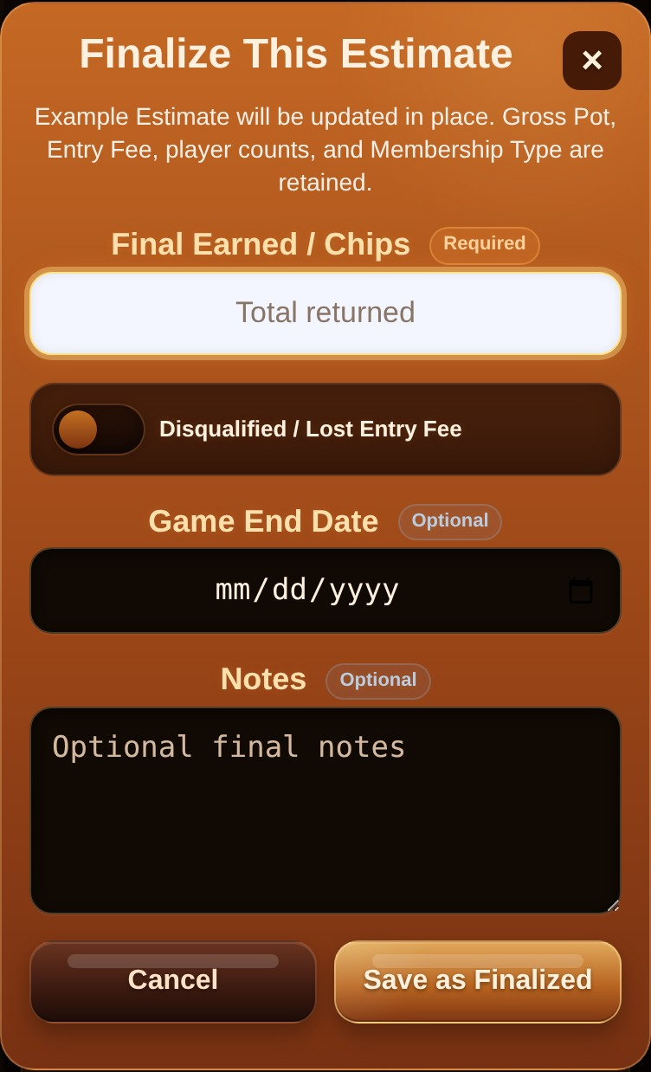
Enter the completed Final Earned / Chips and any optional final details.
- The Saved History count does not increase.
- The card changes from Estimate to Finalized in its original position.
- StepCat scrolls to the record that was actually updated.
- The original Estimated Earned and the difference from Estimate remain visible when available.
Workbook update
After finalizing an Estimate, copy the finalized A-M row over that game’s existing A-M workbook row. Do not add a second workbook row for the same game.

7. Copy records into the workbook
The app copies input values only. In the workbook, columns A-M are inputs and columns N-Z contain formulas. Never paste over N-Z.
1. Open Game Records in the StepCat workbook.
2. Tap the first empty cell in column A, such as A5 in a blank workbook.
3. Tap Copy This Sheet Row in StepCat, or Copy All Sheet Rows for the full history.
4. Paste into the selected column-A cell.
5. Check that the row appears across A-M and that N-Z calculates automatically.
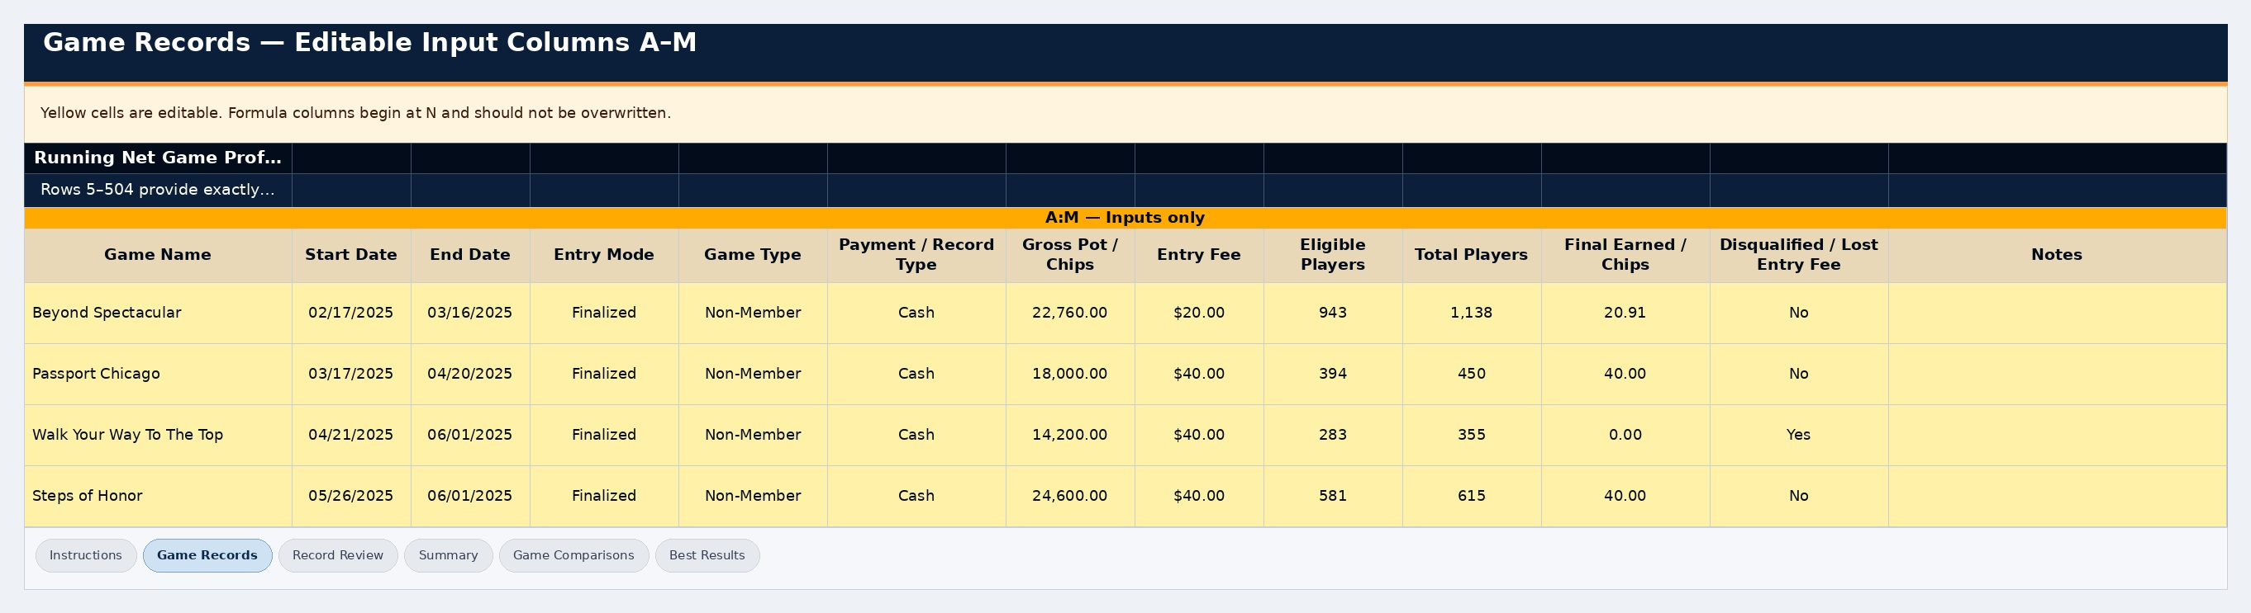 | 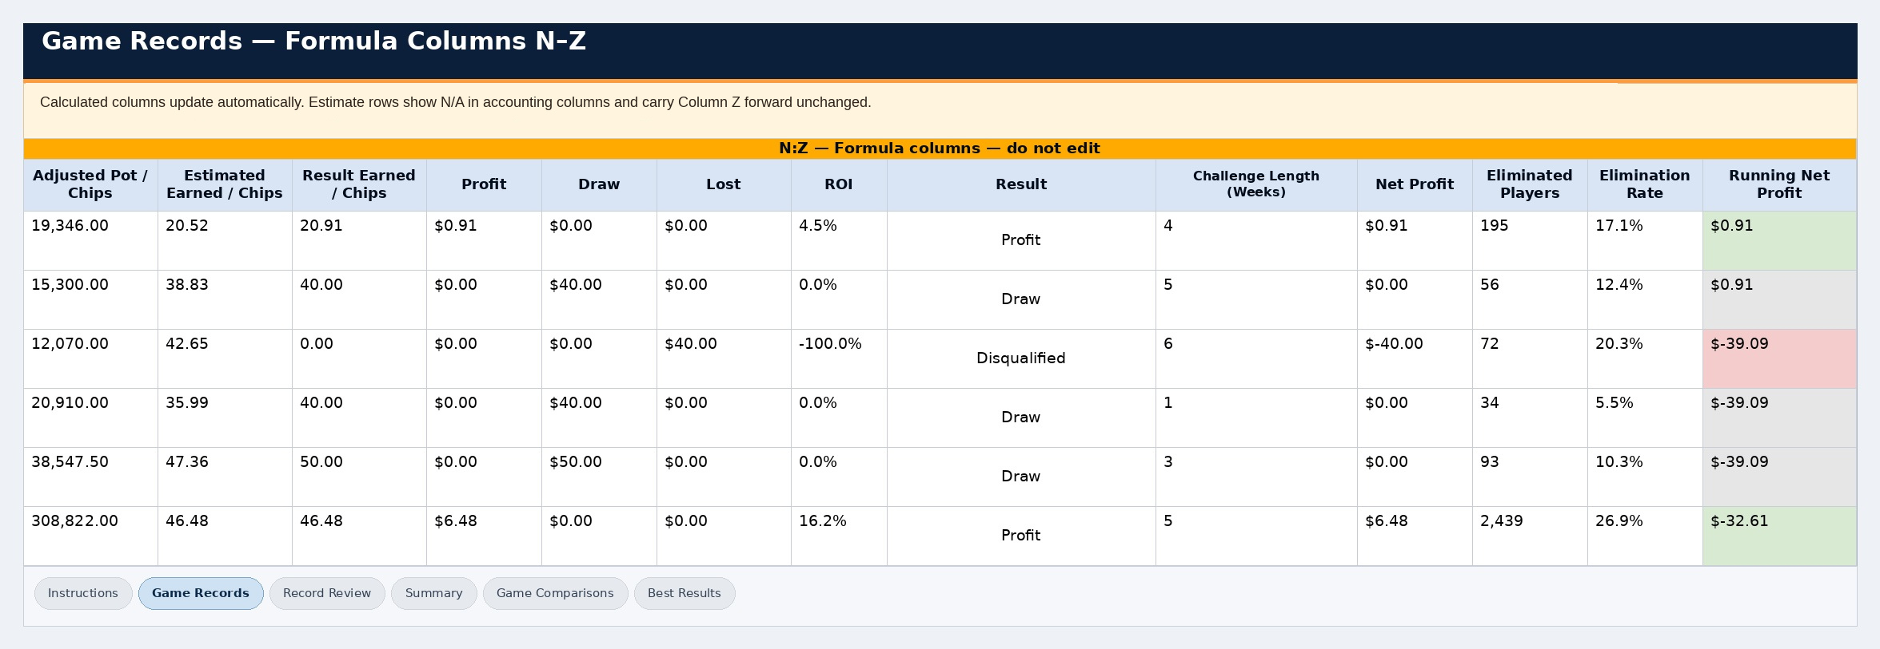
Game Records input columns begin at A-M. | Formula columns N-Z calculate automatically and should not be edited.

Do not enter cell-edit mode
Select the cell itself before pasting. Pasting while editing inside a cell can place the entire copied row into one cell.

8. Review workbook reports
The workbook uses the copied A-M values to calculate accounting fields, review data, and build report sheets. Estimate rows remain projections until finalized.
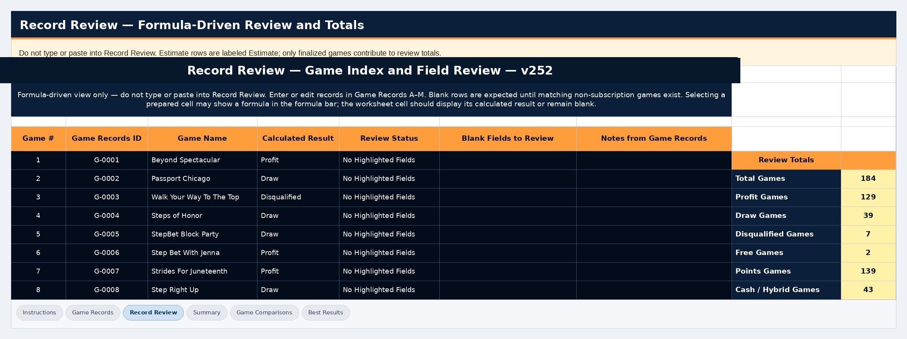
Record Review summarizes review status and points to fields that need attention.
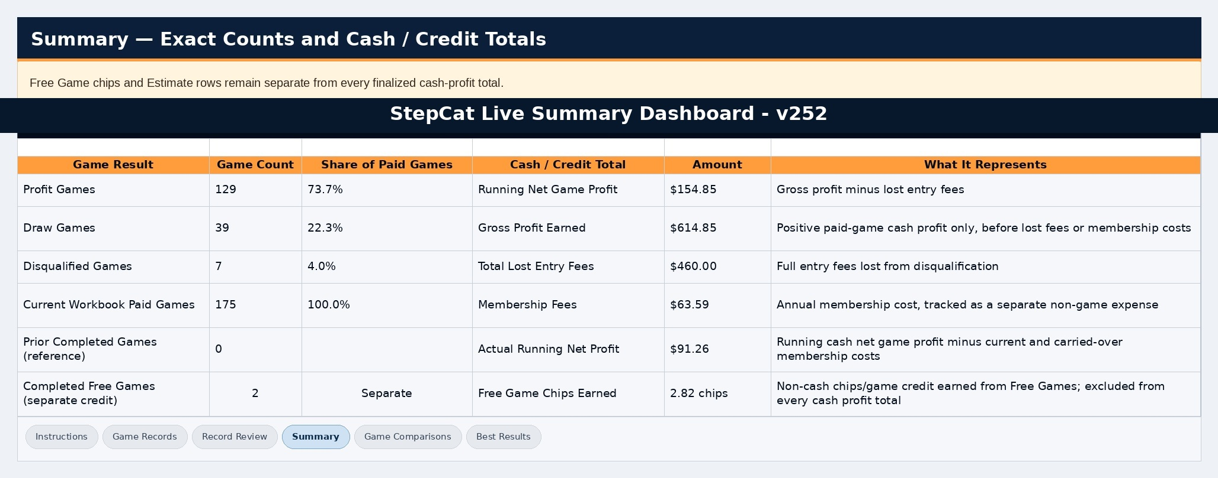 | 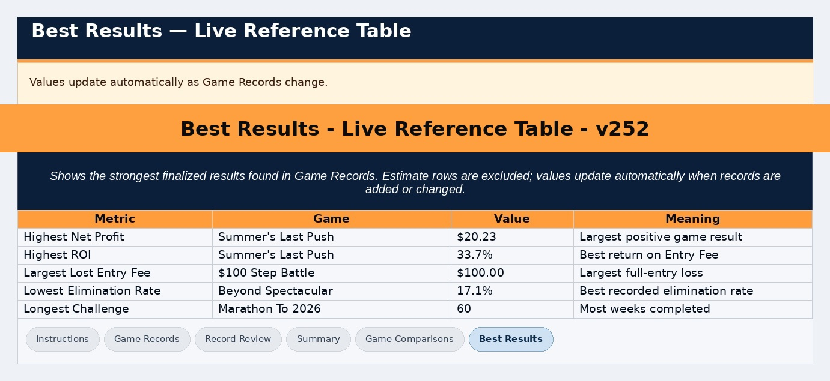
Summary presents totals and result counts. | Best Results highlights top completed records.

Workbook comparisons
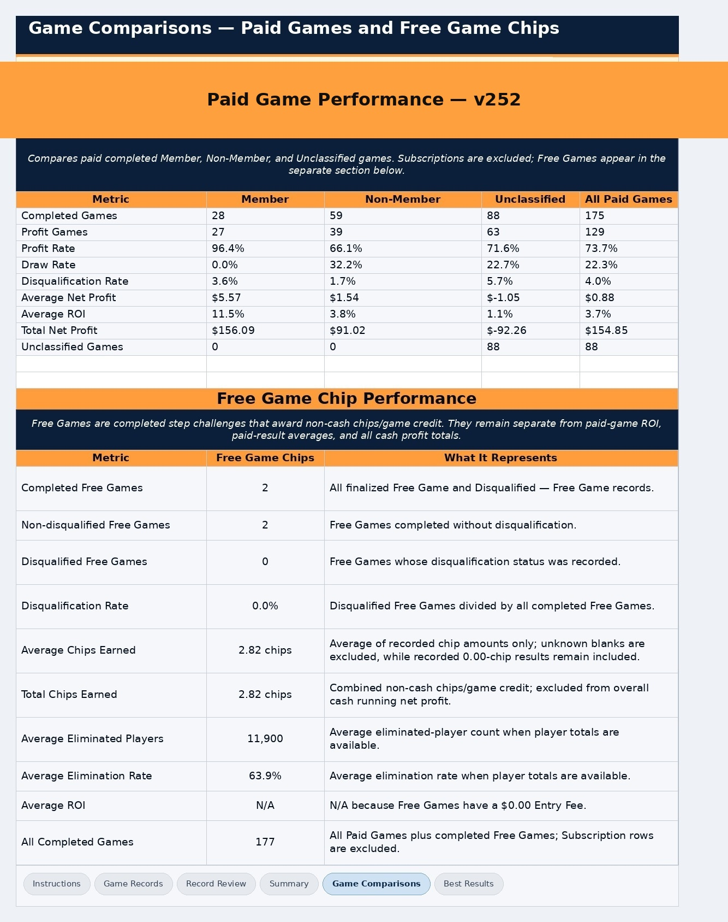
Game Comparisons groups completed records for comparison.
Older invalid rows
Record Review flags Free Game rows with a non-zero Entry Fee. Valid Free Games with a $0 Entry Fee are treated normally.

9. Personalize Settings safely
All ordinary setting changes save automatically. The X closes Settings; it is not a Save button. Restore Defaults is the one bulk action that requires confirmation.
- Entry Preferences: remember Entry Mode, Membership Type, Payment / Record Type, unfinished Game Entry inputs, and the $0 Entry Fee warning.
- Section Display & Starting State: choose which sections are visible and which start open after load or refresh.
- Help & Guides: remember guide progress.
- Feedback & Haptic: choose Off, Low, or High vibration feedback.
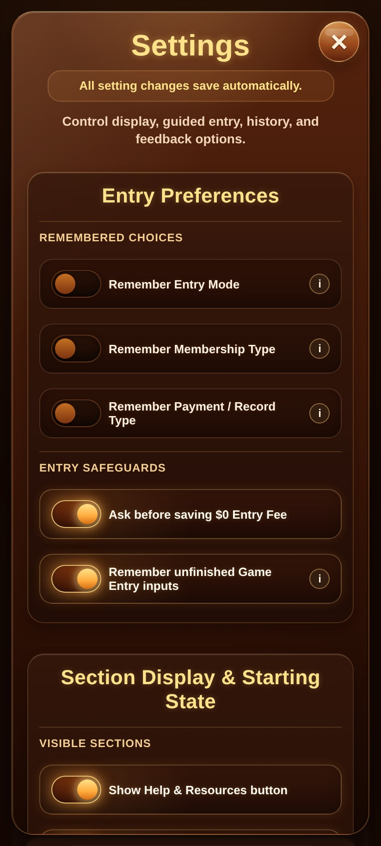
Settings are grouped by purpose and save automatically.
Restore Defaults
Confirming Restore Defaults returns all app settings, including Haptic Feedback, to the original defaults. Haptic Feedback returns to Low. Saved History and workbook records are not deleted.

10. Find Help & Resources
Help & Resources places destinations first so users can quickly reach the guide, workbook, downloads, troubleshooting, installation guidance, and feedback.
- Open Quick Start Guide
- Open Full Documentation
- Make a Google Sheets Copy
- Quick Start PDF
- Editable DOCX
- Rules & Troubleshooting
- Spreadsheet Copy Help
- Installation & Shortcuts
- Write Feedback
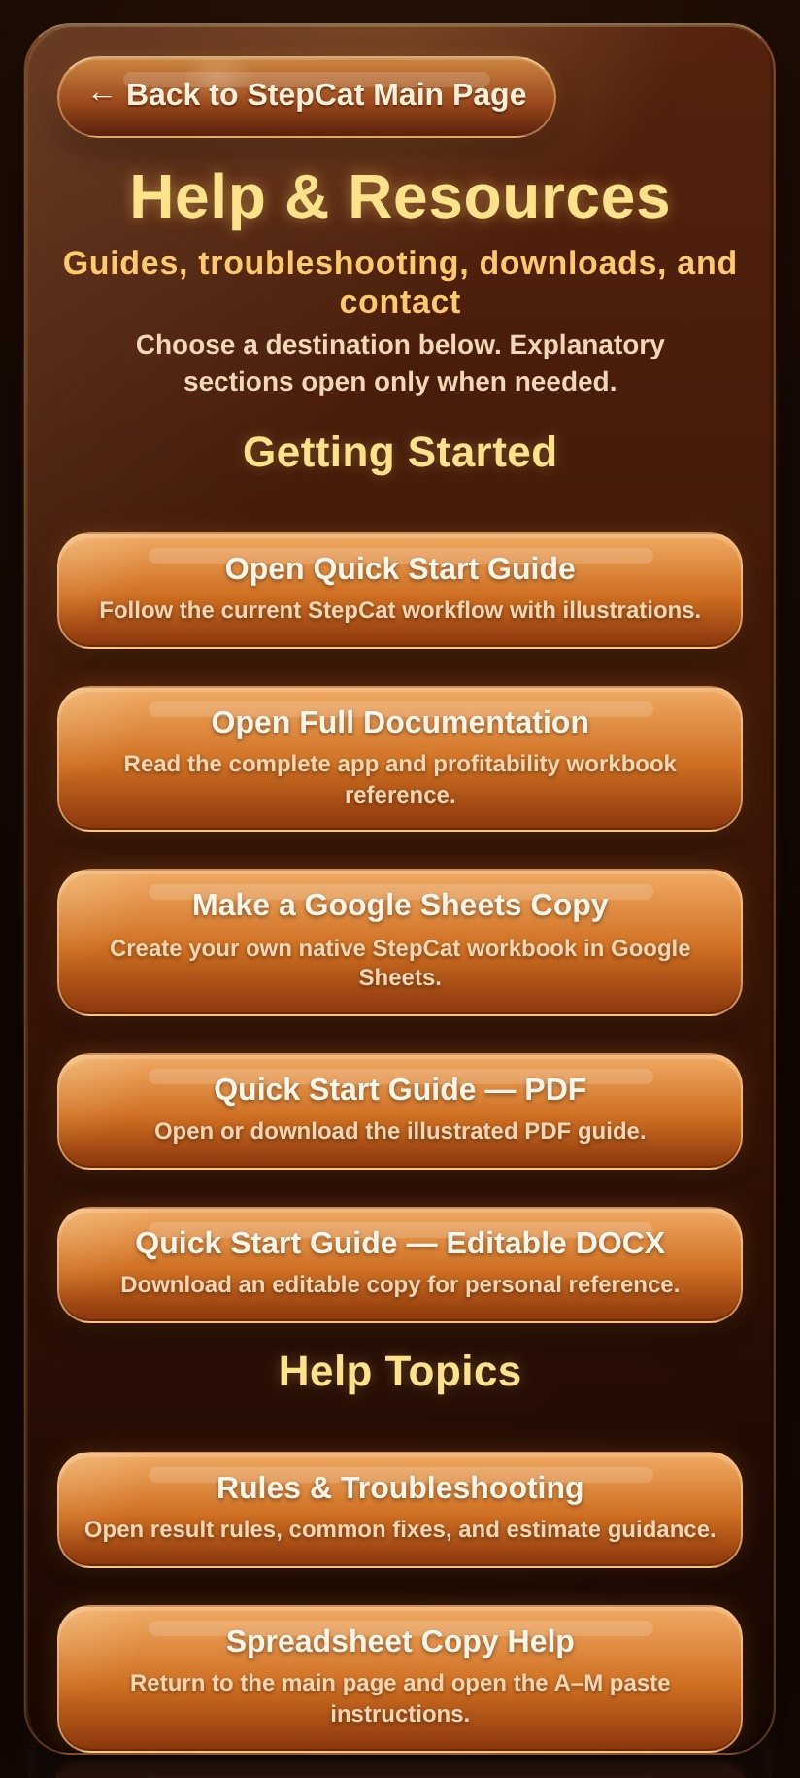
Help & Resources places guides, downloads, workbook access, troubleshooting, installation, and feedback in one destination panel.

11. Install StepCat or create a shortcut
Installation requires the hosted StepCat page and a supported browser. Local HTML viewers can show installation guidance but may not offer native installation.
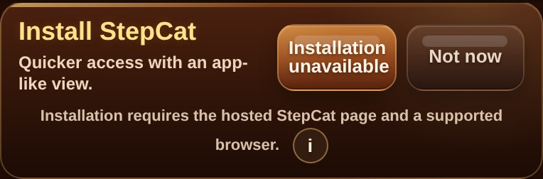
The Install StepCat card reports the current installation state.
 | 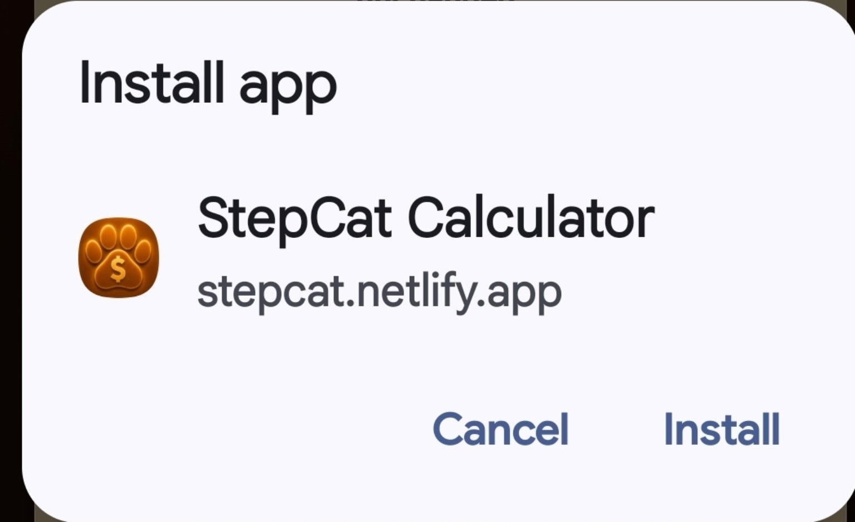
Android Chrome may offer Install app or Add to Home screen. | Confirm installation when the browser provides the prompt.


Installed StepCat icon on the device home screen.
Hosted release check
After uploading a new release, close open StepCat tabs and the installed app, then reopen the hosted site. Confirm the visible version is v252.

12. Send feedback
Write Feedback is available from the main page and Help & Resources. Enter a message, continue to the email app, and review the prepared recipient, subject, and message before sending.
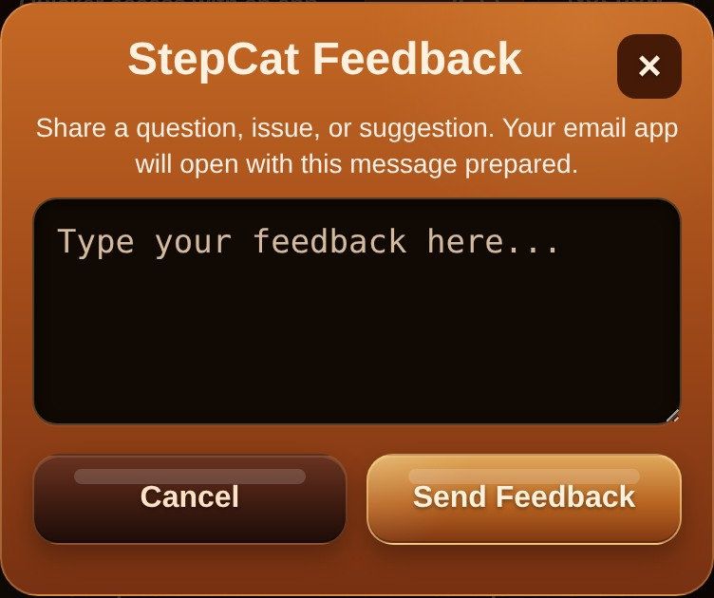 | 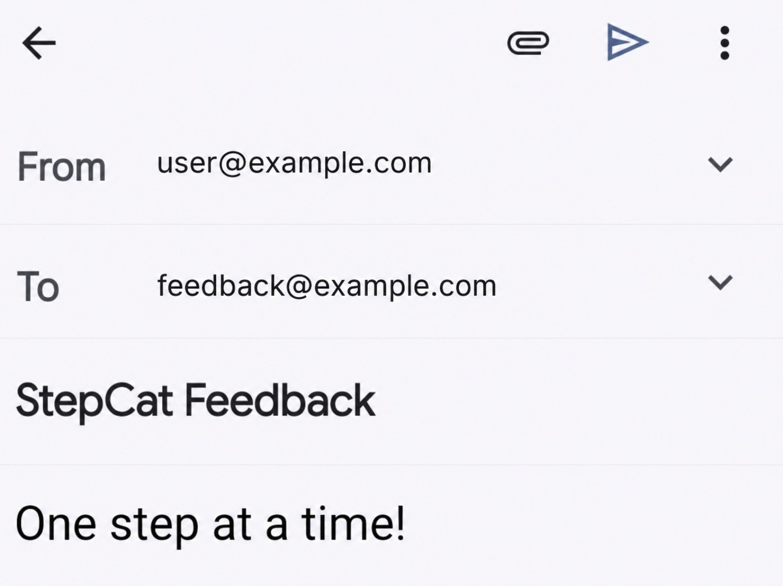
Enter feedback inside StepCat. | Review the prepared email before sending.

13. Migrate old workbook data
Simple migration
In the old workbook, copy Game Records from A5 through column M on the last used row. In the new workbook, paste into A5.

1. Make a backup copy of the old workbook.
2. Open the old workbook’s Game Records sheet.
3. Select A5:M[last used row]. Example: A5:M54.
4. Copy the selected range.
5. Open the new v252 workbook and select Game Records cell A5.
6. Paste. Use Values only when available.
7. Confirm the first and last records appear once and that N-Z formulas calculate.
- Do not copy rows 1-4.
- Do not copy the column headings.
- Do not copy columns N-Z.
- Do not copy or replace whole sheets.
- Existing named workbook rows do not need SC Record IDs.

14. Troubleshooting and rules
Issue | What to do
Calculate does not continue | Correct the highlighted field. StepCat scrolls to the first blocking error.
Free Game fee is rejected | Set Entry Fee to 0 or use another Payment / Record Type.
Membership or Entry Mode reset | Enable the corresponding Remember setting, or make a fresh selection.
Saved entry returned as a draft | Confirm the hosted page and service worker are v252. Successful saves clear completed draft storage.
Disqualified returned after reopening | v252 never restores Disqualified through draft recovery. Start a fresh entry and confirm the active release.
Copied row did not calculate | Paste into the column-A cell and preserve formula columns N-Z.
Installation unavailable | Use the hosted page in a supported browser, or follow Add to Home Screen guidance.
Drawer changed after Settings | v252 preserves live drawer state; startup defaults apply only after load or refresh.

Unsaved-entry protection
Clear Entry and Start New Entry warn before discarding meaningful unfinished content. Continue Editing is the safe default.

For the complete reference, open Full Documentation from Help & Resources. Keep an older workbook and site package as backups until the hosted v252 release and migrated workbook have been checked.

