StepCat Simplified User Guide

StepCat title screen.
Live app URL:
https://gatorball345-ux.github.io/StepCat-Profit-Calculator-/
Independent Project Notice
StepCat is an independent calculator for personal payout estimates. It is not affiliated with, endorsed by, or sponsored by any challenge platform. Results are estimates based on user-entered information.
If the link does not open from Word, copy and paste the full URL into your browser.

Quick Start
1. Choose Member or Non-Member.
2. Open Required Fields.
3. Enter Total Pot, Entry Fee, Eligible Players, and Total Players.
4. Tap Calculate.
5. Copy History into your spreadsheet if needed.

1. Game Type and Math Info
Choose Member or Non-Member. The Math Info drawer changes with the game type.
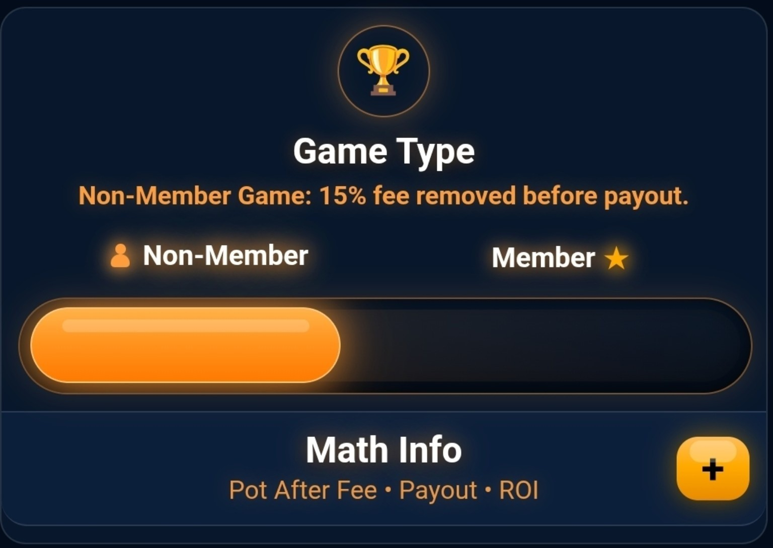
Choose Member or Non-Member. The Math Info drawer changes with the game type.
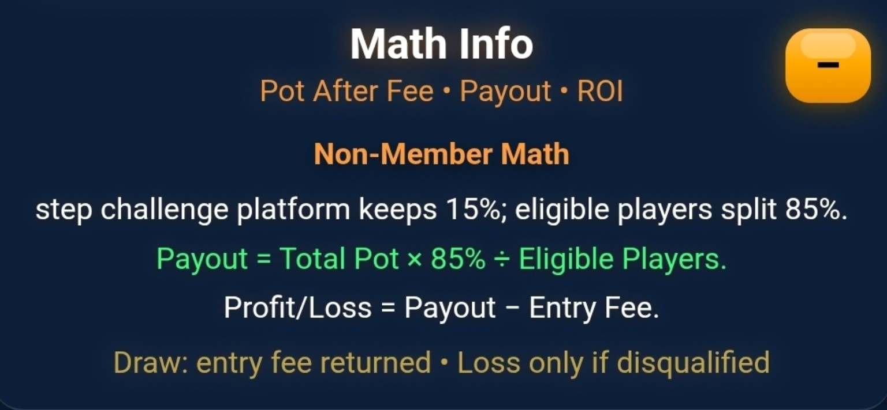
Non-Member: a 15% platform fee is withheld; eligible players split 85%.
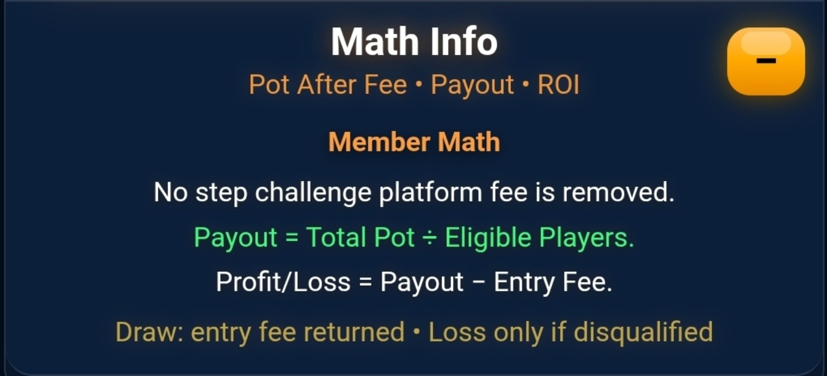
Member: no platform fee is removed; eligible players split the full pot.
Profit / Draw / Loss
Profit: payout is above Entry Fee.
Draw: eligible player receives the Entry Fee back.
Loss: only applies if the player is disqualified and forfeits the Entry Fee.

2. Enter the Fields
Required Fields: Total Pot, Entry Fee, Eligible Players, and Total Players. Optional Details are used for labels, dates, and spreadsheet history.
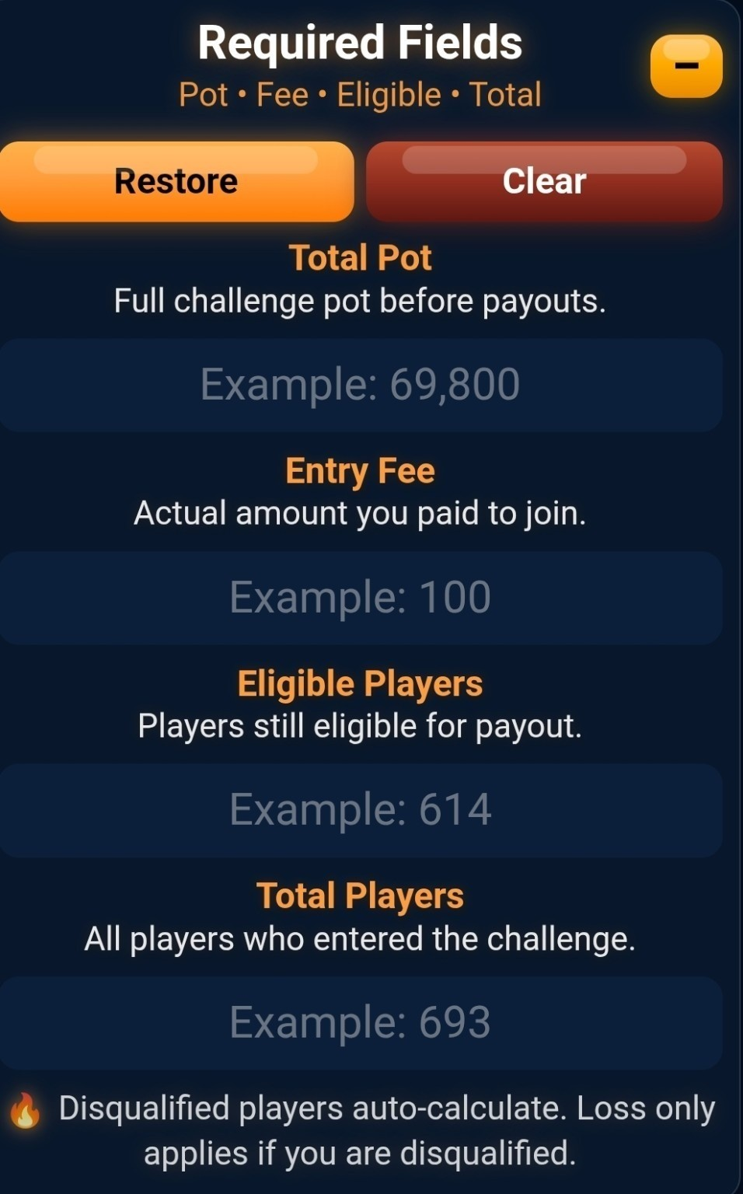
Required Fields: Total Pot, Entry Fee, Eligible Players, and Total Players.
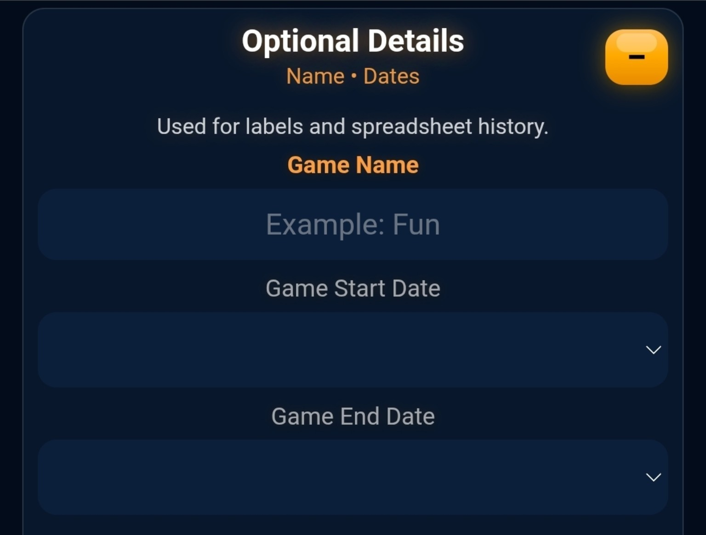
Optional Details: game name, start date, end date, and history organization.

Tap Calculate after entering the required fields.
Input Reminders
Total Pot: full challenge pot before payouts.
Entry Fee: actual amount paid to join.
Eligible Players: players still eligible for payout.
Total Players: everyone who entered the challenge.

3. Basic Formulas and Examples
Member Game  Payout = Total Pot ÷ Eligible Players  Profit = Payout − Entry Fee  ROI = Profit ÷ Entry Fee × 100 | Non-Member Game  Pot After Fee = Total Pot × 85%  Payout = Pot After Fee ÷ Eligible Players  Profit = Payout − Entry Fee

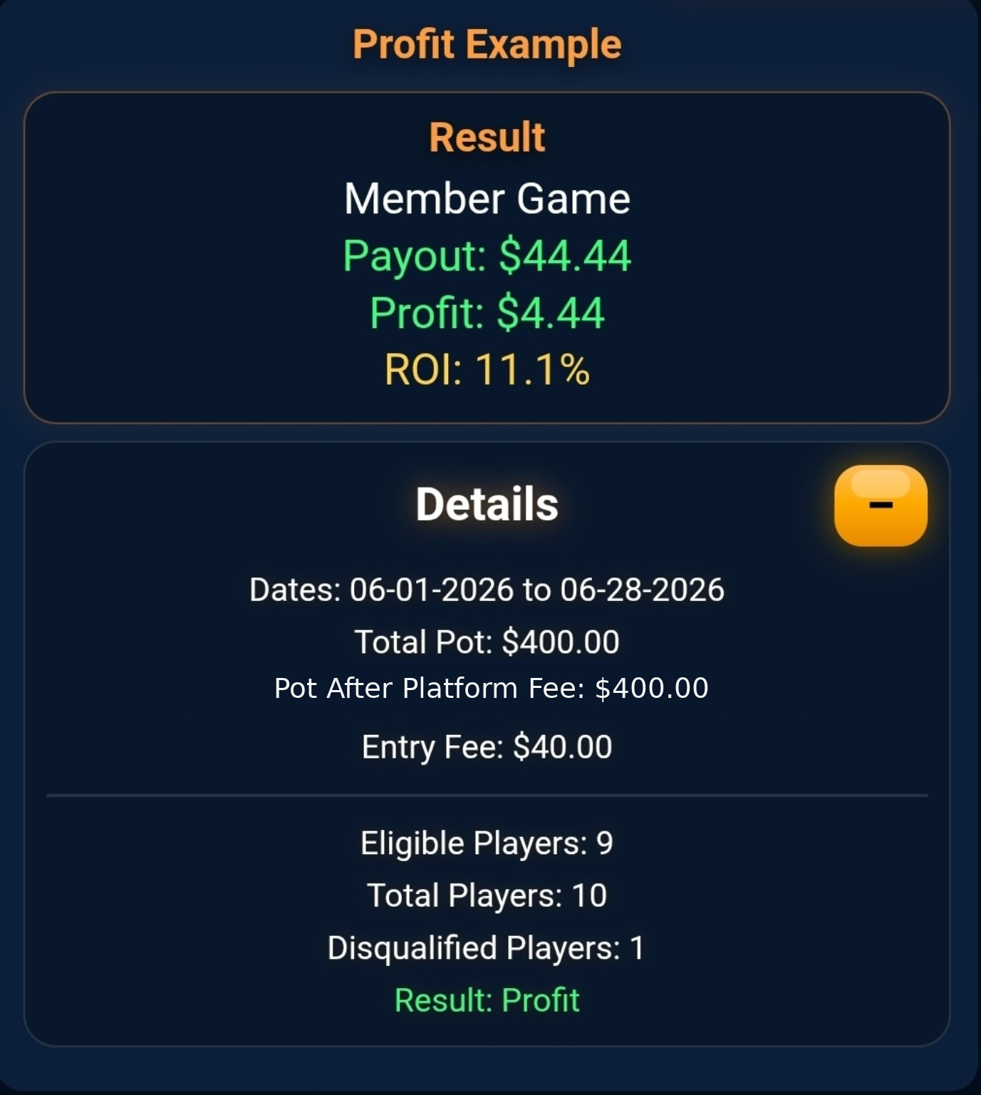
Profit Example: the payout is above Entry Fee.
$400 ÷ 9 = $44.44 payout. Profit: $4.44. ROI: 11.1%.
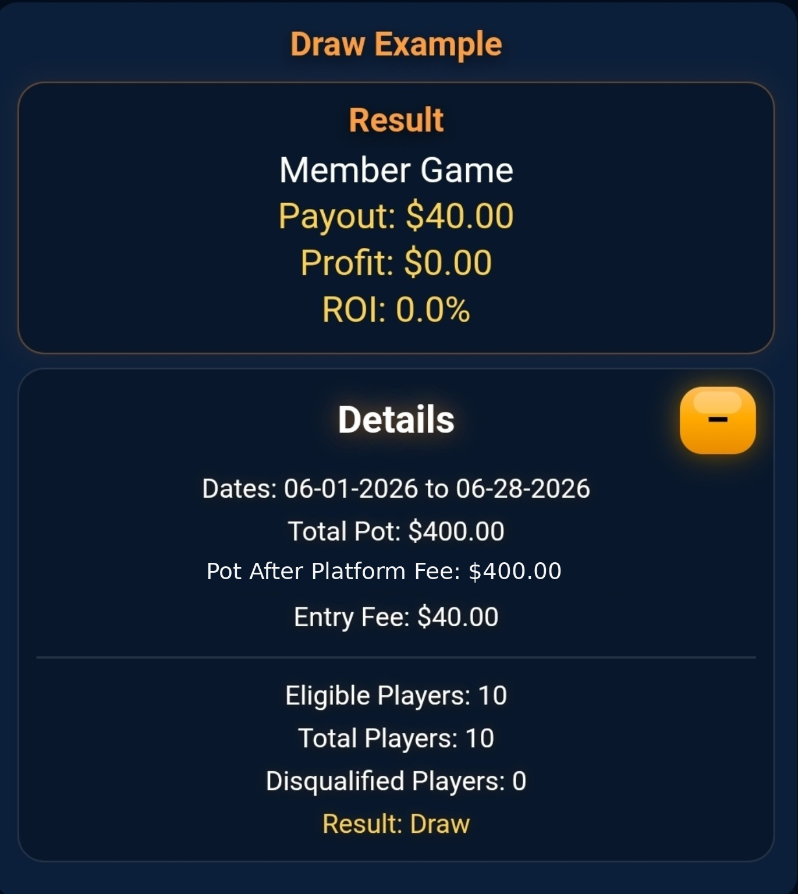
Draw Example: the payout equals Entry Fee.
$400 ÷ 10 = $40.00 payout. Profit: $0.00. ROI: 0.0%.

4. Draw Floor and Break-Even
Draw Floor
If the raw eligible share is below Entry Fee, StepCat still shows a Draw for eligible players.
Final Payout = Entry Fee
Profit = $0.00
ROI = 0.0%

Pot-Funded Break-Even
Break-even eligible players = Pot After Fee ÷ Entry Fee.
Example: $9,945 ÷ $100 = 99.45, so 99 eligible players or fewer reaches pot math break-even.

Loss Rule
A true loss happens when the player is disqualified and must forfeit their Entry Fee. StepCat focuses on projected payout for eligible players.

5. History and Spreadsheet Workflow
History saves calculations and provides Copy Full History, Copy Latest Row, and Clear History.
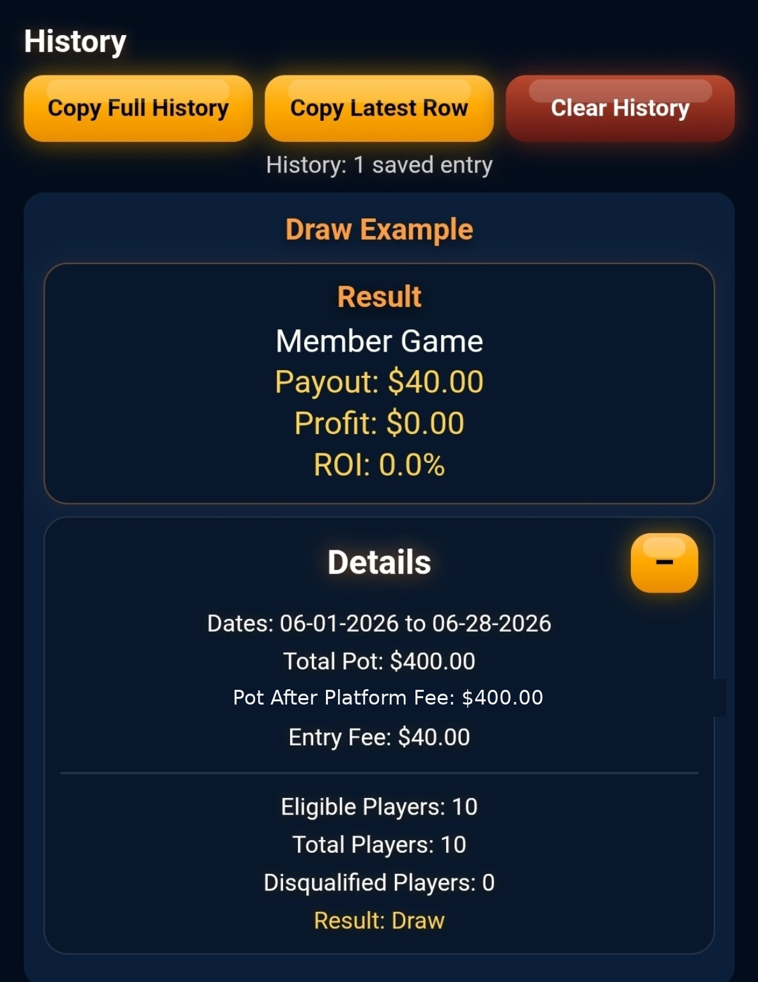
History saves calculations and provides Copy Full History, Copy Latest Row, and Clear History.
Copy Workflow
Copy Full History: create or replace a spreadsheet with headers.
Copy Latest Row: append only the newest saved result.

Spreadsheet screenshots are wide. Rotate your phone or zoom in if needed.

6. Spreadsheet Examples
Copy Full History sets up or replaces the sheet with headers. Copy Latest Row appends only the newest saved calculation.
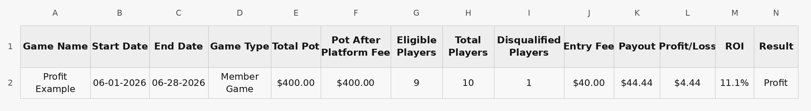
Copy Full History: sets up or replaces the sheet with headers.
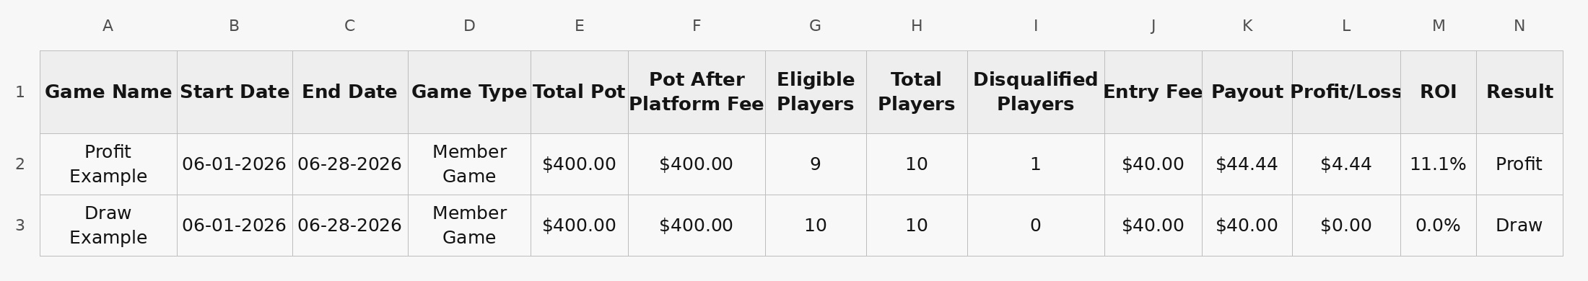
Copy Latest Row: appends only the newest saved calculation.
Columns include game name, dates, game type, pot, players, payout, profit/loss, ROI, and result.

7. Settings, Help, and Support
Settings controls haptics, drawer visibility, remembered settings, and reset. Help & README gives a quick reminder and a link to the full README.
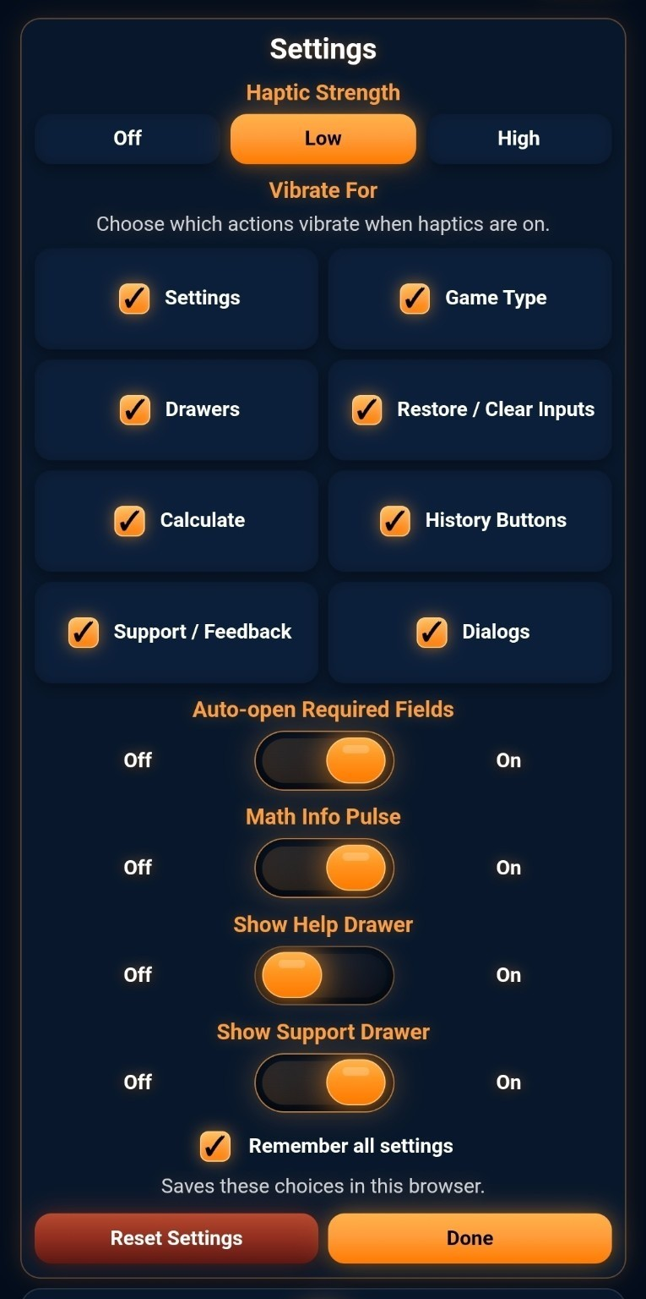
Settings: haptics, drawer visibility, remembered settings, and reset.
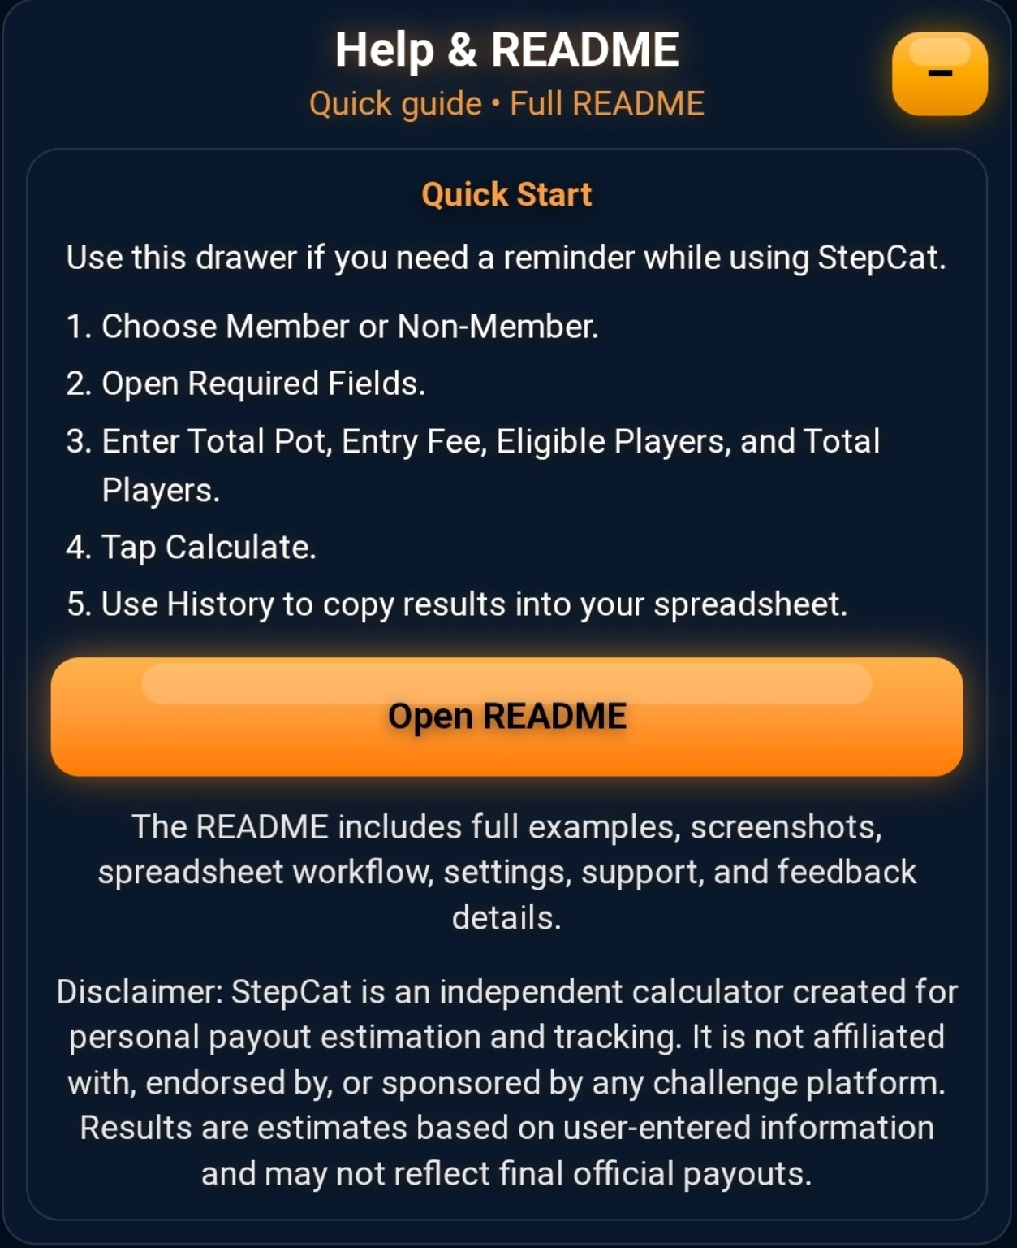
Help & README: quick reminder and a link to the full README.
Support StepCat provides optional PayPal, Venmo, and Feedback buttons.

Support StepCat drawer closed.
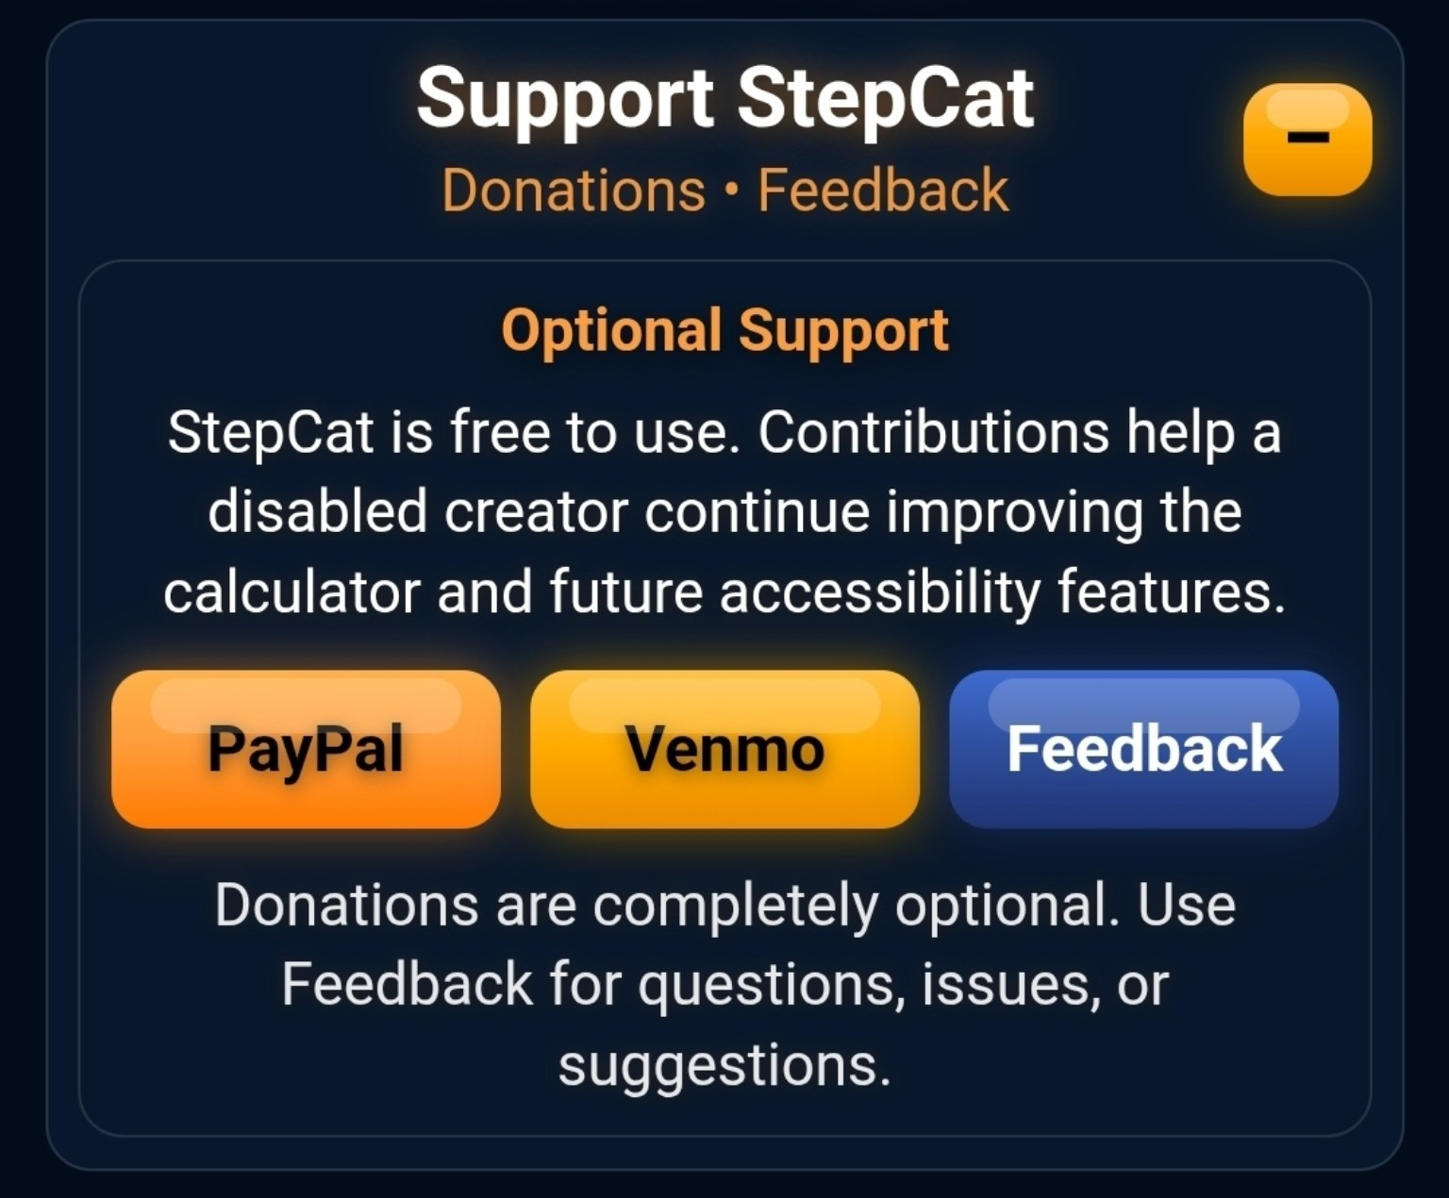
Support StepCat drawer open with optional support and feedback options.
Donations are optional. Contributions are personal support, not tax-deductible charitable donations.

8. Feedback, Privacy, and Final Note
Feedback opens a prepared email draft. You still need to tap Send in your email app.
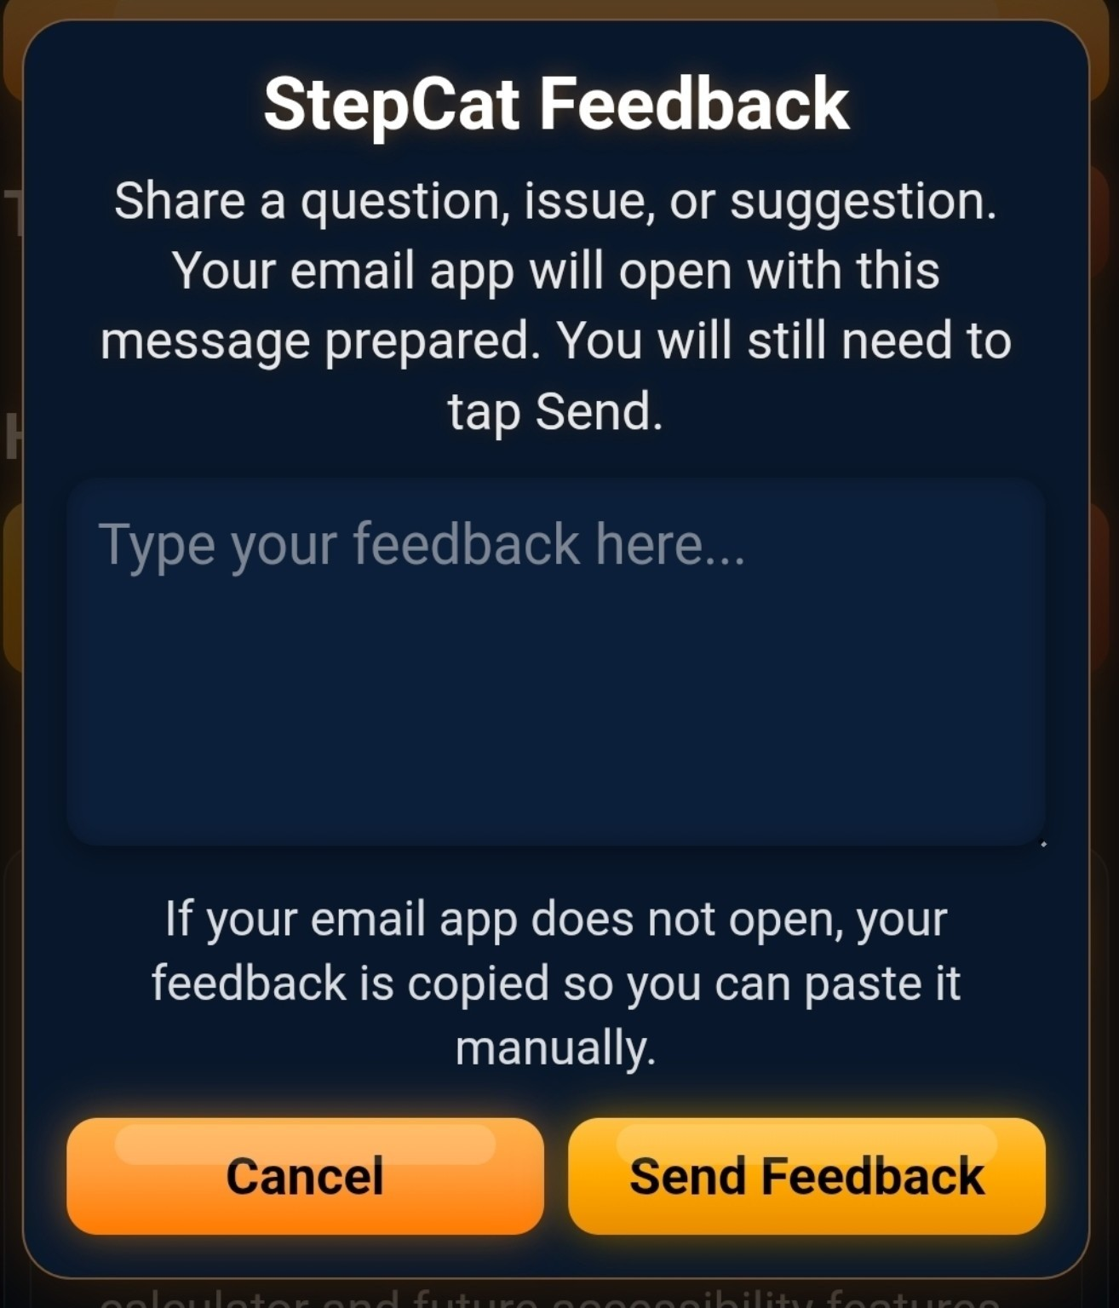
Feedback pop-up before typing.
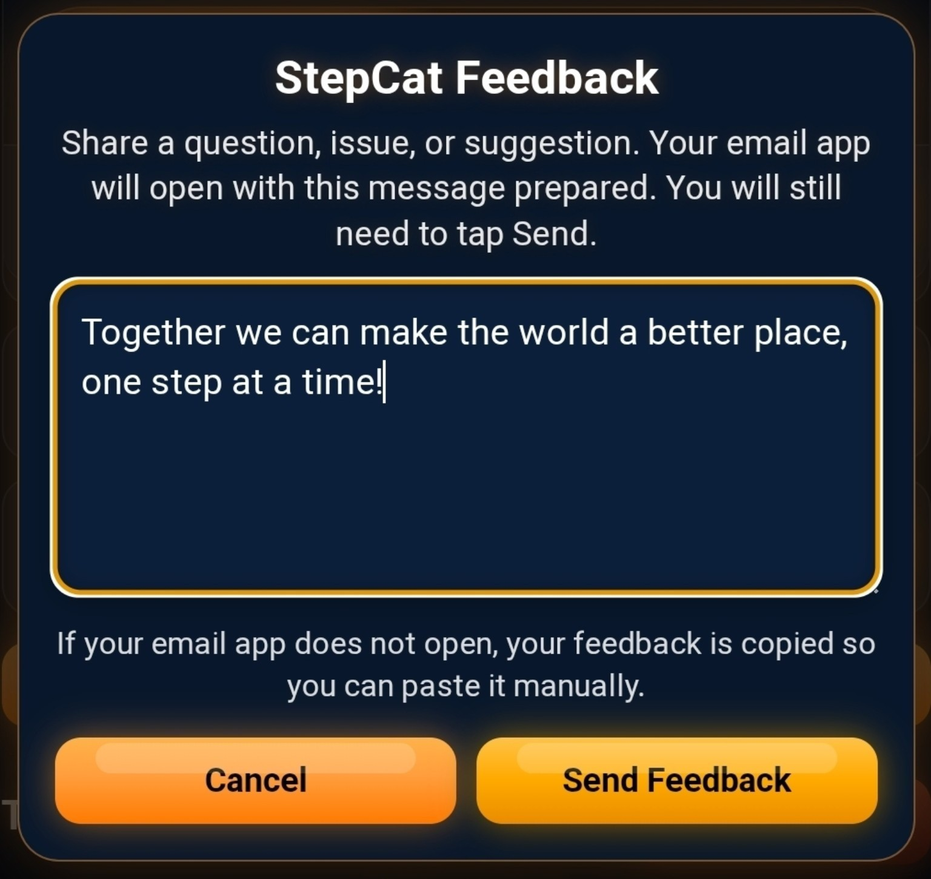
Feedback pop-up with typed feedback.
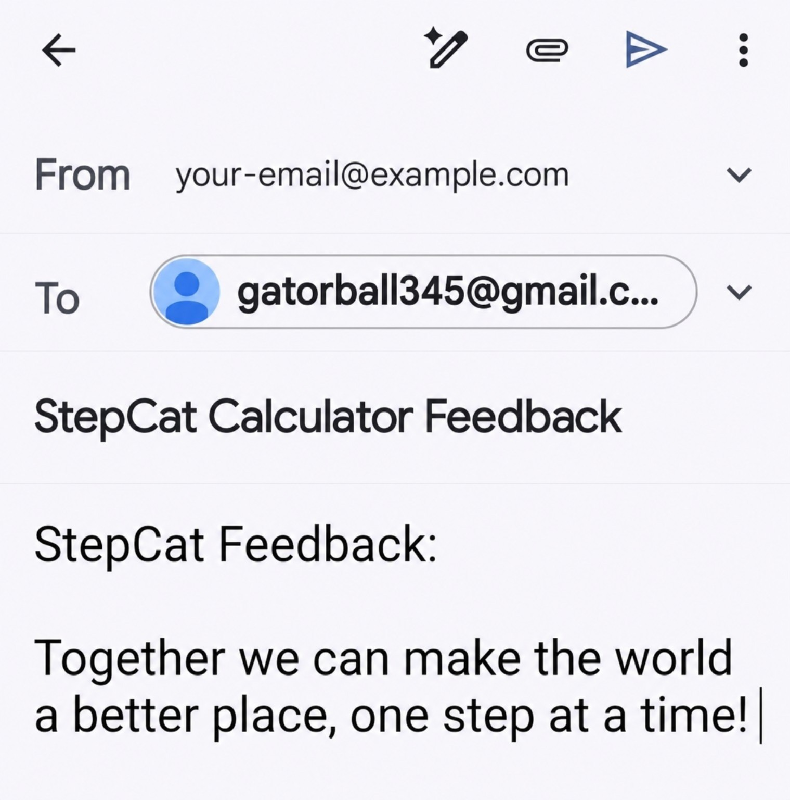
Prepared email draft opened from StepCat feedback.
Privacy
History and settings are saved locally in the browser.
StepCat does not require an account and does not send saved history to a server.
Clearing browser data may remove saved history and settings.

Final Note
StepCat is a simple estimating tool. Use official challenge information when entering pot, Entry Fee, and player counts. Final official payouts may differ from estimates.

