StepCat Quick Start Guide
StepCat Calculator v145
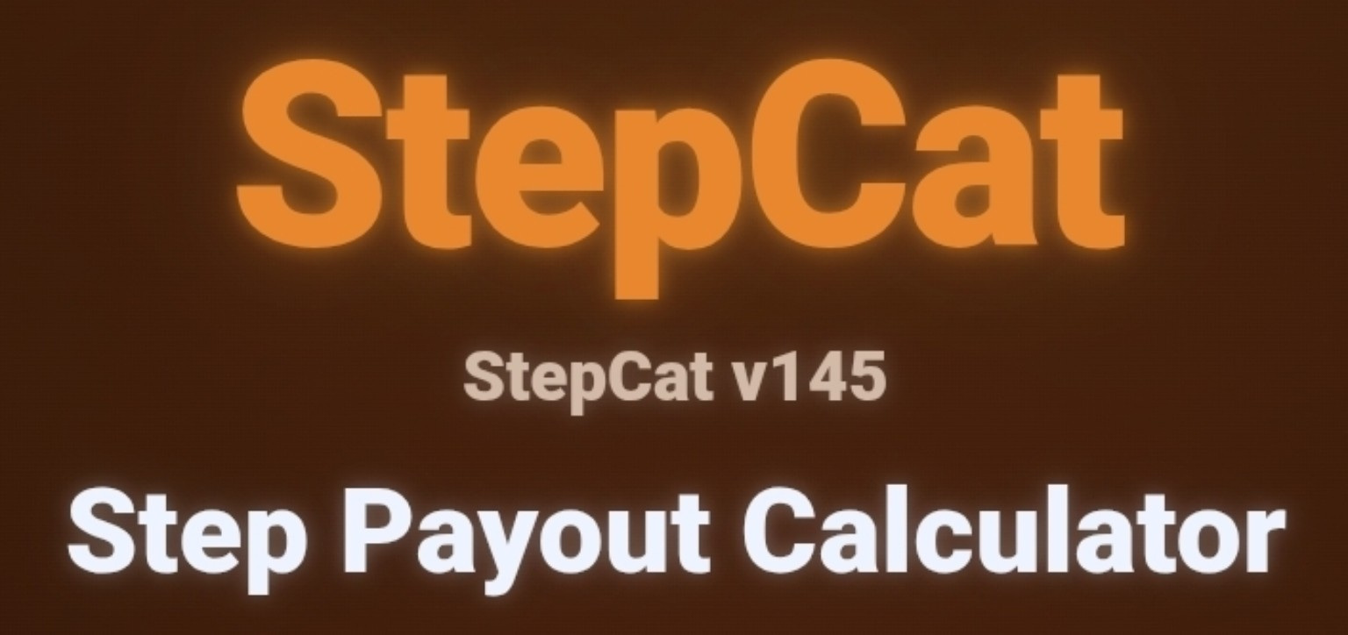
StepCat Calculator v145.
Independent project notice: StepCat is an independent calculation and recordkeeping tool. Estimates are projections. Use Finalized mode and the Official Earned Amount for confirmed records.

Quick Start
- Choose Estimate or Finalized.
- For Estimate, select Member or Non-Member and enter Gross Pot, Entry Fee, and Eligible Winners.
- For Finalized, confirm Game Type and enter Entry Fee plus the Official Earned Amount. Use Disqualified / Lost Entry Fee only when the full fee was forfeited.
- Add optional details when useful, then tap Calculate & Save.
- Use Saved History and Spreadsheet Copy Setup to copy results.
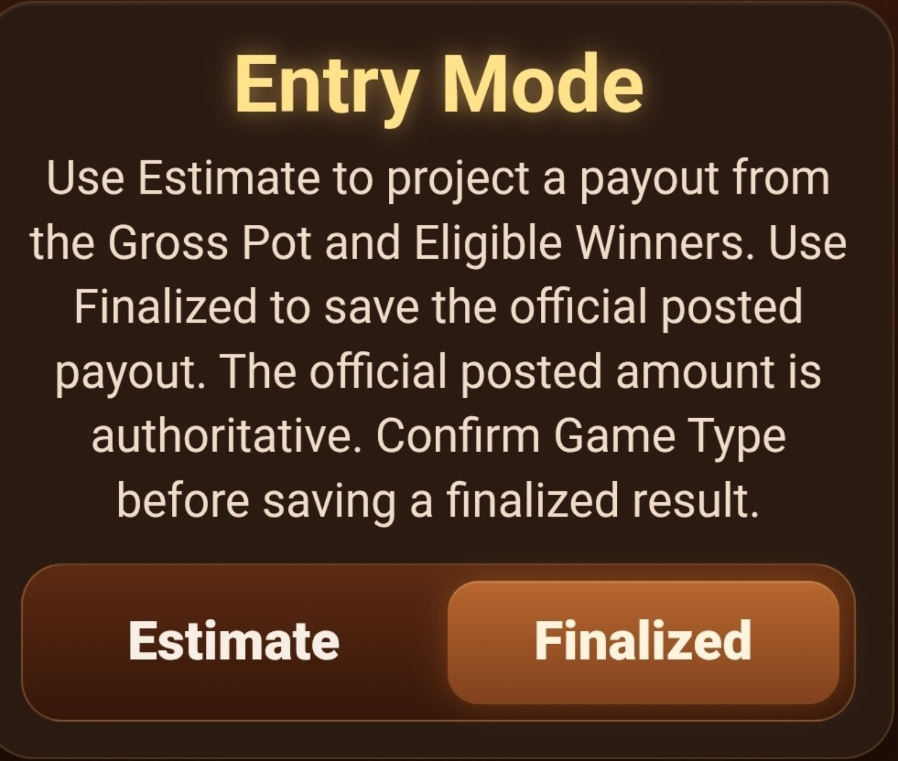
Choose Estimate for projections or Finalized for confirmed records.

Estimate Math
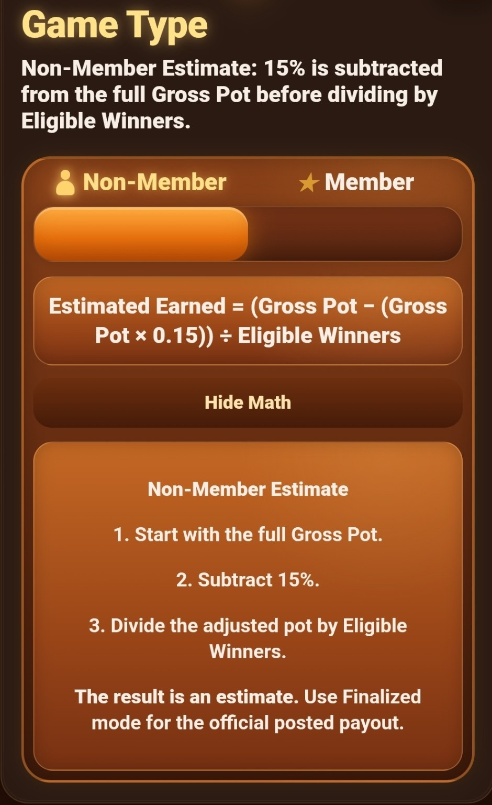  Non-Member estimate math. | 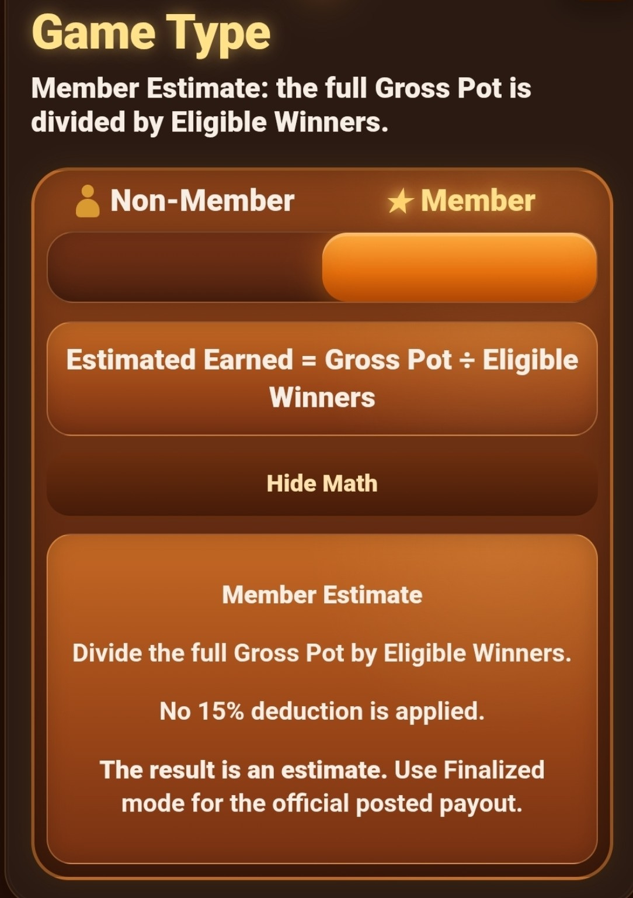  Member estimate math.

Enter Game Information
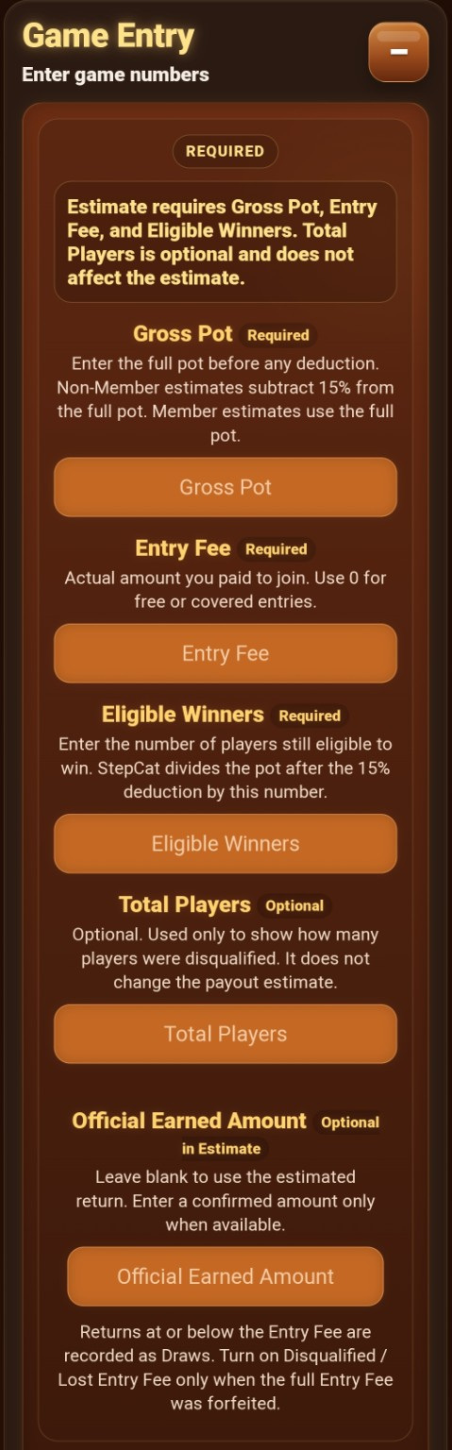
Estimate required fields.

Optional Details
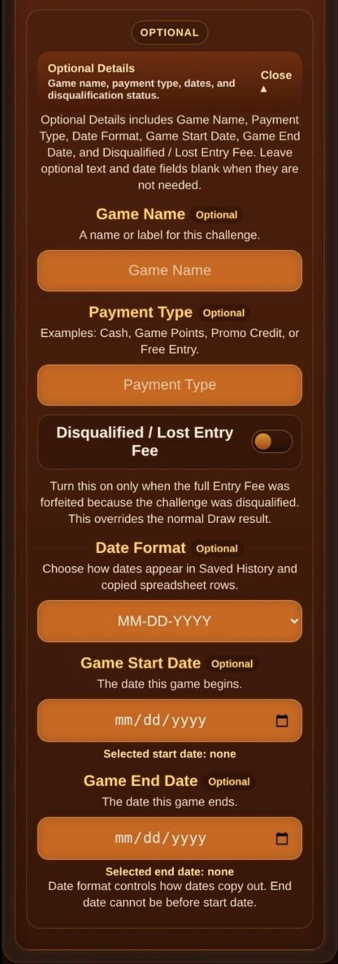
Optional details, dates, and disqualification status.

Finalized Game Type
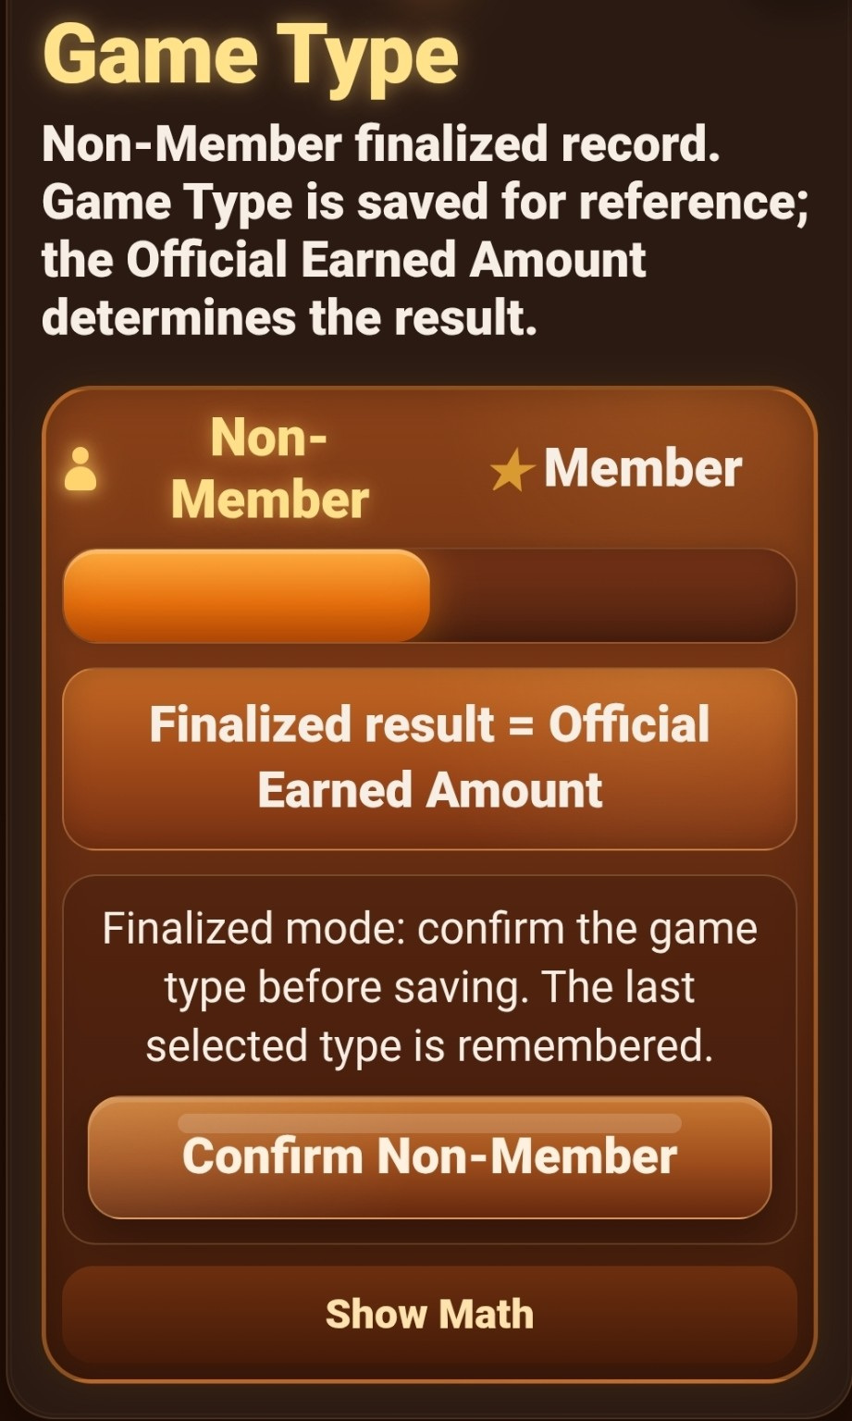
Confirm the remembered Game Type before saving a finalized result.

Finalized Game Entry
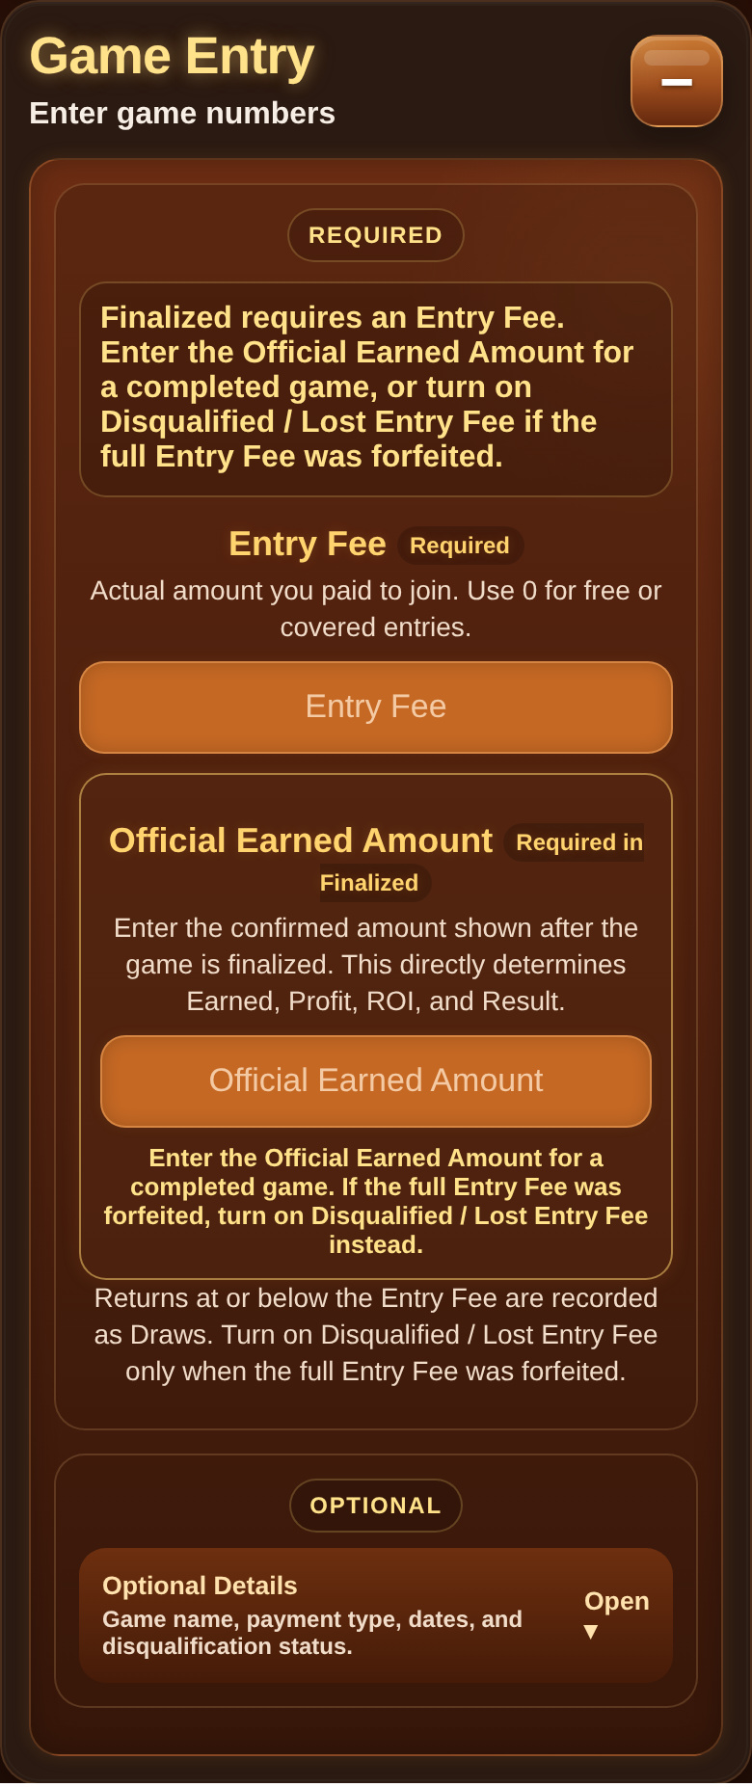
Finalized Game Entry.

Finalized Requirement
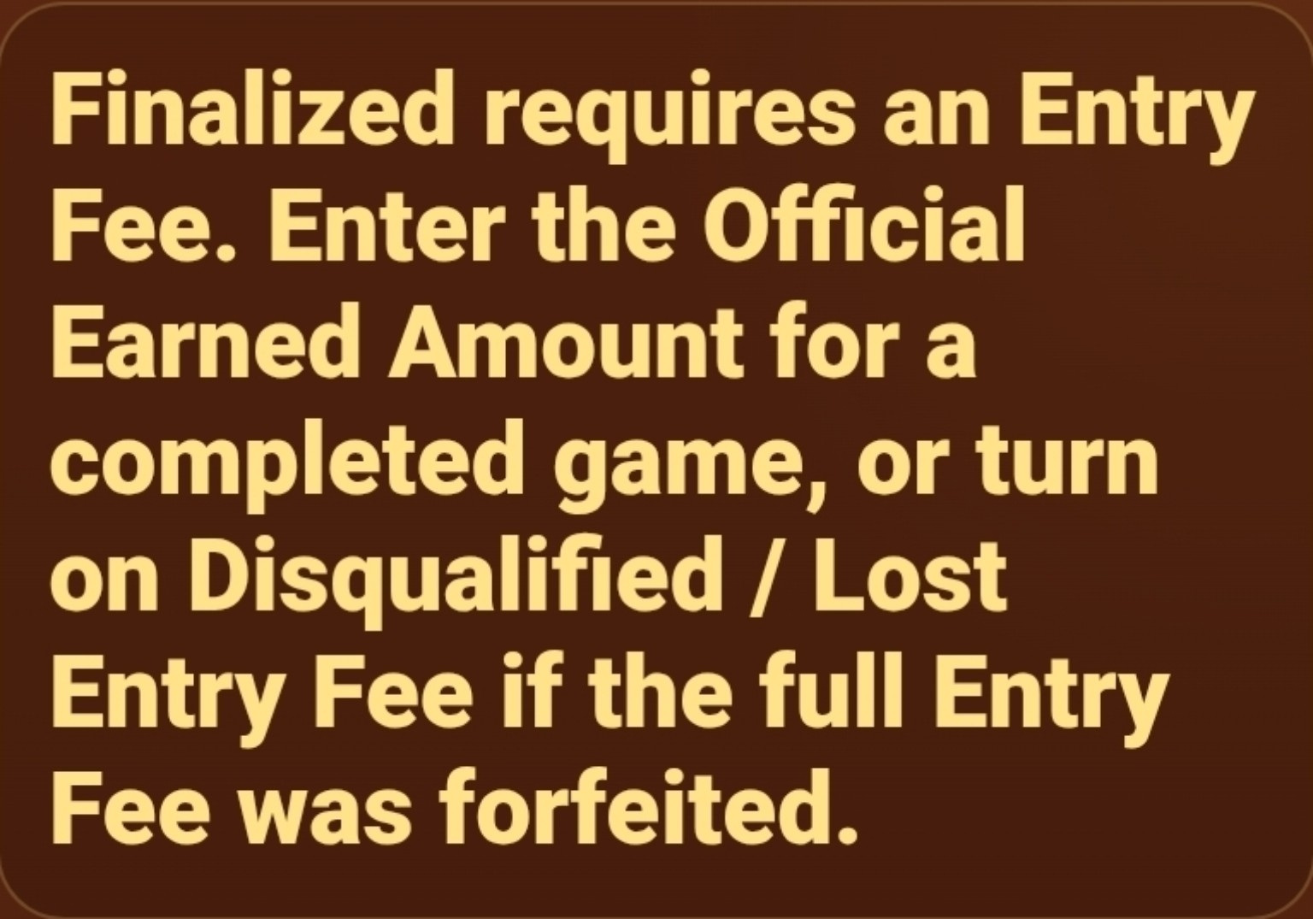
Finalized requirement reminder.

Calculate and Save
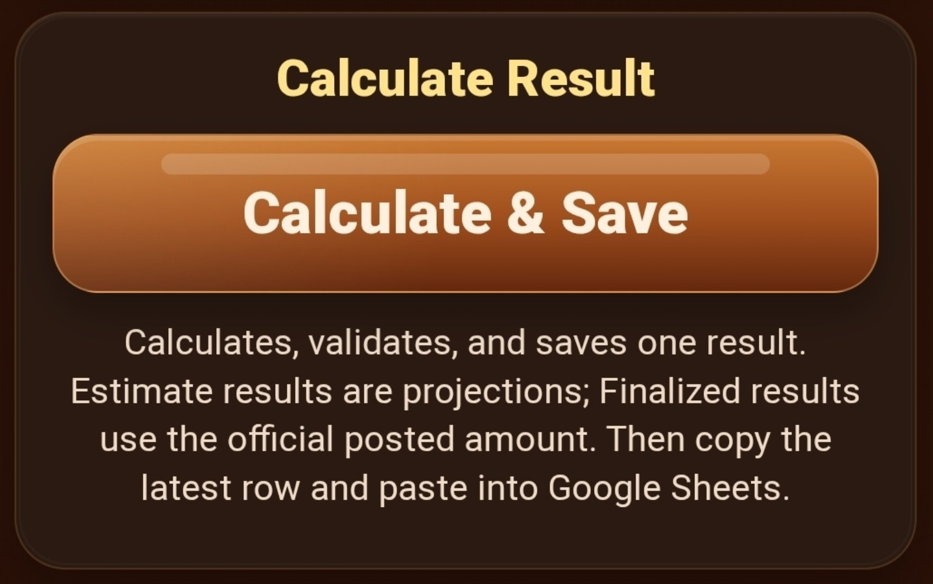
Calculate, validate, and save one result.

Profit Example — Estimate
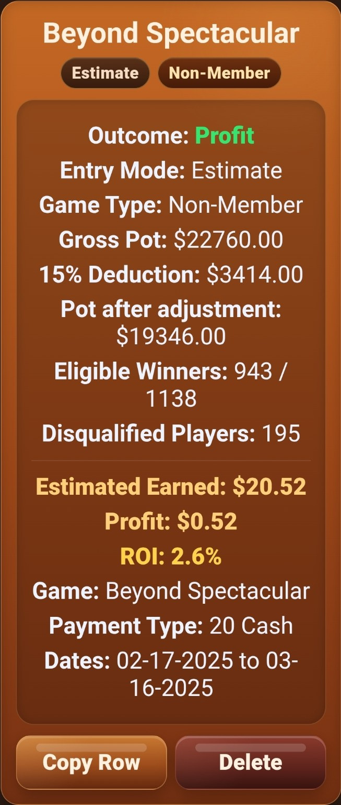
Estimate profit example.

Profit Example — Finalized
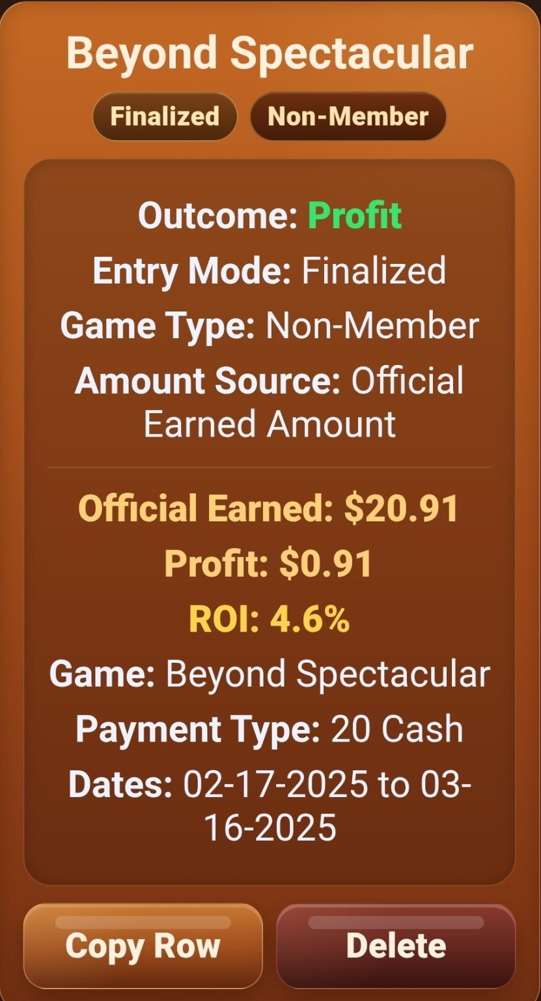
Finalized official profit example.

Draw Example — Estimate
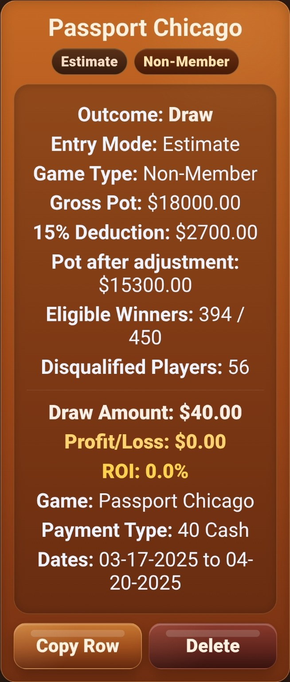
Estimate Draw example.

Draw Example — Finalized
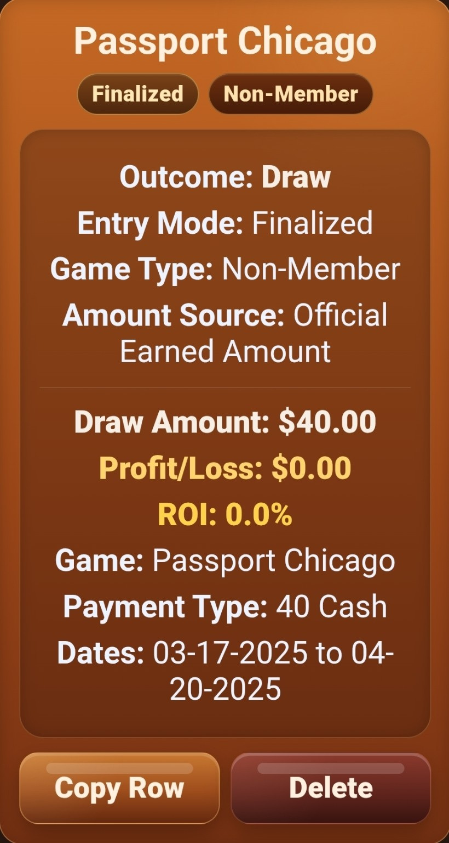
Finalized Draw example.

Saved History Overview
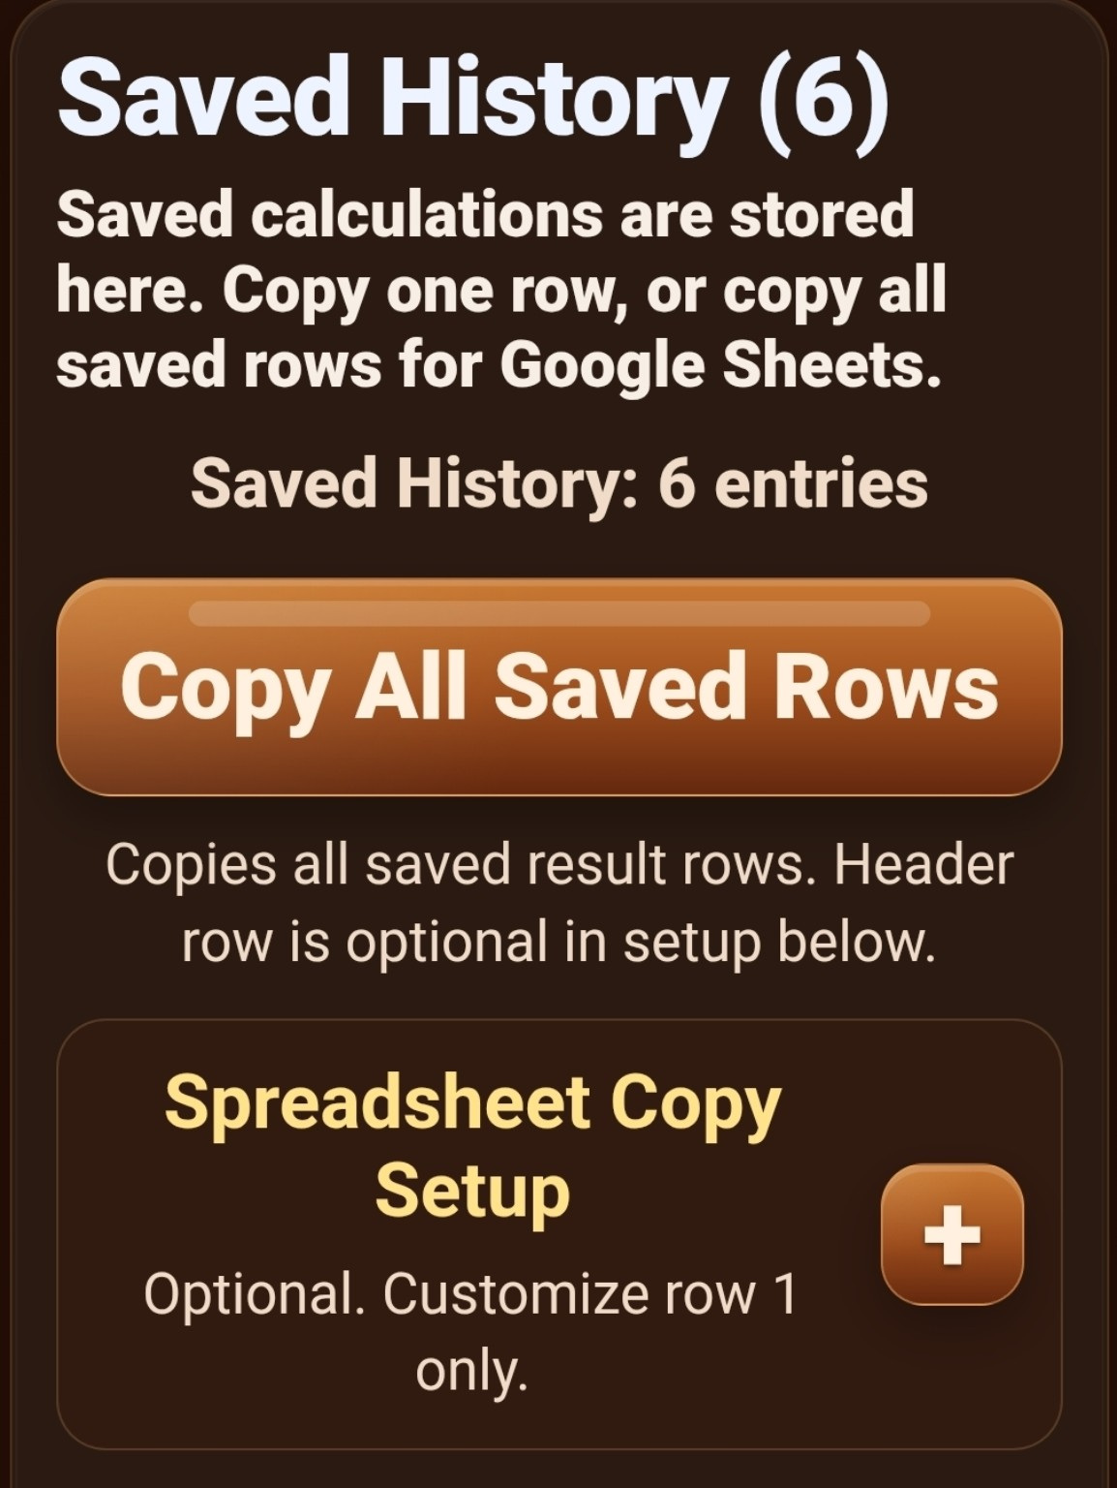
Saved History overview and Copy All Saved Rows.

Complete Saved History — Full Screenshot
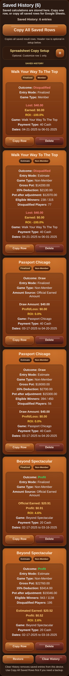
Complete Saved History with six entries.
The complete screenshot is preserved above. Enlarged continuation views follow so every saved result remains readable.

Saved History Detail — 1 of 7
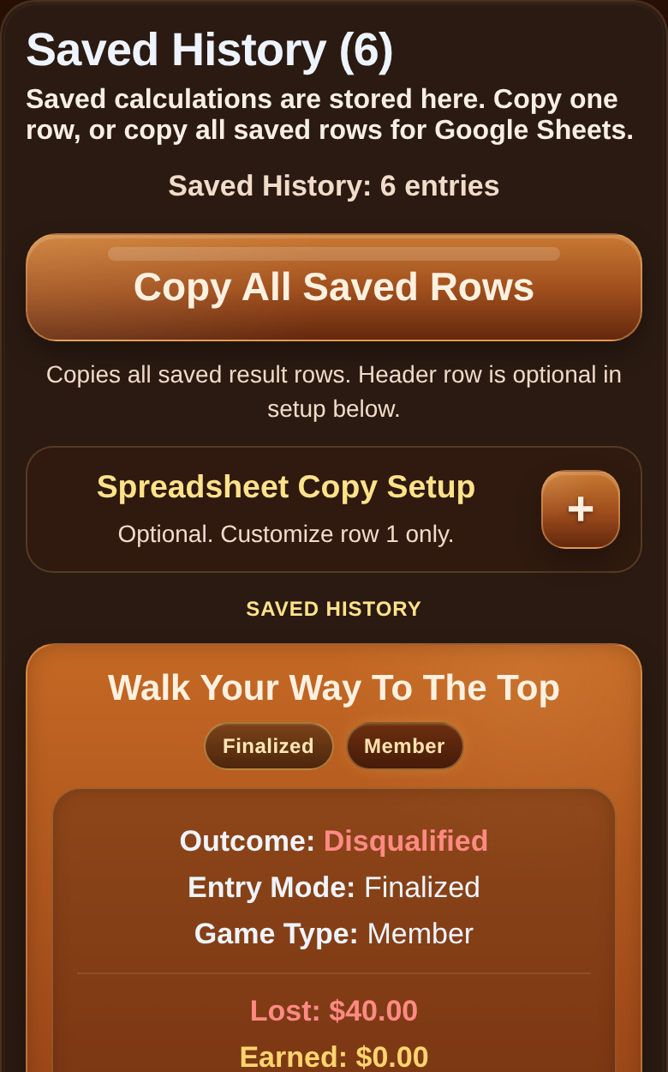
Enlarged continuation of the complete Saved History screenshot — part 1 of 7.

Saved History Detail — 2 of 7
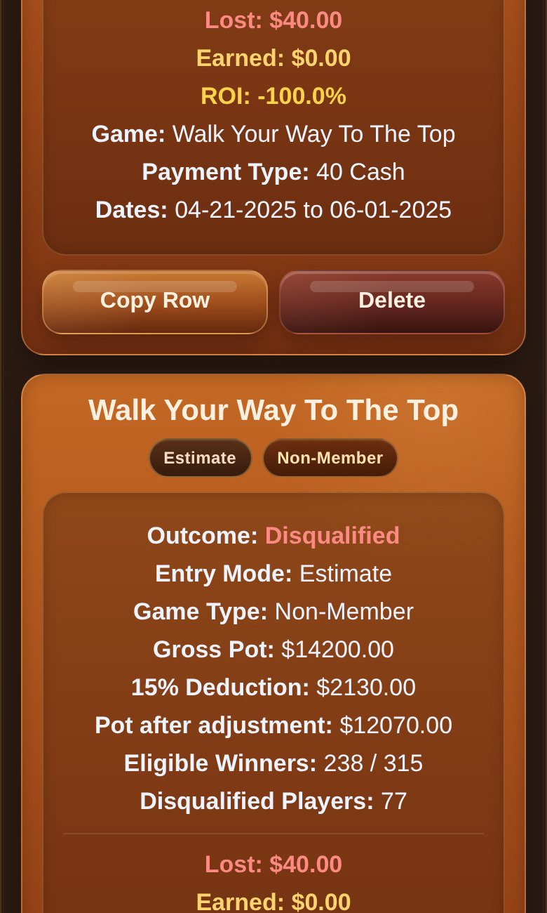
Enlarged continuation of the complete Saved History screenshot — part 2 of 7.

Saved History Detail — 3 of 7
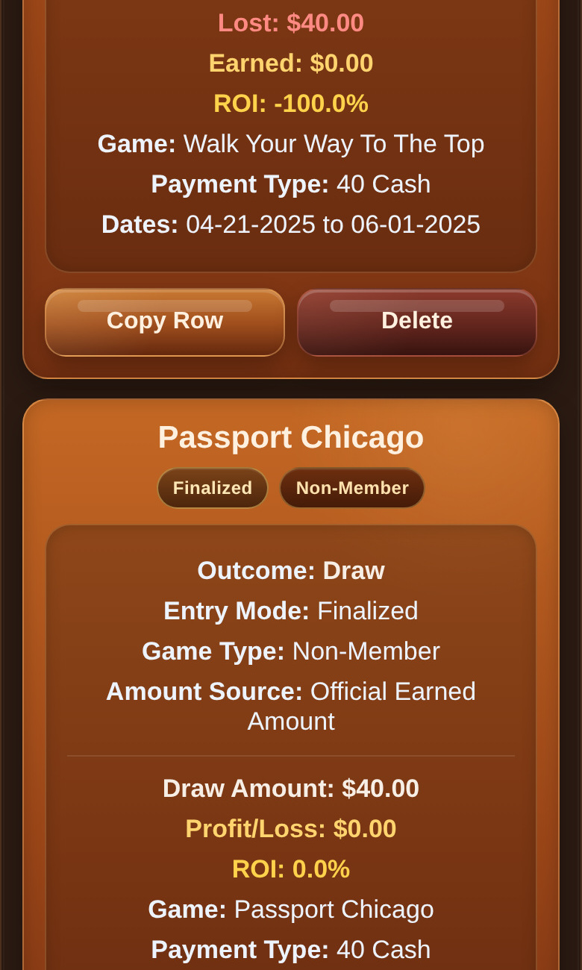
Enlarged continuation of the complete Saved History screenshot — part 3 of 7.

Saved History Detail — 4 of 7
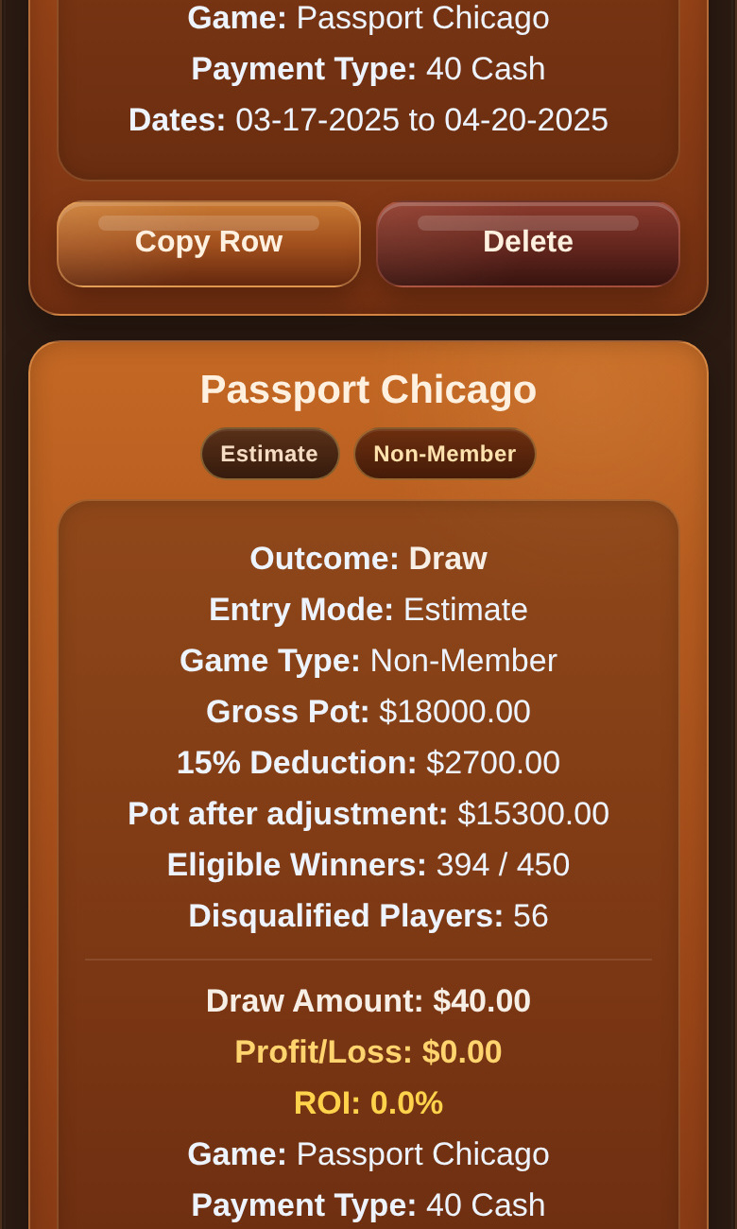
Enlarged continuation of the complete Saved History screenshot — part 4 of 7.

Saved History Detail — 5 of 7
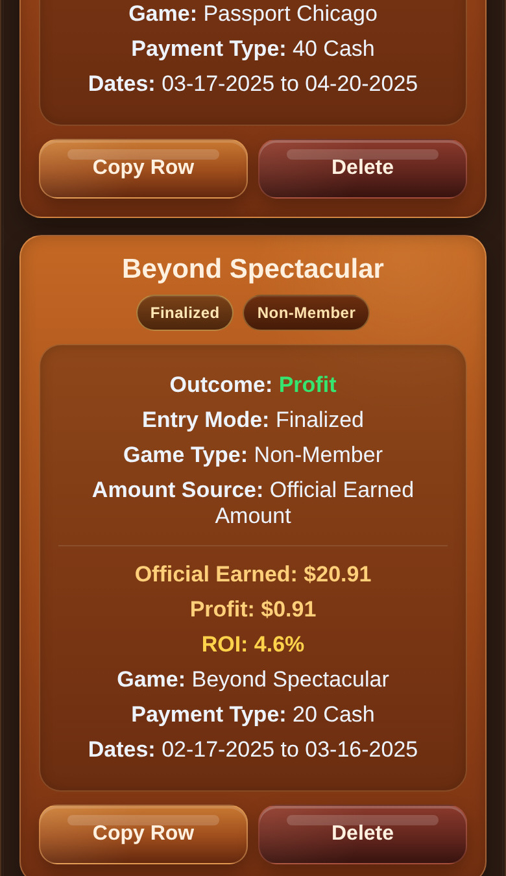
Enlarged continuation of the complete Saved History screenshot — part 5 of 7.

Saved History Detail — 6 of 7
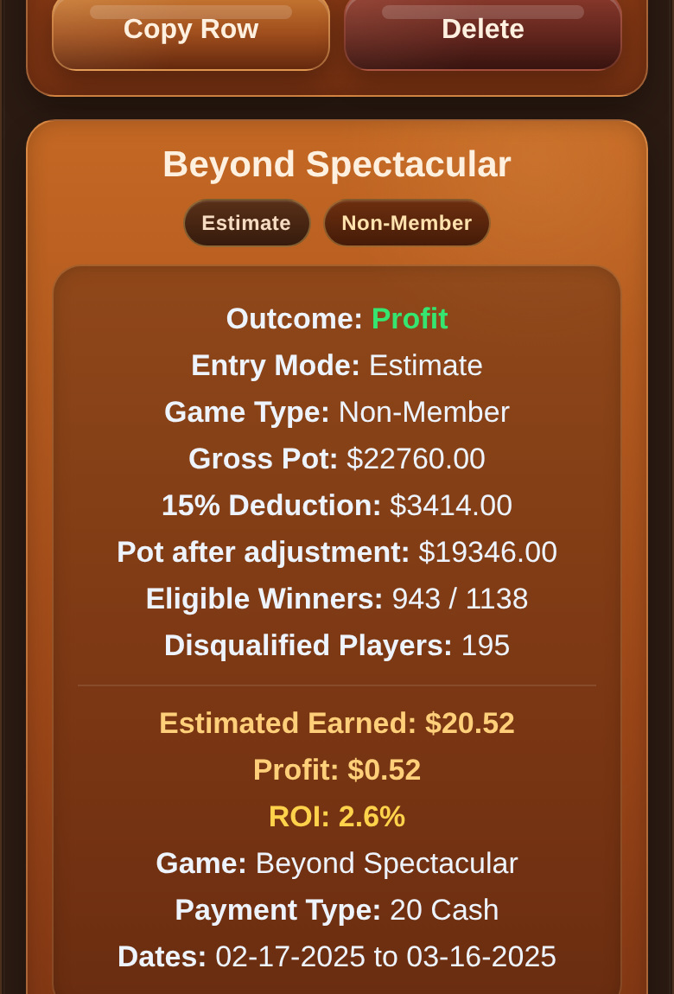
Enlarged continuation of the complete Saved History screenshot — part 6 of 7.

Saved History Detail — 7 of 7
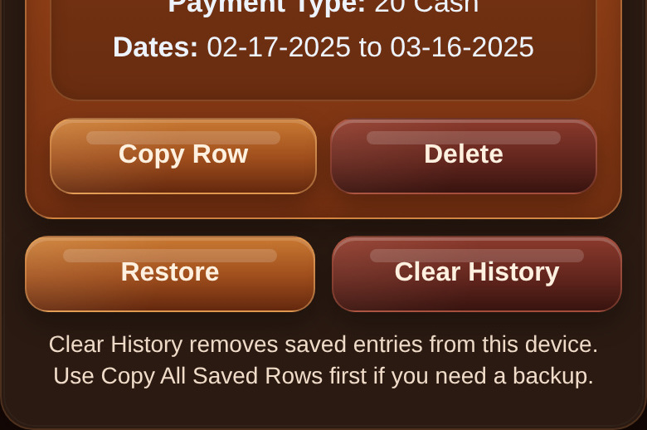
Enlarged continuation of the complete Saved History screenshot — part 7 of 7.

Spreadsheet Copy Setup — Full Screenshot
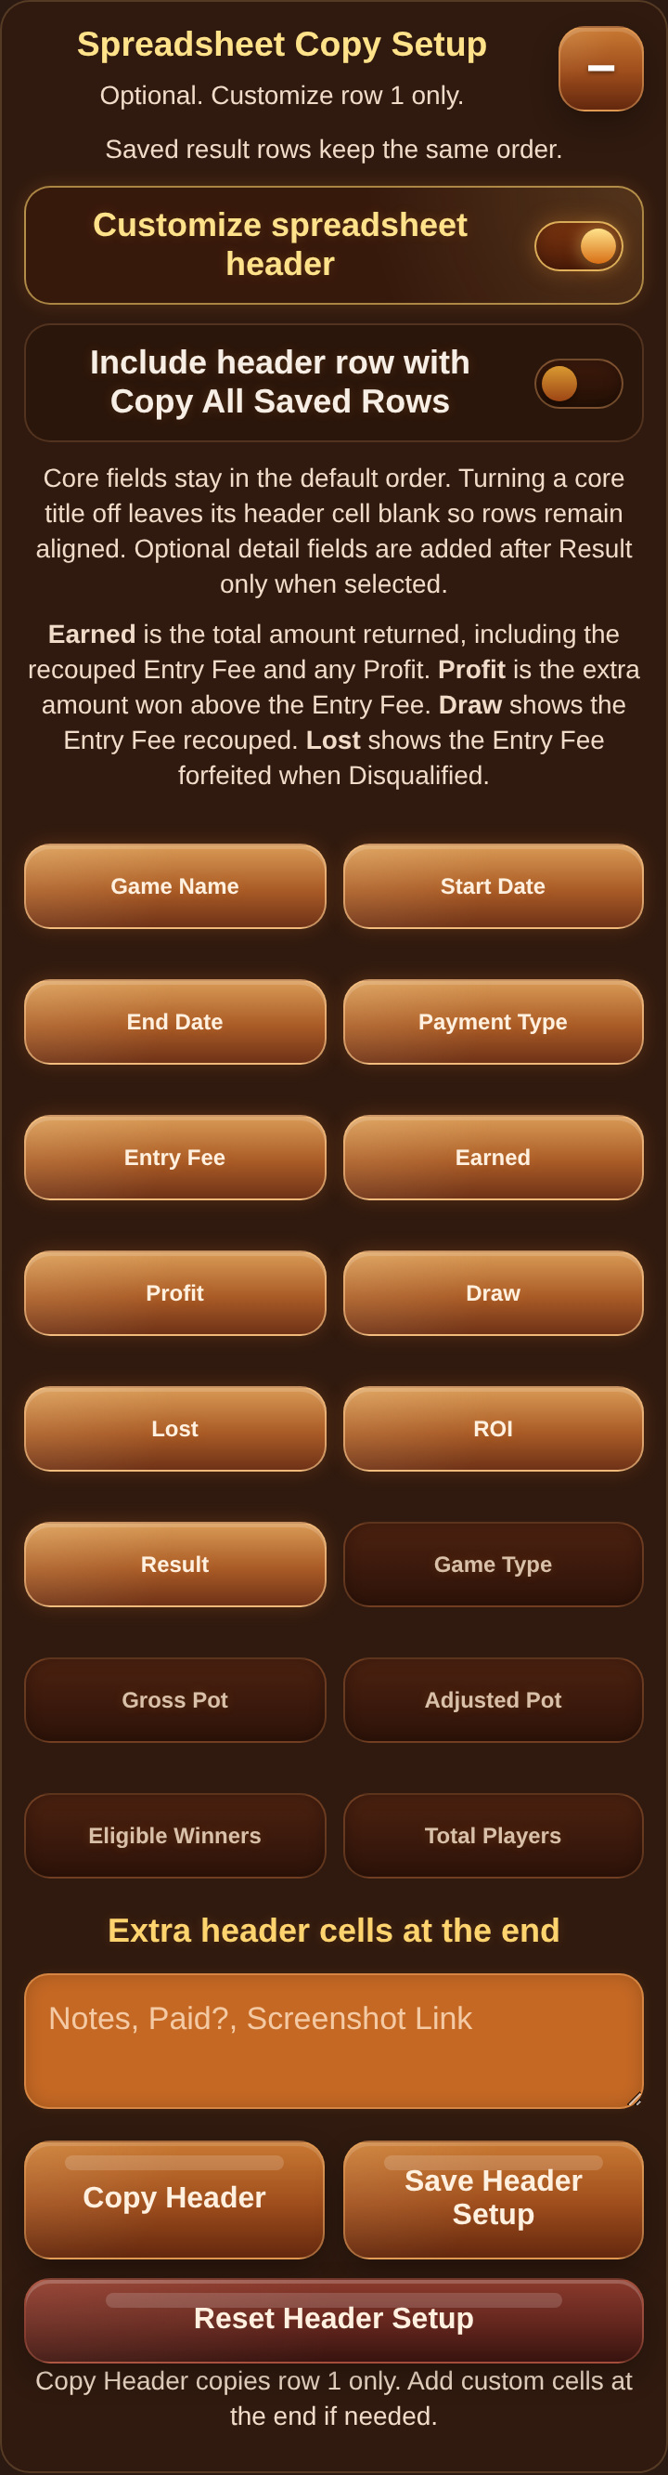
Complete Spreadsheet Copy Setup.
The full screenshot is preserved above. Enlarged continuation views follow.

Spreadsheet Copy Setup Detail — 1 of 4
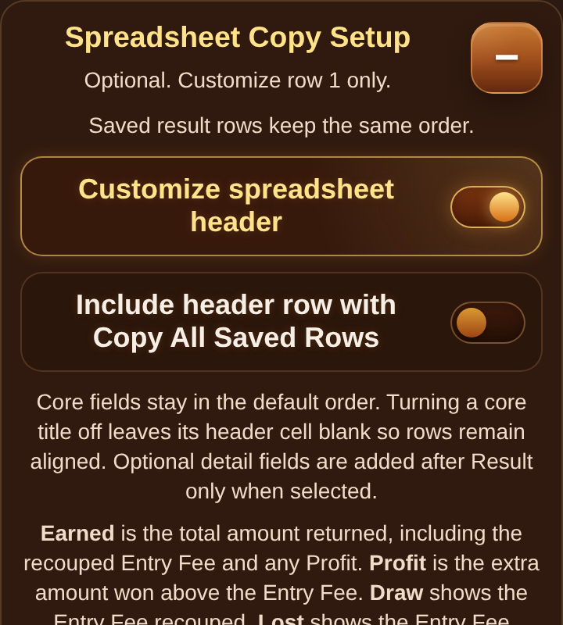
Enlarged continuation of Spreadsheet Copy Setup — part 1 of 4.

Spreadsheet Copy Setup Detail — 2 of 4
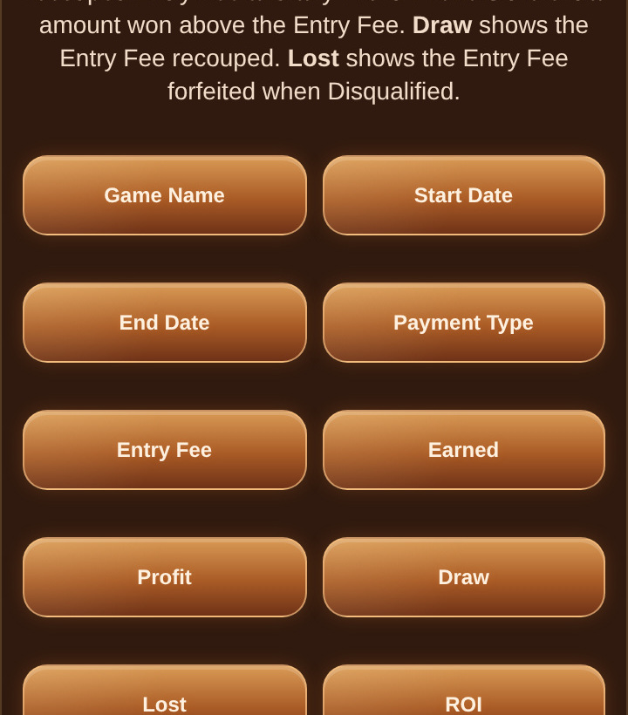
Enlarged continuation of Spreadsheet Copy Setup — part 2 of 4.

Spreadsheet Copy Setup Detail — 3 of 4
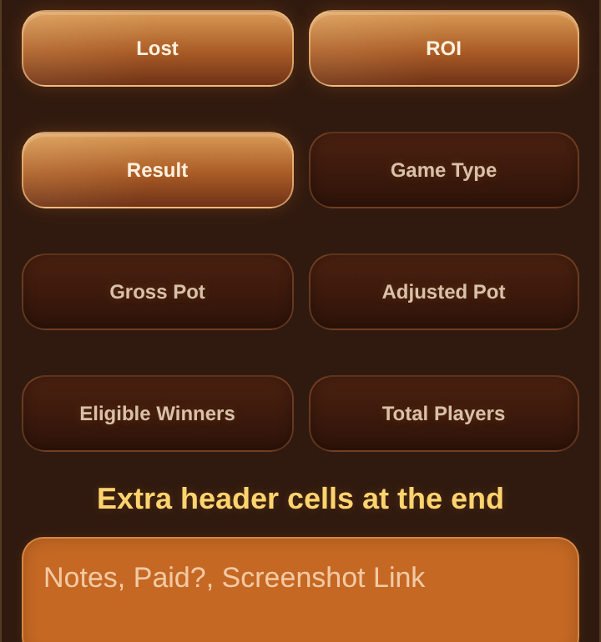
Enlarged continuation of Spreadsheet Copy Setup — part 3 of 4.

Spreadsheet Copy Setup Detail — 4 of 4
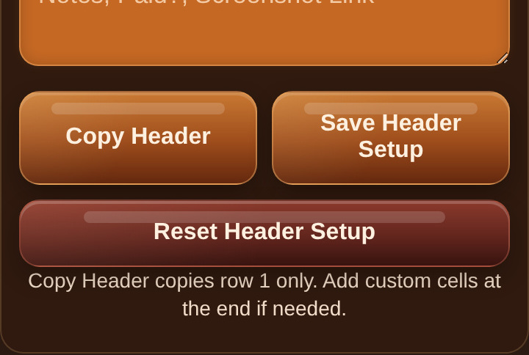
Enlarged continuation of Spreadsheet Copy Setup — part 4 of 4.

Google Sheets — Header Row
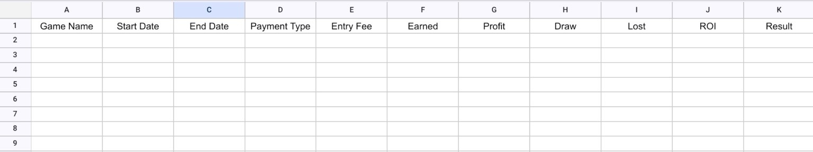
Header row pasted into Google Sheets.
Formatting shown was applied by the user after pasting.

Google Sheets — Saved Results
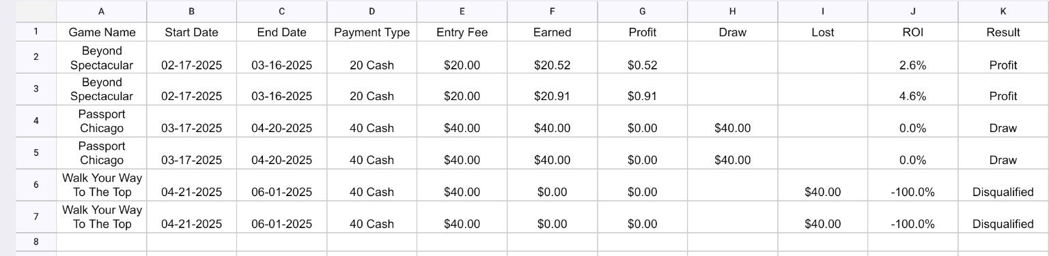
Estimate and Finalized rows pasted into Google Sheets.
Repeated games are intentional Estimate/Finalized pairs. Amounts may differ—especially Profit—because the Finalized row uses the official posted amount.

Settings
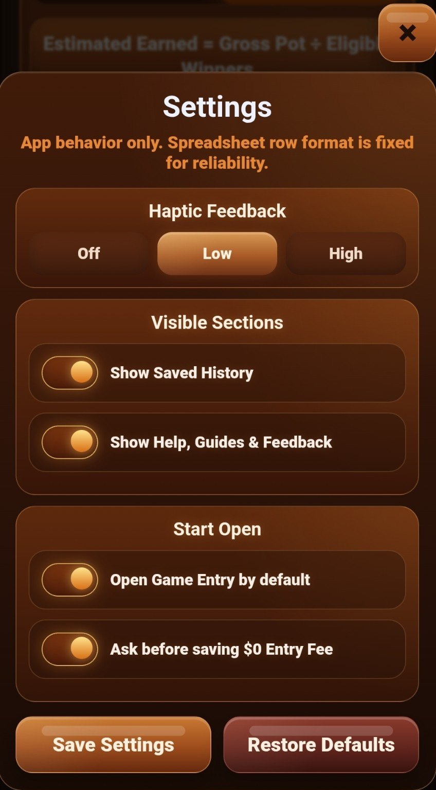
StepCat Settings.

Help, Guides & Feedback — Full Screenshot
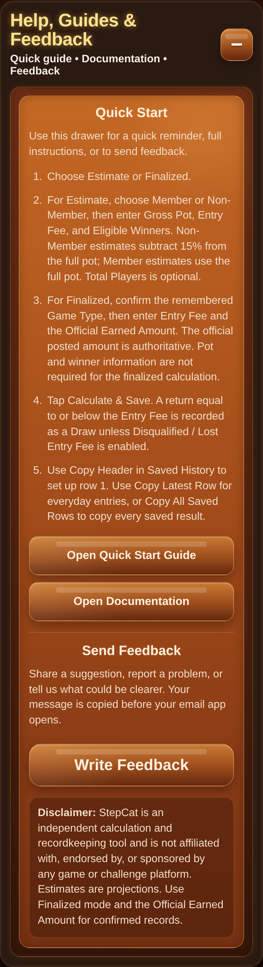
Complete Help, Guides & Feedback drawer.
The full screenshot is preserved above. Enlarged continuation views follow.

Help Drawer Detail — 1 of 3
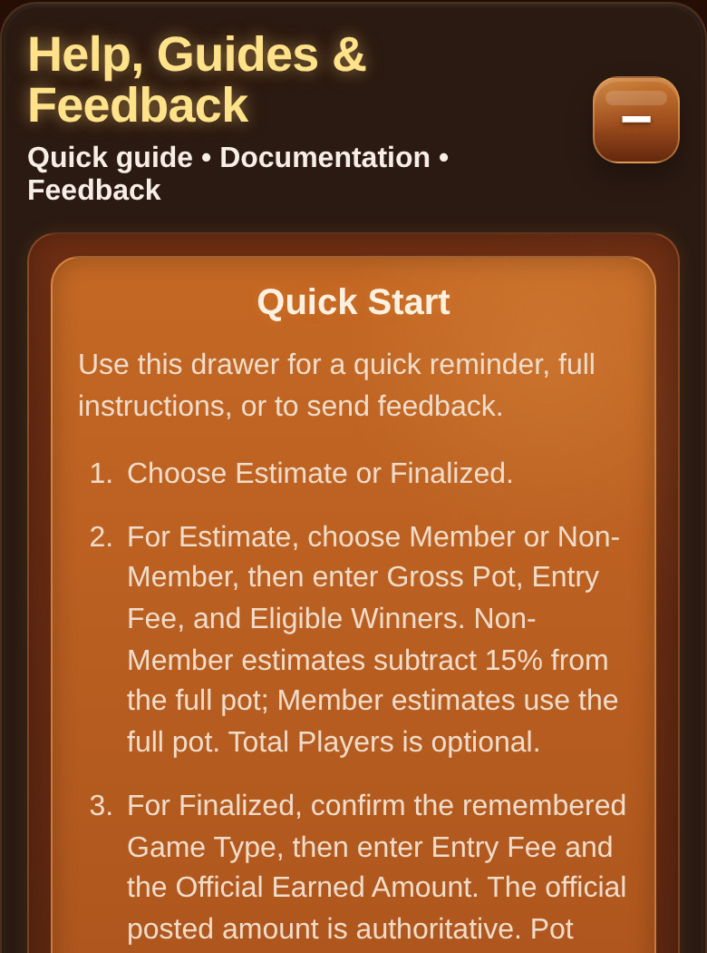
Enlarged continuation of the complete Help drawer — part 1 of 3.

Help Drawer Detail — 2 of 3
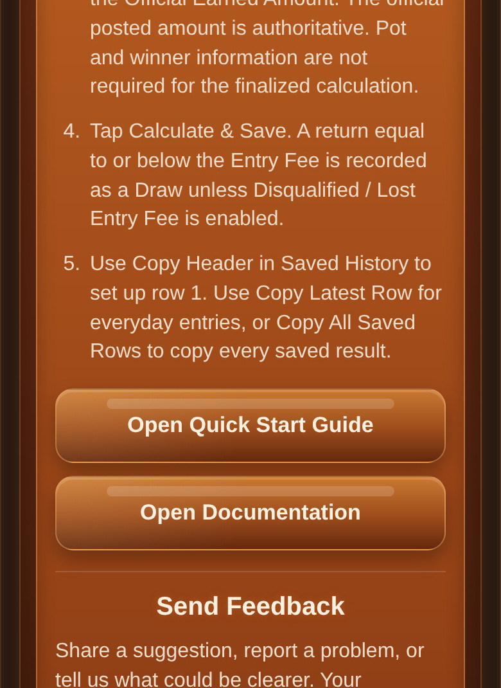
Enlarged continuation of the complete Help drawer — part 2 of 3.

Help Drawer Detail — 3 of 3
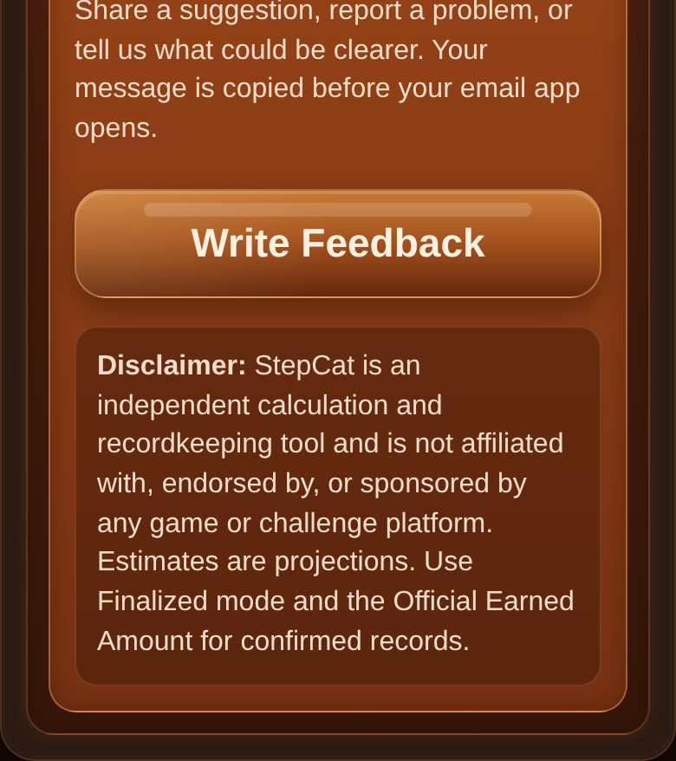
Enlarged continuation of the complete Help drawer — part 3 of 3.

Built-in Quick Start
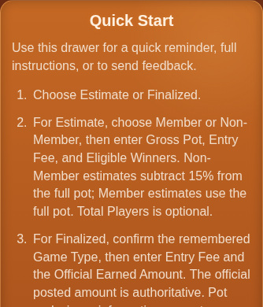
Built-in Quick Start reminder.

Documentation Links

Quick Start Guide and Documentation links.

Feedback and Disclaimer
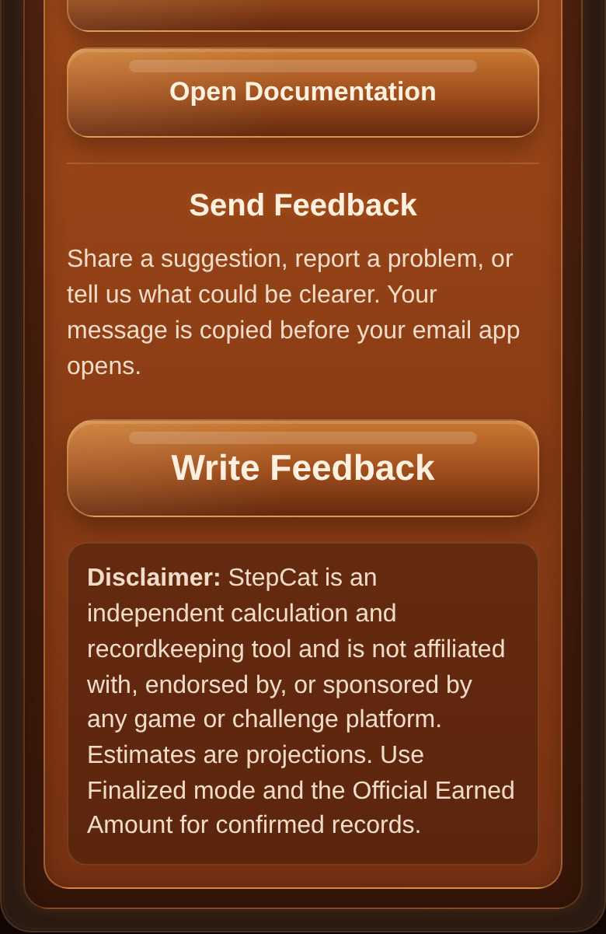
Feedback controls and disclaimer.

Optional Reference — Non-Member Confirmed
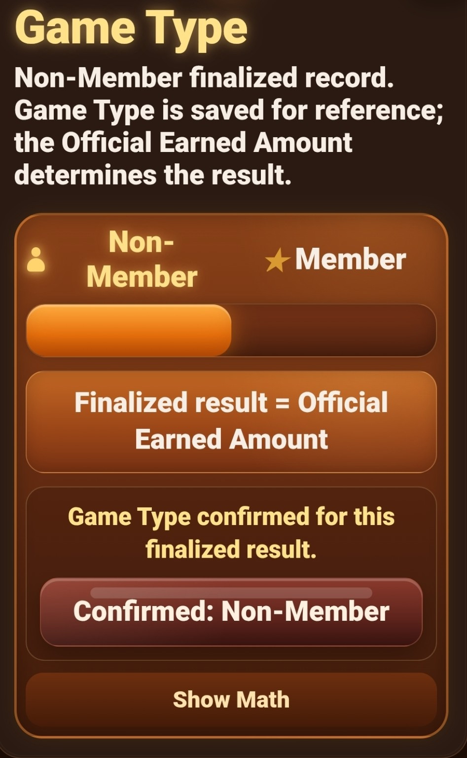
Non-Member Game Type confirmed.

Optional Reference — Member Awaiting Confirmation
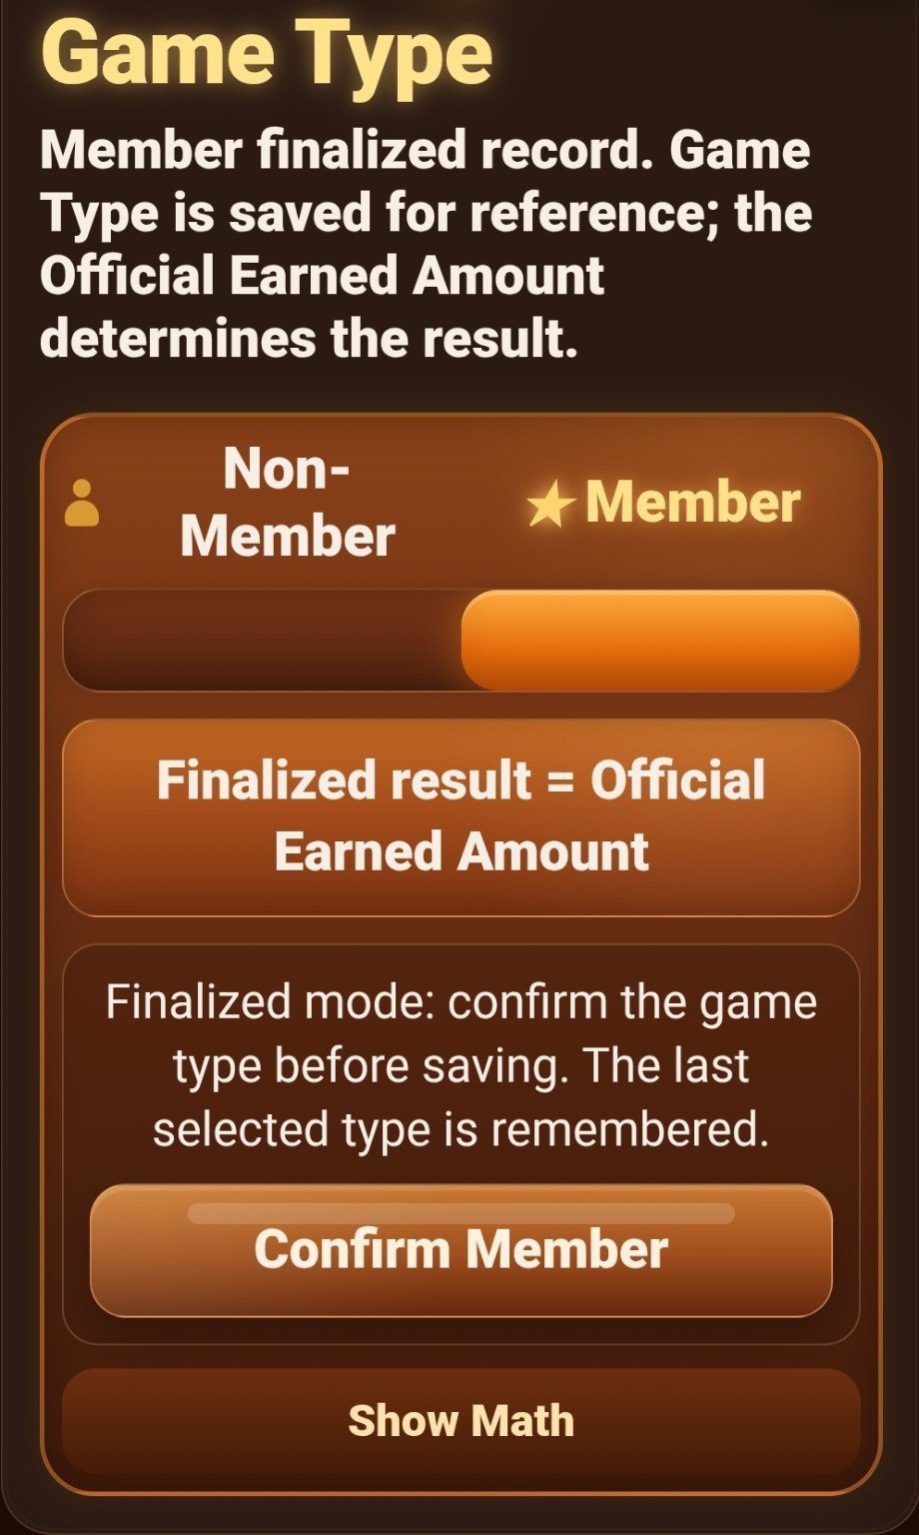
Member Game Type awaiting confirmation.

Optional Reference — Member Confirmed
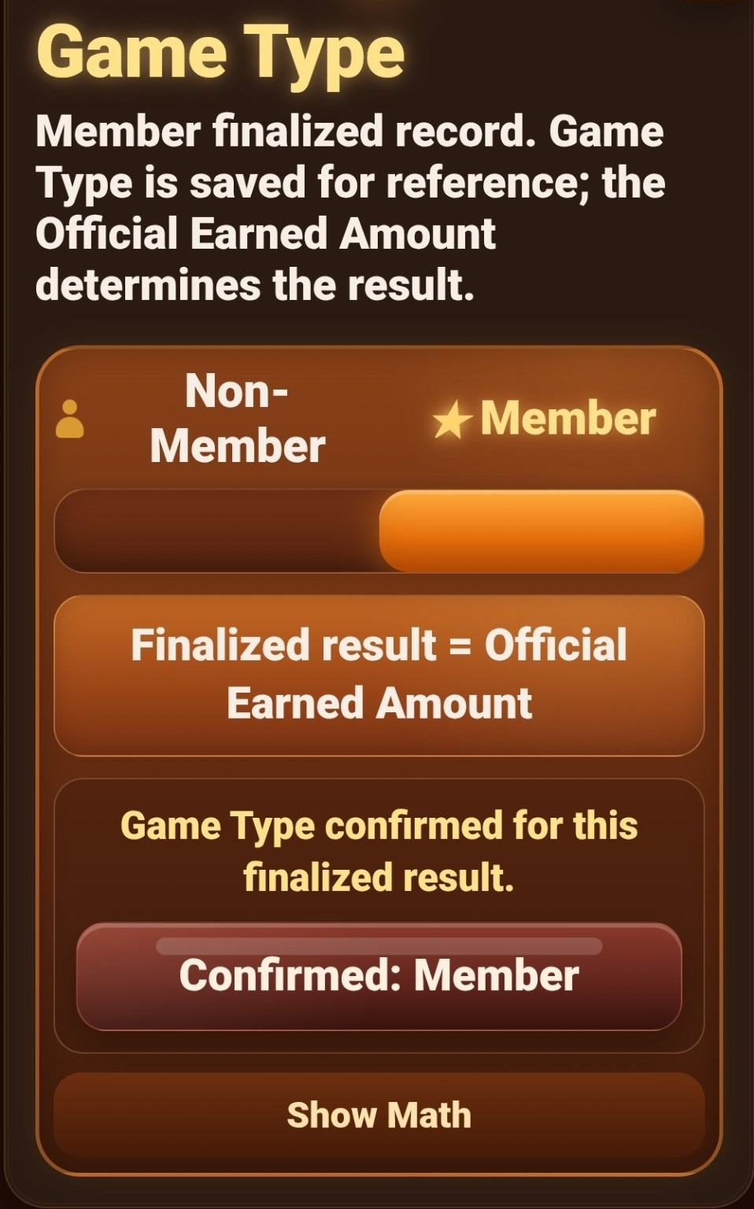
Member Game Type confirmed.

Optional Profitability Analysis Template
The blank analysis template is optional, contains no personal game records, and does not change StepCat v145.
1. In Spreadsheet Copy Setup, include Game Type, Gross Pot, Adjusted Pot, Eligible Winners, and Total Players.
2. Leave the header-row toggle off when copying rows into the template.
3. Paste copied StepCat rows into Game Records starting in cell A5.
4. Enter Count Source, Confidence, and Notes only when useful.
StepCat supplies copied values: Estimate rows include the Adjusted Pot and estimated Earned amount. StepCat also supplies Profit, Draw/Lost, ROI, and Result before the row is copied.
Template-only automatic fields: Challenge Length, Net Profit, Eliminated Players, and Elimination Rate. The template stores the copied StepCat values and does not recalculate Adjusted Pot.
- Count Source: Reported, Estimated, or Partly Estimated.
- Confidence: High, Medium, or Low for estimated player counts.
- Notes: Optional explanation of an estimate or unusual result.
Download the blank profitability analysis template: StepCat_Blank_Profitability_Analysis_Template.xlsx
Which StepCat Row Should You Paste?
The Result Card and its matching Saved History card are two views of the same saved calculation.
- Routine use: Tap Copy Latest Row and paste it into the next empty Game Records row. Use Copy Row for a specific older Saved History entry.
- Complete-history workflow: Keep every Saved History entry as a local archive. After the first full-history transfer, add future games one row at a time.
- Transfer-queue workflow: Use Copy All Saved Rows to transfer several unpasted entries together.
- Verify before deleting: Confirm that every row pasted into the correct columns. Only then delete each transferred entry individually from Saved History.
- Prevent later duplicates: Leave only untransferred entries in Saved History before the next full-history copy.
- Important: Deleting an entry removes StepCat's local Saved History copy, but it does not remove a row already pasted into the spreadsheet. Keep another backup when needed.
- Use the buttons: Do not manually copy the visible Result Card text; the copy buttons create the aligned spreadsheet row.

Storage and Safety
- Saved History, inputs, and preferences are stored locally in the current browser.
- Copy important saved rows before clearing browser or site data.
- Verify spreadsheet transfers before deleting individual Saved History entries.
- End Date cannot be before Start Date.
- Restoring default settings does not erase Saved History.
- StepCat is independent and is not affiliated with, endorsed by, or sponsored by any game or challenge platform.

Sending Feedback
Tap Write Feedback, enter your message, and tap Send Feedback. StepCat opens your device's default email app with the subject and message prepared. Review the email and send it manually; StepCat does not send feedback automatically.
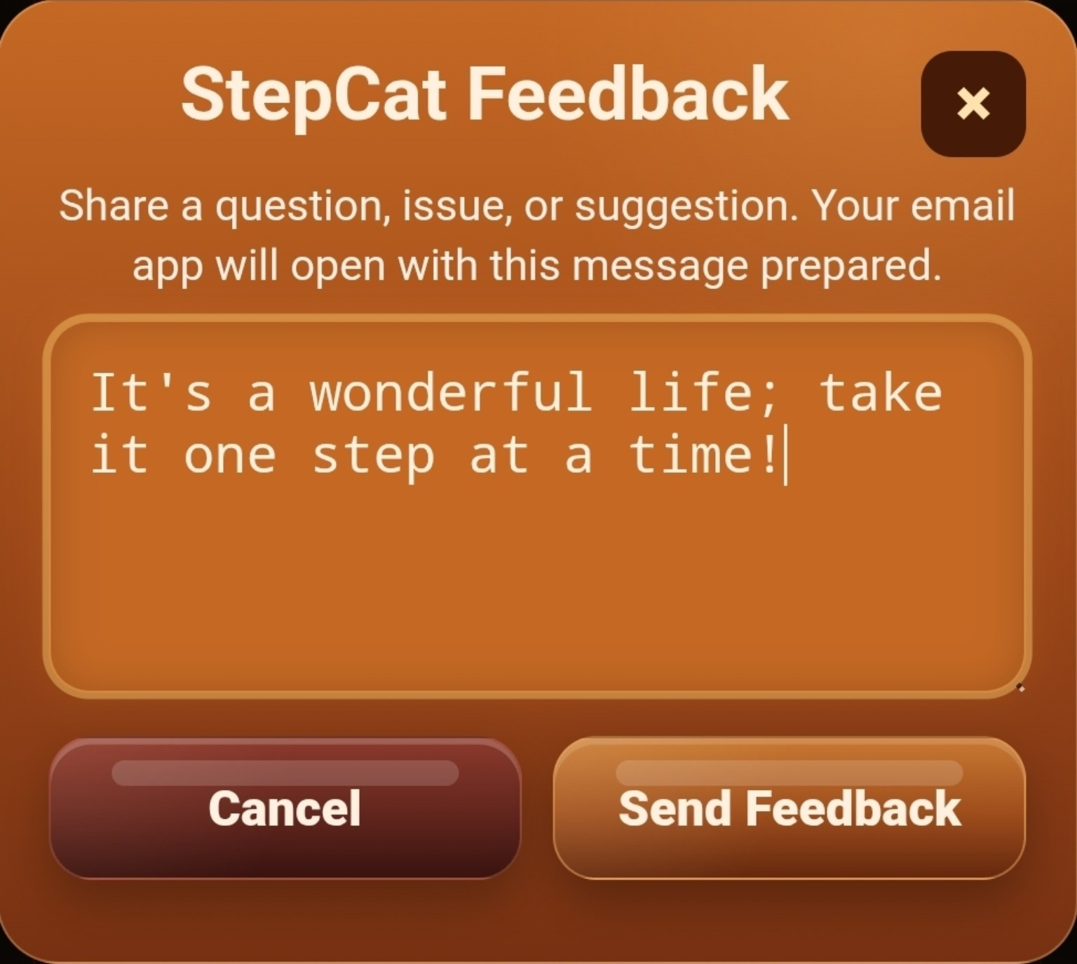  Figure: Enter a message, then tap Send Feedback. | 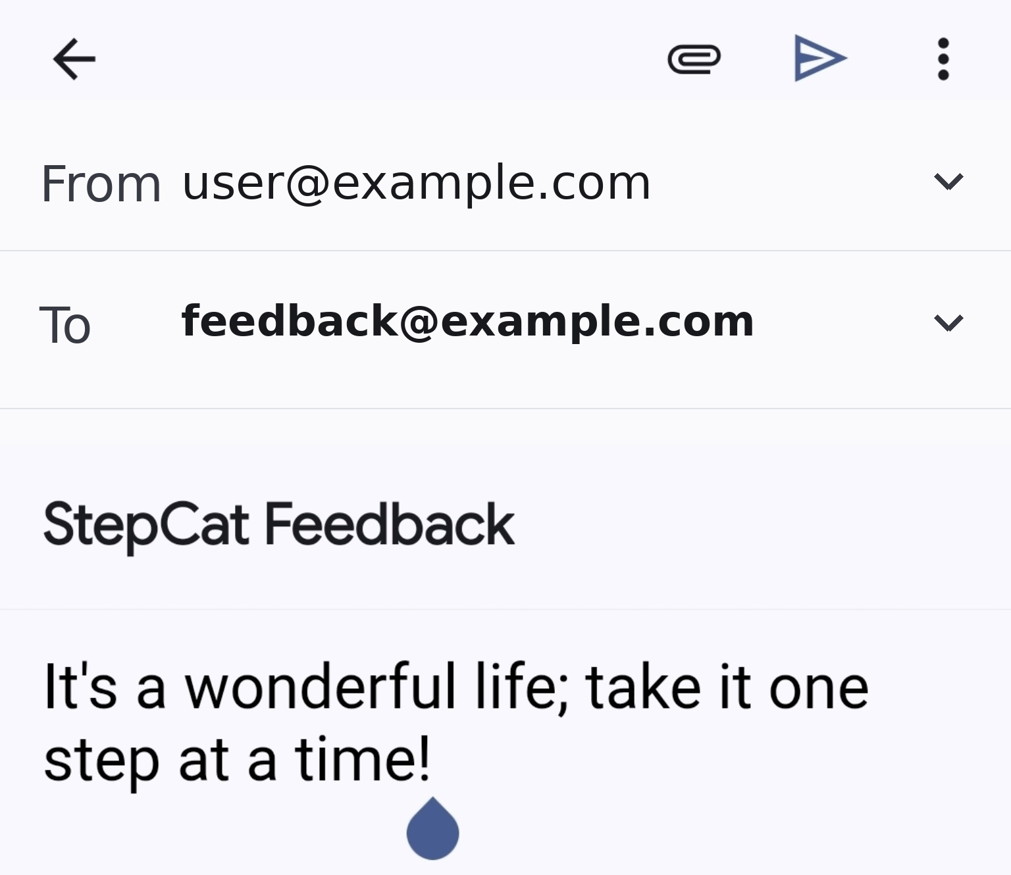  Figure: The default email app opens with the subject and message prepared. Addresses are generic examples.
Privacy note: Feedback is sent by email. StepCat does not send the message automatically or store it inside the app.

