StepCat
Quick Start Guide
StepCat Calculator v246.3.6
Quick workflow
- Choose Estimate or Finalized.
- Confirm Member or Non-Member.
- Enter the record and calculation details.
- Tap Calculate & Save.
- Copy the saved A-M row into the first empty Game Records cell in column A.
This guide uses the final app and workbook screenshots supplied for v246.3.6.

1. Enter the record information
Add the game name, dates, date format, and payment or record type. Optional fields can remain blank when they do not apply.
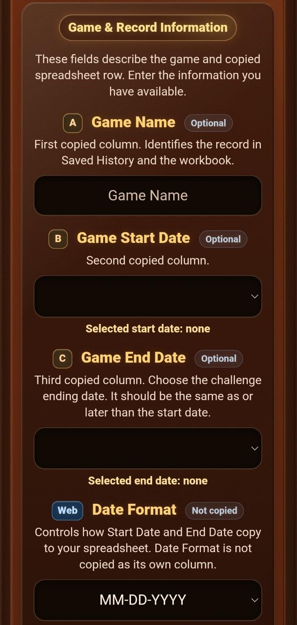  Game and record information | 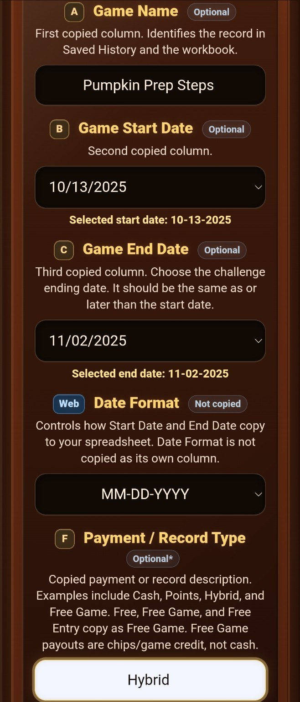  Completed record details

2. Confirm membership and enter calculation details
Tap the Member or Non-Member side to confirm it for the current entry. Then enter the pot, Entry Fee, and player information required by the selected mode.
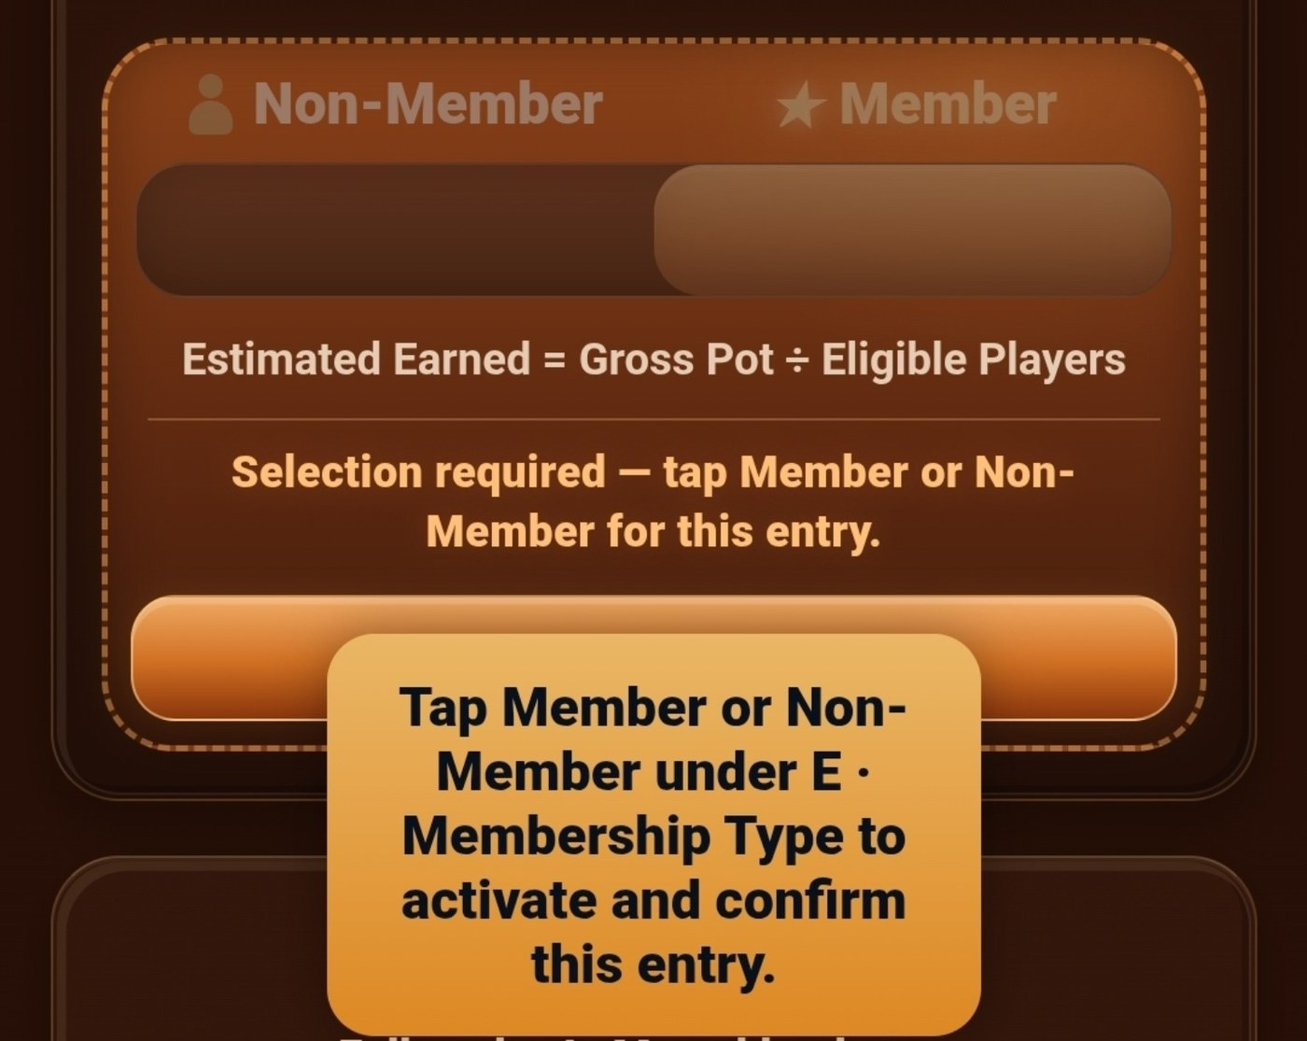  Confirm Member or Non-Member  Non-Member uses 85% of Gross Pot. Member uses 100% of Gross Pot. | 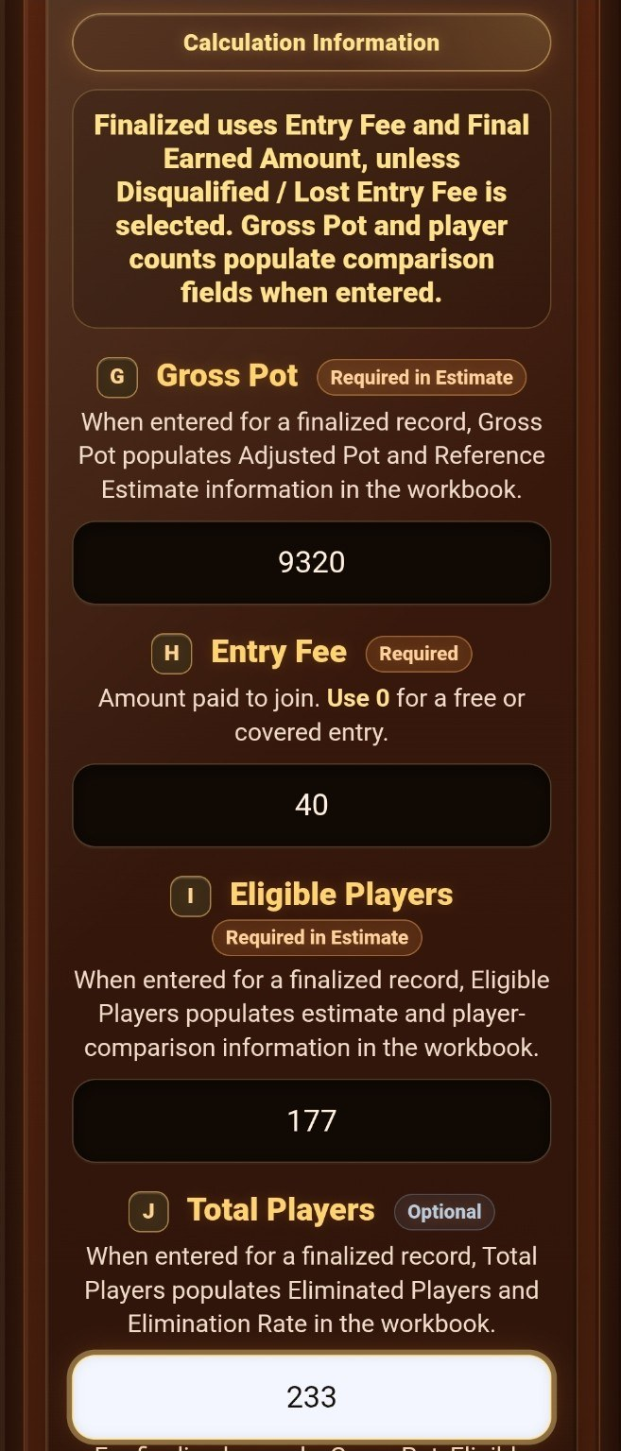  Enter calculation information

3. Complete a finalized result
Finalized mode uses the official total returned. Enter the full Final Earned amount, not only the extra profit.
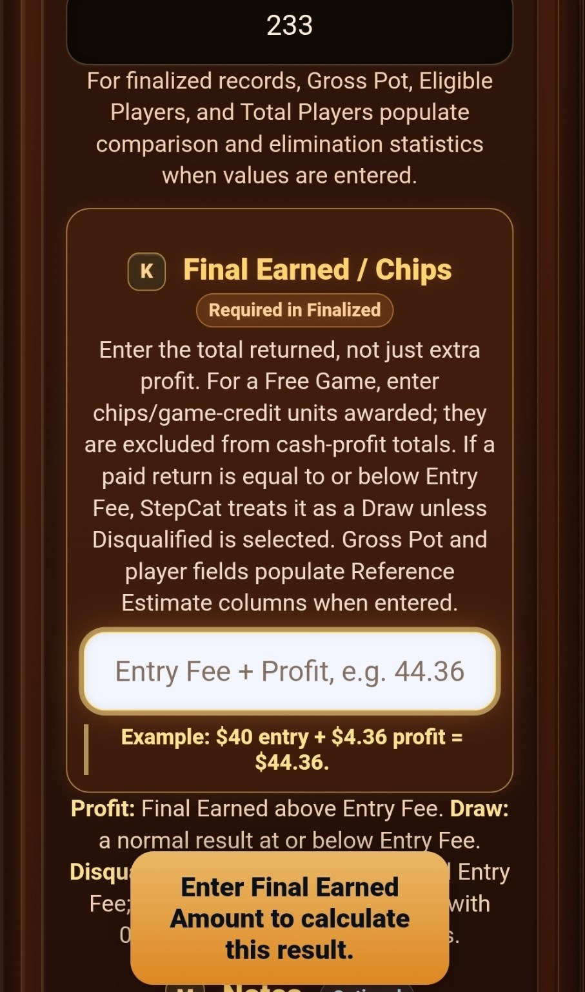  Final Earned is required in Finalized mode | 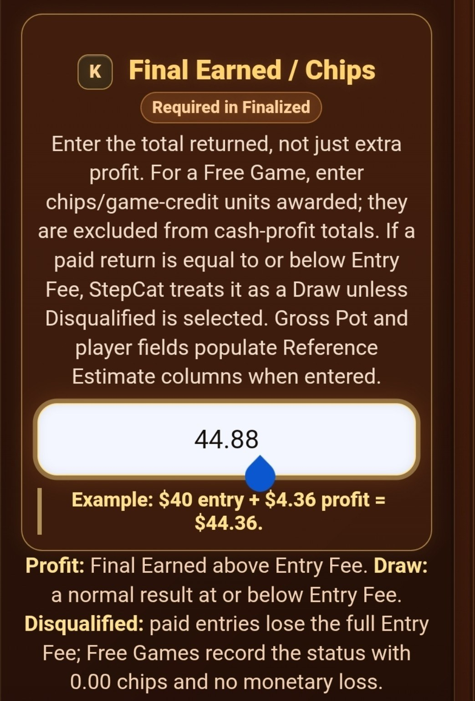  Enter the official Final Earned amount

4. Add notes, then calculate and save
Use Notes for optional details such as a Hybrid cash-and-points breakdown. Calculate & Save validates the entry and stores one Saved History result.
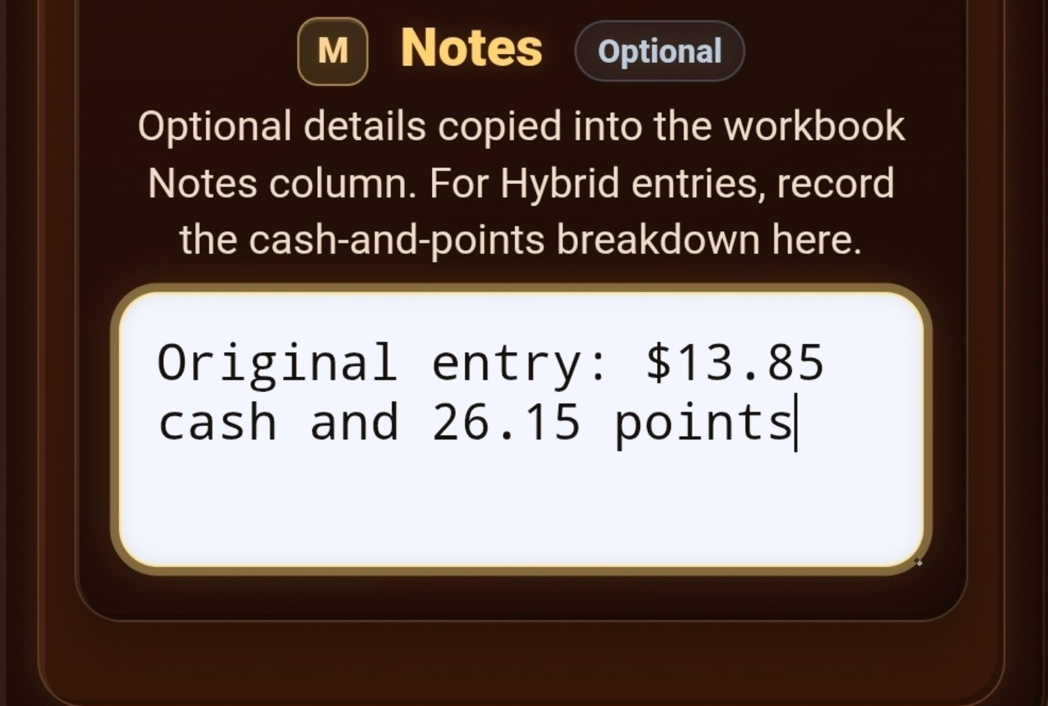
Use Notes for cash-and-points details
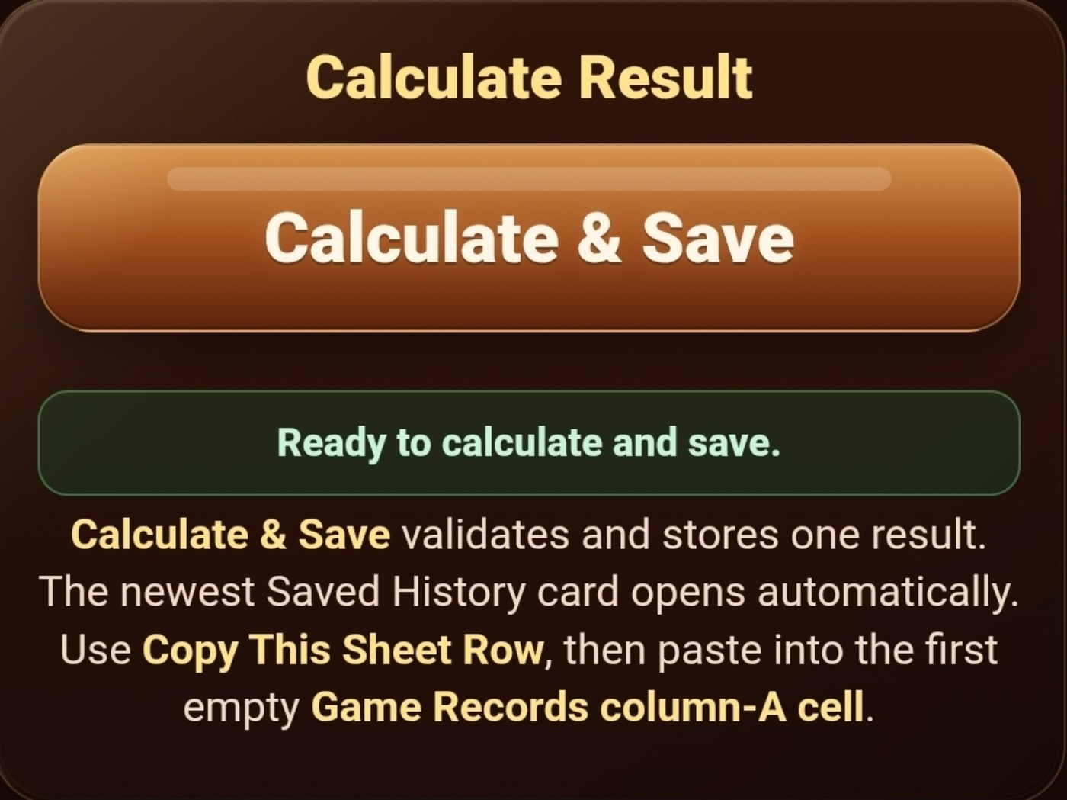
Calculate and save the record

5. Review Saved History
The newest saved result opens automatically. Review the outcome, official amount, profit or draw, ROI, record details, and reference estimate before copying.
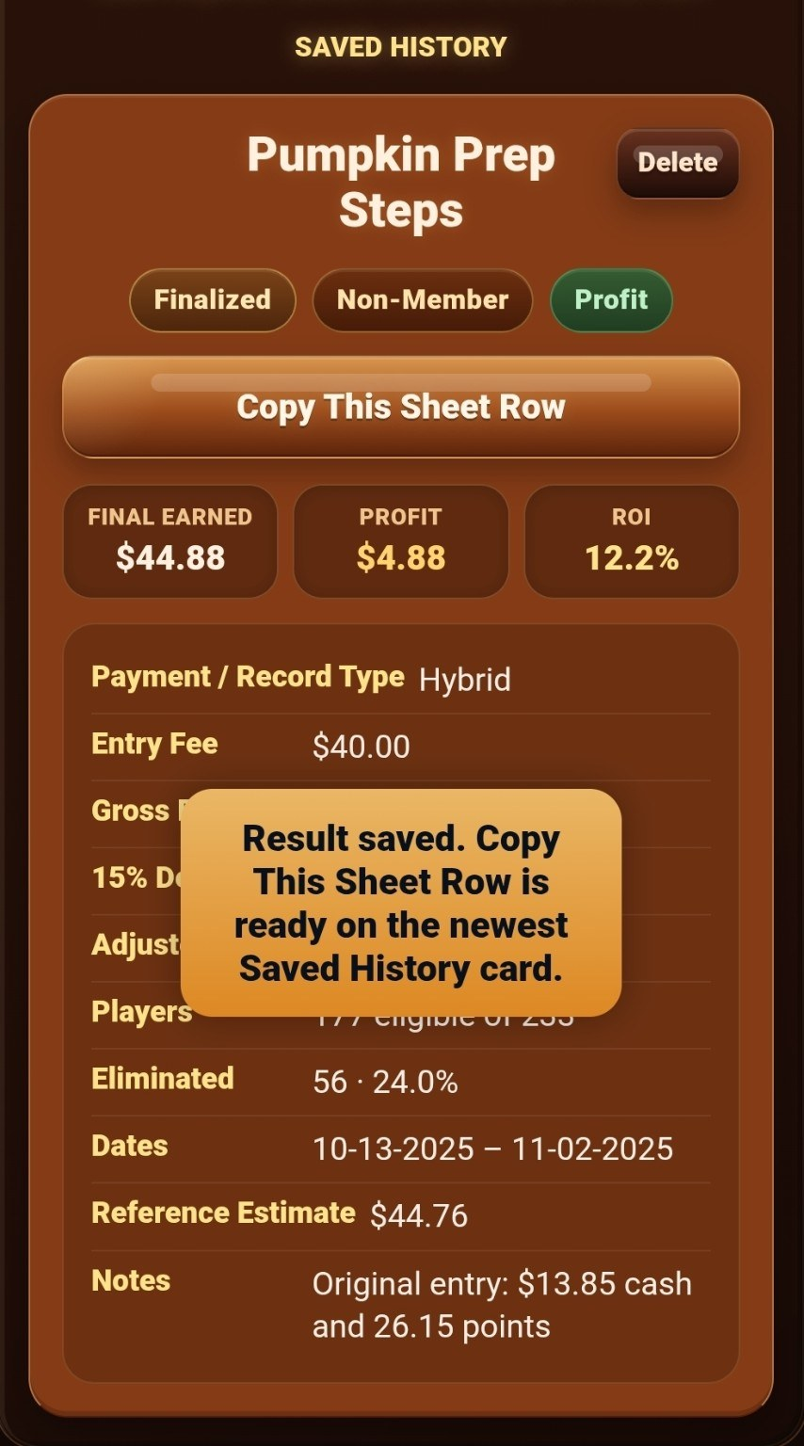  Newest Saved History result | 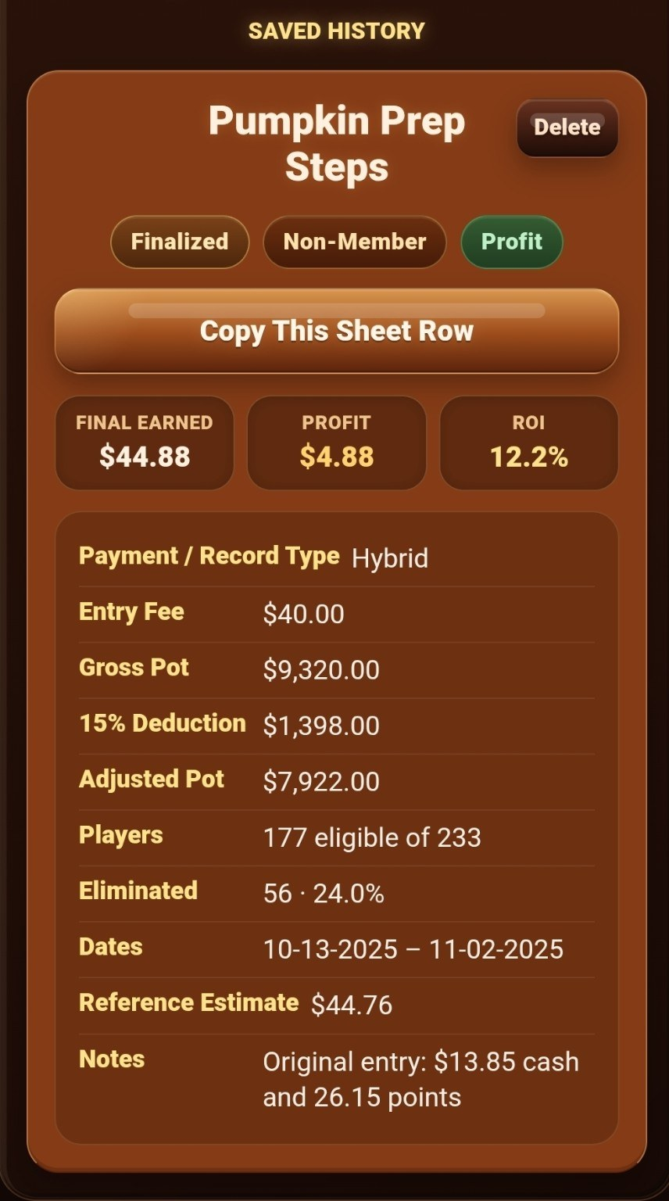  Full Saved History card

6. Copy the row into the workbook
Tap Copy This Sheet Row, open Game Records, select the first empty cell in column A beginning with A5, and paste. Do not paste over formula columns N-Z.
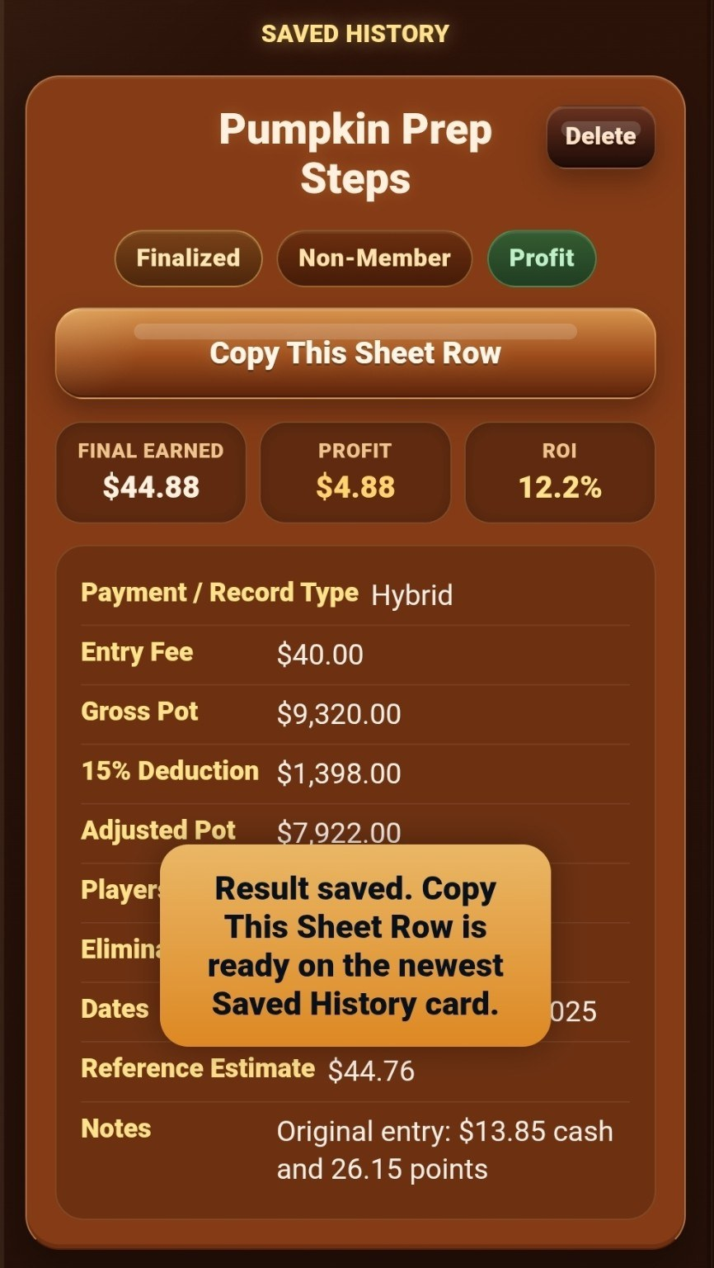  Copy the workbook row | 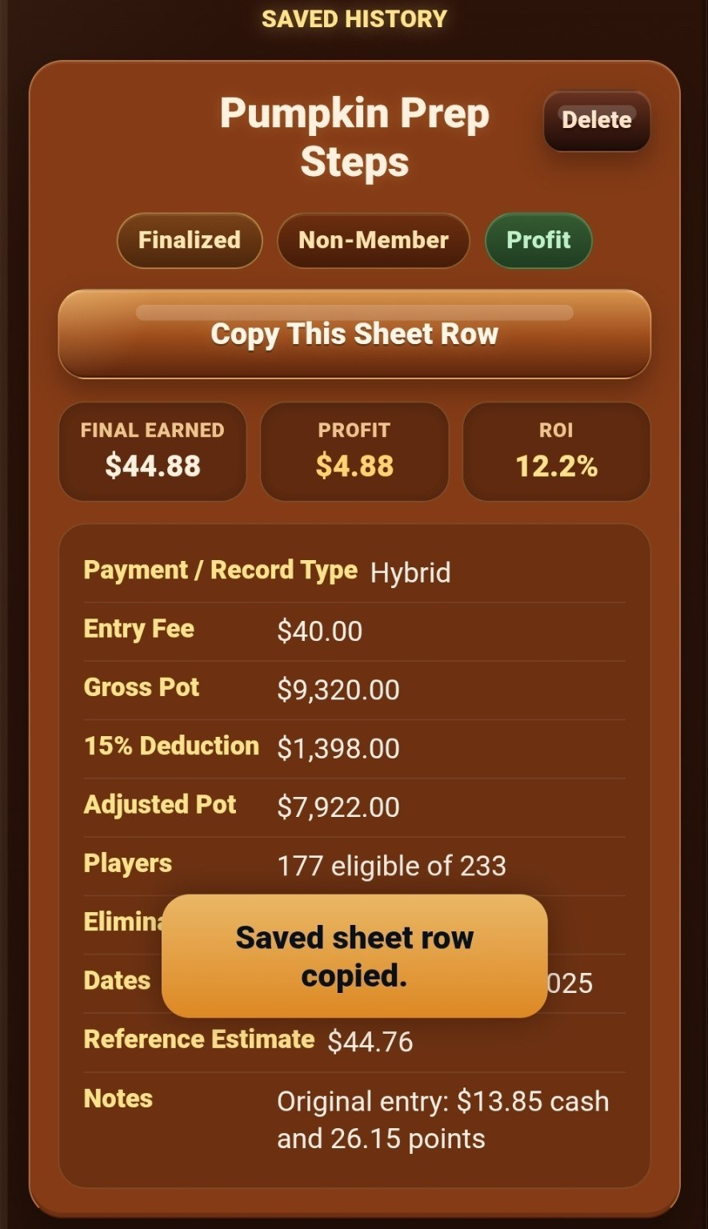  Sheet row copied

7. Follow the workbook instructions
The Instructions sheet explains where to enter records and which columns calculate automatically. In Game Records, rows 1-4 remain compact and frozen.
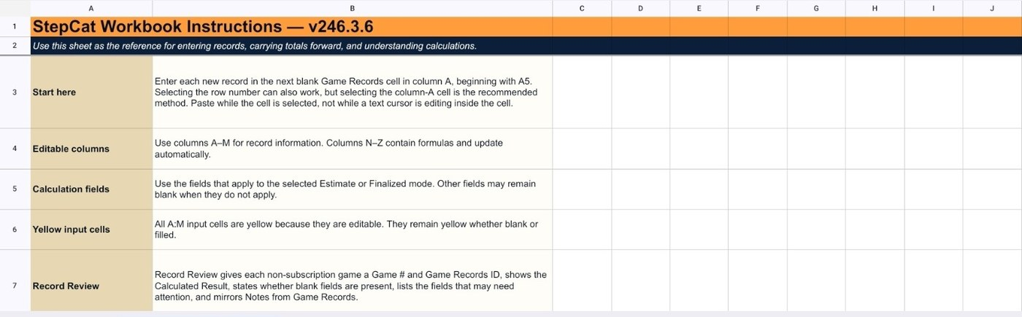
Workbook instructions and entry guidance
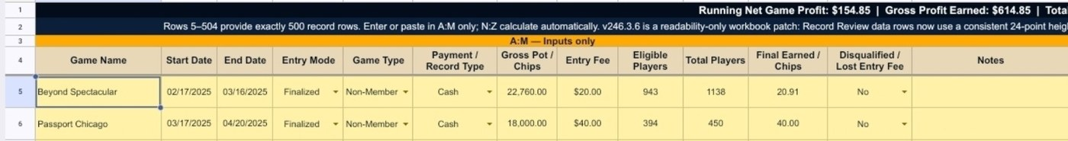
Compact frozen headings in Game Records

8. Enter values in A-M and leave N-Z intact
The frozen headings remain visible while you scroll. Enter or paste only in the yellow A-M input area; the blue N-Z columns calculate the result automatically.
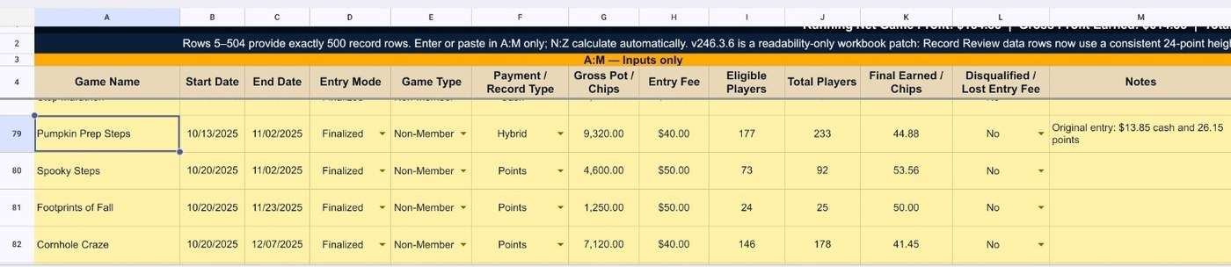
Frozen headings remain visible while scrolling
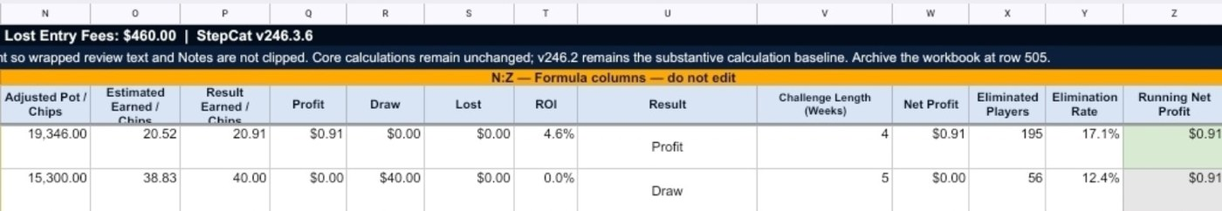
Formula columns N-Z calculate automatically

9. Use Record Review to check the workbook
Record Review lists each non-subscription game, identifies the calculated result, flags blank fields that may deserve attention, mirrors notes, and shows review totals.
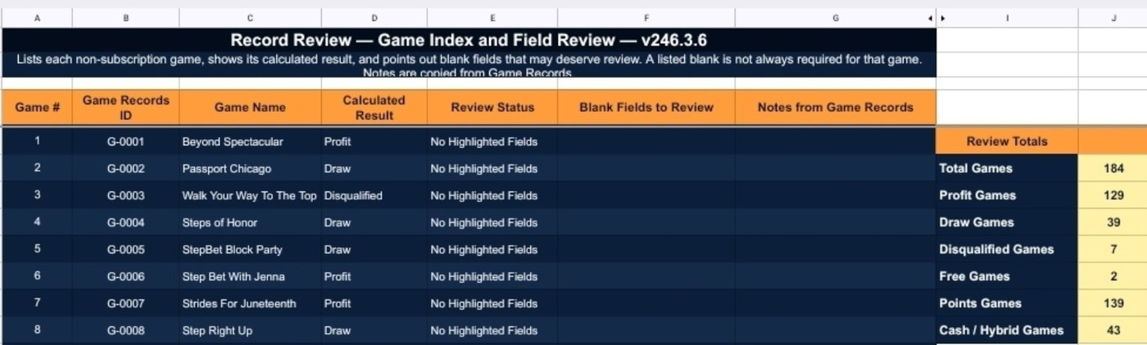
Record Review checks fields and summarizes results
Final workbook check
- Paste into the next blank cell in column A.
- Keep formulas in columns N-Z unchanged.
- Subscription rows are workbook-only non-game costs.
- Archive the workbook when the record area reaches row 505.

