StepCat
Quick Start Guide
StepCat Calculator v250
Quick workflow
Choose Estimate or Finalized.
Confirm Member or Non-Member.
Enter the record and calculation details.
Tap Calculate & Save.
Copy the saved A-M row into Game Records. For a forgotten game, insert a row above or below from inside the native Google Sheets table.
This guide explains the v250 app and native Google Sheets workbook workflow. Privacy-sensitive screens use clearly labeled generic examples.

1. Enter the record information
Add the game name, dates, date format, and payment or record type. Optional fields can remain blank when they do not apply.
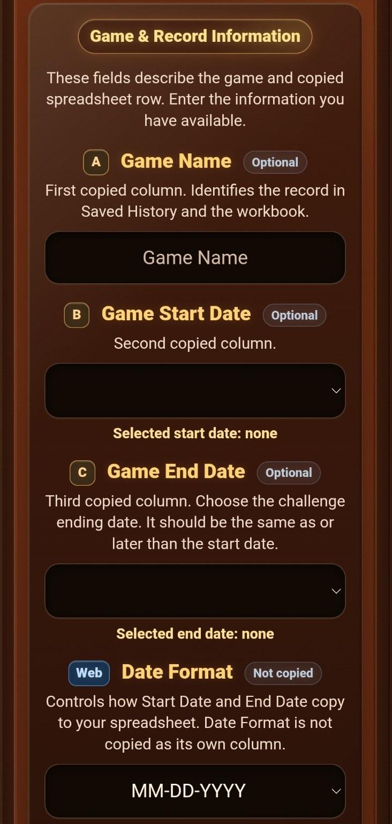  Game and record information | 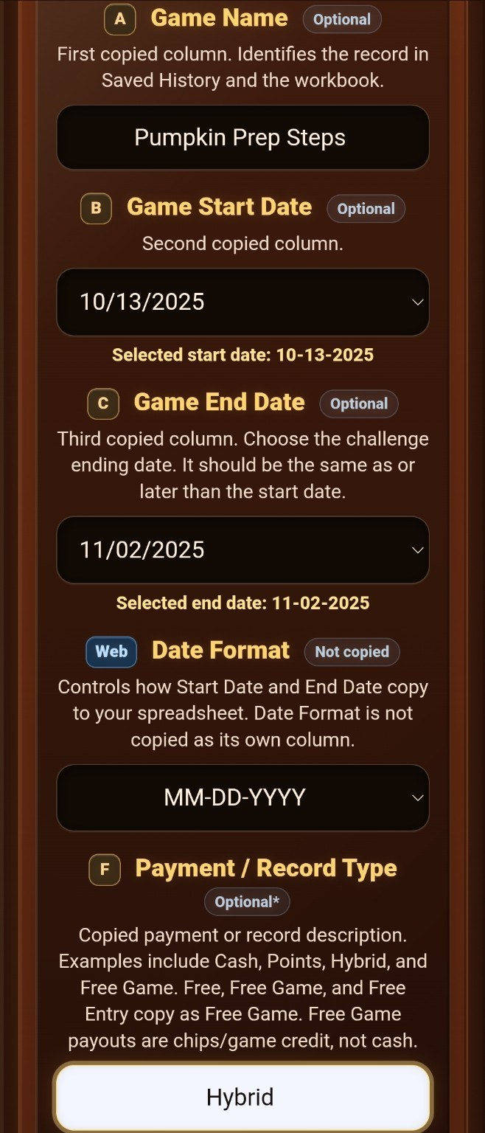  Completed record details

2. Confirm membership and enter calculation details
Tap the Member or Non-Member side to confirm it for the current entry. Then enter the pot, Entry Fee, and player information required by the selected mode.
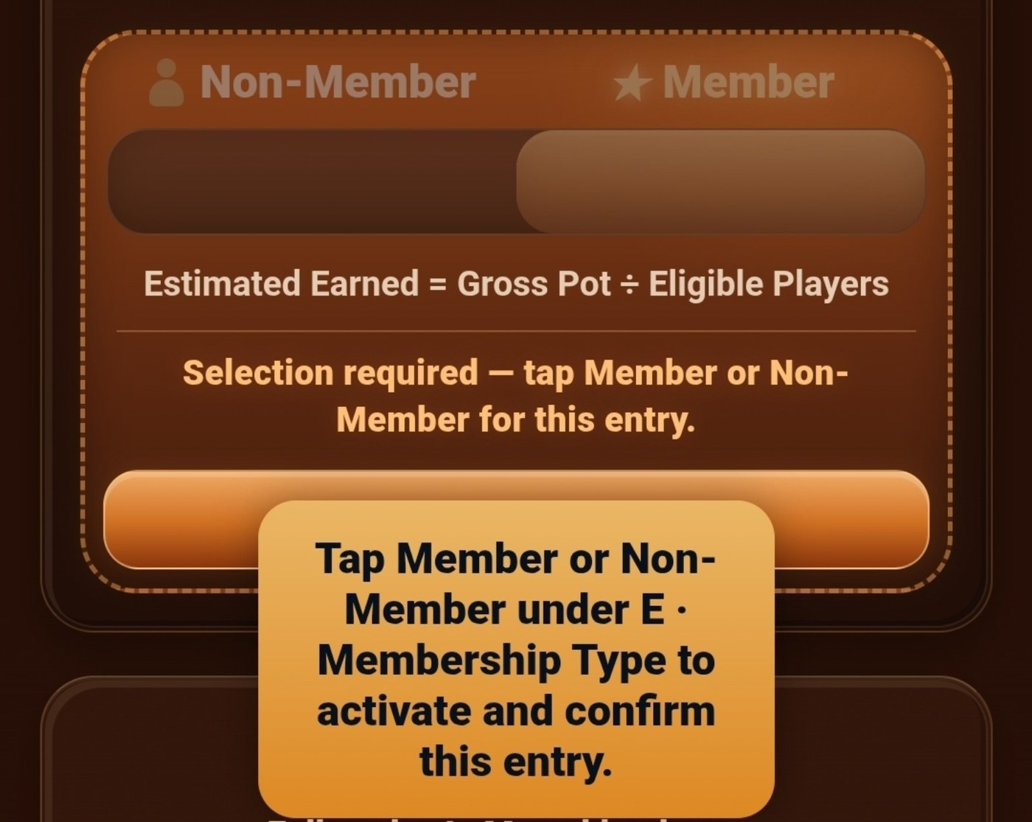  Confirm Member or Non-Member  Non-Member uses 85% of Gross Pot. Member uses 100% of Gross Pot. | 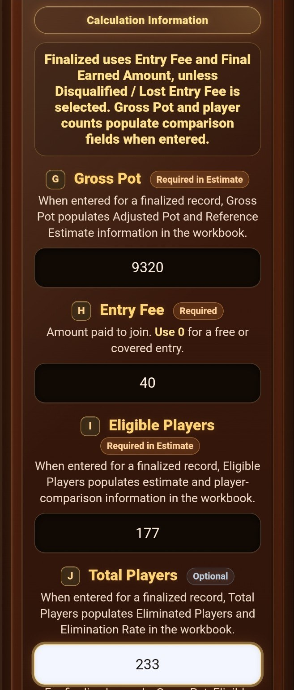  Enter calculation information

3. Complete a finalized result
Finalized mode uses the official total returned. Enter the full Final Earned amount, not only the extra profit.
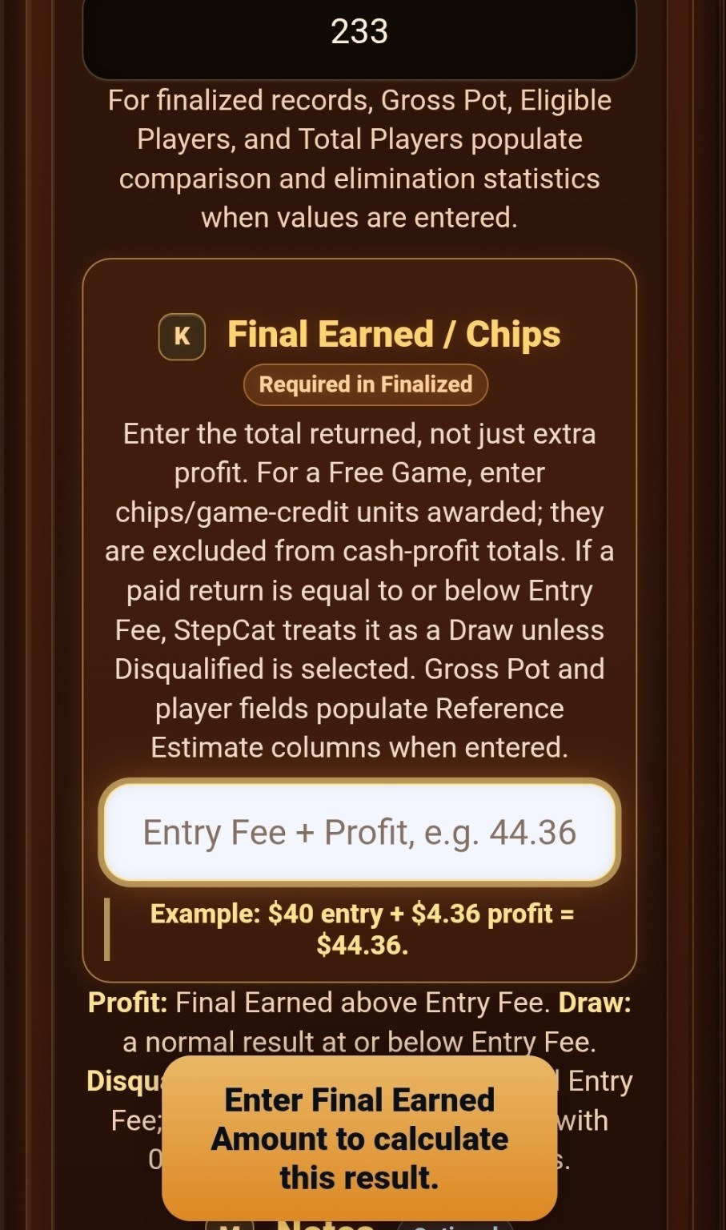  Final Earned is required in Finalized mode | 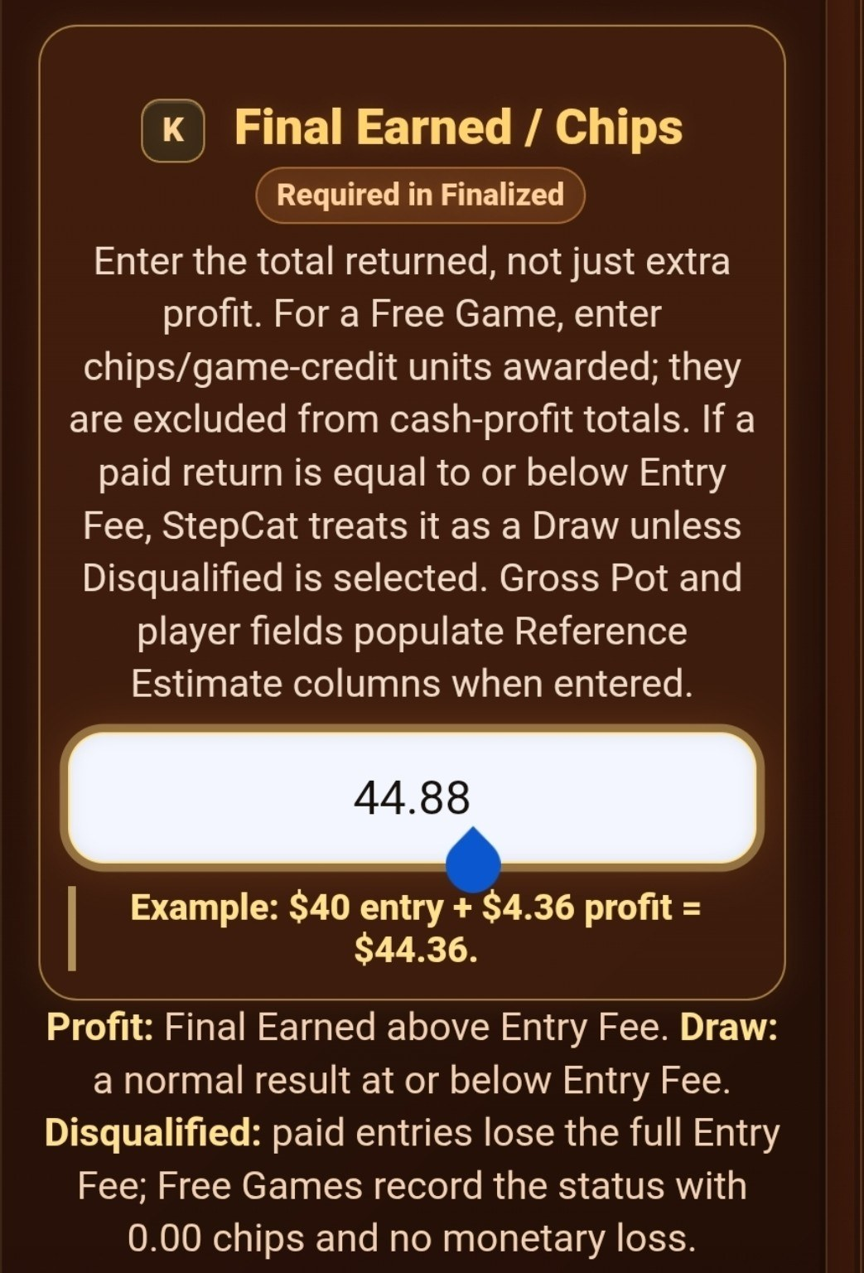  Enter the official Final Earned amount

4. Add notes, then calculate and save
Use Notes for optional details such as a Hybrid cash-and-points breakdown. Calculate & Save validates the entry and stores one Saved History result.
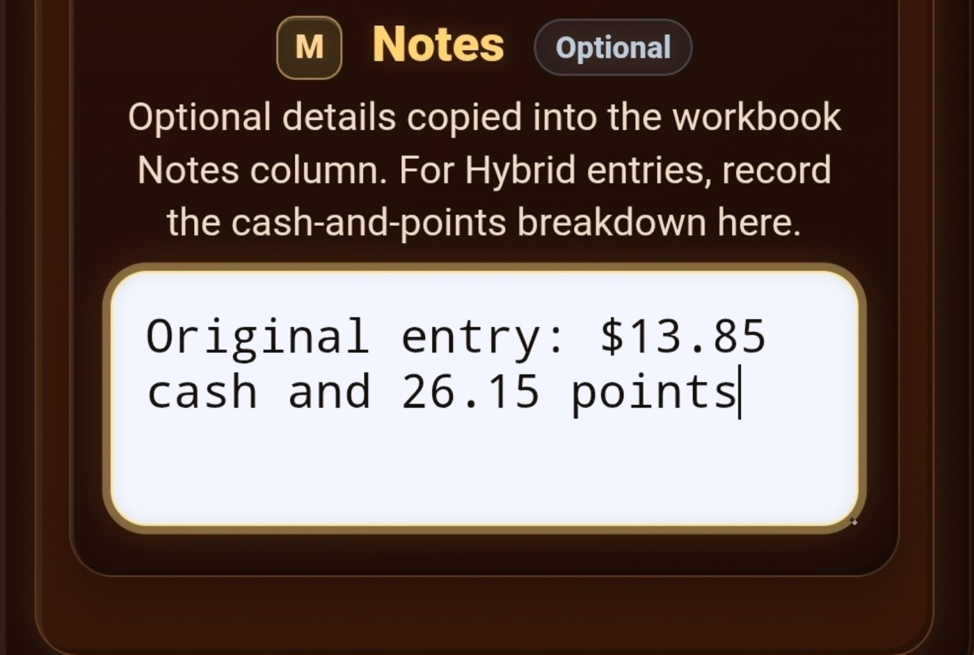
Use Notes for cash-and-points details
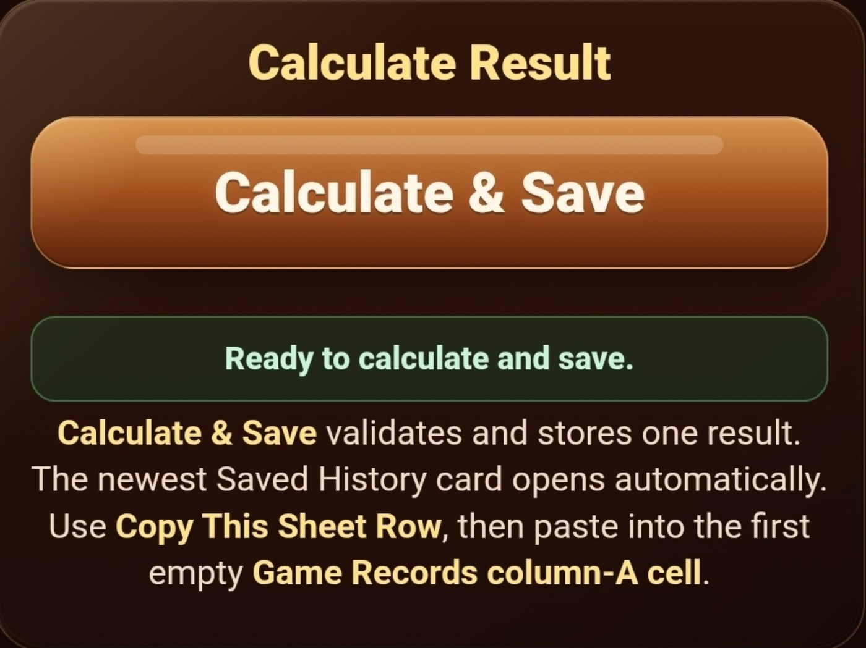
Calculate and save the record

5. Review Saved History
The newest saved result opens automatically. Review the outcome, official amount, profit or draw, ROI, record details, and reference estimate before copying.
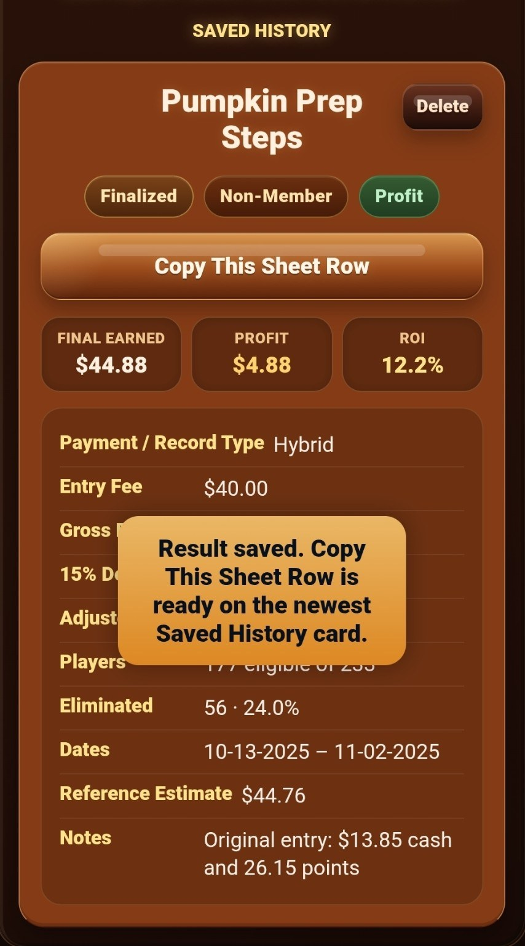  Newest Saved History result | 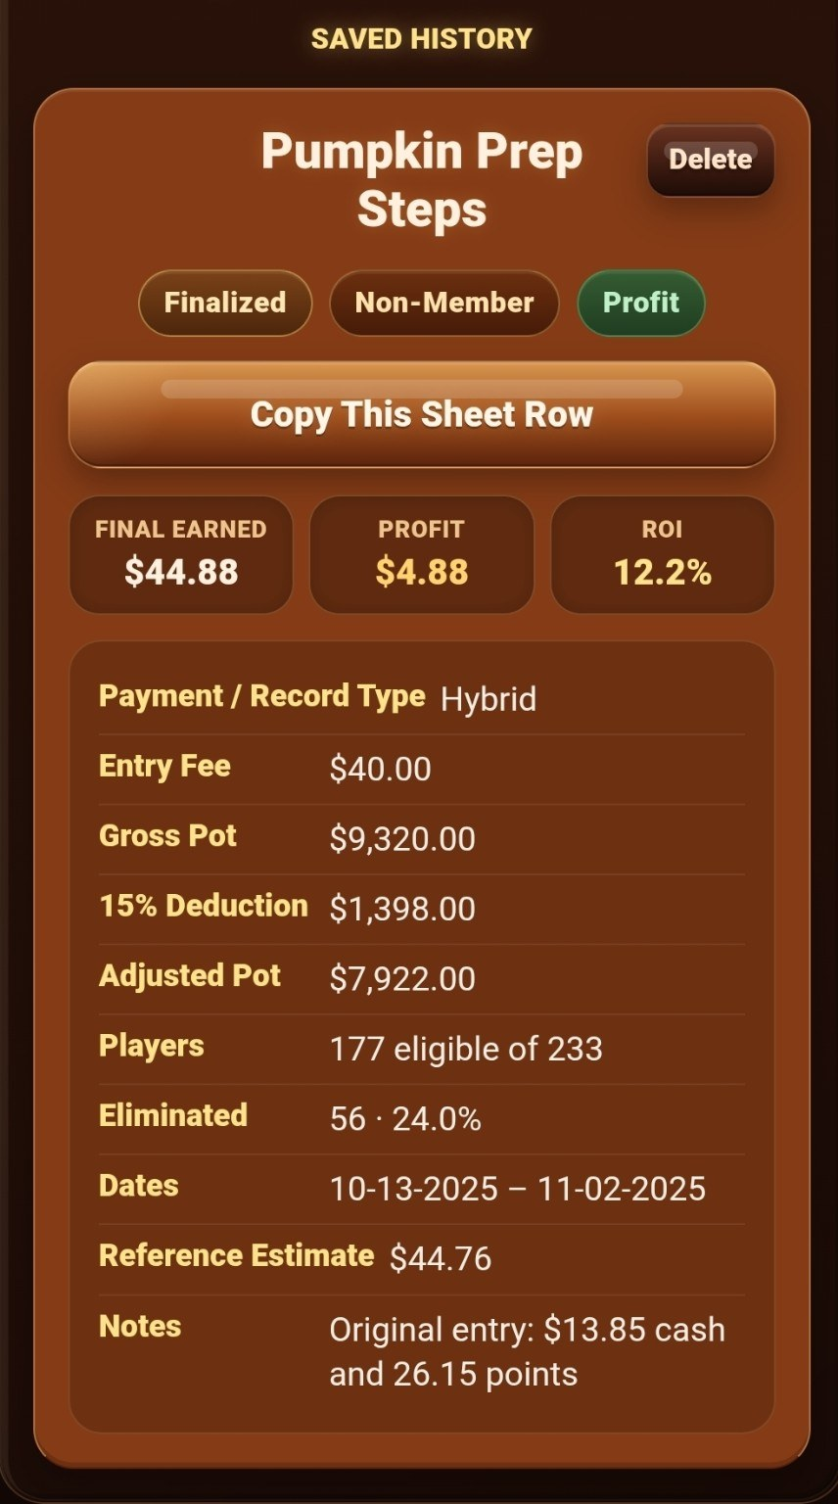  Full Saved History card

6. Copy the row into the workbook
Tap Copy This Sheet Row. Open your native StepCat Google Sheet and go to Game Records. For a new record, select the next prepared blank cell in column A beginning with A5. For a forgotten game, select a cell inside the table near the correct location and insert a row above or below. Paste into column A only and never overwrite N-Z. The inserted row automatically receives formulas, dropdowns, formatting, and visible borders.
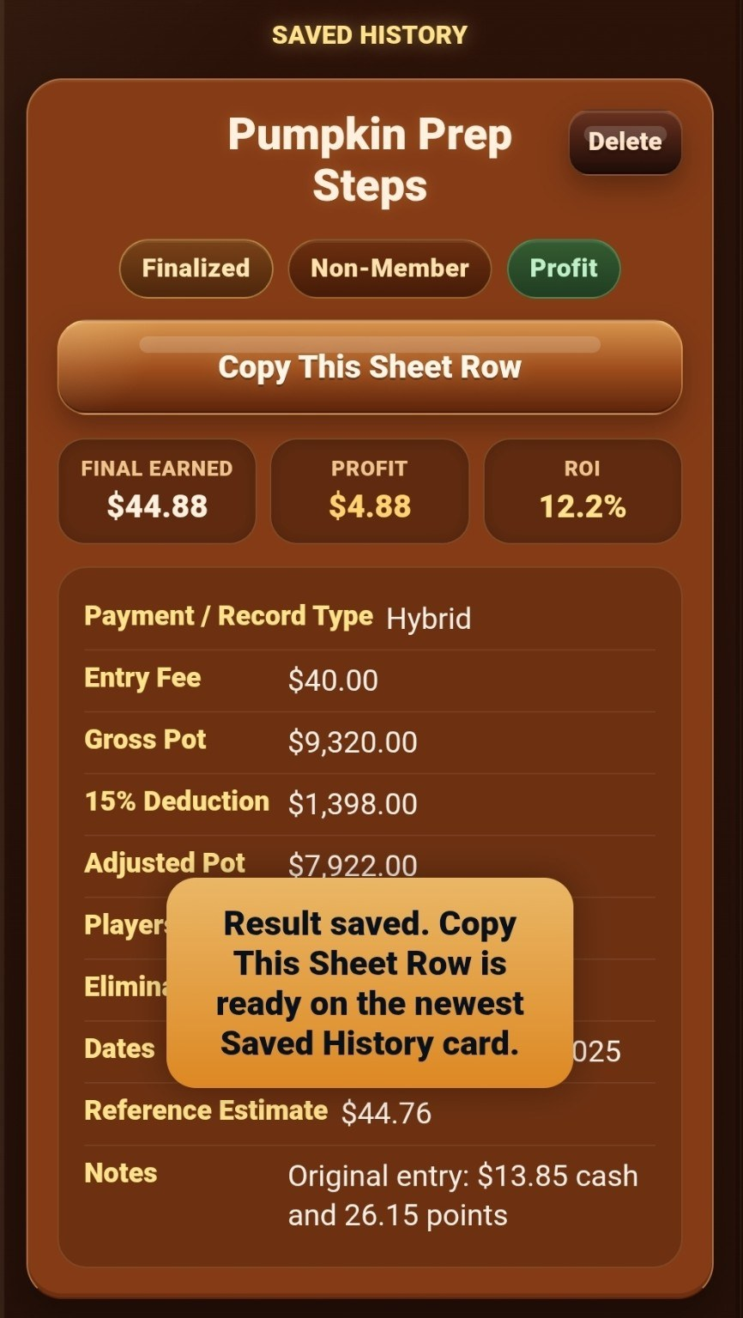  Copy the workbook row | 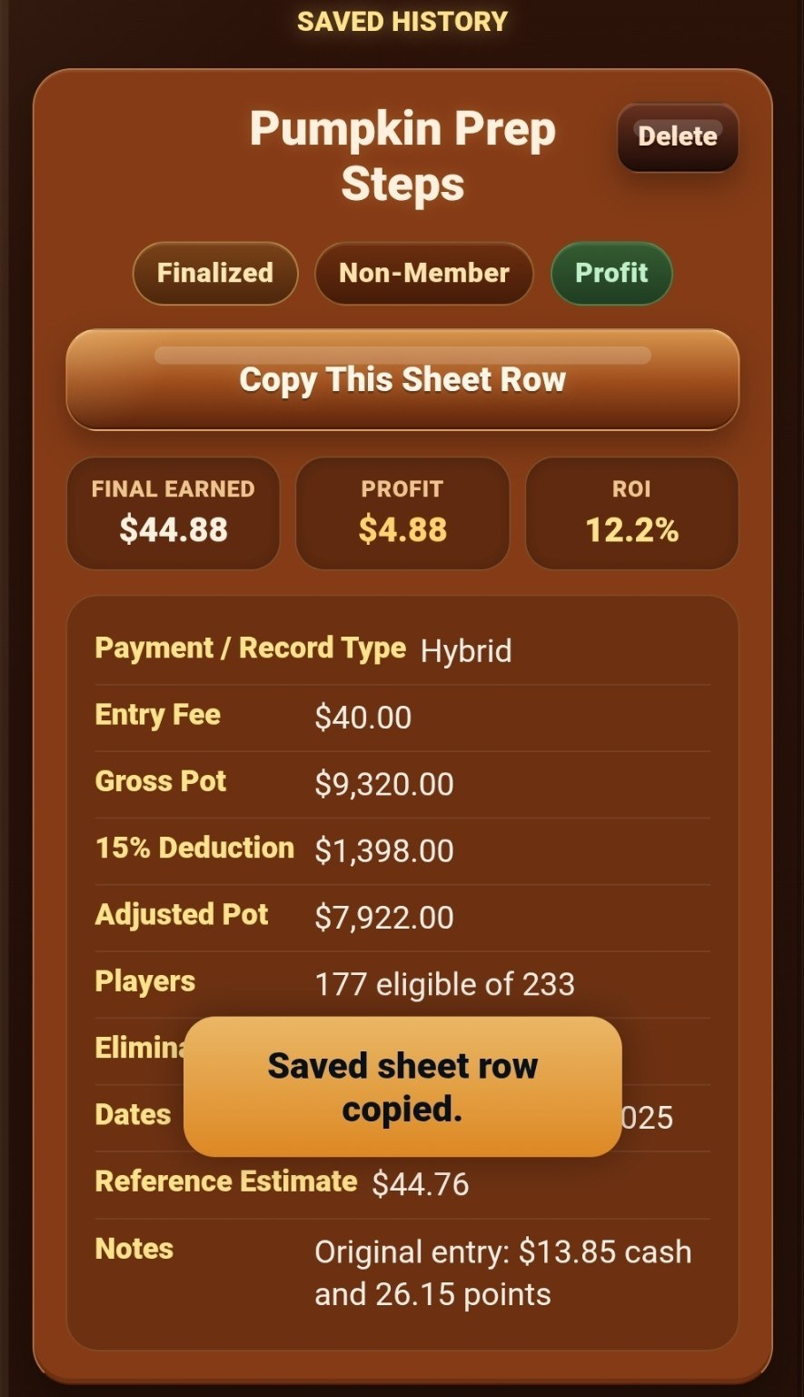  Sheet row copied

7. Make your own Google Sheets copy
Tap Make a StepCat Google Sheets Copy. In Google Sheets, choose Make a copy. You may keep the suggested title or rename it. My Drive is the default destination; tap the arrow beside Folder only when you want to select another Google Drive folder. Tap OK to create the editable native workbook.
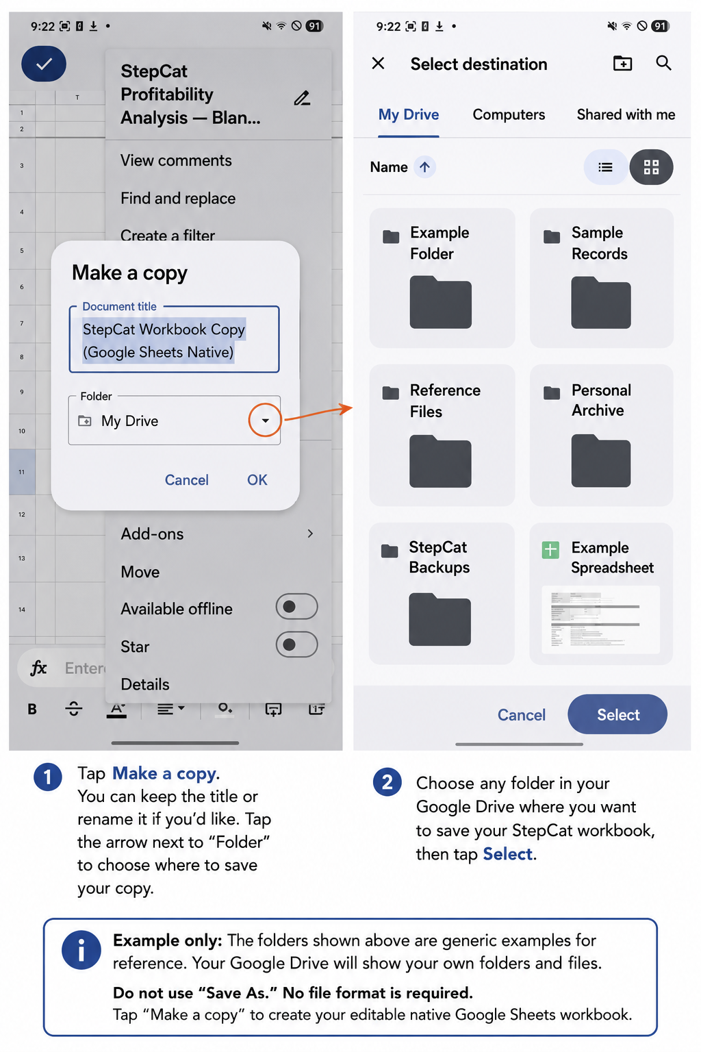
Example only for privacy: the folders and files shown are generic placeholders. Each user will see their own Google Drive folders and files.
Do not use Save As. No file format is required. Save As exports the workbook instead of creating the native Google Sheets copy used by StepCat.

8. Follow the workbook instructions
The Instructions sheet explains new records, native Google Sheets row insertion, formula recovery, and which columns calculate automatically. In Game Records, rows 1-4 remain compact and frozen.
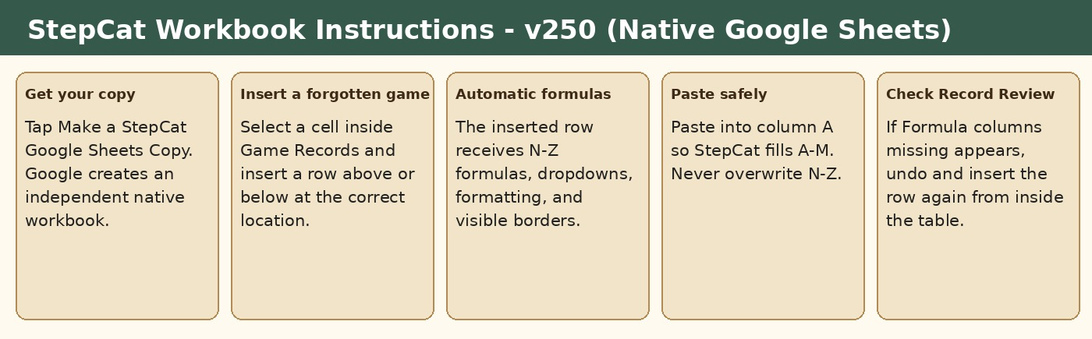
Workbook instructions and entry guidance
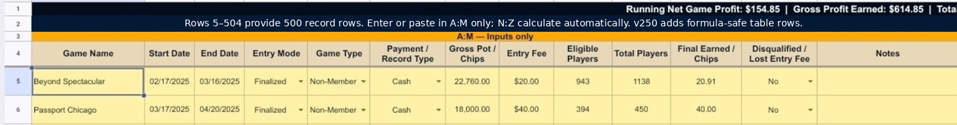
Compact frozen headings in Game Records

9. Enter values in A-M and leave N-Z intact
The frozen headings remain visible while you scroll. Enter or paste only in the yellow A-M input area; the blue N-Z columns calculate automatically. Free Games show N/A in N and O when the estimate cannot be calculated, and disqualified games show $0.00 in Final Earned / Chips. Changes made later in A-M recalculate whenever the N-Z formulas remain present.
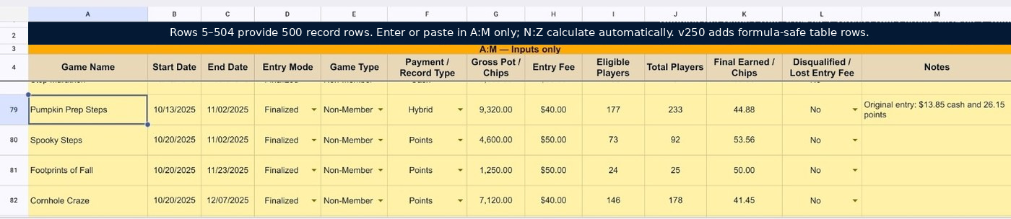
Frozen headings remain visible while scrolling
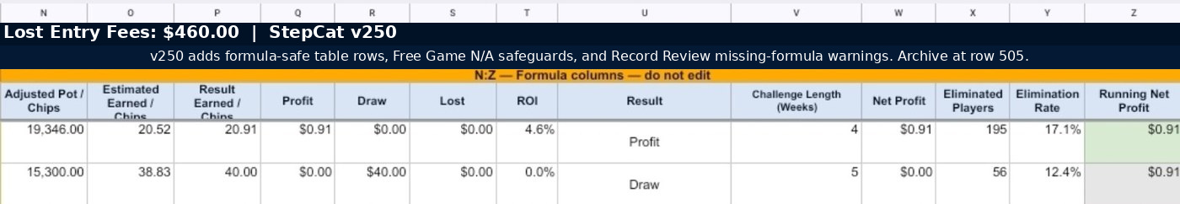
Formula columns N-Z calculate automatically

10. Use Record Review to check the workbook
Record Review lists each non-subscription game, identifies the calculated result, flags blank fields that may deserve attention, mirrors notes, and shows review totals. In v250, it also reports Formula columns missing when a populated record has lost one or more N-Z formulas.
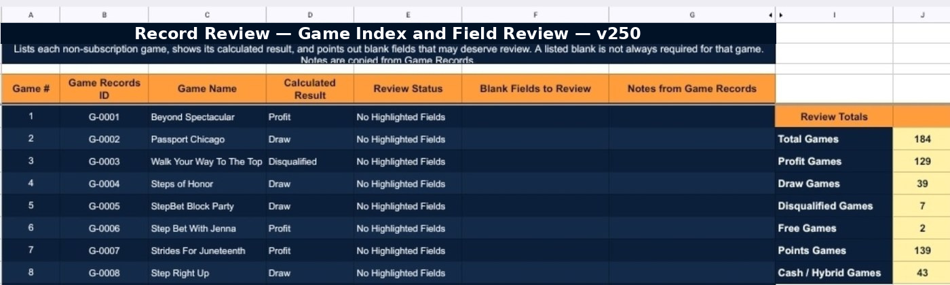
Record Review checks fields and summarizes results
Final workbook check
For a new game, paste into the next prepared blank cell in column A.
For a forgotten game, insert a row above or below from inside the Google Sheets table.
Keep formulas in columns N-Z unchanged; Record Review warns when they are missing.
Free Games may show N/A in N and O; disqualified games show $0.00 in K.
Visible cell borders remain across the Game Records table.
Subscription rows are workbook-only non-game costs.
Archive the workbook when the record area reaches row 505.

11. Send feedback from Help
Open Help (?), scroll to Guides & Downloads, and tap Write Feedback. The feedback form opens over the Help drawer, so Cancel returns to the same location.
- Enter a question, issue, or suggestion.
- Tap Send Feedback.
- Review the prepared recipient, subject, and message in your email app.
- Send the email, then swipe back or return to StepCat. Help remains open at the same location when the browser preserves the page.
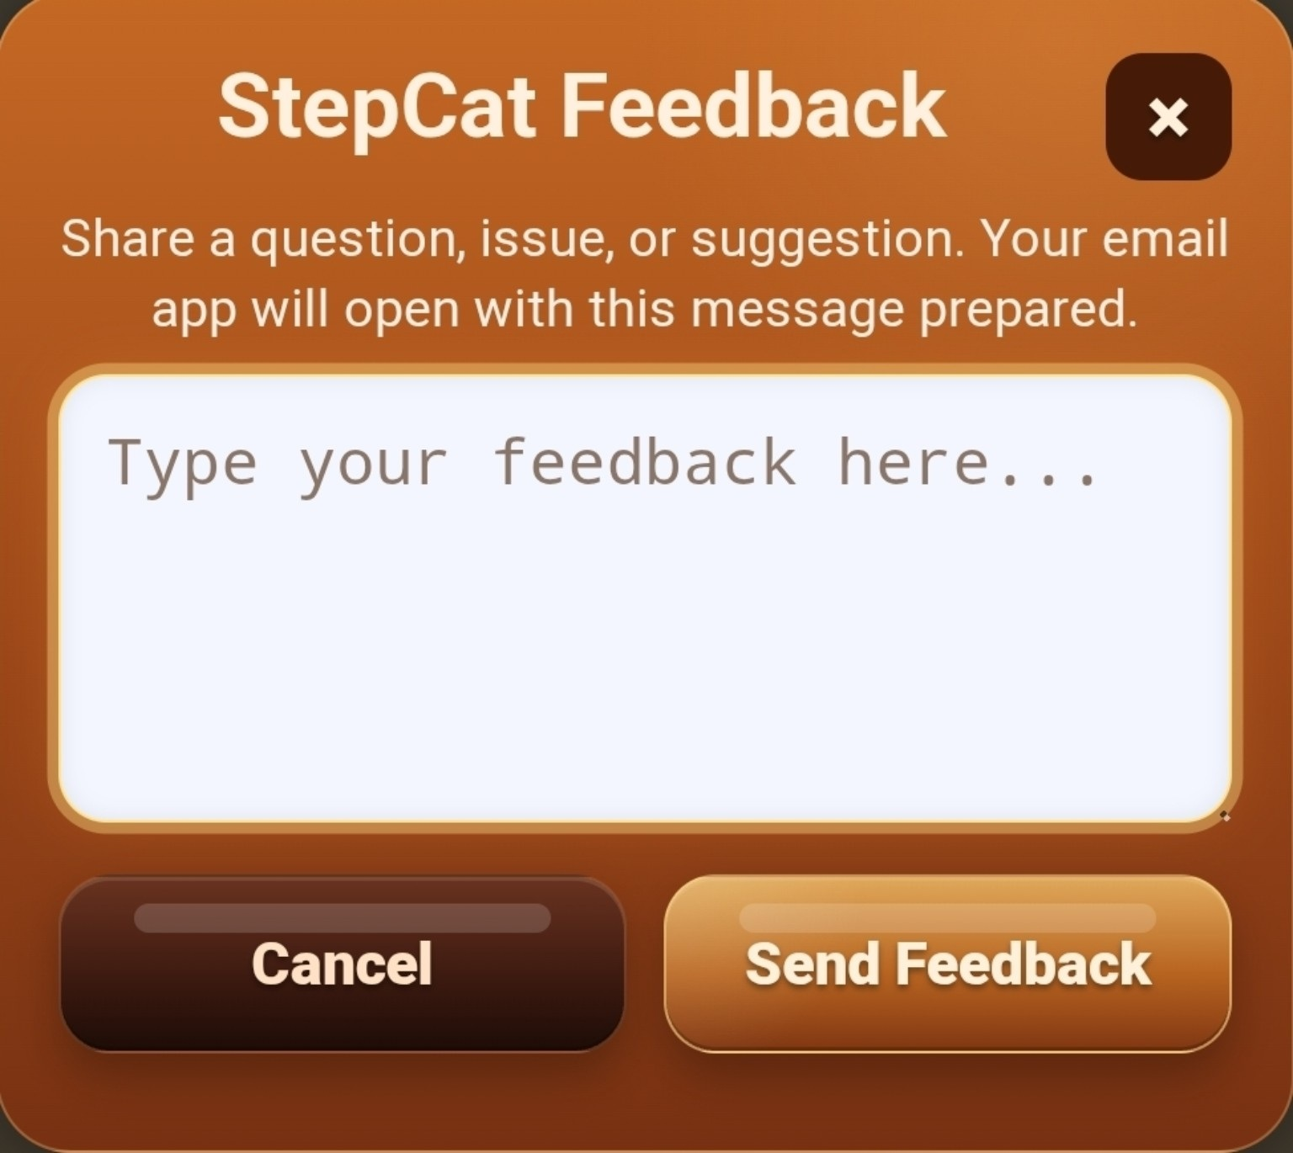  Enter a question, issue, or suggestion | 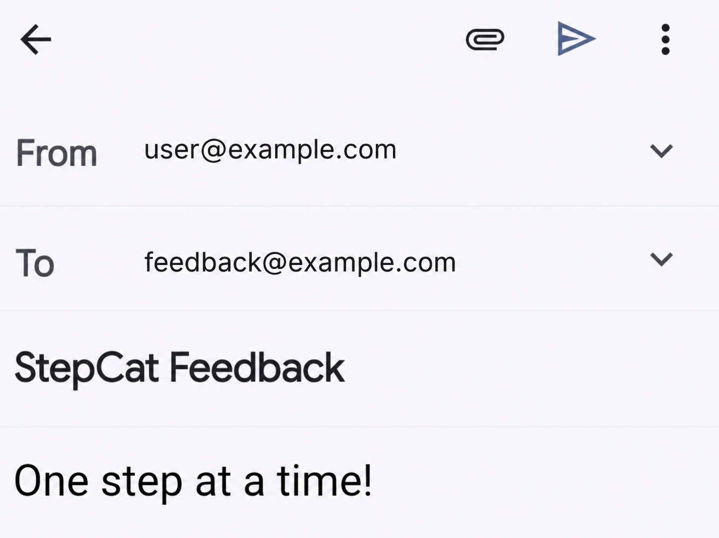  Email opens with the message prepared
Privacy note: The addresses shown in the guide image are generic examples. StepCat does not place a feedback email address in the workbook. The actual recipient appears only when the device prepares the email.
Get the public workbook: https://docs.google.com/spreadsheets/d/1STrfkd-GI7LL8BBIaPv6v3YtSv4oQKqP8LL_GvDmTj4/copy
Requires a free Google account. Mobile users should use the Google Sheets app; the Google Drive app is optional. Choose Make a copy—not Save As—so no file format selection is needed.

