StepCat
Payout Calculator - Quick Start Guide
StepCat Calculator v253.1 + Profitability Workbook v253.3
August 31, 2026 workbook v253.3 clarity update

Release note: Workbook v253.3 is the current recommended workbook with StepCat Calculator v253.1. It retains the finalized v253.2 formulas and reports, shortens the annual membership record label to Membership Fee, and aligns the guides with the current user-facing workflow.
All illustrations remain genuine screenshots. Several Guided Entry, navigation, and workbook images are scheduled for fresh v253.3/current-calculator recapture after this refinement is approved; until then, older screenshots are labeled as layout references rather than altered to imitate a newer version.

Contents
- 1. Four-step entry workflow
- 2. Game Details and Calculation Information
- 3. Review, Calculate & Save
- 4. Settings
- 5. Help & Resources
- 6. Using the workbook
- 7. Workbook update and migration
- 8. Move Existing Records dialog
- 9. Google Sheets workbook structure
- 10. Record Review, Summary and Best Results
- 11. Installation, feedback, and troubleshooting
Fastest workflow: Choose Entry Mode (Step 1), confirm Membership Type (Step 2), complete Game Entry (Step 3), open Review Entry (Step 4), then choose Calculate & Save.
Record-copy rule: When moving existing records, copy only A5:M through the last actual record row. Do not copy unused yellow rows down to the red boundary, and never copy N:Z.

1. Four-step entry workflow
Choose Estimate for a projection or Finalized for a completed result. Membership Type is Step 2 and becomes available after Step 1 is confirmed. Gold indicates the current action; completed steps move to the completed state.
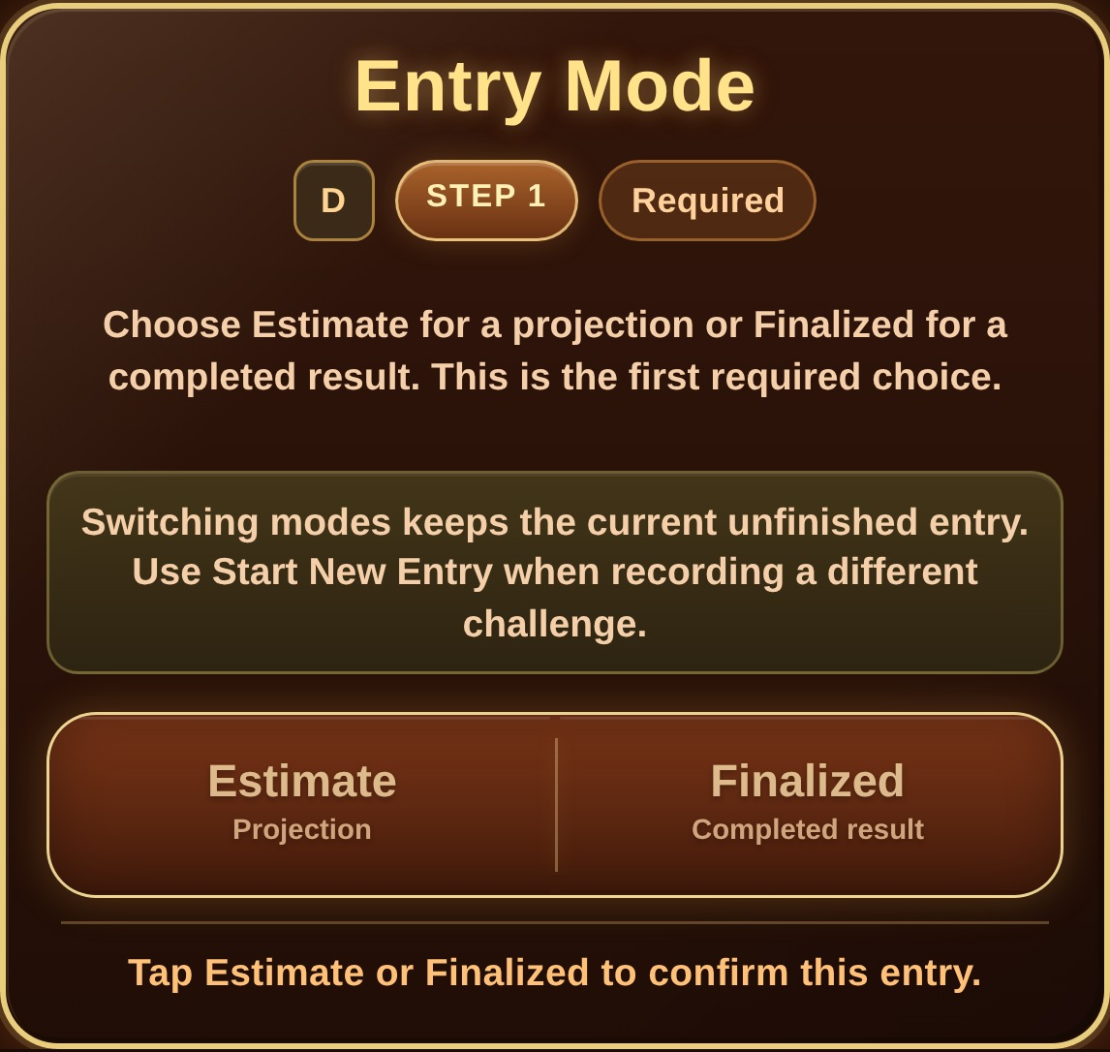  Entry Mode - Step 1, before a selection. | 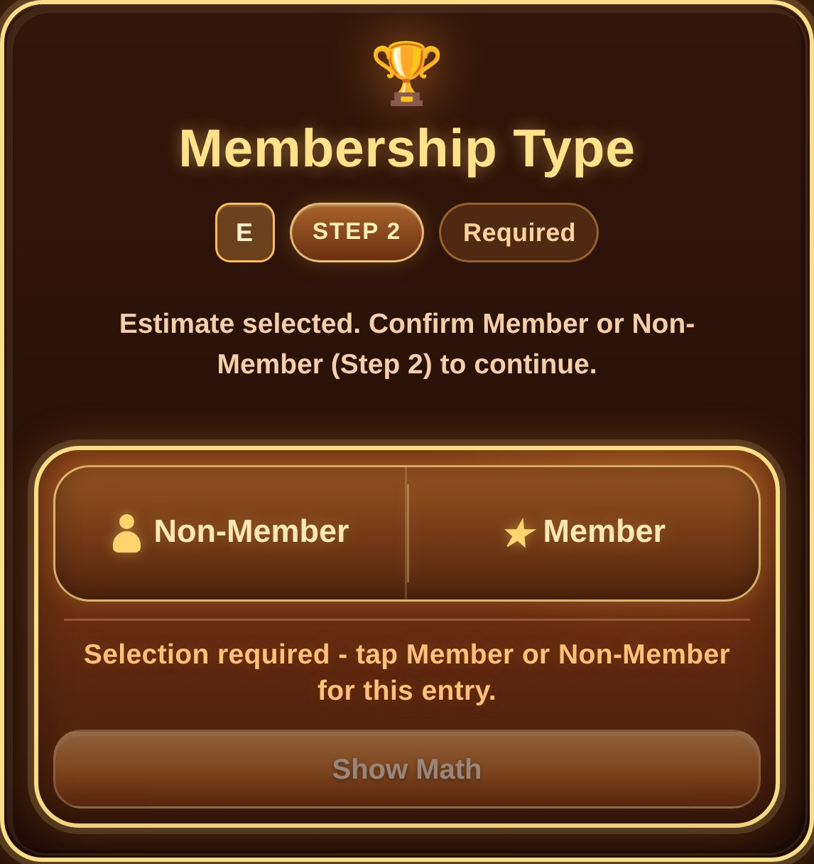  Membership Type - Step 2 after Estimate is selected.
Current Settings labels: Remember Estimate / Finalized Mode, Remember Game Entry Layout, Remember Membership Choice, and Remember Payment / Record Type.

2. Game Details and Calculation Information
Step 3 uses focused subsections in Guided Sections mode. Use Continue to move to the next subsection and Back to return to the previous one. Your entered values remain in place as you move between sections. Show All Fields displays the complete Step 3 form. Amount fields accept no more than two digits after the decimal. The example below is an Estimate for Step Marathon.
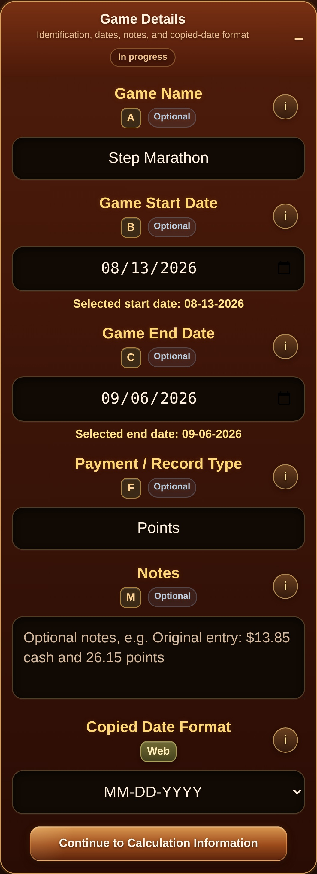  Game Details in Guided Entry. Continue moves to Calculation Information; Back returns without clearing entered values. | 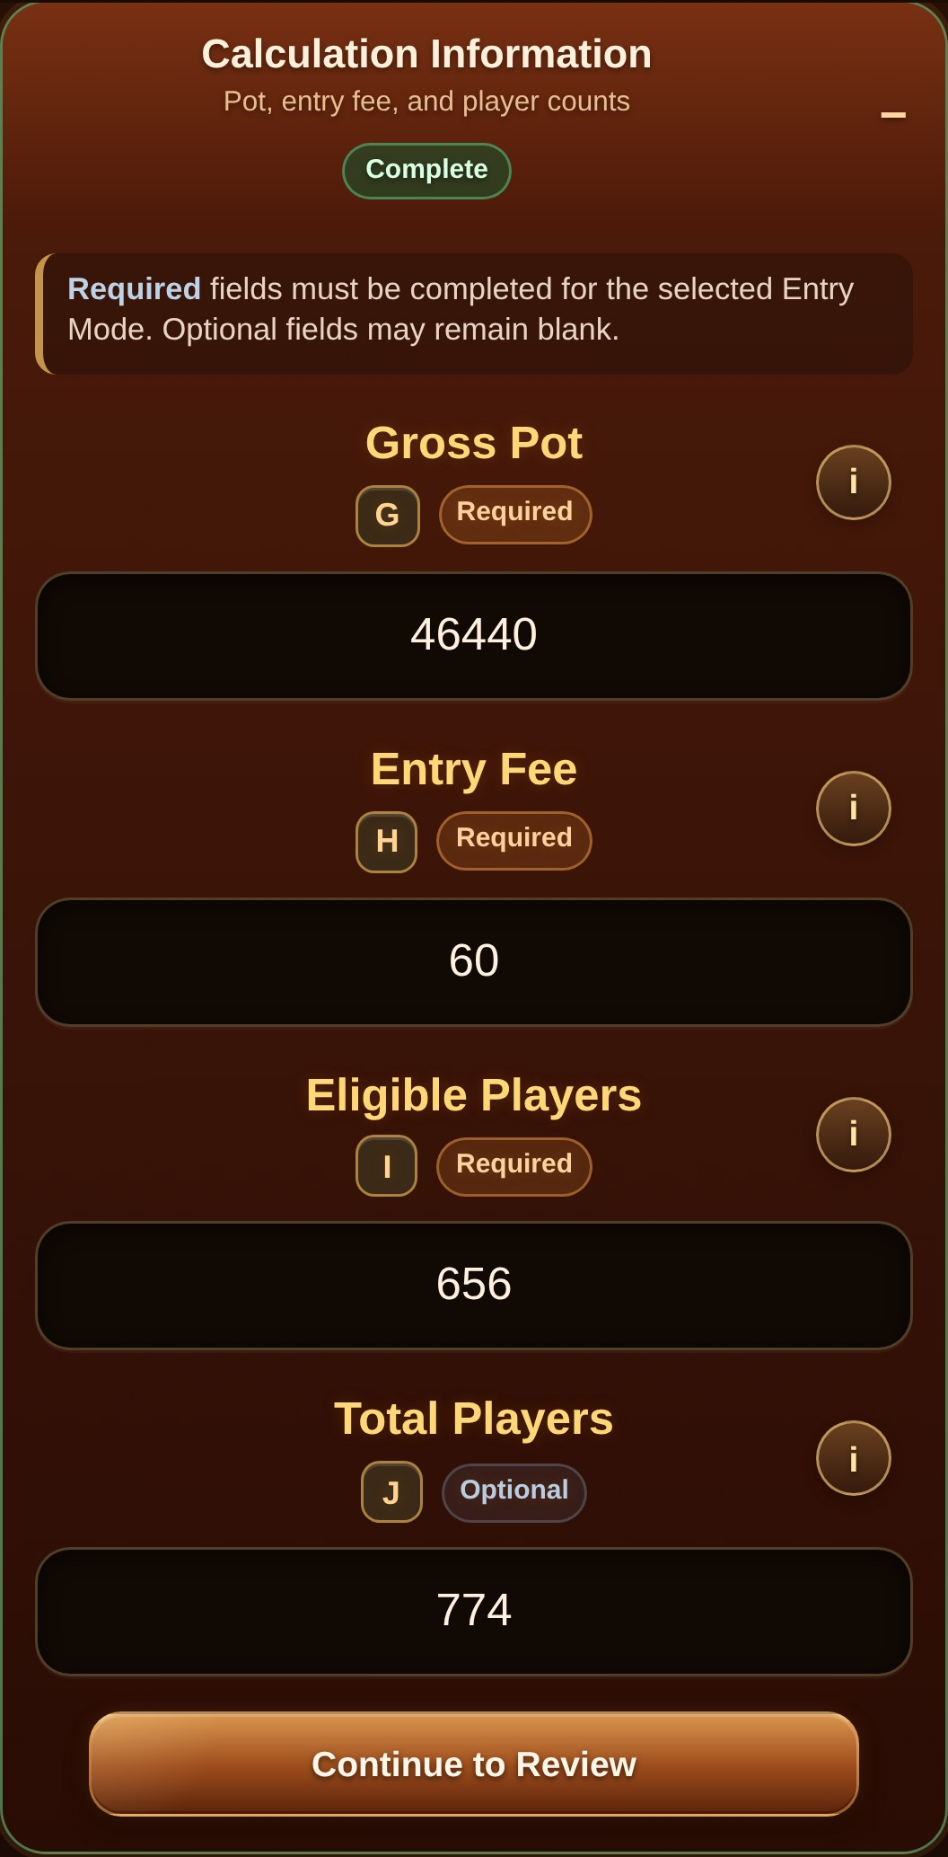  Calculation Information in Guided Entry. Complete the required values, then choose Continue to Review.
Estimate rule: An Estimate does not require Final Earned / Chips. Finalized entries require the completed result unless Disqualified / Lost Entry Fee is selected.

3. Review, Calculate & Save
When required Step 3 values are ready, choose Review Entry. In Guided Sections, Step 3 collapses and dims as a completed group so Step 4 Review becomes the visual focus. Step 4 shows the complete record before anything is saved. Use Edit beside any review group to return to the exact section that needs a correction, or Continue Editing to reopen the current Step 3 subsection.
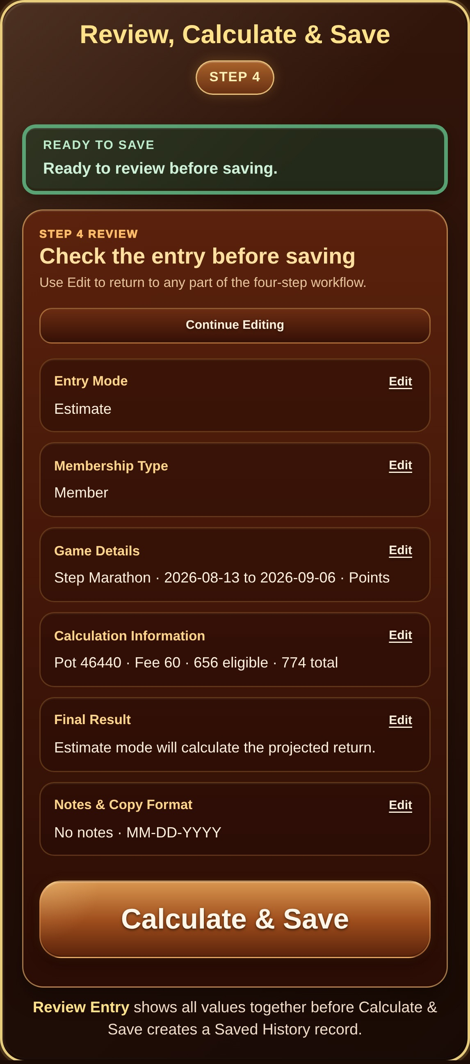
Step 4 Review Entry with Calculate & Save ready.
After a successful save: the completed fields remain visible for review during the current session, while that completed record is removed from unfinished-draft recovery. Use Start New Entry when you are ready to reset the form.
Before you save: Opening Review Entry does not save anything. A Saved History record is created only after you choose Calculate & Save.

4. Settings
Ordinary setting changes save automatically. Restore Defaults is the bulk reset action. These are the current v253.1 Settings groups and labels.
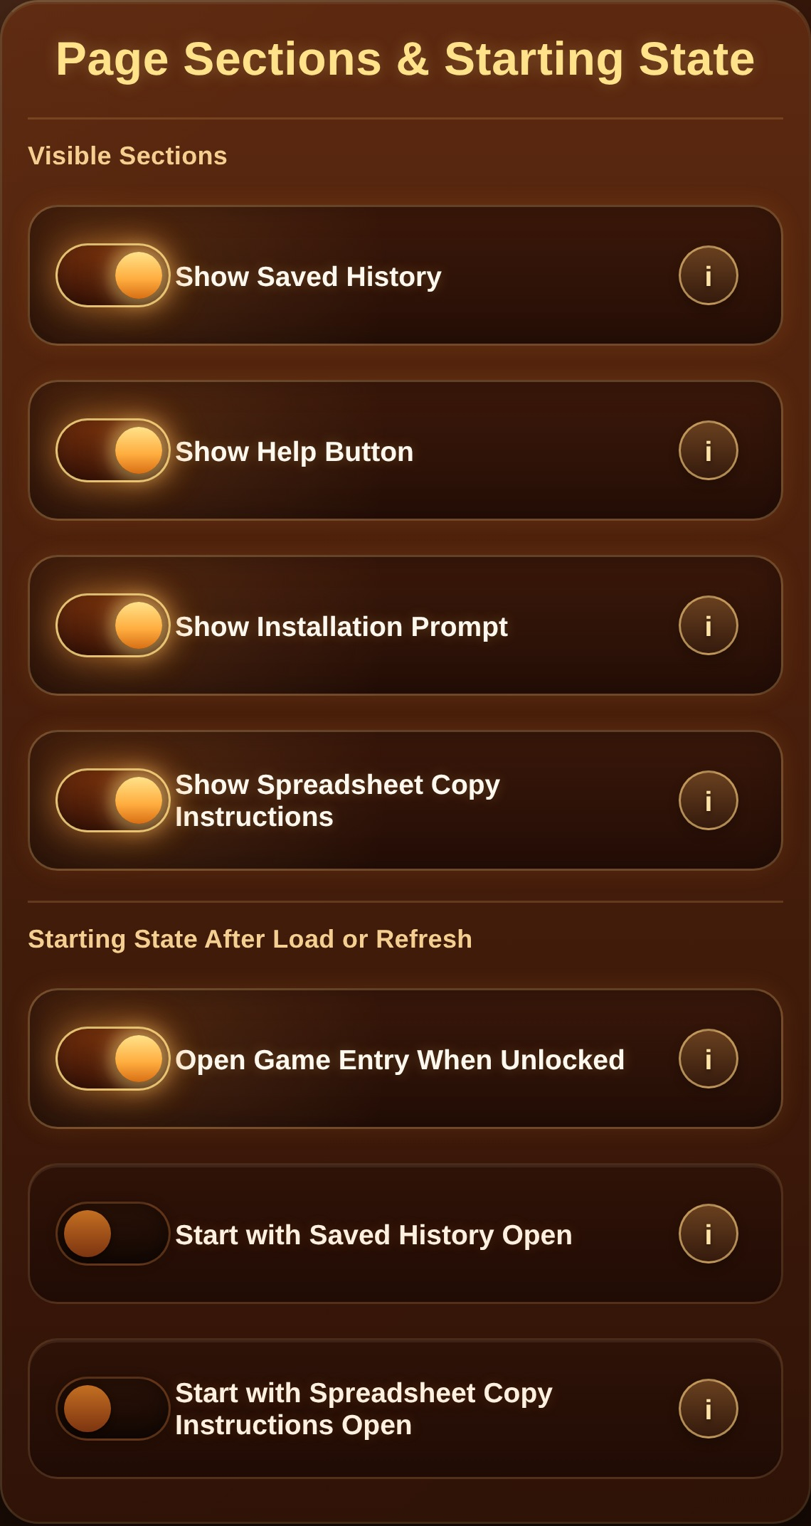  Page Sections & Starting State. | 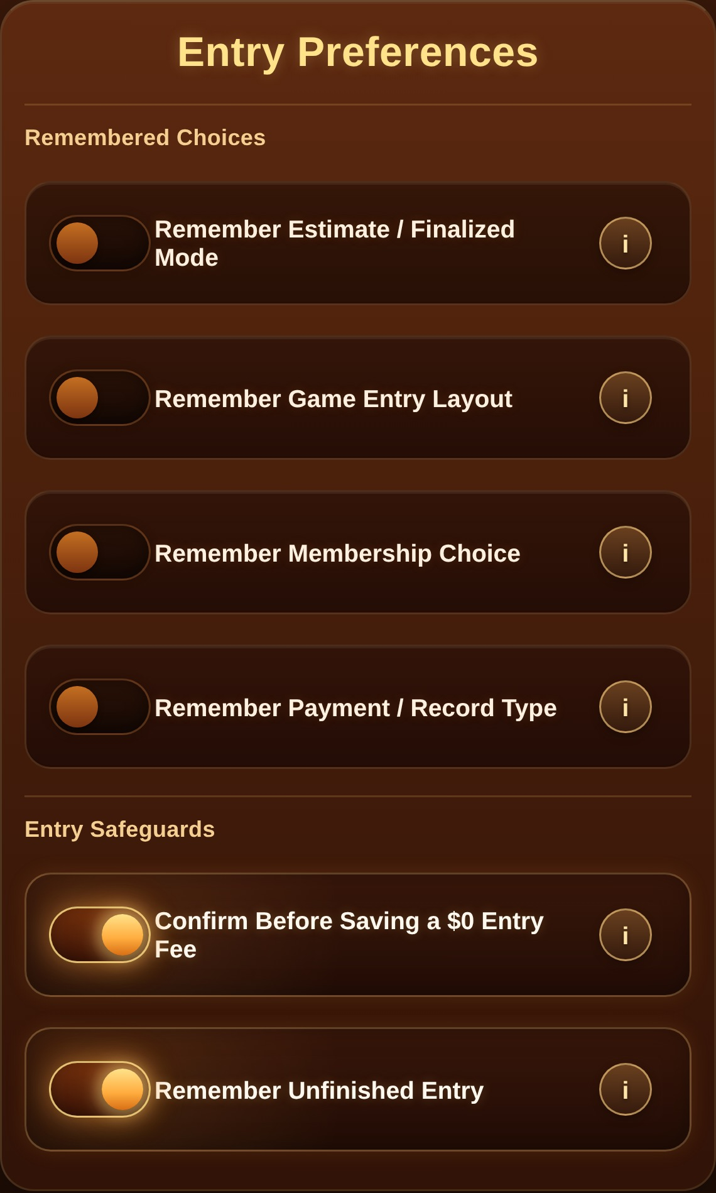  Entry Preferences and Entry Safeguards. | 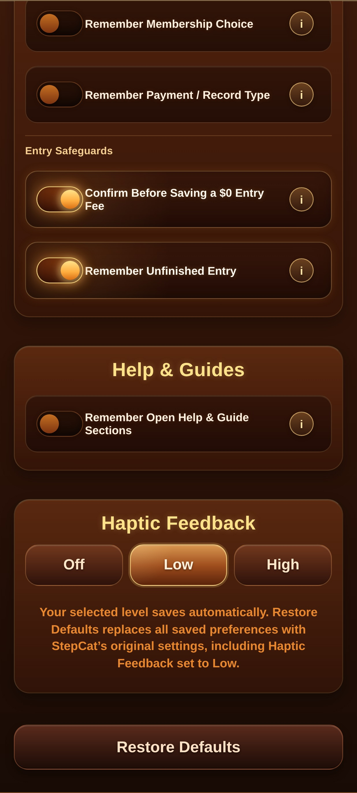  Help & Guides, Haptic Feedback, and Restore Defaults.

5. Help & Resources
Quick Explanations use the current topic name Using the Workbook. Guides & Workbook contains the current HTML guides, the Workbook v253.3 Google Sheets link, migration dialog, PDF, and editable DOCX.
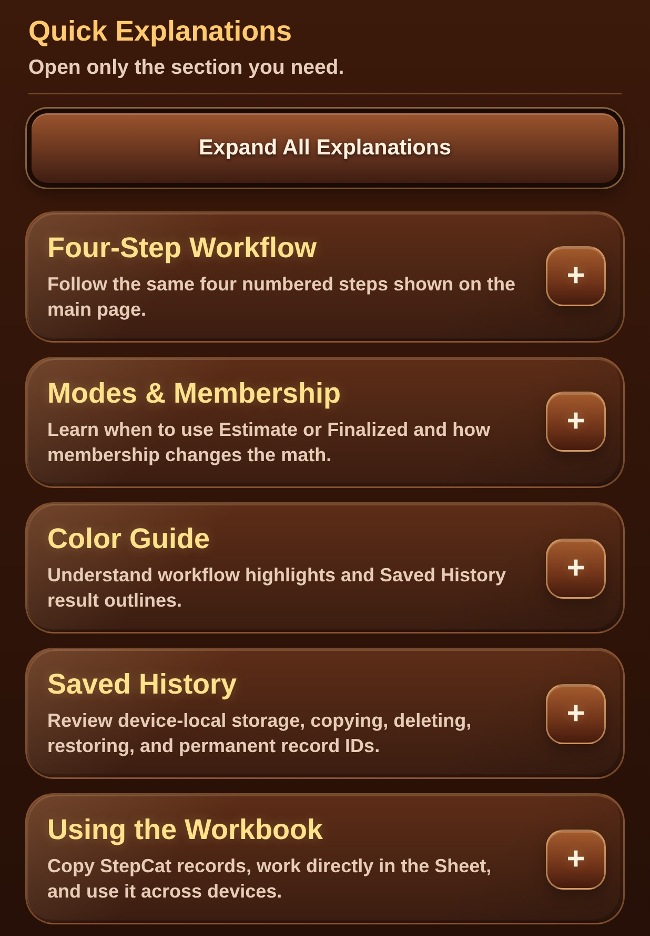  Quick Explanations overview. | 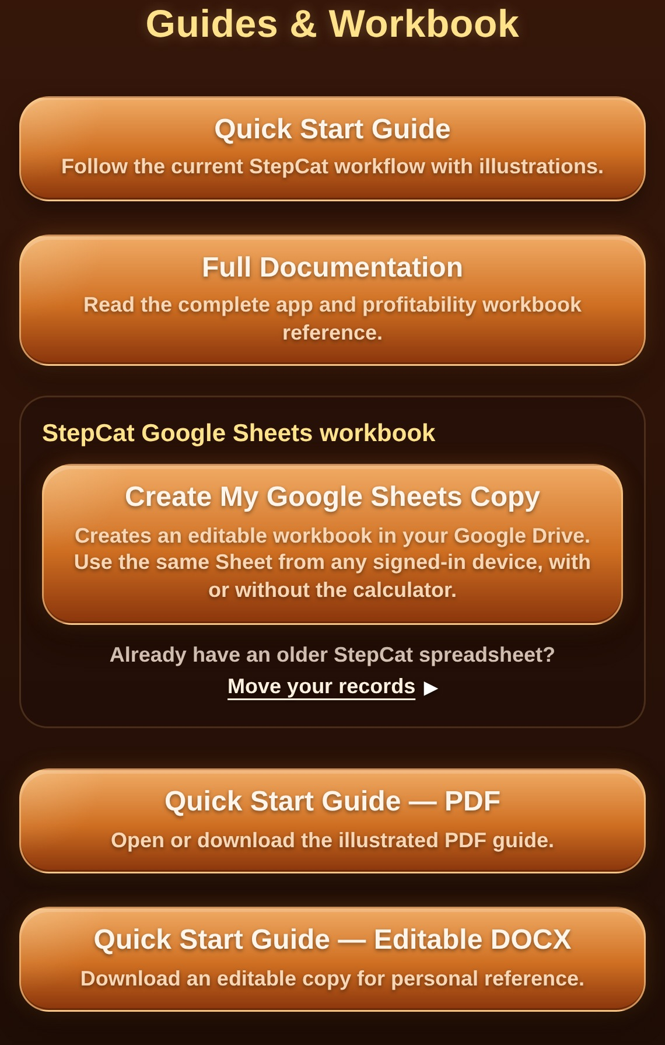  Previous v253.1 Guides & Workbook screenshot shown for layout reference; current workbook action opens Workbook v253.3.

6. Using the workbook
The Google Sheet is the permanent cross-device record. Enter or paste A:M only. Leave N:Z untouched so protected formulas calculate results and reports automatically.
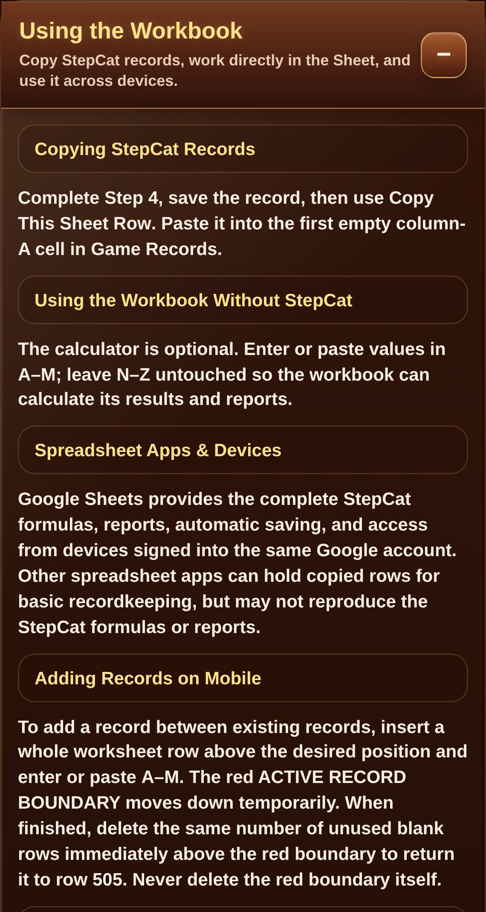  Direct workbook use, devices, and mobile row insertion. | 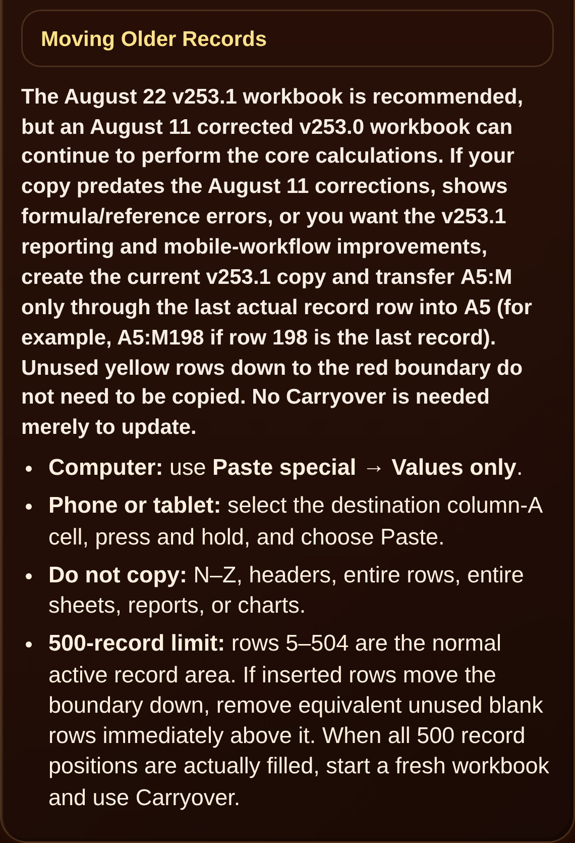  Previous v253.1 migration screenshot shown for layout reference; current workbook is v253.3.
Mobile insertion: Insert a whole worksheet row above the desired position, enter or paste A:M, then remove the same number of unused blank rows immediately above the red boundary so it returns to row 505. Never delete the red boundary itself.

7. Workbook update and migration
Workbook v253.3 is recommended. It keeps the v253.2 calculation and reporting structure while shortening the annual membership Payment / Record Type to Membership Fee. Earlier corrected workbooks may remain in use if they are calculating normally, but v253.3 is the current recommended public workbook.
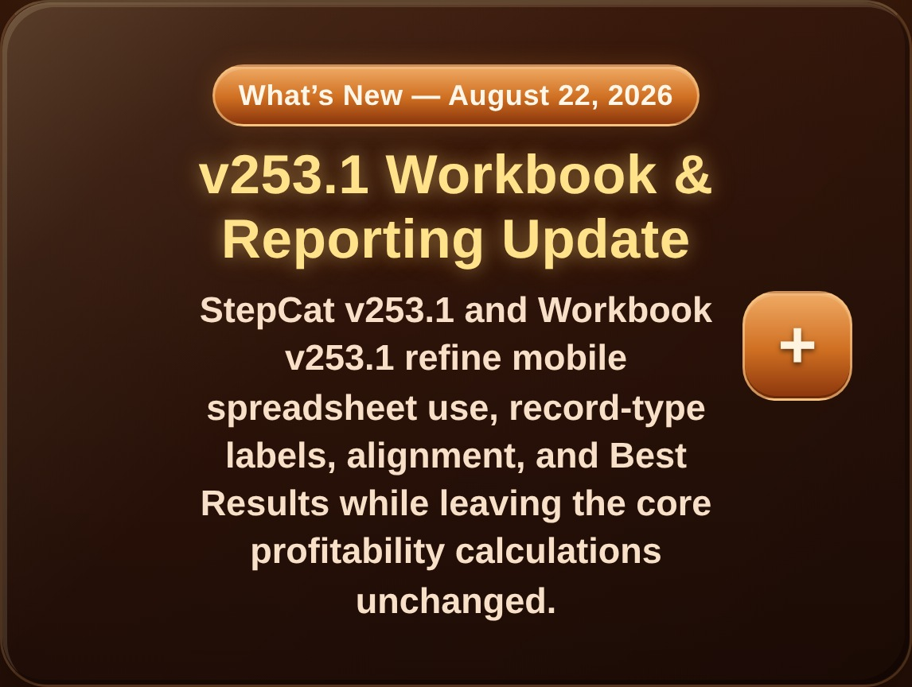  Previous v253.1 What's New overview shown for layout reference; current workbook is v253.3. | 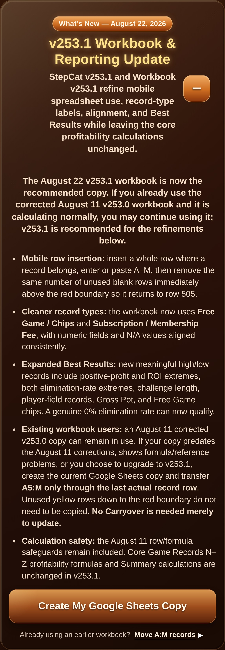  Previous v253.1 Workbook & Reporting Update shown for layout reference; current workbook is v253.3.
- Copy A5:M through the last actual record row (for example A5:M198 if row 198 is the last record).
- Do not select unused yellow rows down to the red boundary. Include blank rows that occur between existing records.
- Computer: Paste special -> Values only. Mobile: regular Paste is acceptable when only A:M are selected.
- Do not copy N:Z, headers, entire rows, entire sheets, reports, charts, or the red boundary.
- No Carryover is needed merely to update. Carryover is for a fresh workbook after all 500 active record positions are actually filled.

8. Move Existing Records dialog
The corrected mobile dialog opens at its true top, scrolls to its true bottom, keeps an accessible close control, and browser/Android Back closes the dialog before leaving StepCat.
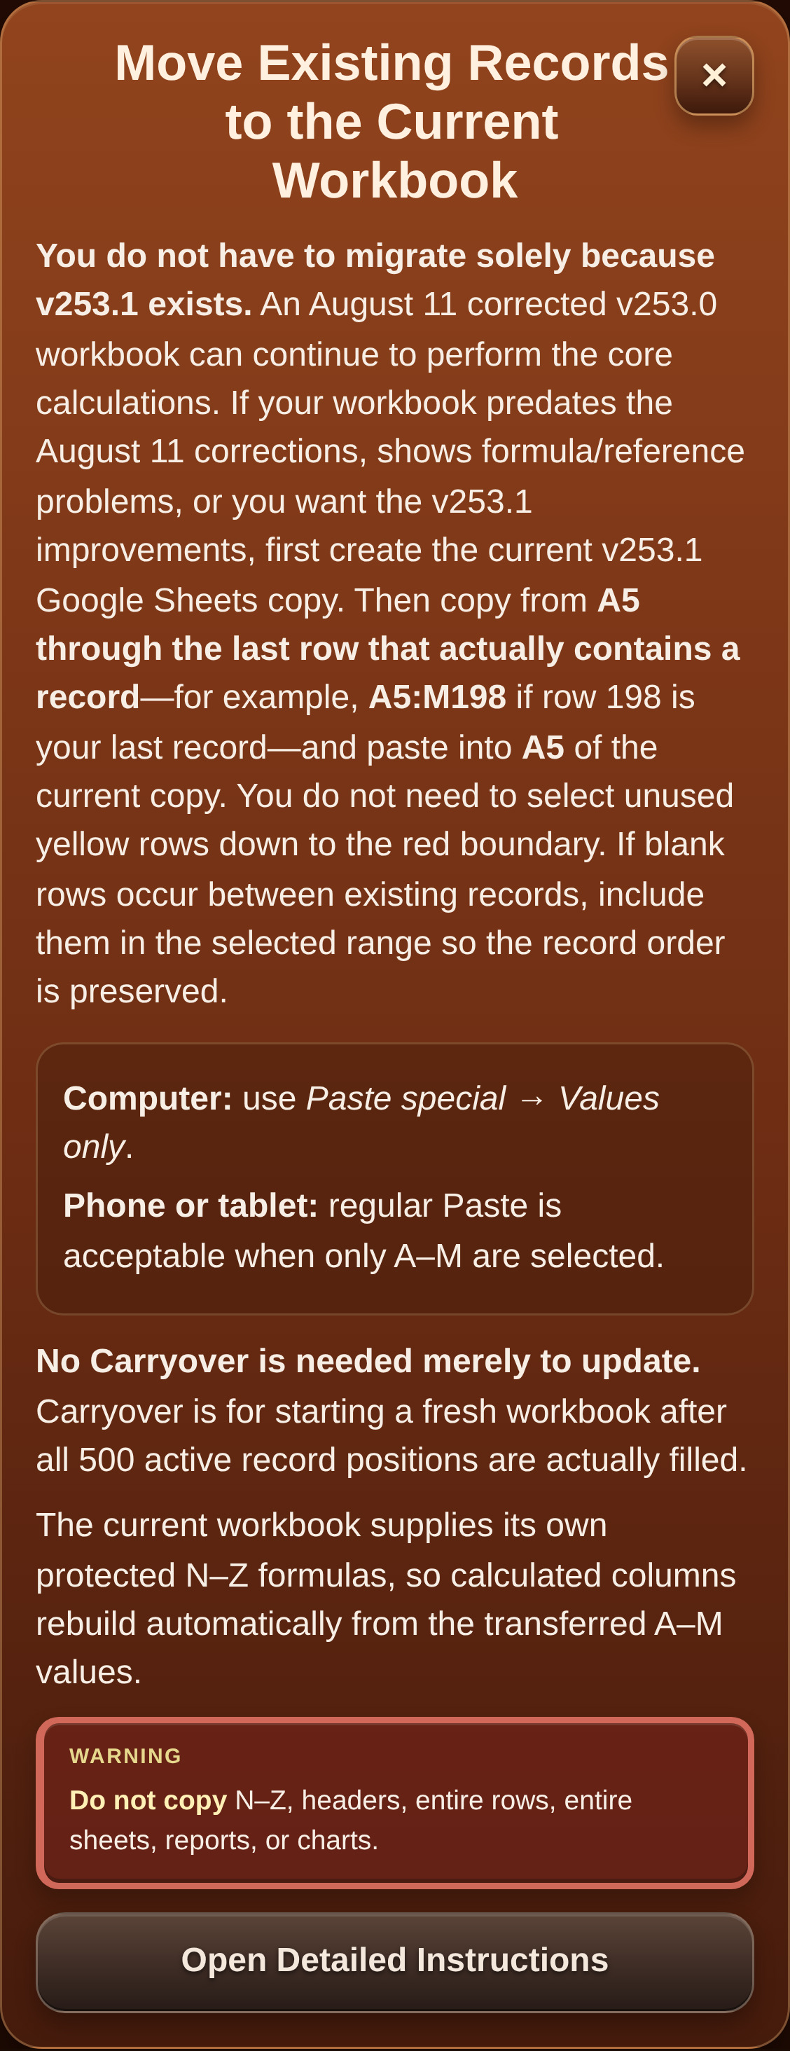
Previous v253.1 Move Existing Records screenshot shown for control/layout reference; current dialog points to Workbook v253.3.

9. Google Sheets workbook - Instructions
Workbook screenshots contain no personal records. Images that still visibly show an earlier workbook version are retained only as genuine layout references and will be replaced with fresh Workbook v253.3 captures after the refinement is approved.
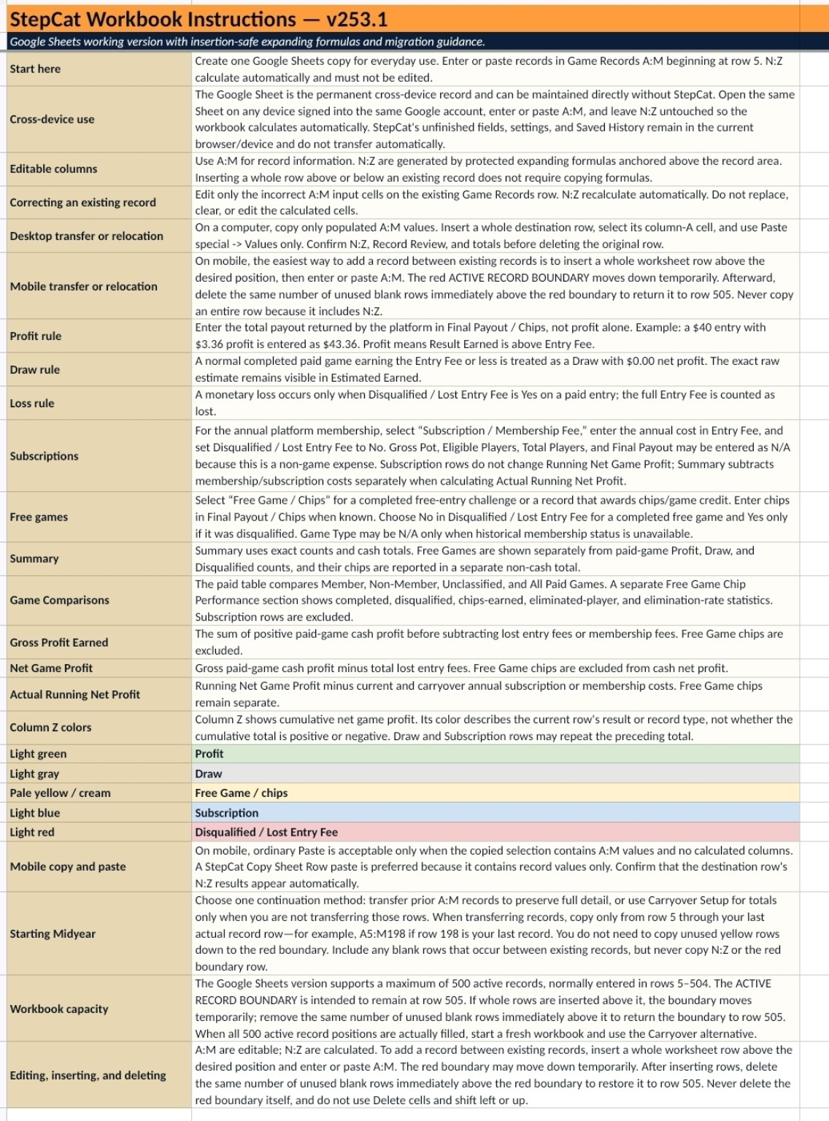
Upper Instructions sheet structure shown; current public workbook is v253.3.

9A. Carryover alternative
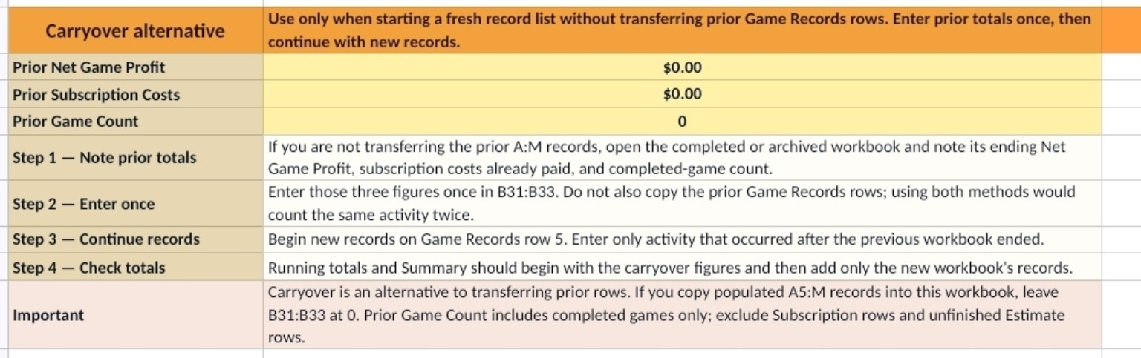
Lower Instructions sheet - Carryover alternative and its safeguards.
Carryover is an alternative, not an update step: If you transfer prior A:M records into the current workbook, leave Carryover values at zero. Use Carryover only when starting a fresh record list without transferring the prior rows.

10. Game Records A:M and N:Z
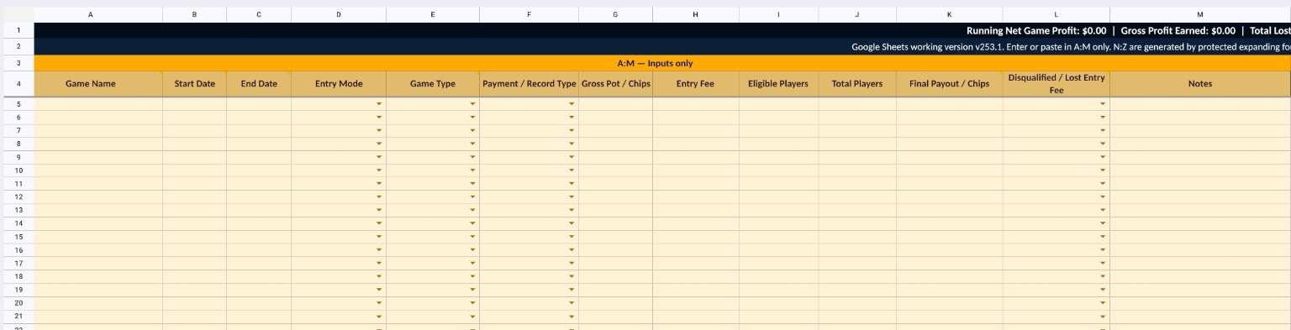
Game Records A:M - input columns only.
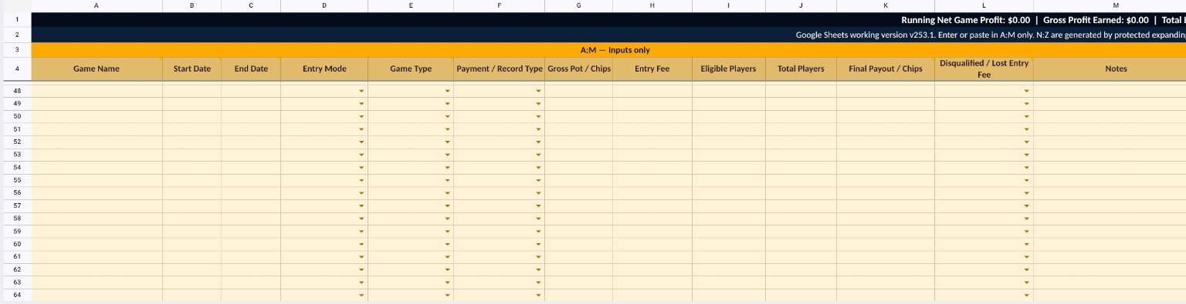
Game Records A:M farther down the sheet with rows 1-4 frozen.
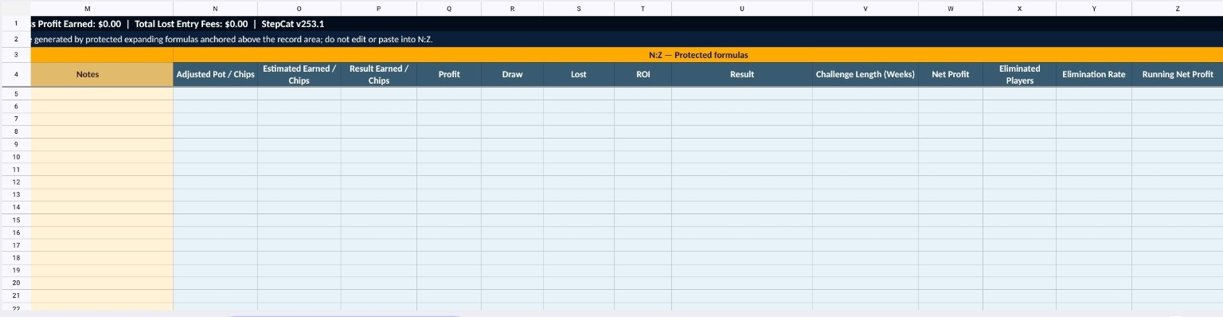
N:Z protected formula columns. Do not edit or paste into these columns.

11. Record Review, Summary and Best Results
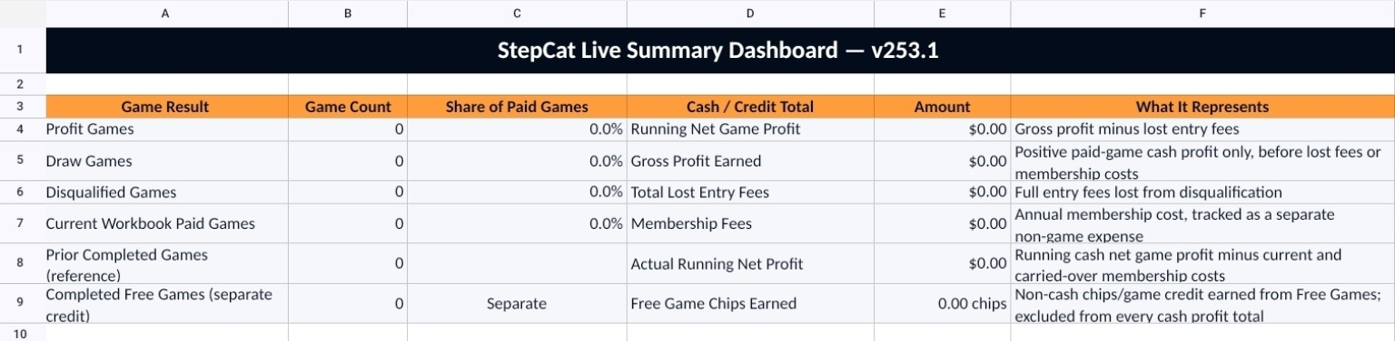  Summary dashboard with exact counts and financial totals. | 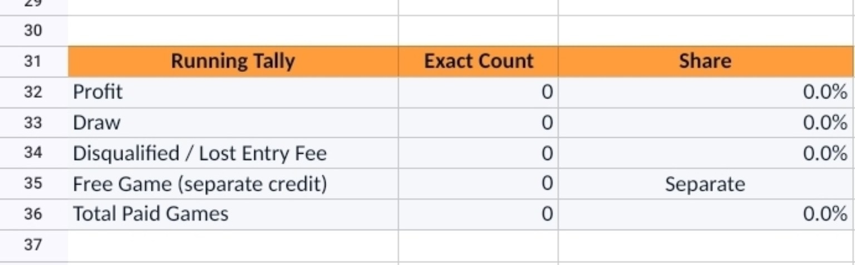  Running Tally with exact counts and shares.

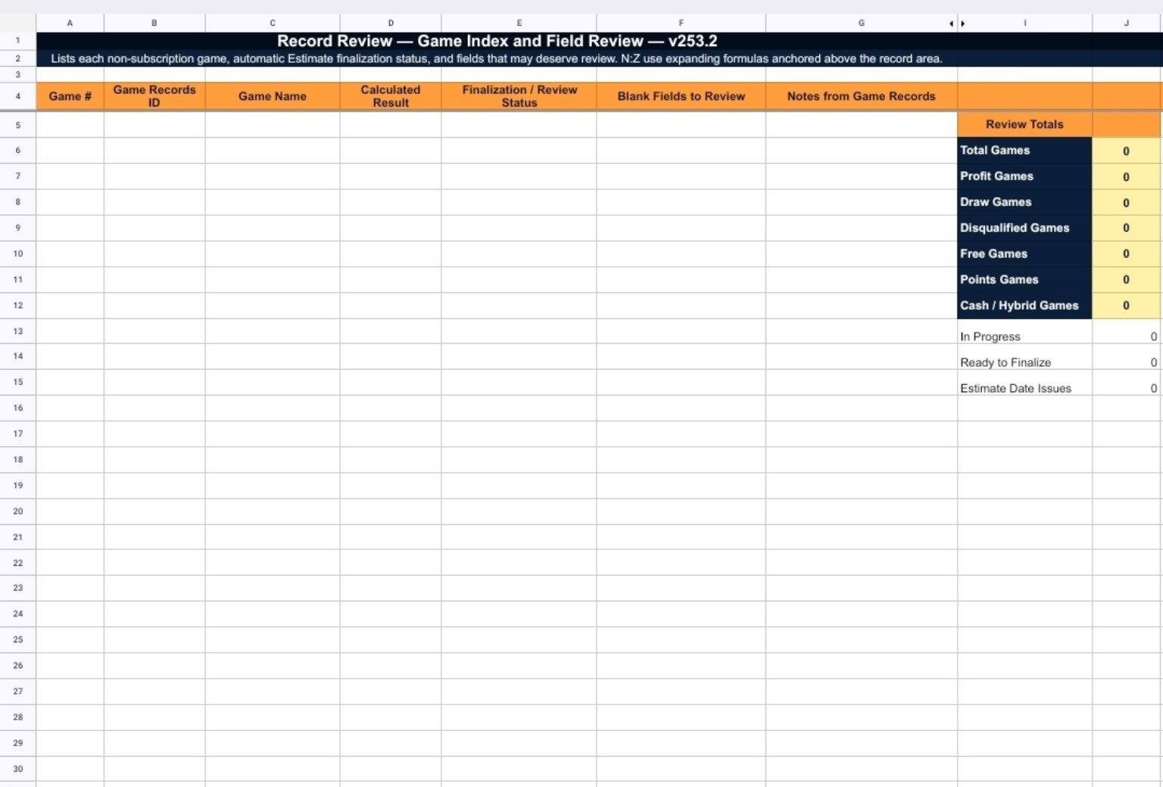
Previous Workbook v253.2 Record Review capture retained as a layout reference; the current v253.3 sheet keeps the corrected row sizing and will be recaptured after approval.

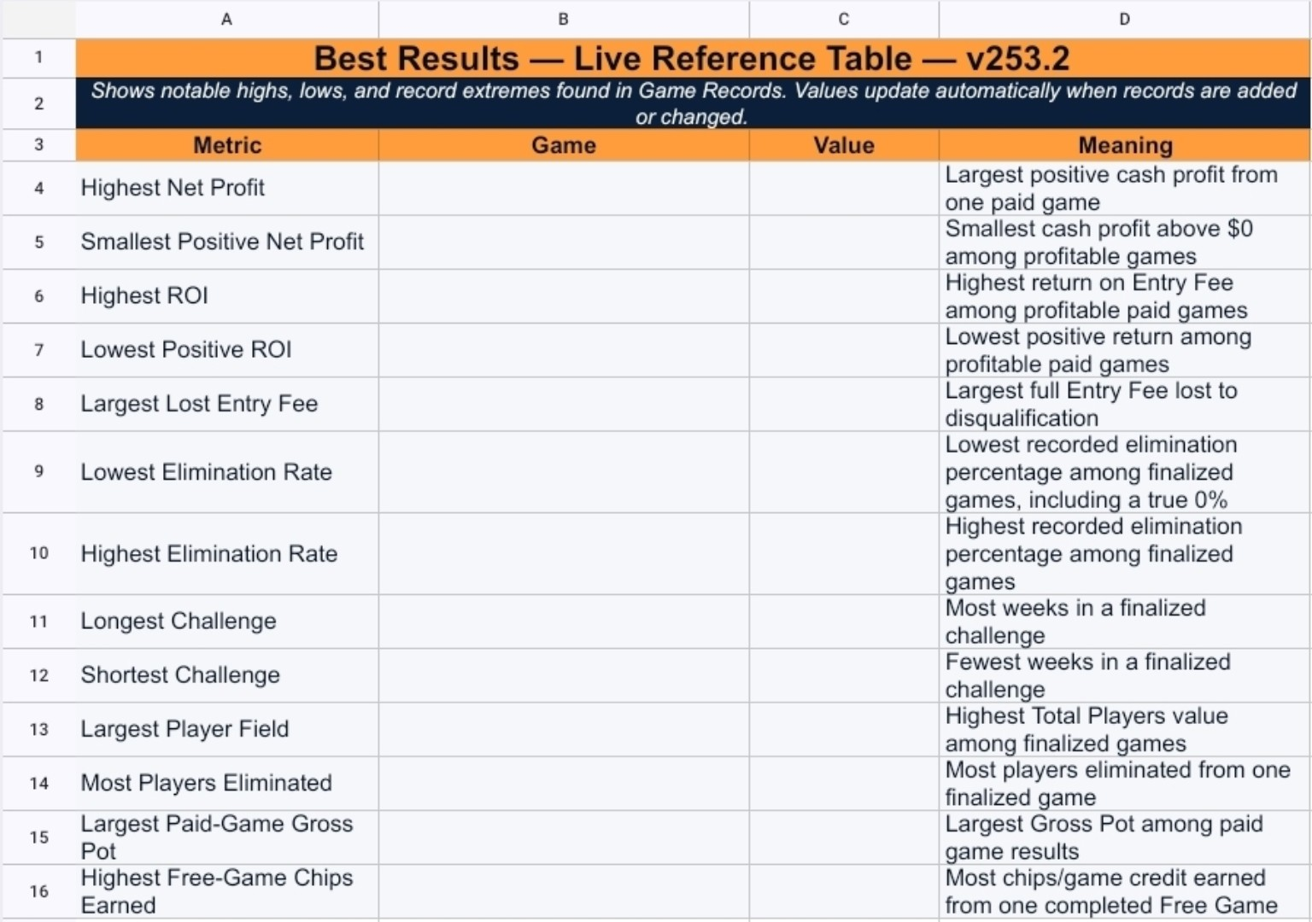
Previous Workbook v253.2 Best Results capture retained as a layout reference; the current v253.3 sheet keeps the finalized row-height consistency and will be recaptured after approval.

12. Installation, feedback, and troubleshooting

Installation
Use the hosted StepCat page in a supported browser. When installation is unavailable, use the Installation information and Add to Home Screen guidance. A local test page may not offer the same installation controls as the hosted site.

Feedback
Write Feedback prepares a message for your email app. Review the recipient, subject, and message before sending.

Troubleshooting
Calculate does not continue: Correct the highlighted field. StepCat identifies the first blocking value.
Free Game fee is rejected: Use Entry Fee 0 for Free Game / Chips, or choose another Payment / Record Type.
Membership or Entry Mode resets: Enable the matching Remember setting or make a fresh selection.
Saved entry appears as unfinished work: Current v253.1 removes a completed saved record from unfinished-draft recovery while leaving the completed fields visible for review during the current session.
Copied row does not calculate: Paste into the destination column-A cell and only across A:M. N:Z should calculate automatically.
Switching devices: Open the same Google Sheet on the other device. StepCat Saved History, settings, and unfinished fields do not automatically transfer.
Move Existing Records behavior: The current dialog keeps Close reachable, supports full scrolling, and browser/Android Back closes the dialog before navigating away.
Release check: After deployment, close old StepCat tabs/apps, reopen the hosted site, confirm StepCat v253.1 is displayed, open the public Workbook v253.3 link, and verify that the current screenshots and v253.3 downloadable guides load.

