Steps:

1)Open Weka tool.

2)Click on Weka Explorer.

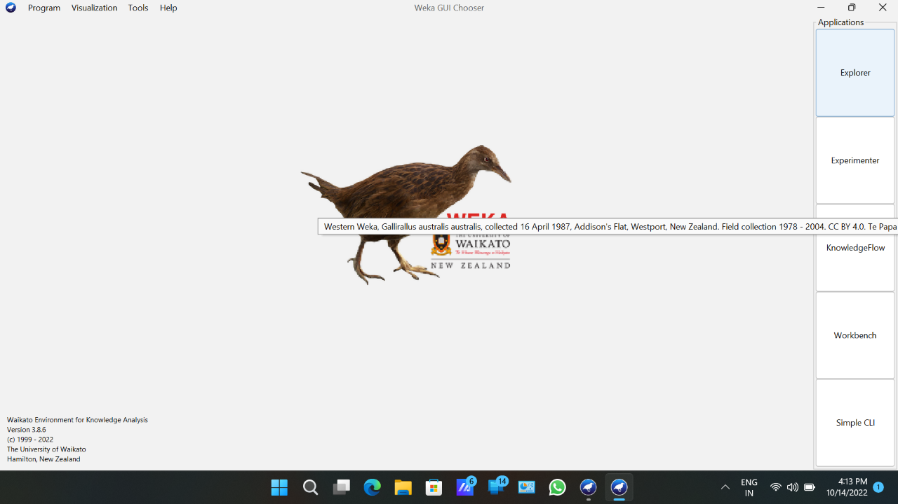  
3)Click on Preprocessing tab.

4)Click On Open file button.

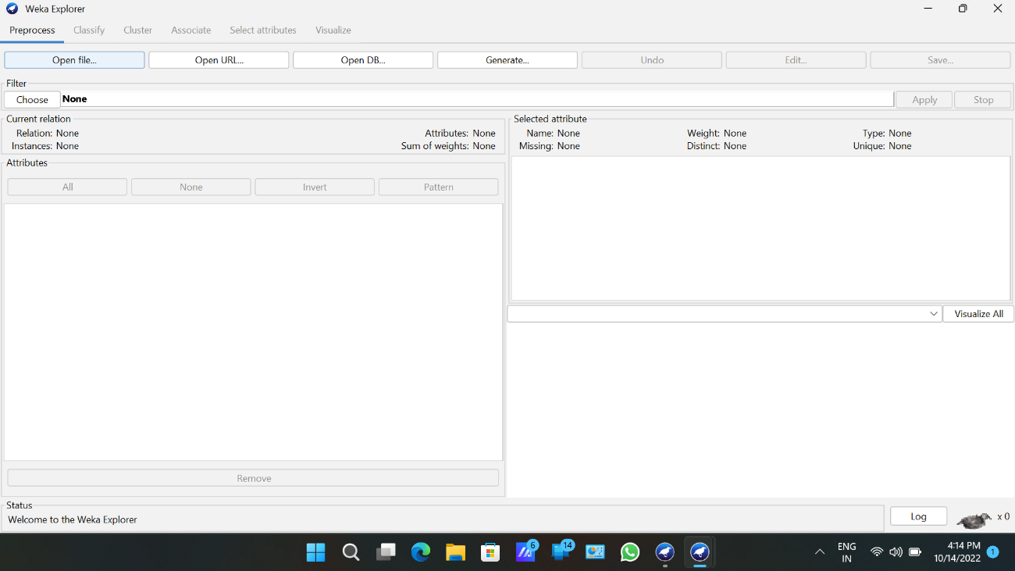

5)Choose Weka folder in C drive.

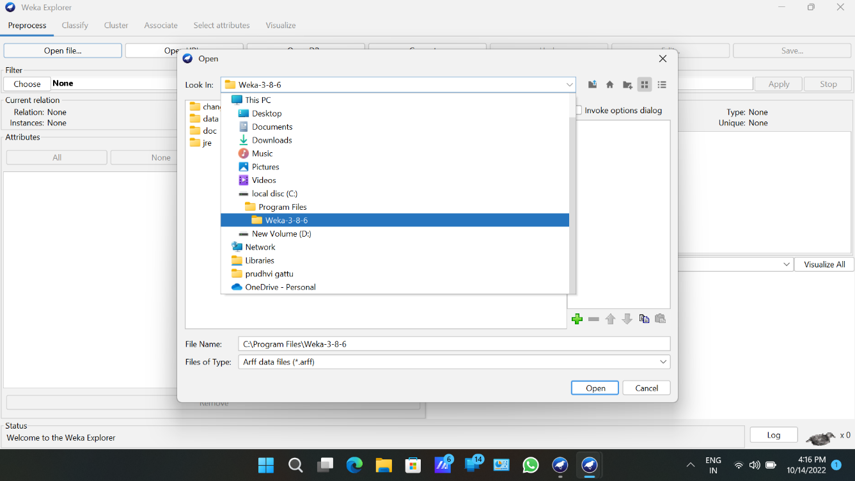

6)Select and click on data Option.

7)Choose labor data set and open file.

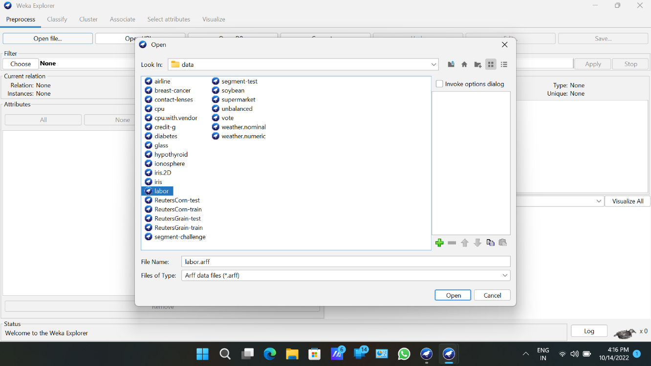

8)Choose filter button and select the Unsupervised-Discretize option and apply.

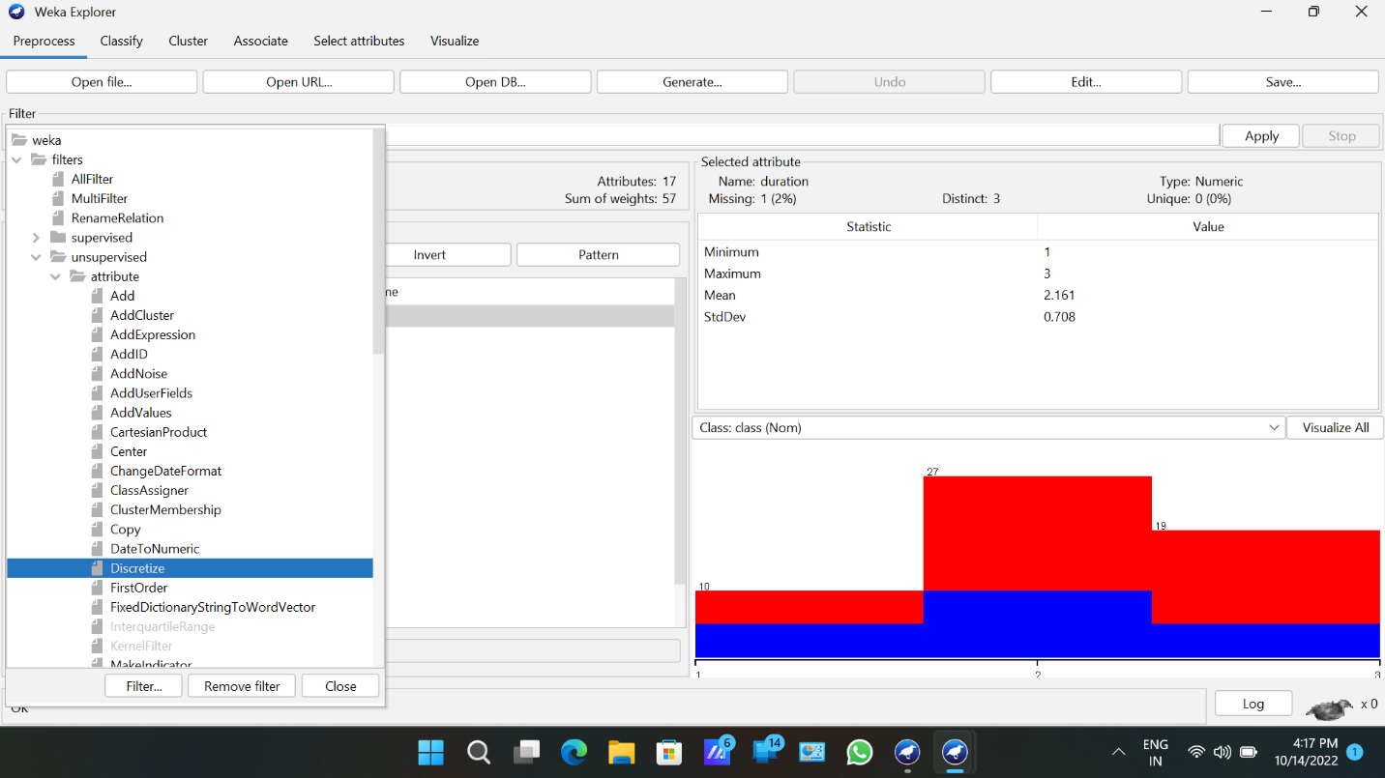

9)Click on associate tab and choose apriori algorithm.

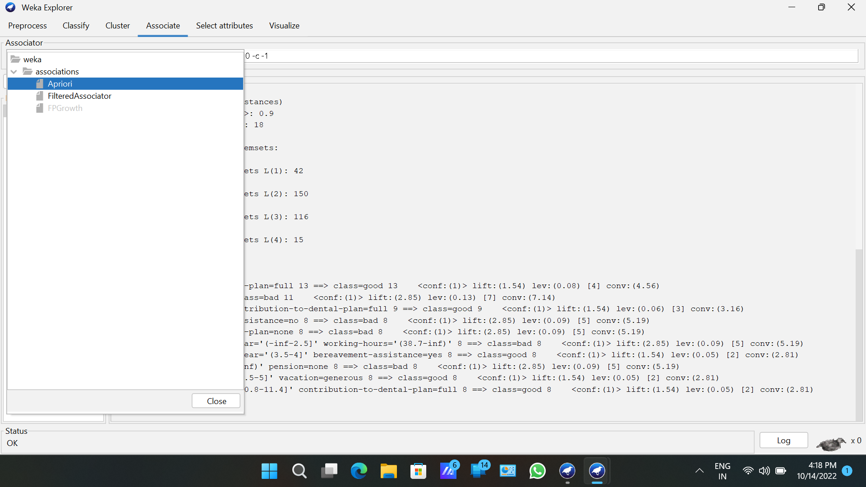

Output:-

