Steps:-

1)Open Weka Tool.

2)Click on Weka Explorer.

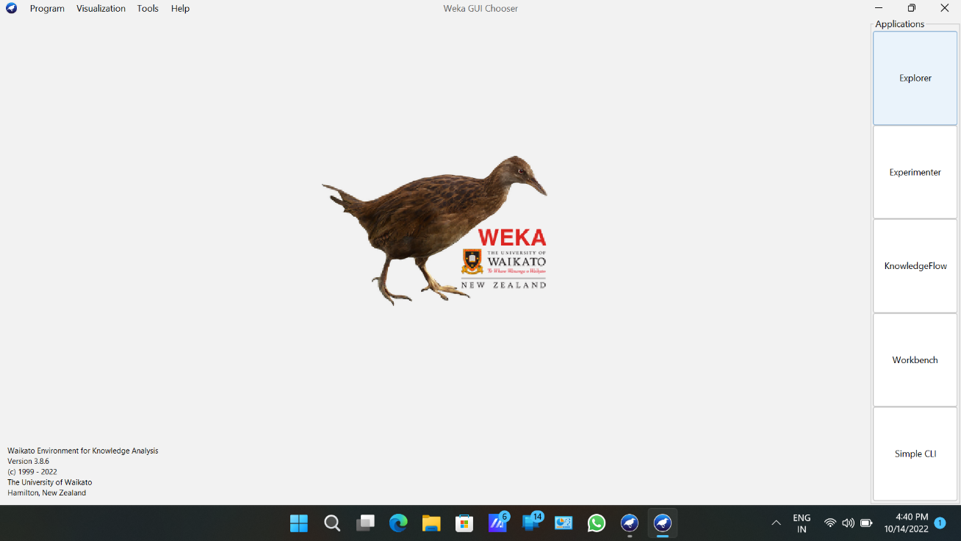

3)Click On Preprocessing tab.

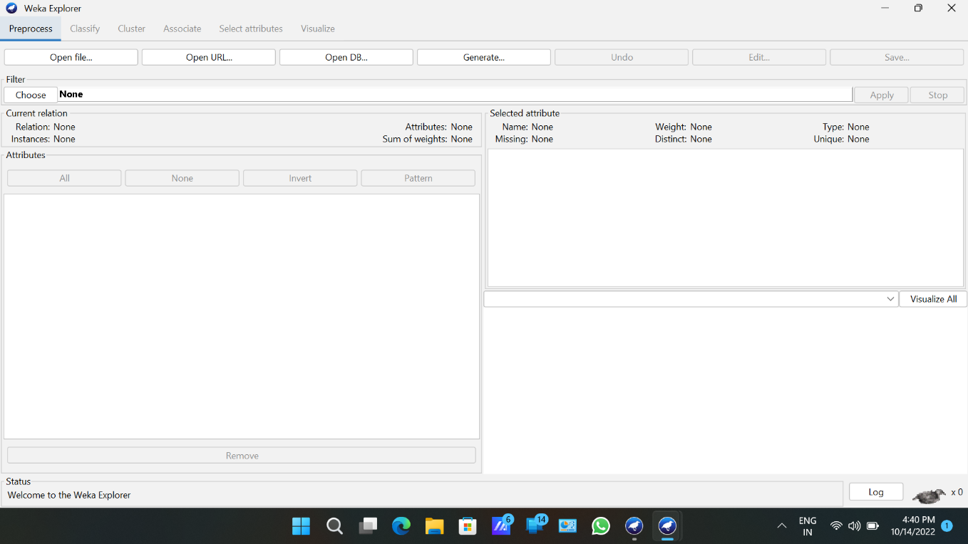

4)Click on Open file button.

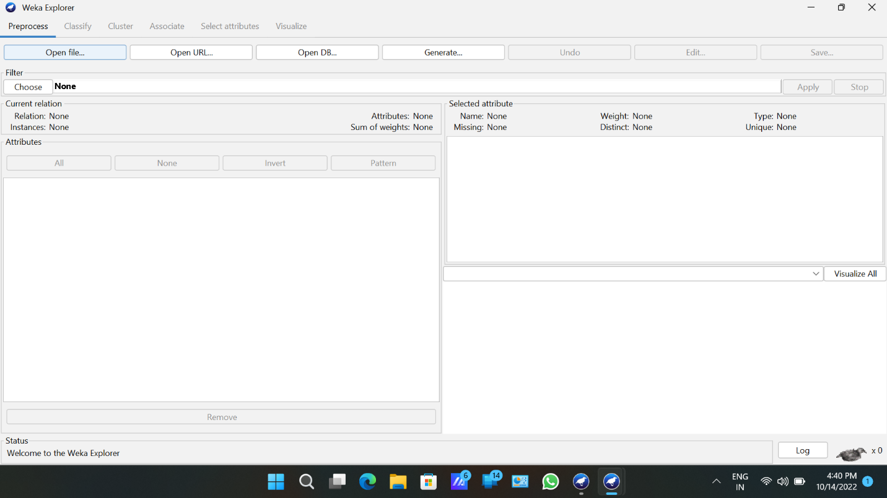

5)Choose Weka folder in C drive.

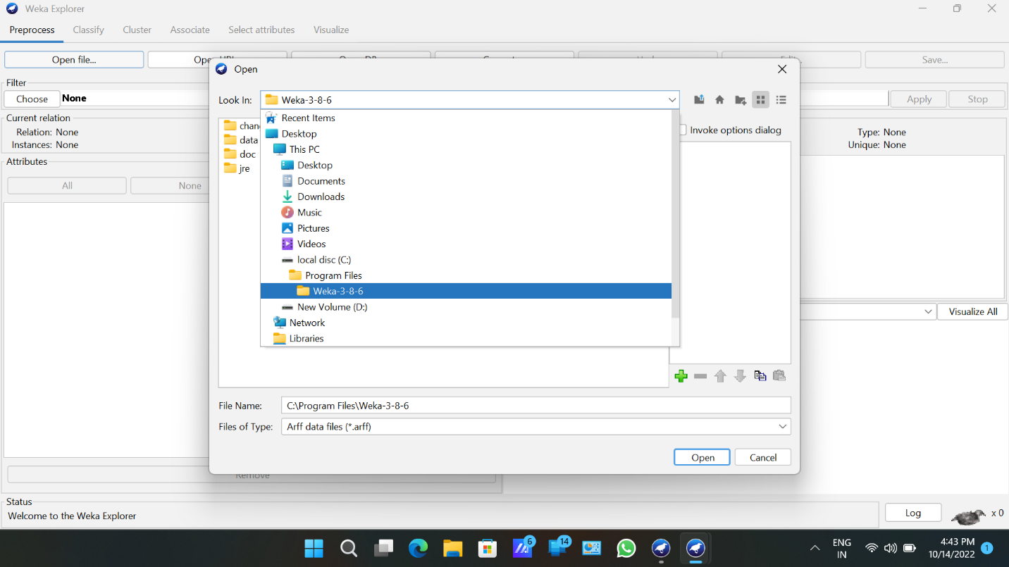

6)select and click on data option button.

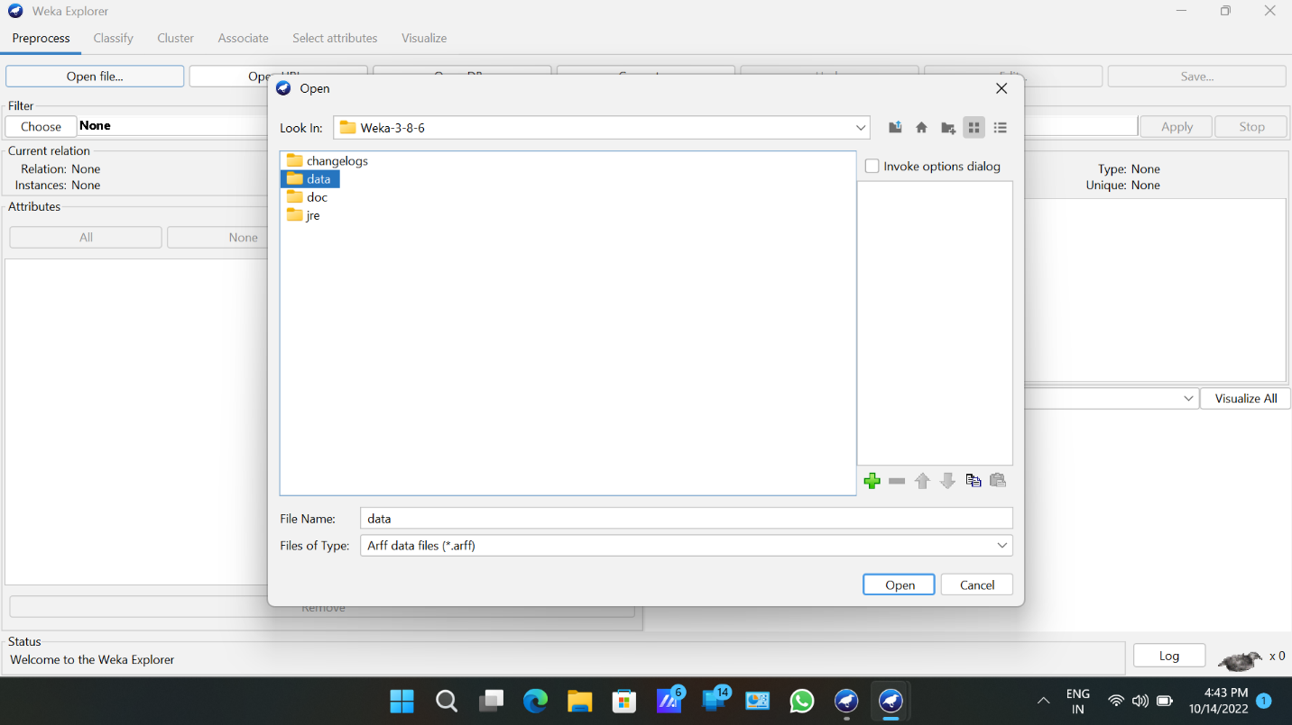

7)Choose iris data set and open file.

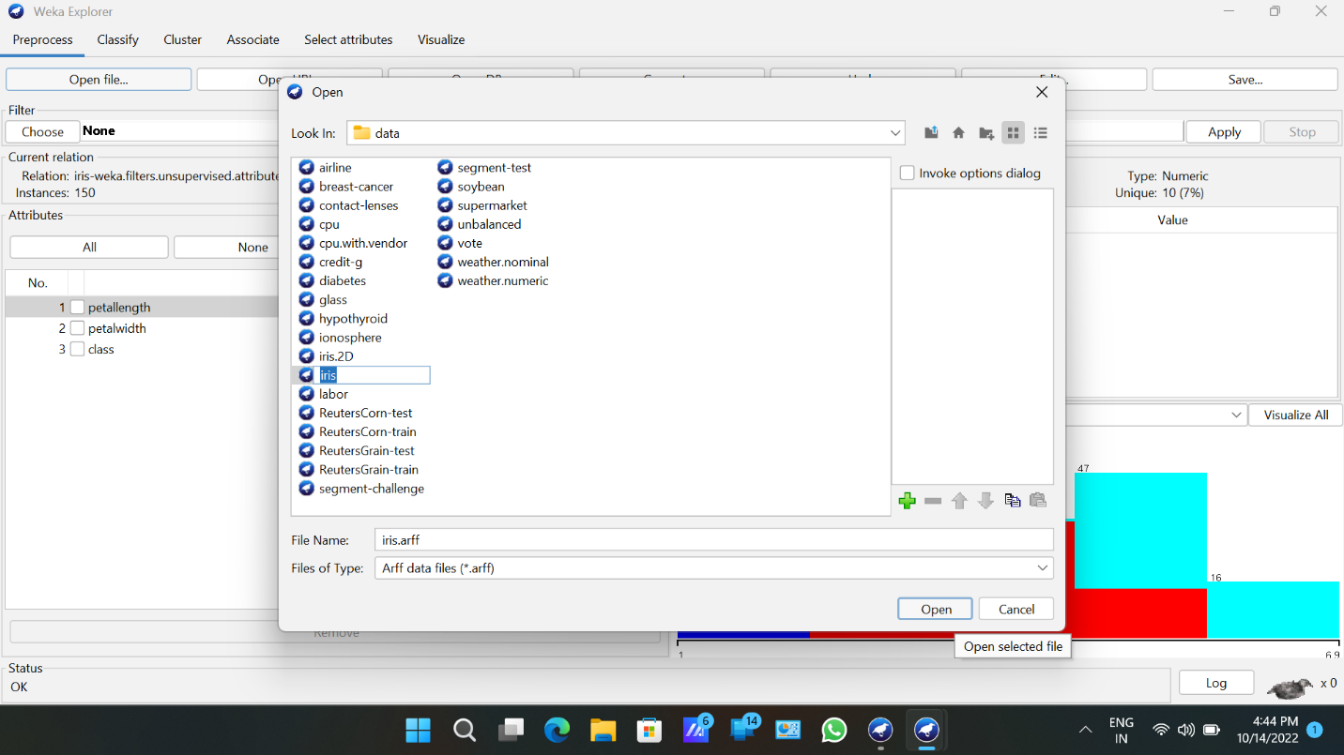

8)Click on cluster tab and choose k-means and select the use training set test option.

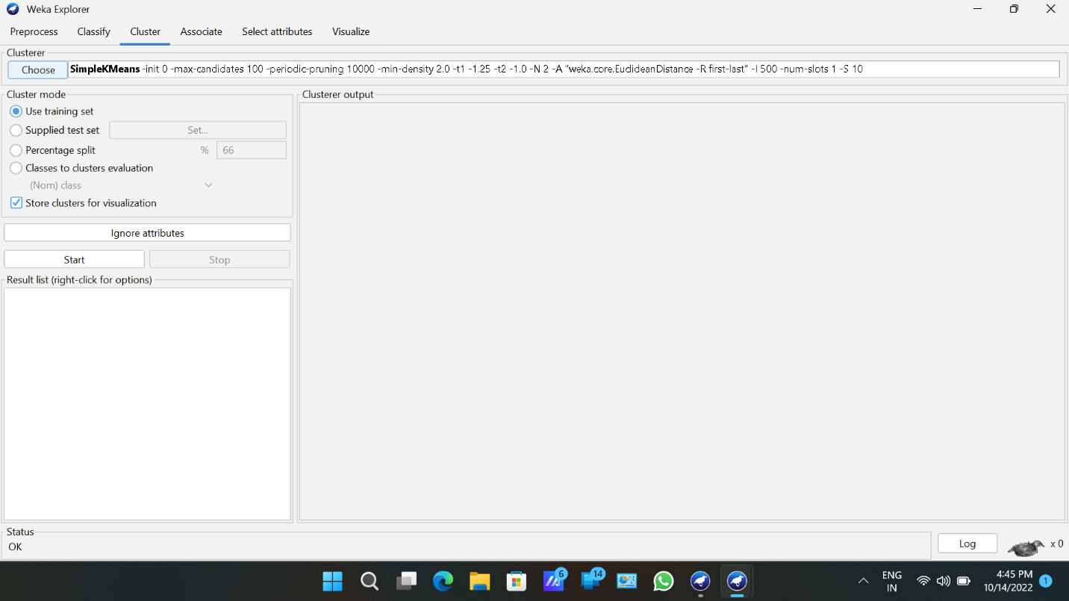

9)Click on start button.

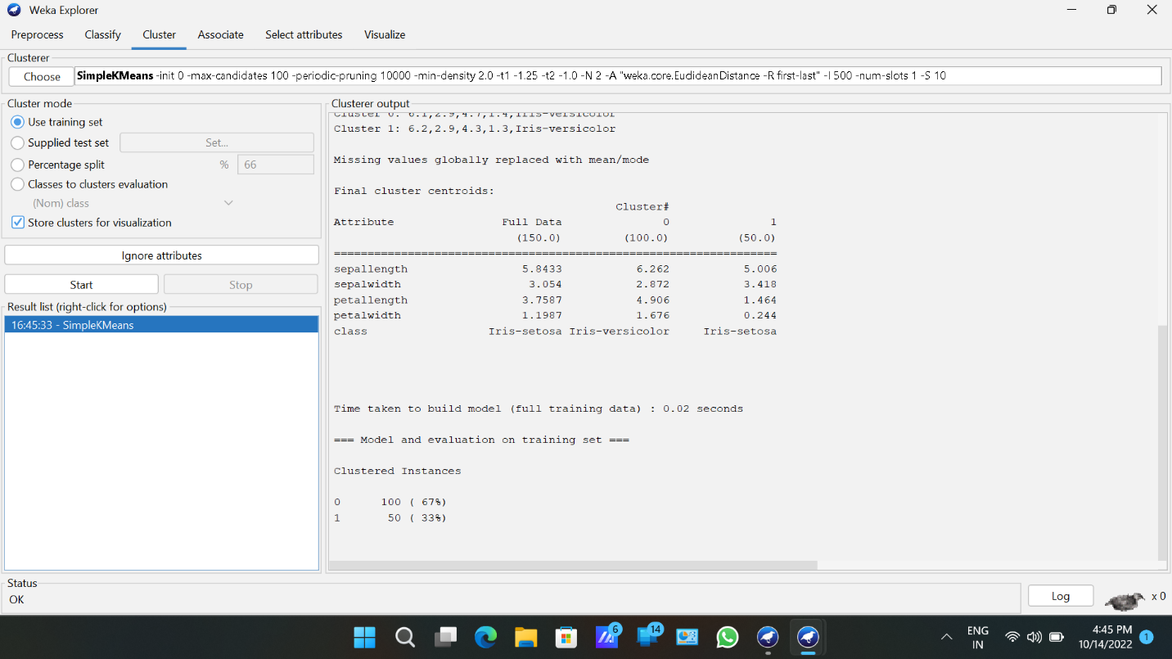

10)click on visualize tab.

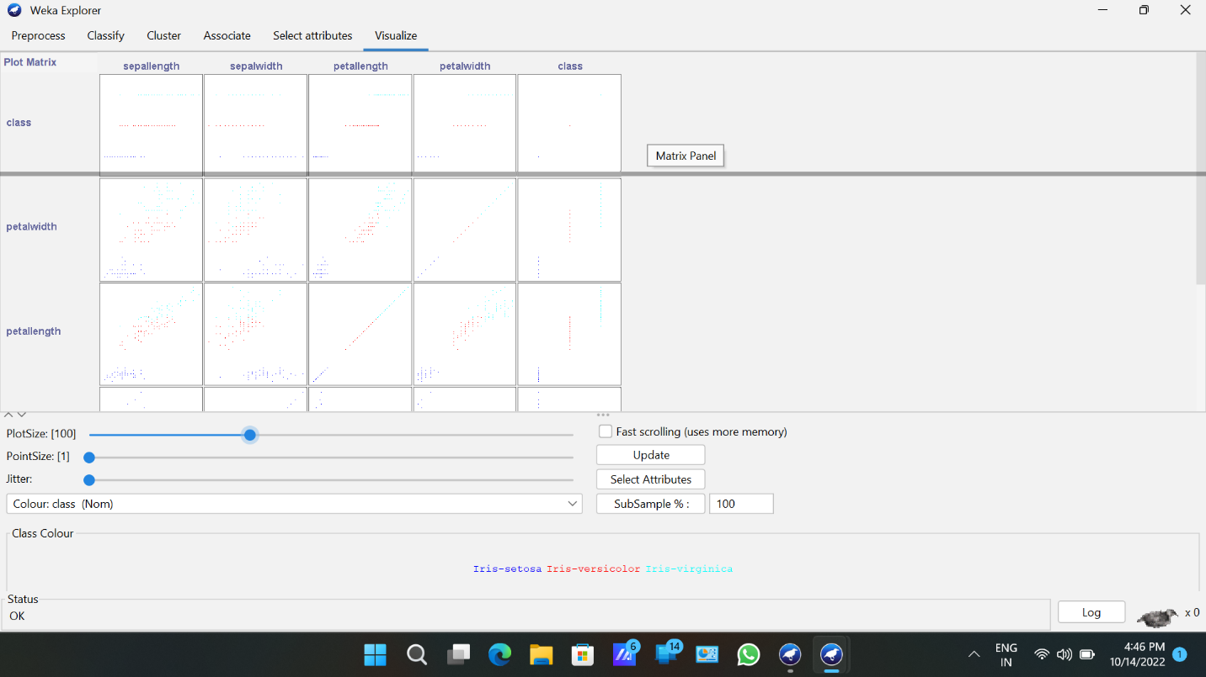

11)Select a square that corresponds to the attributes you would like to visualize.

