Steps:

1.Open Weka tool,Click on Weka explorer

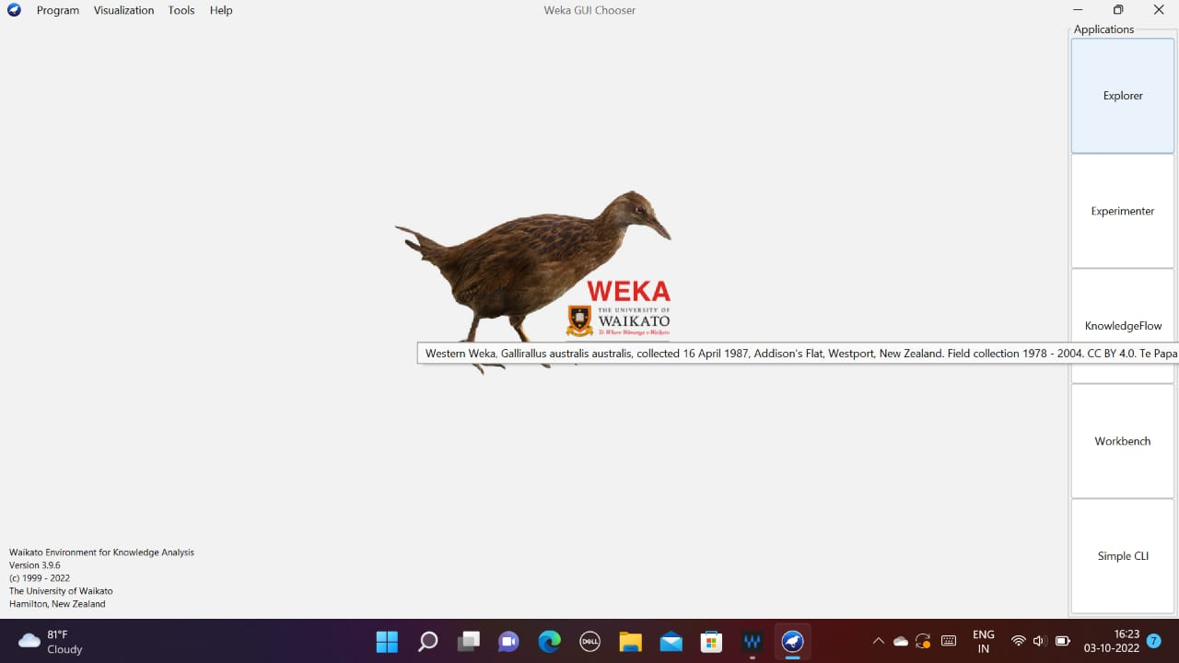

2.Click on the Preprocess, and click on open file

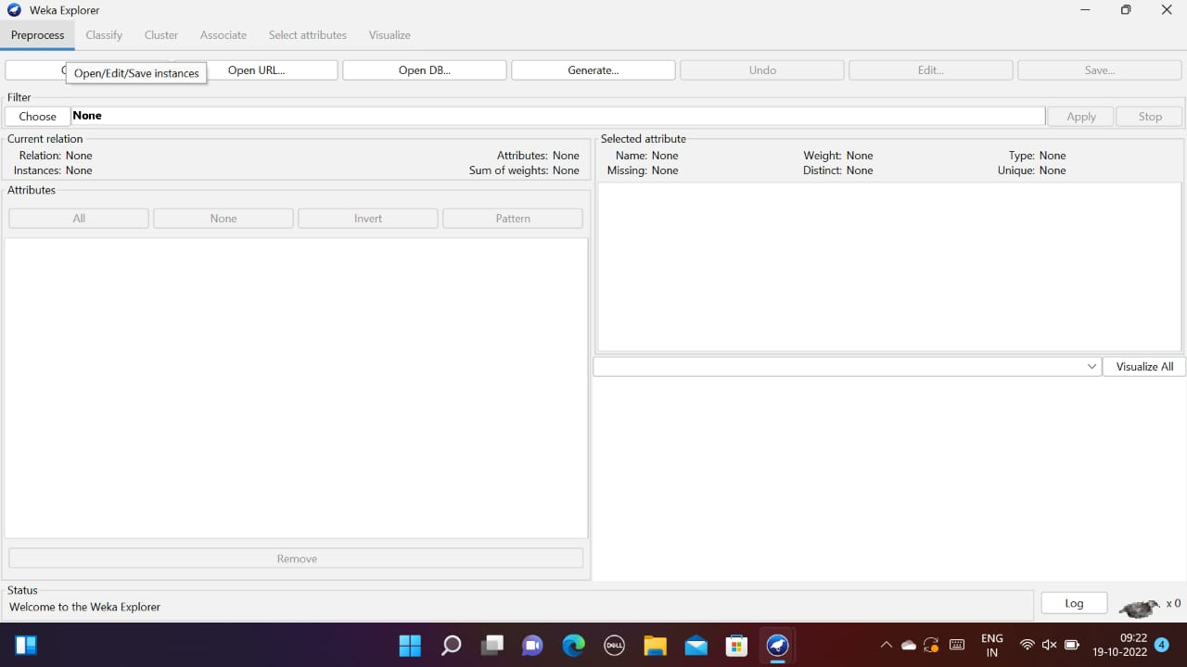

3.Open C drive, then click on open file, then select on weka 3.9.6.

Select datafile

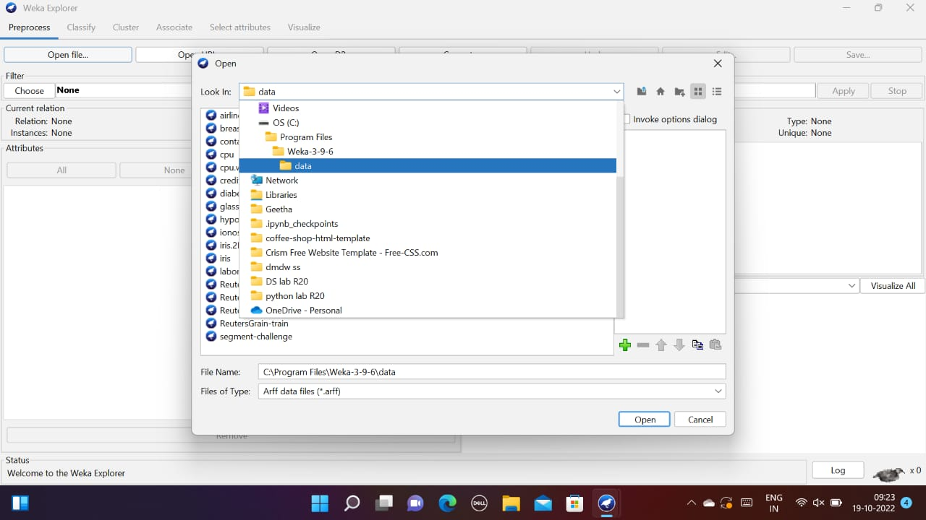

4.Select iris dataset

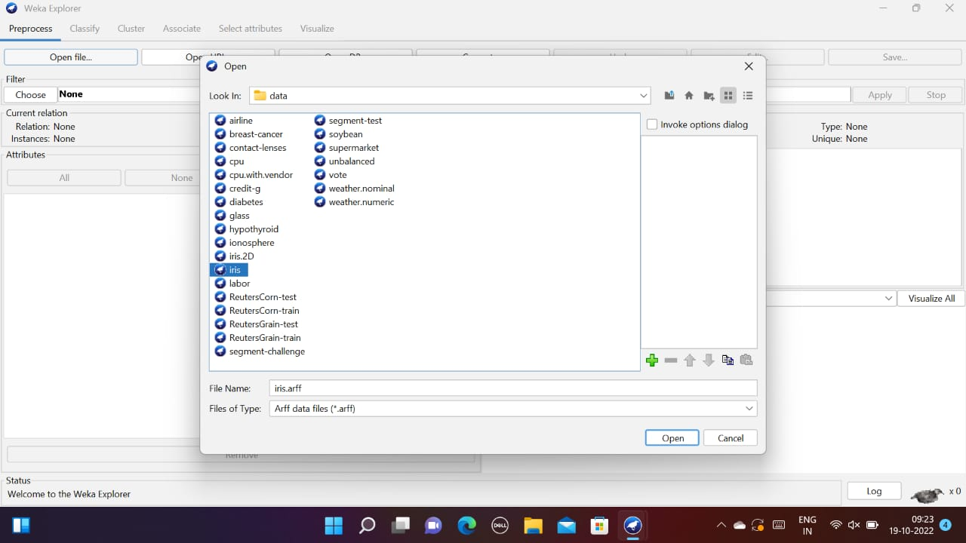

5.You can see the variance of the graph.

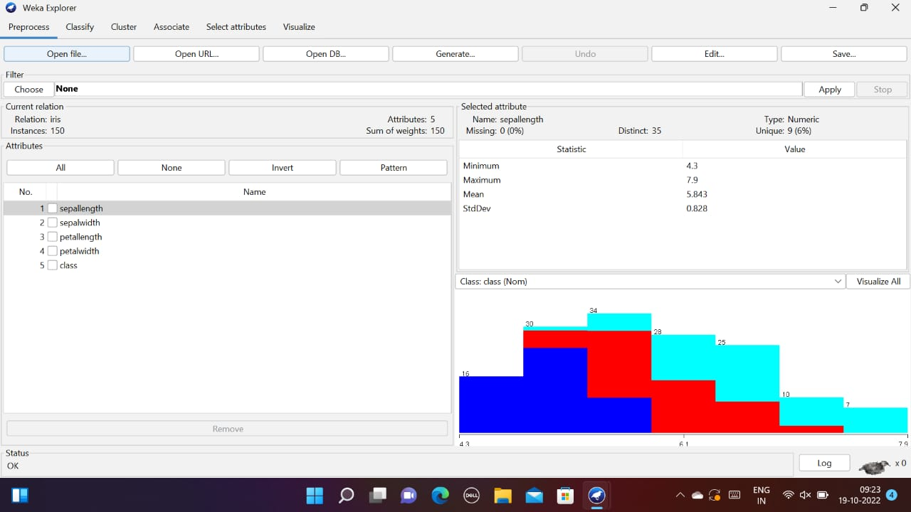

6.Click on the classifier, then ZeroR

Set cross validation fold as 10

Click on start

