Marc Gatti Lab 3

**1**

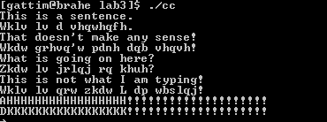

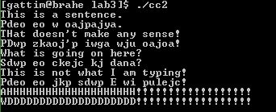

Change to handle less than ‘a’ because we are shifting left.

Subtracted 4 instead of adding 3.

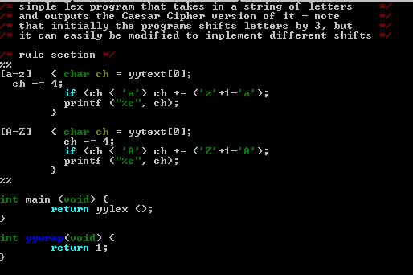

Added because we are wrapping around to ‘z’.

**2**

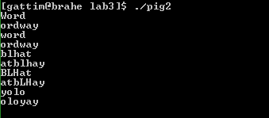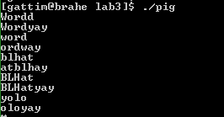

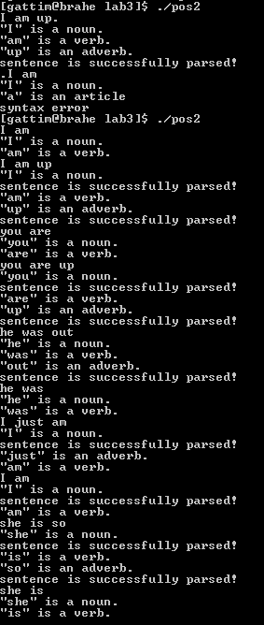This does not work with everything in our language because we as Americans use a ton of emojis and that does not exist here.

**3**

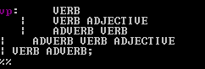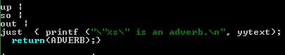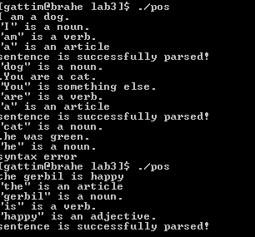

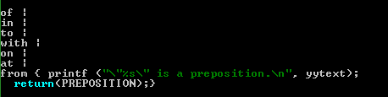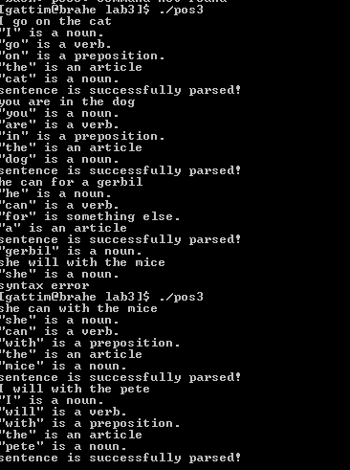

I added prepositions because they are a big part of the way we speak.

**4**

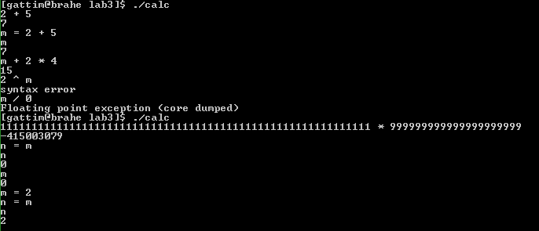

The limitations are:

* No exponentiation
* Bit overflow
* Doesn’t handle division by 0