Project Report

on

GAS AGENCY SYSTEM

Project work submitted in partial fulfillment
of the requirement for the award of the degree

Master of Computer Applications

By

XXXXXXXXX

( Regd.No: XXXXXXXX )

Under the Guidance of

Mr. XXXXXXXX

(Project Coordinator, XXXXXXXXXXX)

<Paste your university emblem here>

XXXXXXX UNIVERSITY

CERTIFICATE

This is to certify that this project entitled “E2M Conference” is a bonafide work carried out by XXXXXXXX bearing Hall Ticket No: XXXXXX in XXXXXXXXXXXXX and submitted to XXXXX University in partial fulfillment of the requirements for the award of Master of Computer Applications.

Project Guide External Examiner Principal

Acknowledgement

ACKNOWLEDGMENT

“Task successful” makes everyone happy. But the happiness will be gold without glitter if we didn’t state the persons who have supported us to make it a success.
Success will be crowned to people who made it a reality but the people whose constant guidance and encouragement made it possible will be crowned first on the eve of success.
This acknowledgement transcends the reality of formality when we would like to express deep gratitude and respect to all those people behind the screen who guided, inspired and helped me for the completion of our project work.
I consider myself lucky enough to get such a good project. This project would add as an asset to my academic profile.
I would like to express my thankfulness to my project guide, Mr. XXXXX for his constant motivation and valuable help through the project work, and I express my gratitude to Mr. XXXXXXX, Director of XXXXXXXXX, Hyderabad, for his constant supervision, guidance and co-operation through out the project.
I also extend my thanks to my Team Members for their co-operation during my course.
Finally I would like to thanks my friends for their co-operation to complete this project.

XXXXXXX

Abstract

ABSTRACT

Now a days for livelihood every user need gas. So we are having no companies and that having no of distributors. User will have any one the company connection. So he can book the gas whenever he need.

The Gas Agency system is providing facility to the users from that the user can make online gas booking easily. If the user (Consumer) has no gas connection, the system is providing facility that user can make a request for new connection. And also providing the facility like he can make a request for transfer gas connection from one location to another.

Organization Profile

Paste Organization profile here

Contents
CONTENTS

- INTRODUCTION

INTRODUCTION TO PROJECT
PURPOSE OF THE PROJECT
PROBLEM IN EXISTING SYSTEM
SOLUTION OF THESE PROBLEMS

- SYSTEM ANALYSIS

  - STUDY OF THE SYSTEM
  - PROPOSED SYSTEM
  - INPUT & OUTPUT
  - PROCESS MODELS USED WITH JUSTIFICATION
  - SYSTEM ARCHITECTURE

- FEASIBILITY STUDY

  - TECHNICAL FEASIBILITY
  - OPERATIONAL FEASIBILITY
  - ECONOMIC FEASIBILITY

- SOFTWARE REQUIREMENT SPECIFICATIONS

  - FUNCIONAL REQUIREMENTS
  - PERFORMANCE REQUIREMENTS
  - HARDWARE REQUIREMENTS
  - SOFTWARE REQUIREMENTS
    - INTRODUCTION TO .NET FRAMEWORK
    - ASP.NET
    - IIS PROCESS MODEL
    - C#.NET
    - SQL SERVER

- SYSTEM DESIGN

  - . INTRODUCTION
  - NORMALIZATION
  - E-R DIAGRAM
  - DATA FLOW DIAGRAMS
  - UML DIAGRAMS
  - DATA DICTIONARY

- OUTPUT SCREENS

- SYSTEM TESTING AND IMPLEMENTATION

  - INTRODUCTION TO TESTING
  - TESTING STRATEGIES
  - IMPLEMENTATION

- SYSTEM SECURITY

8.1 INTRODUCTION
8.2 SECURITY IN SOFTWARE

- CONCLUSION

- FUTURE SCOPE

- BIBLIOGRAPHY

Introduction
Chapter - 1
1.1. INTRODUCTION & OBJECTIVE

Providing the facility to the users (Consumers) that can make online bookings for gas cylinder to concerned distributor or agency

  - PURPOSE OF THE PROJECT

The Gas Agency system is providing facility to the users from that the user can make online gas booking easily. If the user (Consumer) has no gas connection, the system is providing facility that user can make a request for new connection. And also providing the facility like he can make a request for transfer gas connection from one location to another.
.
  - PROBLEMS EXISTING SYSTEM

Through this existing consumer unable to make online gas booking. For gas booking he has to make a cal to distributor and book the gas on. Data has located in single system. Making online request is not possible in existing system. Online requests are like gas booking request and connection transfer request. For maintain the large data not possible with the existing system. More physical interaction needed.

  - SOLUTION OF THESE PROBLEMS

  - Reliability: The project performs intended function with required precision; hence this project is very reliable.
  - Feasibility: The project maintenance is very easy and modifications can be made in the existing system in future. All data will locate as centralized.
  - Online Processing: The online processing of the project is very simple following the existing manual method without changes and suitable validation is provided for the easy and correct access of users.
  - Security: Security measures are taken to avoid mishandling of database. Password restrictions are provided to enter into database. A correct password only will access to the database

System Analysys
Chapter - 2

2.1 STUDY OF THE SYSTEM
In the flexibility of the uses the interface has been developed a graphics concept in mind, associated through a browser interface. The GUI’S at the top level have been categorized as
- Administrative user interface
- The operational or generic user interface(Distributor, Consumer)
The administrative user interface concentrates on the consistent information that is practically, part of the organizational activities and which needs proper authentication for the data collection. The interfaces help the administrations with all the transactional states like Data insertion, and Date updating along with the extensive data search capabilities.

The operational or generic user interface helps the users upon the system in Transactions through the existing data and required services. The operational user interface also helps the ordinary users in managing their Personal information helps the ordinary users in managing their own information in a customized manner as per the assisted flexibilities.

NUMBER OF MODULES

  - Administration
  - Registration
  - Reports
  - Authentication
Users:
Distributor
Consumer
Administrator
Administration:
This is the module under this various tasks will takes place. That task are like Managing the States, District, City details. In this module distributors registration will be done. Statical data can be entered for gas cylinders on agency wise. Consumers transfer requests will be accepted in this module. And generates various reports in this module.
Registration:
Under this module various users registration will takes places. Distributors registration, User (Consumer) registration will be done through this module. At the time of registration that the user should provide the all information and also providing the facility the user can upload the image also.
Reports:
This module is comes under admin module as sub module as well as in distributor. In this module various reports will be generated. The system will generate reports like Consumers reports, Distributors reports, Feedback reports etc.
All these can view by the admin only. The distributor can view only his consumers reports.
Authentication Module:

This module contains all the information about the authenticated users. User without his username and password can’t enter into the login if he is only the authenticated user then he can enter to his login and then he will have authorization based upon their roles.
Distributor:
The distributor authenticate through system. Then he will get his home page. In this the distributor having facility like that he can modify his personal information.
He can view the online gas connection requests from the consumers. That Request will send to Admin. And also he can view the gas booking requests. Along with he will receive transfer requests from one location to other location. For further verification and decisions purpose these requests send to Admin. The distributor can send feed back to the admin. He can view the reports how many consumers are under his agency.

Consumer:
Consumer is the registered user. He can login in to the system. After that he can modify his profile if needed. Through this he can book the gas. And also he can make a request for transferring connection from one location to another. He can view the Status of his requests
Admin:
Admin is super user of this application. He is owner of this application. The admin will authenticate through system. After that he will perform his functionalities. He will add the New Agency Details; view the transfer requests send by distributor,
Update the gas cylinders information agency wise. That it displays home page of system. He can view the feedback send by consumer as well as distributor. And also he can view the various reports generated by system like consumers, distributor etc.

2.2. PROPOSED SYSTEM

By considering the existing system the new proposed system providing the facility like that the consumer can make on line gas books as well as connection transfer request. Data has located as centralized. That data can be accessed by authorized persons. By this new system general user can know that statical data about gas cylinders in particular gas agency. The System also providing Online Registration for new connection.

2.3. INPUT AND OUTPUT
Inputs and Outputs
The following some are the projects inputs and outputs.
Inputs:
Admin enters his credentials.
Admin registers Agency (Distributors) details.
Admin enters State, District, and City Details into system
Admin select consumer requests send by Distributor
Distributor enters his credentials
Distributor enters feedback Details
Distributor enters personal info for updation.
Distributor selects Users Requests.
User (Consumers) enters personal data
Consumer enters credentials.
Consumer enters data for making gas booking.
Consumer enters data for making connection transfer request.
Consumer enters feedback details
Out Puts:
Admin will get his home page.
Registration details will be stored in centralized database.
Admin can view feedback details
Consumer requests will be stored in centralized database.
Users (Consumer,Ditributor) will get their home page.
Distributor information will be update in database.
Consumer can view the status on his request.
Admin view the various reports.

2.4. PROCESS MODELS USED WITH JUSTIFICATION

SDLC MODEL:
Software Development Life Cycle (SDLC)
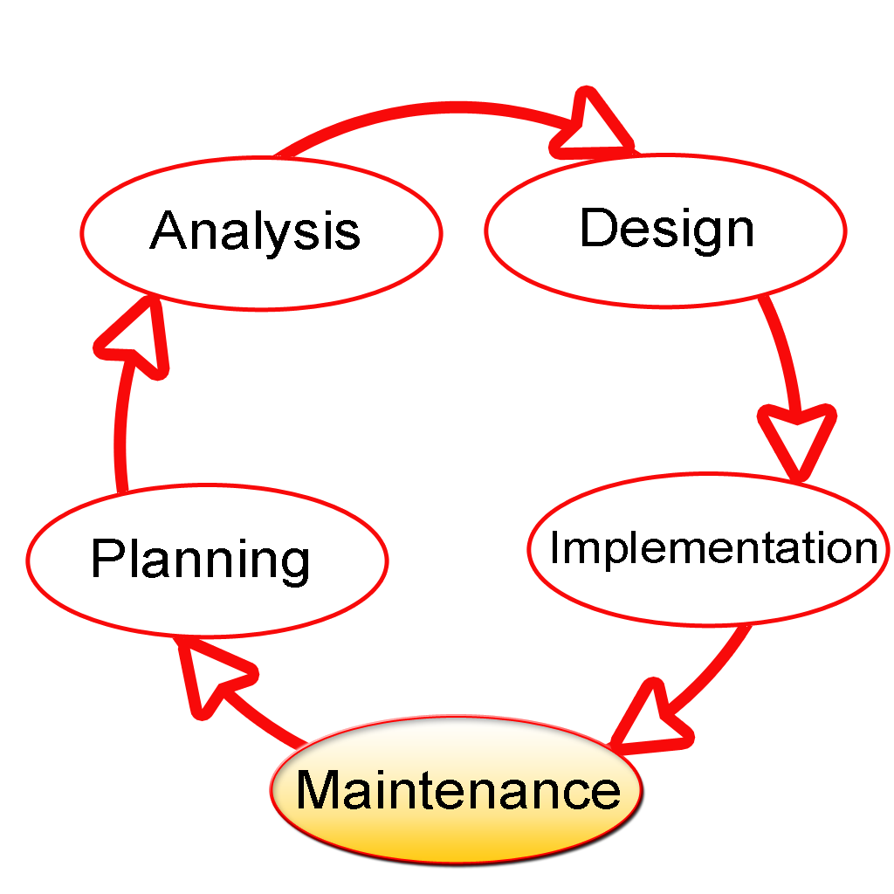

The Software Development Lifecycle(SDLC) for small to medium database application development efforts.

This project uses iterative development lifecycle, where components of the application are developed through a series of tight iteration. The first iteration focus on very basic functionality, with subsequent iterations adding new functionality to the previous work and or correcting errors identified for the components in production.

The six stages of the SDLC are designed to build on one another, taking outputs from the previous stage, adding additional effort, and producing results that leverage the previous effort and are directly traceable to the previous stages. During each stage, additional information is gathered or developed, combined with the inputs, and used to produce the stage deliverables. It is important to not that the additional information is restricted in scope, new ideas that would take the project in directions not anticipated by the initial set of high-level requirements or features that are out-of-scope are preserved for later consideration
.
Too many software development efforts go awry when development team and customer personnel get caught up in the possibilities of automation. Instead of focusing on high priority features, the team can become mired in a sea of nice to have features that are not essential to solve the problem, but in themselves are highly attractive. This is the root cause of large percentage of failed and or abandoned development efforts and is the primary reason the development team utilizes the iterative model.

Roles and Responsibilities of PDR AND PER

The iterative lifecycle specifies two critical roles that act together to clearly communicate project issues and concepts between the end-user community and the development team.

Primary End-user Representative (PER)

The PER is a person who acts as the primary point of contact and principal approver for the end-user community. The PER is also responsible for ensuring that appropriate subject matter experts conduct end-user reviews in a timely manner.
PER-PDR Relationship
The PER and PDR are the brain trust for the development effort. The PER has the skills and domain knowledge necessary to understand the issues associated with the business processes to the supported by the application and has a close working relationship with the other members of the end-user community. The PDR has the same advantages regarding the application development process and the other members of the development team together, they act as the concentration points for knowledge about the application to be developed.
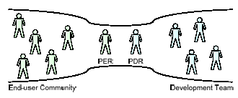

The objective of this approach is to create the close relationship that is characteristic of a software project with one developer and one end-user in essence, this approach the “pair programming” concept from Agile methodologies and extends it to the end-user community. While it is difficult to create close relationships between the diverse members of an end-user community and a software development team, it is much simpler to create a close relationship between the lead representatives for each group.
When multiple end-users are placed into relationship with multiple members of a development team, communication between the two groups degrades as the number of participants grows. In this model, members of end-user community may communicate with members of the development team as needed, but it is the responsibility of all participants to keep the PER and PDR apprised of the communications for example, this allows the PER and PDR to resolve conflicts that arise when two different end-users communicate different requirements for the same application feature to different members of the development team.
INPUT DESIGN

Input design is a part of overall system design. The main objective during the input design is as given below:
- To produce a cost-effective method of input.
- To achieve the highest possible level of accuracy.
- To ensure that the input is acceptable and understood by the user.

INPUT STAGES:

The main input stages before the information gets stored in the database media:
Ex: In this project voter either existing or new user data will be stored in database as the inputs given by users….
- Data recording ,Data transcription, Data conversion, Data verification
- Data control, Data transmission, Data validation, Data correction

OUTPUT DESIGN

Outputs from computer systems are required primarily to communicate the results of processing to users. They are also used to provide a permanent copy of the results for later consultation. The various types of outputs in general are:
- External Outputs, whose destination is outside the organization,
- Internal Outputs whose destination is with in organization and they are the
    - User’s main interface with the computer.
- Operational outputs whose use is purely with in the computer department.
- Interface outputs, which involve the user in communicating directly with

The outputs were needed to be generated as a hard copy and as well as queries to be viewed on the screen. Keeping in view these outputs, the format for the output is taken from the outputs, which are currently being obtained after manual processing. The standard printer is to be used as output media for hard copies.

DESIGN PRINCIPLES & METHODOLOGY:
Object Oriented Analysis And Design
When Object orientation is used in analysis as well as design, the boundary between OOA and OOD is blurred. This is particularly true in methods that combine analysis and design. One reason for this blurring is the similarity of basic constructs (i.e.,objects and classes) that are used in OOA and OOD. Through there is no agreement about what parts of the object-oriented development process belongs to analysis and what parts to design, there is some general agreement about the domains of the two activities.
The fundamental difference between OOA and OOD is that the former models the problem domain, leading to an understanding and specification of the problem, while the latter models the solution to the problem. That is, analysis deals with the problem domain, while design deals with the solution domain. However, in OOAD subsumed in the solution domain representation. That is, the solution domain representation, created by OOD, generally contains much of the representation created by OOA. The separating line is matter of perception, and different people have different views on it. The lack of clear separation between analysis and design can also be considered one of the strong points of the object-oriented approach the transition from analysis to design is “seamless”. This is also the main reason OOAD methods-where analysis and designs are both performed.
The main difference between OOA and OOD, due to the different domains of modeling, is in the type of objects that come out of the analysis and design process.

Features of OOAD:
- It users Objects as building blocks of the application rather functions
- All objects can be represented graphically including the relation between them.
- All Key Participants in the system will be represented as actors and the actions done by them will be represented as use cases.
- A typical use case is nothing bug a systematic flow of series of events which can be well described using sequence diagrams and each event can be described diagrammatically by Activity as well as state chart diagrams.
- So the entire system can be well described using OOAD model, hence this model is chosen as SDLC model.

THE GENESIS OF UML:
Software engineering has slowly become part of our everyday life. From washing machines to compact disc player, through cash machines and phones, most of our daily activities use software, and as time goes by, the more complex and costly this software becomes.
The demand for sophisticated software greatly increases the constraints imposed on development teams. Software engineers are facing a world of growing complexity due to the nature of applications, the distributed and heterogeneous environments, the size of programs, the organization of software development teams, and the end-users ergonomic expectations.
To surmount these difficulties, software engineers will have to learn not only how to do their job, but also how to explain their work to others, and how to understand when others work is explained to them. For these reasons, they have (and will always have) an increasing need for methods.

From Functional to Object-Oriented Methods
Although object-oriented methods have roots that are strongly anchored back in the 60s, structured and functional methods were the first to be used. This is not very surprising, since functional methods are inspired directly my computer architecture (a proven domain well known to computer scientists). The separation of data and code, just as exists physically in the hardware, was translated into the methods; this is how computer scientists got into the habit of thinking in terms of system functions.
This approach is natural when looked at in its historical context, but today, because of its lack of abstraction, it has become almost completely anachronistic. There is no reason to impose the underlying hardware on a software solution. Hardware should act as the servant of the software that is executed on it, rather than imposing architectural constraints.

TOWARDS A UNIFIED MODELLING LANGUAGE

The unification of object-oriented modeling methods became possible as experience allowed evaluation of the various concepts proposed by existing methods. Based on the fact that differences between the various methods were becoming smaller, and that the method wars did not move object-oriented technology forward any longer, Jim Rumbaugh and Grady Booch decided at the end of 1994 to unify their work within a single method: the Unified Method. A year later they were joined by Ivar Jacobson, the father of use cases, a very efficient technique for the determination of requirements.

Booch, Rumbaugh and Jacobson adopted four goals:
- To represent complete systems (instead of only the software portion) using object oriented concepts.
- To establish an explicit coupling between concepts and executable code.
- To take into account the scaling factors that are inherent to complex and critical systems.
- To creating a modeling language usable by both humans and machines.

2.6. SYSTEM ARCHITECTURE
The current application is being developed by taking the 3-tier architecture as a prototype. The 3-tier architecture is the most common approach used for web applications today. In the typical example of this model, the web browser acts as the client, IIS handles the business logic, and a separate tier MS-SQL Server handles database functions.
Although the 3-tier approach increases scalability and introduces a separation of business logic from the display and database layers, it does not truly separate the application into specialized, functional layers. For prototype or simple web applications, the 3-tier architecture may be sufficient. However, with complex demands placed on web applications, a 3-tiered approach falls short in several key areas, including flexibility and scalability. These shortcomings occur mainly because the business logic tier is still too broad- it has too many functions grouped into one tier that could be separated out into a finer grained model.

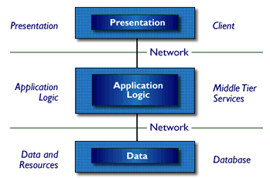

Three-Tier Architecture
- Tier 1: the client contains the presentation logic, including simple control and user input validation. This application is also known as a thin client. The client interface is developed using ASP.Net Server Controls and HTML controls in some occasions
- Tier 2: the middle tier is also known as the application server, which provides the business processes logic and the data access. The business logic/ business rules can be written either with C#.Net or VB.Net languages. These business runes will be deployed as DLL’s in IIS web server.
- Tier 3: the data server provides the business data. MS-SQL server acts as Tier-3, which is the database layer.
These are some of the advantages of three-tier architecture:
- It is easier to modify or replace any tier without affecting the other tiers.
- Separating the application and database functionality means better load balancing.
- Adequate security policies can be enforced within the server tiers without hindering the clients.
The proposed system can be designed perfectly with the three tier model, as all layers are perfectly getting set as part of the project. In the future, while expanding the system, in order to implement integration touch points and to provide enhanced user interfaces, the n-tier architecture can be used.

Feasibility Study
Chapter - 3

FEASIBILITY
Preliminary investigation examine project feasibility, the likelihood the system will be useful to the organization. The main objective of the feasibility study is to test the Technical, Operational and Economical feasibility for adding new modules and debugging old running system. All system is feasible if they are unlimited resources and infinite time. There are aspects in the feasibility study portion of the preliminary investigation:

- Technical Feasibility
- Economical Feasibility
- Operation Feasibility

3.1 TECHINICAL FEASIBILITY:
In the feasibility study first step is that the organization or company has to decide that what technologies are suitable to develop by considering existing system.
Here in this application used the technologies like Visual Studio 2008 and SqlServer 2005. These are free software that would be downloaded from web.
Visual Studio 2008 –it is tool or technology.

3.2 OPERATIONAL FEASIBILITY:
Not only must an application make economic and technical sense, it must also make operational sense.
Issues to consider when determining the operational feasibility of a project.
Operations Issues | Support Issues
- What tools are needed to support operations?  - What skills will operators need to be trained in?  - What processes need to be created and/or updated?  - What documentation does operations need? | - What documentation will users be given?  - What training will users be given?  - How will change requests be managed?
Very often you will need to improve the existing operations, maintenance, and support infrastructure to support the operation of the new application that you intend to develop. To determine what the impact will be you will need to understand both the current operations and support infrastructure of your organization and the operations and support characteristics of your new application.
To operate this application Gas Agency system that the user no needs to require any technical knowledge that we are used to develop this project is. Asp.net, C#.net. That the application providing rich user interface by user can do the operation in flexible manner.
3.3 ECONOMIC FEASIBILITY:
It refers to the benefits or Outcomes we are deriving from the product as compared to the total cost we are spending for developing the product. If the benefits are more or less the same as the older system, then it is not feasible to develop the product.
In the present system, the development of new product greatly enhances the accuracy
of the system and cuts short the delay in the processing of Birth and Death application. The errors can be greatly reduced and at the same time providing a great level of security. Here we don’t need any additional equipment except memory of required capacity.
No need for spending money on client for maintenance because the database used is web enabled database.

The software, Site Explorer is designed for management of web sites from a remote location.

INTRODUCTION

Purpose: The main purpose for preparing this document is to give a general insight into the analysis and requirements of the existing system or situation and for determining the operating characteristics of the system.

Scope: This Document plays a vital role in the development life cycle (SDLC) and it describes the complete requirement of the system. It is meant for use by the developers and will be the basic during testing phase. Any changes made to the requirements in the future will have to go through formal change approval process.

DEVELOPERS RESPONSIBILITIES OVERVIEW:

The developer is responsible for:

- Developing the system, which meets the SRS and solving all the requirements of the system?
- Demonstrating the system and installing the system at client's location after the acceptance testing is successful.
- Submitting the required user manual describing the system interfaces to work on it and also the documents of the system.
- Conducting any user training that might be needed for using the system.
- Maintaining the system for a period of one year after installation.

4.1. FUNCTIONAL REQUIREMENTS:

Proposed system should possess the following features

- Managing state, district and city details
- Managing Gas Cylinders
- Maintains the information about consumers
- Maintains the information about Distributors.
- Stores the requests send by consumer.
4.2. PERFORMANCE REQUIREMENTS

Performance is measured in terms of the output provided by the application.

Requirement specification plays an important part in the analysis of a system. Only when the requirement specifications are properly given, it is possible to design a system, which will fit into required environment. It rests largely in the part of the users of the existing system to give the requirement specifications because they are the people who finally use the system. This is because the requirements have to be known during the initial stages so that the system can be designed according to those requirements. It is very difficult to change the system once it has been designed and on the other hand designing a system, which does not cater to the requirements of the user, is of no use.

The requirement specification for any system can be broadly stated as given below:
- The system should be able to interface with the existing system
- The system should be accurate
- The system should be better than the existing system

The existing system is completely dependent on the user to perform all the duties.

4.3. HARDWARE REQUIREMENTS

Content | Description
HDD | 20 GB Min  40 GB Recommended
RAM | 512 GB Min  1 GB Recommended

4.4. SOFTWARE REQUIREMENTS

Content | Description
OS | Windows XP with SP2 or Windows Vista
Database | MS-SQL server 2005
Technologies | ASP.NET with C#.NET
IDE | Ms-Visual Studio .Net 2008
Browser | IE

4.4.1. INTRODUCTION TO .NET Framework

The .NET Framework is a new computing platform that simplifies application development in the highly distributed environment of the Internet. The .NET Framework is designed to fulfill the following objectives:

- To provide a consistent object-oriented programming environment whether object code is stored and executed locally, executed locally but Internet-distributed, or executed remotely.
- To provide a code-execution environment that minimizes software deployment and versioning conflicts.
- To provide a code-execution environment that guarantees safe execution of code, including code created by an unknown or semi-trusted third party.
- To provide a code-execution environment that eliminates the performance problems of scripted or interpreted environments.
- To make the developer experience consistent across widely varying types of applications, such as Windows-based applications and Web-based applications.
- To build all communication on industry standards to ensure that code based on the .NET Framework can integrate with any other code.
The .NET Framework has two main components: the common language runtime and the .NET Framework class library. The common language runtime is the foundation of the .NET Framework. You can think of the runtime as an agent that manages code at execution time, providing core services such as memory management, thread management, and Remoting, while also enforcing strict type safety and other forms of code accuracy that ensure security and robustness. In fact, the concept of code management is a fundamental principle of the runtime. Code that targets the runtime is known as managed code, while code that does not target the runtime is known as unmanaged code. The class library, the other main component of the .NET Framework, is a comprehensive, object-oriented collection of reusable types that you can use to develop applications ranging from traditional command-line or graphical user interface (GUI) applications to applications based on the latest innovations provided by ASP.NET, such as Web Forms and XML Web services.
The .NET Framework can be hosted by unmanaged components that load the common language runtime into their processes and initiate the execution of managed code, thereby creating a software environment that can exploit both managed and unmanaged features. The .NET Framework not only provides several runtime hosts, but also supports the development of third-party runtime hosts.

For example, ASP.NET hosts the runtime to provide a scalable, server-side environment for managed code. ASP.NET works directly with the runtime to enable Web Forms applications and XML Web services, both of which are discussed later in this topic.

Internet Explorer is an example of an unmanaged application that hosts the runtime (in the form of a MIME type extension). Using Internet Explorer to host the runtime enables you to embed managed components or Windows Forms controls in HTML documents. Hosting the runtime in this way makes managed mobile code (similar to Microsoft® ActiveX® controls) possible, but with significant improvements that only managed code can offer, such as semi-trusted execution and secure isolated file storage.

The following illustration shows the relationship of the common language runtime and the class library to your applications and to the overall system. The illustration also shows how managed code operates within a larger architecture.

FEATURES OF THE COMMON LANGUAGE RUNTIME
The common language runtime manages memory, thread execution, code execution, code safety verification, compilation, and other system services. These features are intrinsic to the managed code that runs on the common language runtime.
With regards to security, managed components are awarded varying degrees of trust, depending on a number of factors that include their origin (such as the Internet, enterprise network, or local computer). This means that a managed component might or might not be able to perform file-access operations, registry-access operations, or other sensitive functions, even if it is being used in the same active application.
The runtime enforces code access security. For example, users can trust that an executable embedded in a Web page can play an animation on screen or sing a song, but cannot access their personal data, file system, or network. The security features of the runtime thus enable legitimate Internet-deployed software to be exceptionally featuring rich.
The runtime also enforces code robustness by implementing a strict type- and code-verification infrastructure called the common type system (CTS). The CTS ensures that all managed code is self-describing. The various Microsoft and third-party language compilers
Generate managed code that conforms to the CTS. This means that managed code can consume other managed types and instances, while strictly enforcing type fidelity and type safety.
In addition, the managed environment of the runtime eliminates many common software issues. For example, the runtime automatically handles object layout and manages references to objects, releasing them when they are no longer being used. This automatic memory management resolves the two most common application errors, memory leaks and invalid memory references.
The runtime also accelerates developer productivity. For example, programmers can write applications in their development language of choice, yet take full advantage of the runtime, the class library, and components written in other languages by other developers. Any compiler vendor who chooses to target the runtime can do so. Language compilers that target the .NET Framework make the features of the .NET Framework available to existing code written in that language, greatly easing the migration process for existing applications.
While the runtime is designed for the software of the future, it also supports software of today and yesterday. Interoperability between managed and unmanaged code enables developers to continue to use necessary COM components and DLLs.
The runtime is designed to enhance performance. Although the common language runtime provides many standard runtime services, managed code is never interpreted. A feature called just-in-time (JIT) compiling enables all managed code to run in the native machine language of the system on which it is executing. Meanwhile, the memory manager removes the possibilities of fragmented memory and increases memory locality-of-reference to further increase performance.
Finally, the runtime can be hosted by high-performance, server-side applications, such as Microsoft® SQL Server™ and Internet Information Services (IIS). This infrastructure enables you to use managed code to write your business logic, while still enjoying the superior performance of the industry's best enterprise servers that support runtime hosting.

.NET FRAMEWORK CLASS LIBRARY

The .NET Framework class library is a collection of reusable types that tightly integrate with the common language runtime. The class library is object oriented, providing types from which your own managed code can derive functionality. This not only makes the .NET Framework types easy to use, but also reduces the time associated with learning new features of the .NET Framework. In addition, third-party components can integrate seamlessly with classes in the .NET Framework.
For example, the .NET Framework collection classes implement a set of interfaces that you can use to develop your own collection classes. Your collection classes will blend seamlessly with the classes in the .NET Framework.
As you would expect from an object-oriented class library, the .NET Framework types enable you to accomplish a range of common programming tasks, including tasks such as string management, data collection, database connectivity, and file access. In addition to these common tasks, the class library includes types that support a variety of specialized development scenarios. For example, you can use the .NET Framework to develop the following types of applications and services:
- Console applications.
- Scripted or hosted applications.
- Windows GUI applications (Windows Forms).
- ASP.NET applications.
- XML Web services.
- Windows services.
For example, the Windows Forms classes are a comprehensive set of reusable types that vastly simplify Windows GUI development. If you write an ASP.NET Web Form application, you can use the Web Forms classes.

CLIENT APPLICATION DEVELOPMENT

Client applications are the closest to a traditional style of application in Windows-based programming. These are the types of applications that display windows or forms on the desktop, enabling a user to perform a task. Client applications include applications such as word processors and spreadsheets, as well as custom business applications such as data-entry tools, reporting tools, and so on. Client applications usually employ windows, menus, buttons, and other GUI elements, and they likely access local resources such as the file system and peripherals such as printers.
Another kind of client application is the traditional ActiveX control (now replaced by the managed Windows Forms control) deployed over the Internet as a Web page. This application is much like other client applications: it is executed natively, has access to local resources, and includes graphical elements.
In the past, developers created such applications using C/C++ in conjunction with the Microsoft Foundation Classes (MFC) or with a rapid application development (RAD) environment such as Microsoft® Visual Basic®. The .NET Framework incorporates aspects of these existing products into a single, consistent development environment that drastically simplifies the development of client applications.
The Windows Forms classes contained in the .NET Framework are designed to be used for GUI development. You can easily create command windows, buttons, menus, toolbars, and other screen elements with the flexibility necessary to accommodate shifting business needs.
For example, the .NET Framework provides simple properties to adjust visual attributes associated with forms. In some cases the underlying operating system does not support changing these attributes directly, and in these cases the .NET Framework automatically recreates the forms. This is one of many ways in which the .NET Framework integrates the developer interface, making coding simpler and more consistent.
Unlike ActiveX controls, Windows Forms controls have semi-trusted access to a user's computer. This means that binary or natively executing code can access some of the resources on the user's system (such as GUI elements and limited file access) without being able to access or compromise other resources. Because of code access security, many applications that once needed to be installed on a user's system can now be safely deployed through the Web. Your applications can implement the features of a local application while being deployed like a Web page.

    - ASP.NET

Server Application Development
Server-side applications in the managed world are implemented through runtime hosts. Unmanaged applications host the common language runtime, which allows your custom managed code to control the behavior of the server. This model provides you with all the features of the common language runtime and class library while gaining the performance and scalability of the host server.
The following illustration shows a basic network schema with managed code running in different server environments. Servers such as IIS and SQL Server can perform standard operations while your application logic executes through the managed code.

SERVER-SIDE MANAGED CODE

ASP.NET is the hosting environment that enables developers to use the .NET Framework to target Web-based applications. However, ASP.NET is more than just a runtime host; it is a complete architecture for developing Web sites and Internet-distributed objects using managed code. Both Web Forms and XML Web services use IIS and ASP.NET as the publishing mechanism for applications, and both have a collection of supporting classes in the .NET Framework.
XML Web services, an important evolution in Web-based technology, are distributed, server-side application components similar to common Web sites. However, unlike Web-based applications, XML Web services components have no UI and are not targeted for browsers such as Internet Explorer and Netscape Navigator. Instead, XML Web services consist of reusable software components designed to be consumed by other applications, such as traditional client applications, Web-based applications, or even other XML Web services. As a result, XML Web services technology is rapidly moving application development and deployment into the highly distributed environment of the Internet.
If you have used earlier versions of ASP technology, you will immediately notice the improvements that ASP.NET and Web Forms offers. For example, you can develop Web Forms pages in any language that supports the .NET Framework. In addition, your code no longer needs to share the same file with your HTTP text (although it can continue to do so if you prefer). Web Forms pages execute in native machine language because, like any other managed application, they take full advantage of the runtime. In contrast, unmanaged ASP pages are always scripted and interpreted. ASP.NET pages are faster, more functional, and easier to develop than unmanaged ASP pages because they interact with the runtime like any managed application.
The .NET Framework also provides a collection of classes and tools to aid in development and consumption of XML Web services applications. XML Web services are built on standards such as SOAP (a remote procedure-call protocol), XML (an extensible data format), and WSDL ( the Web Services Description Language). The .NET Framework is built on these standards to promote interoperability with non-Microsoft solutions.
For example, the Web Services Description Language tool included with the .NET Framework SDK can query an XML Web service published on the Web, parse its WSDL description, and produce C# or Visual Basic source code that your application can use to become a client of the XML Web service. The source code can create classes derived from classes in the class library that handle all the underlying communication using SOAP and XML parsing. Although you can use the class library to consume XML Web services directly, the Web Services Description Language tool and the other tools contained in the SDK facilitate your development efforts with the .NET Framework.
If you develop and publish your own XML Web service, the .NET Framework provides a set of classes that conform to all the underlying communication standards, such as SOAP, WSDL, and XML. Using those classes enables you to focus on the logic of your service, without concerning yourself with the communications infrastructure required by distributed software development.
Finally, like Web Forms pages in the managed environment, your XML Web service will run with the speed of native machine language using the scalable communication of IIS.

ACTIVE SERVER PAGES.NET
ASP.NET is a programming framework built on the common language runtime that can be used on a server to build powerful Web applications. ASP.NET offers several important advantages over previous Web development models:
- Enhanced Performance. ASP.NET is compiled common language runtime code running on the server. Unlike its interpreted predecessors, ASP.NET can take advantage of early binding, just-in-time compilation, native optimization, and caching services right out of the box. This amounts to dramatically better performance before you ever write a line of code.
- World-Class Tool Support. The ASP.NET framework is complemented by a rich toolbox and designer in the Visual Studio integrated development environment. WYSIWYG editing, drag-and-drop server controls, and automatic deployment are just a few of the features this powerful tool provides.
- Power and Flexibility. Because ASP.NET is based on the common language runtime, the power and flexibility of that entire platform is available to Web application developers. The .NET Framework class library, Messaging, and Data Access solutions are all seamlessly accessible from the Web. ASP.NET is also language-independent, so you can choose the language that best applies to your application or partition your application across many languages. Further, common language runtime interoperability guarantees that your existing investment in COM-based development is preserved when migrating to ASP.NET.
- Simplicity. ASP.NET makes it easy to perform common tasks, from simple form submission and client authentication to deployment and site configuration. For example, the ASP.NET page framework allows you to build user interfaces that cleanly separate application logic from presentation code and to handle events in a simple, Visual Basic - like forms processing model. Additionally, the common language runtime simplifies development, with managed code services such as automatic reference counting and garbage collection.
- Manageability. ASP.NET employs a text-based, hierarchical configuration system, which simplifies applying settings to your server environment and Web applications. Because configuration information is stored as plain text, new settings may be applied without the aid of local administration tools. This "zero local administration" philosophy extends to deploying ASP.NET Framework applications as well. An ASP.NET Framework application is deployed to a server simply by copying the necessary files to the server. No server restart is required, even to deploy or replace running compiled code.
- Scalability and Availability. ASP.NET has been designed with scalability in mind, with features specifically tailored to improve performance in clustered and multiprocessor environments. Further, processes are closely monitored and managed by the ASP.NET runtime, so that if one misbehaves (leaks, deadlocks), a new process can be created in its place, which helps keep your application constantly available to handle requests.
- Customizability and Extensibility. ASP.NET delivers a well-factored architecture that allows developers to "plug-in" their code at the appropriate level. In fact, it is possible to extend or replace any subcomponent of the ASP.NET runtime with your own custom-written component. Implementing custom authentication or state services has never been easier.
- Security. With built in Windows authentication and per-application configuration, you can be assured that your applications are secure.

LANGUAGE SUPPORT
The Microsoft .NET Platform currently offers built-in support for three languages: C#, Visual Basic, and JScript.

WHAT IS ASP.NET WEB FORMS?
The ASP.NET Web Forms page framework is a scalable common language runtime programming model that can be used on the server to dynamically generate Web pages.
Intended as a logical evolution of ASP (ASP.NET provides syntax compatibility with existing pages), the ASP.NET Web Forms framework has been specifically designed to address a number of key deficiencies in the previous model. In particular, it provides:
- The ability to create and use reusable UI controls that can encapsulate common functionality and thus reduce the amount of code that a page developer has to write.
- The ability for developers to cleanly structure their page logic in an orderly fashion (not "spaghetti code").
- The ability for development tools to provide strong WYSIWYG design support for pages (existing ASP code is opaque to tools).

ASP.NET Web Forms pages are text files with an .aspx file name extension. They can be deployed throughout an IIS virtual root directory tree. When a browser client requests .aspx resources, the ASP.NET runtime parses and compiles the target file into a .NET Framework class. This class can then be used to dynamically process incoming requests. (Note that the .aspx file is compiled only the first time it is accessed; the compiled type instance is then reused across multiple requests).
An ASP.NET page can be created simply by taking an existing HTML file and changing its file name extension to .aspx (no modification of code is required). For example, the following sample demonstrates a simple HTML page that collects a user's name and category preference and then performs a form post back to the originating page when a button is clicked:
ASP.NET provides syntax compatibility with existing ASP pages. This includes support for <% %> code render blocks that can be intermixed with HTML content within an .aspx file. These code blocks execute in a top-down manner at page render time.

CODE-BEHIND WEB FORMS
ASP.NET supports two methods of authoring dynamic pages. The first is the method shown in the preceding samples, where the page code is physically declared within the originating .aspx file. An alternative approach--known as the code-behind method--enables the page code to be more cleanly separated from the HTML content into an entirely separate file.

INTRODUCTION TO ASP.NET SERVER CONTROLS

In addition to (or instead of) using <% %> code blocks to program dynamic content, ASP.NET page developers can use ASP.NET server controls to program Web pages. Server controls are declared within an .aspx file using custom tags or intrinsic HTML tags that contain a runat="server" attributes value. Intrinsic HTML tags are handled by one of the controls in the System.Web.UI.HtmlControls namespace. Any tag that doesn't explicitly map to one of the controls is assigned the type of System.Web.UI.HtmlControls.HtmlGenericControl.
Server controls automatically maintain any client-entered values between round trips to the server. This control state is not stored on the server (it is instead stored within an <input type="hidden"> form field that is round-tripped between requests). Note also that no client-side script is required.
In addition to supporting standard HTML input controls, ASP.NET enables developers to utilize richer custom controls on their pages. For example, the following sample demonstrates how the <asp:adrotator> control can be used to dynamically display rotating ads on a page.
- ASP.NET Web Forms provide an easy and powerful way to build dynamic Web UI.
- ASP.NET Web Forms pages can target any browser client (there are no script library or cookie requirements).
- ASP.NET Web Forms pages provide syntax compatibility with existing ASP pages.
- ASP.NET server controls provide an easy way to encapsulate common functionality.
- ASP.NET ships with 45 built-in server controls. Developers can also use controls built by third parties.
- ASP.NET server controls can automatically project both up level and down-level HTML.
- ASP.NET templates provide an easy way to customize the look and feel of list server controls.
- ASP.NET validation controls provide an easy way to do declarative client or server data validation.

4.4.3. IIS 6.0 Process Model
The IIS 6 process model is the default model on machines running Windows 2003 Server operating system. It introduces several changes and improvements over the IIS 5 process model. One of the biggest changes is the concept of application pools. On IIS 5.X all web applications, that is, all AppDomains, were hosted by the ASP.NET worker process. To achieve a finer granularity over security boundaries and personalization, the IIS 6 process model allows applications to run inside different copies of a new worker process, w3wp.exe. Each application pool can contain multiple AppDomains and is hosted in a single copy of the worker process. In other words, the shift is from a single process hosting all applications to multiple processes hosting each an application pool. This model is also called the worker process isolation mode.
Another big change from the previous model is the way IIS listens for incoming requests. With the IIS 5 model, it was the IIS process, inetinfo.exe, who was listening on a specific TCP port for HTTP requests. In the IIS 6 architecture, incoming requests are handled and queued at kernel level instead of user mode via a kernel driver called http.sys; this approach has several advantages over the old model and is called kernel-level request queuing.

The IIS 6.0 process model
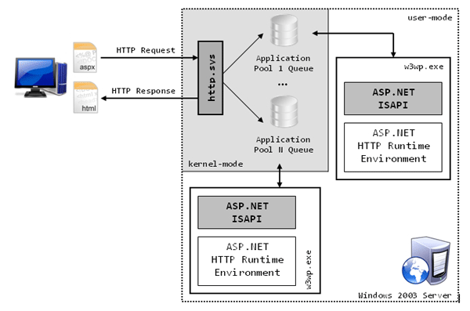
The above figure illustrates the principal components taking part in the request processing when using the II 6 model. Once a request arrives the kernel level device driver http.sys routes it to the right application pool queue. Each queue belongs to a specific application pool, and thus to a specific copy of the worker process, which next receives the request from the queue. This approach highly reduces the overhead introduced by named pipes used in IIS 5 model since no inter process communication is taking place, but the requests are headed to the worker process directly from the kernel level driver. This has many advantages concerning reliability, too. Since running in kernel mode, the request dispatching isn’t influenced by crashes and malfunctions happing at user level, that is, in the worker processes. Thereby, even if a worker process crashes, the system is still capable of accepting incoming requests and eventually restarts the crashed process.
It’s the worker process who is in charge of loading the ASP.NET ISAPI extension, which, in turn, loads the CRL and delegates all the work to the HTTP Runtime.
The w3wp.exe worker process, differently from the aspnet_wp.exe process used in IIS 5 model, isn’t ASP.NET specific, and is used to handle any kind of requests. The specific worker process then decides which ISAPI modules to load according to the type of resources it needs to serve.
A detail not underlined in Figure 3 for simplicity reasons is that incoming requests are forwarded from the application pool queue to the right worker process via a module loaded in IIS 6 called Web Administration Service (WAS). This module is responsible for reading worker process – web application bindings from the IIS metabase and forwarding the request to the right worker process.

IIS Request Processing

This topic describes how a client request is processed on an IIS server.

Request Processing by Type of Request

The following table describes what happens once an IIS process receives a request to be executed.
Request | Action
HTML Page | IIS returns the page in HTML format.
A file whose extension is mapped to a particular ISAPI extension, such as Asp.dll | IIS loads the appropriate DLL file and presents the request through the Extension_Control_Block data structure. For example, the .asp extension is mapped to Asp.dll, so that all requests for files with an .asp extension will be directed to Asp.dll. The .stm and .shtm extensions are mapped to the Ssinc.dll.
ISAPI extension | IIS loads the ISAPI DLL (if it is not already running) and the request is sent to the extension through the EXTENSION_CONTROL_BLOCK structure data structure.
CGI application | IIS creates a new process. IIS will then provide the query string and other parameters that are included with the request through the environment and standard input (STDIN) handle for the process.
ISAPI filters are always loaded as long as the Web service is running and a request to the server has been made.

Preliminary Request Processing on IIS 6.0 in Worker Process Isolation Mode

Before an IIS process receives a request to execute, some preliminary processing occurs that is described in the following steps:
- A request arrives at HTTP.sys.
- HTTP.sys determines if the request is valid. If the request is not valid, it sends a code for an invalid request back to the client.
- If the request is valid, HTTP.sys checks to see if the request is for static content (HTML) because static content can be served immediately.
- If the request is for dynamic content, HTTP.sys checks to see if the response is located in its kernel-mode cache.
- If the response is in the cache, HTTP.sys returns the response immediately.
- If the response is not cached, HTTP.sys determines the correct request queue, and places the request in that queue.
- If the queue has no worker processes assigned to it, HTTP.sys signals the WWW service to start one.
- The worker process pulls the request from the queue and processes the request, evaluating the URL to determine the type of request (ASP, ISAPI, or CGI).
- The worker process sends the response back to HTTP.sys.
10.HTTP.sys sends the response back to the client and logs the request, if configured to do so.

Preliminary Request Processing on IIS 6.0 in IIS 5.0 Isolation Mode and Earlier Versions of IIS

The request processing of IIS 6.0 running in IIS 5.0 isolation mode is nearly identical to the request processing in IIS 5.1, IIS 5.0, and IIS 4.0. Before an IIS process receives a request to execute, some preliminary processing occurs that is described in the following steps:
- A request arrives. If the requested application is running in-process, then Inetinfo.exe takes the request. If not, then DLLHost.exe takes the request.
- Inetinfo.exe or DLLHost.exe determines if the request is valid. If the request is not valid, it sends a code for an invalid request back to the client.
- If the request is valid, Inetinfo.exe or DLLHost.exe checks to see if the response is located in the IIS cache.
- If the response is in the cache, it is returned immediately.
- If the response is not cached, Inetinfo.exe or DLLHost.exe processes the request, evaluating the URL to determine if the request is for static content (HTML), or dynamic content (ASP, ASP.NET or ISAPI).
- The response is sent back to the client and the request is logged, if IIS is configured to do s.

4.4.4. C#.NET

ADO.NET OVERVIEW

ADO.NET is an evolution of the ADO data access model that directly addresses user requirements for developing scalable applications. It was designed specifically for the web with scalability, statelessness, and XML in mind.
ADO.NET uses some ADO objects, such as the Connection and Command objects, and also introduces new objects. Key new ADO.NET objects include the DataSet, DataReader, and DataAdapter.

The important distinction between this evolved stage of ADO.NET and previous data architectures is that there exists an object -- the DataSet -- that is separate and distinct from any data stores. Because of that, the Dataset functions as a standalone entity. You can think of the DataSet as an always disconnected recordset that knows nothing about the source or destination of the data it contains. Inside a DataSet, much like in a database, there are tables, columns, relationships, constraints, views, and so forth.

A DataAdapter is the object that connects to the database to fill the DataSet. Then, it connects back to the database to update the data there, based on operations performed while the DataSet held the data. In the past, data processing has been primarily connection-based. Now, in an effort to make multi-tiered apps more efficient, data processing is turning to a message-based approach that revolves around chunks of information. At the center of this approach is the DataAdapter, which provides a bridge to retrieve and save data between a DataSet and its source data store. It accomplishes this by means of requests to the appropriate SQL commands made against the data store.
The XML-based DataSet object provides a consistent programming model that works with all models of data storage: flat, relational, and hierarchical. It does this by having no 'knowledge' of the source of its data, and by representing the data that it holds as collections and data types. No matter what the source of the data within the DataSet is, it is manipulated through the same set of standard APIs exposed through the DataSet and its subordinate objects.
While the DataSet has no knowledge of the source of its data, the managed provider has detailed and specific information. The role of the managed provider is to connect, fill, and persist the DataSet to and from data stores. The OLE DB and SQL Server .NET Data Providers (System.Data.OleDb and System.Data.SqlClient) that are part of the .Net Framework provide four basic objects: the Command, Connection, DataReader and DataAdapter. In the remaining sections of this document, we'll walk through each part of the DataSet and the OLE DB/SQL Server .NET Data Providers explaining what they are, and how to program against them.
The following sections will introduce you to some objects that have evolved, and some that are new. These objects are:

- Connections. For connection to and managing transactions against a database.
- Commands. For issuing SQL commands against a database.
- DataReaders. For reading a forward-only stream of data records from a SQL Server data source.
- DataSets. For storing, Remoting and programming against flat data, XML data and relational data.
- DataAdapters. For pushing data into a DataSet, and reconciling data against a database.
When dealing with connections to a database, there are two different options: SQL Server .NET Data Provider (System.Data.SqlClient) and OLE DB .NET Data Provider (System.Data.OleDb). In these samples we will use the SQL Server .NET Data Provider. These are written to talk directly to Microsoft SQL Server. The OLE DB .NET Data Provider is used to talk to any OLE DB provider (as it uses OLE DB underneath).

Connections:
Connections are used to 'talk to' databases, and are represented by provider-specific classes such as SqlConnection. Commands travel over connections and resultsets are returned in the form of streams which can be read by a DataReader object, or pushed into a DataSet object.

Commands:
Commands contain the information that is submitted to a database, and are represented by provider-specific classes such as SqlCommand. A command can be a stored procedure call, an UPDATE statement, or a statement that returns results. You can also use input and output parameters, and return values as part of your command syntax. The example below shows how to issue an INSERT statement against the Northwind database.

DataReaders:
The DataReader object is somewhat synonymous with a read-only/forward-only cursor over data. The DataReader API supports flat as well as hierarchical data. A DataReader object is returned after executing a command against a database. The format of the returned DataReader object is different from a recordset. For example, you might use the DataReader to show the results of a search list in a web page.

DATASETS AND DATAADAPTERS:
DataSets
The DataSet object is similar to the ADO Recordset object, but more powerful, and with one other important distinction: the DataSet is always disconnected. The DataSet object represents a cache of data, with database-like structures such as tables, columns, relationships, and constraints. However, though a DataSet can and does behave much like a database, it is important to remember that DataSet objects do not interact directly with databases, or other source data. This allows the developer to work with a programming model that is always consistent, regardless of where the source data resides. Data coming from a database, an XML file, from code, or user input can all be placed into DataSet objects. Then, as changes are made to the DataSet they can be tracked and verified before updating the source data. The GetChanges method of the DataSet object actually creates a second DatSet that contains only the changes to the data. This DataSet is then used by a DataAdapter (or other objects) to update the original data source.
The DataSet has many XML characteristics, including the ability to produce and consume XML data and XML schemas. XML schemas can be used to describe schemas interchanged via WebServices. In fact, a DataSet with a schema can actually be compiled for type safety and statement completion.

DATAADAPTERS (OLEDB/SQL)

The DataAdapter object works as a bridge between the DataSet and the source data. Using the provider-specific SqlDataAdapter (along with its associated SqlCommand and SqlConnection) can increase overall performance when working with a Microsoft SQL Server databases. For other OLE DB-supported databases, you would use the OleDbDataAdapter object and its associated OleDbCommand and OleDbConnection objects.
The DataAdapter object uses commands to update the data source after changes have been made to the DataSet. Using the Fill method of the DataAdapter calls the SELECT command; using the Update method calls the INSERT, UPDATE or DELETE command for each changed row. You can explicitly set these commands in order to control the statements used at runtime to resolve changes, including the use of stored procedures. For ad-hoc scenarios, a CommandBuilder object can generate these at run-time based upon a select statement. However, this run-time generation requires an extra round-trip to the server in order to gather required metadata, so explicitly providing the INSERT, UPDATE, and DELETE commands at design time will result in better run-time performance.
- ADO.NET is the next evolution of ADO for the .Net Framework.
- ADO.NET was created with n-Tier, statelessness and XML in the forefront. Two new objects, the DataSet and DataAdapter, are provided for these scenarios.
- ADO.NET can be used to get data from a stream, or to store data in a cache for updates.
- There is a lot more information about ADO.NET in the documentation.
- Remember, you can execute a command directly against the database in order to do inserts, updates, and deletes. You don't need to first put data into a DataSet in order to insert, update, or delete it.
- Also, you can use a DataSet to bind to the data, move through the data, and navigate data relationships

    - SQL SERVER

A database management, or DBMS, gives the user access to their data and helps them transform the data into information. Such database management systems include dBase, paradox, IMS, SQL Server and SQL Server. These systems allow users to create, update and extract information from their database.
A database is a structured collection of data. Data refers to the characteristics of people, things and events. SQL Server stores each data item in its own fields. In SQL Server, the fields relating to a particular person, thing or event are bundled together to form a single complete unit of data, called a record (it can also be referred to as raw or an occurrence). Each record is made up of a number of fields. No two fields in a record can have the same field name.
During an SQL Server Database design project, the analysis of your business needs identifies all the fields or attributes of interest. If your business needs change over time, you define any additional fields or change the definition of existing fields.

SQL SERVER TABLES
SQL Server stores records relating to each other in a table. Different tables are created for the various groups of information. Related tables are grouped together to form a database.

PRIMARY KEY
Every table in SQL Server has a field or a combination of fields that uniquely identifies each record in the table. The Unique identifier is called the Primary Key, or simply the Key. The primary key provides the means to distinguish one record from all other in a table. It allows the user and the database system to identify, locate and refer to one particular record in the database.

RELATIONAL DATABASE
Sometimes all the information of interest to a business operation can be stored in one table. SQL Server makes it very easy to link the data in multiple tables. Matching an employee to the department in which they work is one example. This is what makes SQL Server a relational database management system, or RDBMS. It stores data in two or more tables and enables you to define relationships between the table and enables you to define relationships between the tables.

FOREIGN KEY
When a field is one table matches the primary key of another field is referred to as a foreign key. A foreign key is a field or a group of fields in one table whose values match those of the primary key of another table.

REFERENTIAL INTEGRITY
Not only does SQL Server allow you to link multiple tables, it also maintains consistency between them. Ensuring that the data among related tables is correctly matched is referred to as maintaining referential integrity.

DATA ABSTRACTION
A major purpose of a database system is to provide users with an abstract view of the data. This system hides certain details of how the data is stored and maintained. Data abstraction is divided into three levels.

Physical level: This is the lowest level of abstraction at which one describes how the data are actually stored.

Conceptual Level: At this level of database abstraction all the attributed and what data are actually stored is described and entries and relationship among them.

View level: This is the highest level of abstraction at which one describes only part of the database.

ADVANTAGES OF RDBMS

- Redundancy can be avoided
- Inconsistency can be eliminated
- Data can be Shared
- Standards can be enforced
- Security restrictions ca be applied
- Integrity can be maintained
- Conflicting requirements can be balanced
- Data independence can be achieved.

DISADVANTAGES OF DBMS
A significant disadvantage of the DBMS system is cost. In addition to the cost of purchasing of developing the software, the hardware has to be upgraded to allow for the extensive programs and the workspace required for their execution and storage. While centralization reduces duplication, the lack of duplication requires that the database be adequately backed up so that in case of failure the data can be recovered.

FEATURES OF SQL SERVER (RDBMS)
SQL SERVER is one of the leading database management systems (DBMS) because it is the only Database that meets the uncompromising requirements of today’s most demanding information systems. From complex decision support systems (DSS) to the most rigorous online transaction processing (OLTP) application, even application that require simultaneous DSS and OLTP access to the same critical data, SQL Server leads the industry in both performance and capability

SQL SERVER is a truly portable, distributed, and open DBMS that delivers unmatched performance, continuous operation and support for every database.
SQL SERVER RDBMS is high performance fault tolerant DBMS which is specially designed for online transactions processing and for handling large database application.

SQL SERVER with transactions processing option offers two features which contribute to very high level of transaction processing throughput, which are

- The row level lock manager

ENTERPRISE WIDE DATA SHARING
The unrivaled portability and connectivity of the SQL SERVER DBMS enables all the systems in the organization to be linked into a singular, integrated computing resource.

PORTABILITY
SQL SERVER is fully portable to more than 80 distinct hardware and operating systems platforms, including UNIX, MSDOS, OS/2, Macintosh and dozens of proprietary platforms. This portability gives complete freedom to choose the database sever platform that meets the system requirements.

OPEN SYSTEMS
SQL SERVER offers a leading implementation of industry –standard SQL. SQL Server’s open architecture integrates SQL SERVER and non –SQL SERVER DBMS with industries most comprehensive collection of tools, application, and third party software products SQL Server’s Open architecture provides transparent access to data from other relational database and even non-relational database.

DISTRIBUTED DATA SHARING
SQL Server’s networking and distributed database capabilities to access data stored on remote server with the same ease as if the information was stored on a single local computer. A single SQL statement can access data at multiple sites. You can store data where system requirements such as performance, security or availability dictate.

UNMATCHED PERFORMANCE
The most advanced architecture in the industry allows the SQL SERVER DBMS to deliver unmatched performance.

SOPHISTICATED CONCURRENCY CONTROL
Real World applications demand access to critical data. With most database Systems application becomes “contention bound” – which performance is limited not by the CPU power or by disk I/O, but user waiting on one another for data access . SQL Server employs full, unrestricted row-level locking and contention free queries to minimize and in many cases entirely eliminates contention wait times.

NO I/O BOTTLENECKS
SQL Server’s fast commit groups commit and deferred write technologies dramatically reduce disk I/O bottlenecks. While some database write whole data block to disk at commit time, SQL Server commits transactions with at most sequential log file on disk at commit time, On high throughput systems, one sequential writes typically group commit multiple transactions. Data read by the transaction remains as shared memory so that other transactions may access that data without reading it again from disk. Since fast commits write all data necessary to the recovery to the log file, modified blocks are written back to the database independently of the transaction commit, when written from memory to disk.

System Design
Chapter - 5

5.1. INTRODUCTION

Software design sits at the technical kernel of the software engineering process and is applied regardless of the development paradigm and area of application. Design is the first step in the development phase for any engineered product or system. The designer’s goal is to produce a model or representation of an entity that will later be built. Beginning, once system requirement have been specified and analyzed, system design is the first of the three technical activities -design, code and test that is required to build and verify software.
The importance can be stated with a single word “Quality”. Design is the place where quality is fostered in software development. Design provides us with representations of software that can assess for quality. Design is the only way that we can accurately translate a customer’s view into a finished software product or system. Software design serves as a foundation for all the software engineering steps that follow. Without a strong design we risk building an unstable system – one that will be difficult to test, one whose quality cannot be assessed until the last stage.
During design, progressive refinement of data structure, program structure, and procedural details are developed reviewed and documented. System design can be viewed from either technical or project management perspective. From the technical point of view, design is comprised of four activities – architectural design, data structure design, interface design and procedural design.

5.2. NORMALIZATION
It is a process of converting a relation to a standard form. The process is used to handle the problems that can arise due to data redundancy i.e. repetition of data in the database, maintain data integrity as well as handling problems that can arise due to insertion, updation, deletion anomalies.
Decomposing is the process of splitting relations into multiple relations to eliminate anomalies and maintain anomalies and maintain data integrity. To do this we use normal forms or rules for structuring relation.

Insertion anomaly: Inability to add data to the database due to absence of other data.

Deletion anomaly: Unintended loss of data due to deletion of other data.

Update anomaly: Data inconsistency resulting from data redundancy and partial update

Normal Forms: These are the rules for structuring relations that eliminate anomalies.

FIRST NORMAL FORM:

A relation is said to be in first normal form if the values in the relation are atomic for every attribute in the relation. By this we mean simply that no attribute value can be a set of values or, as it is sometimes expressed, a repeating group.
SECOND NORMAL FORM:

A relation is said to be in second Normal form is it is in first normal form and it should satisfy any one of the following rules.
- Primary key is a not a composite primary key
- No non key attributes are present
- Every non key attribute is fully functionally dependent on full set of primary key.

THIRD NORMAL FORM:
A relation is said to be in third normal form if their exits no transitive dependencies.

Transitive Dependency: If two non key attributes depend on each other as well as on the primary key then they are said to be transitively dependent.
The above normalization principles were applied to decompose the data in multiple tables thereby making the data to be maintained in a consistent state.

5.3. E – R DIAGRAMS
  - The relation upon the system is structure through a conceptual ER-Diagram, which not only specifics the existential entities but also the standard relations through which the system exists and the cardinalities that are necessary for the system state to continue.
  - The entity Relationship Diagram (ERD) depicts the relationship between the data objects. The ERD is the notation that is used to conduct the date modeling activity the attributes of each data object noted is the ERD can be described resign a data object descriptions.
  - The set of primary components that are identified by the ERD are
◆ Data object  Relationships
◆ Attributes  Various types of indicators.
The primary purpose of the ERD is to represent data objects and their relationships.

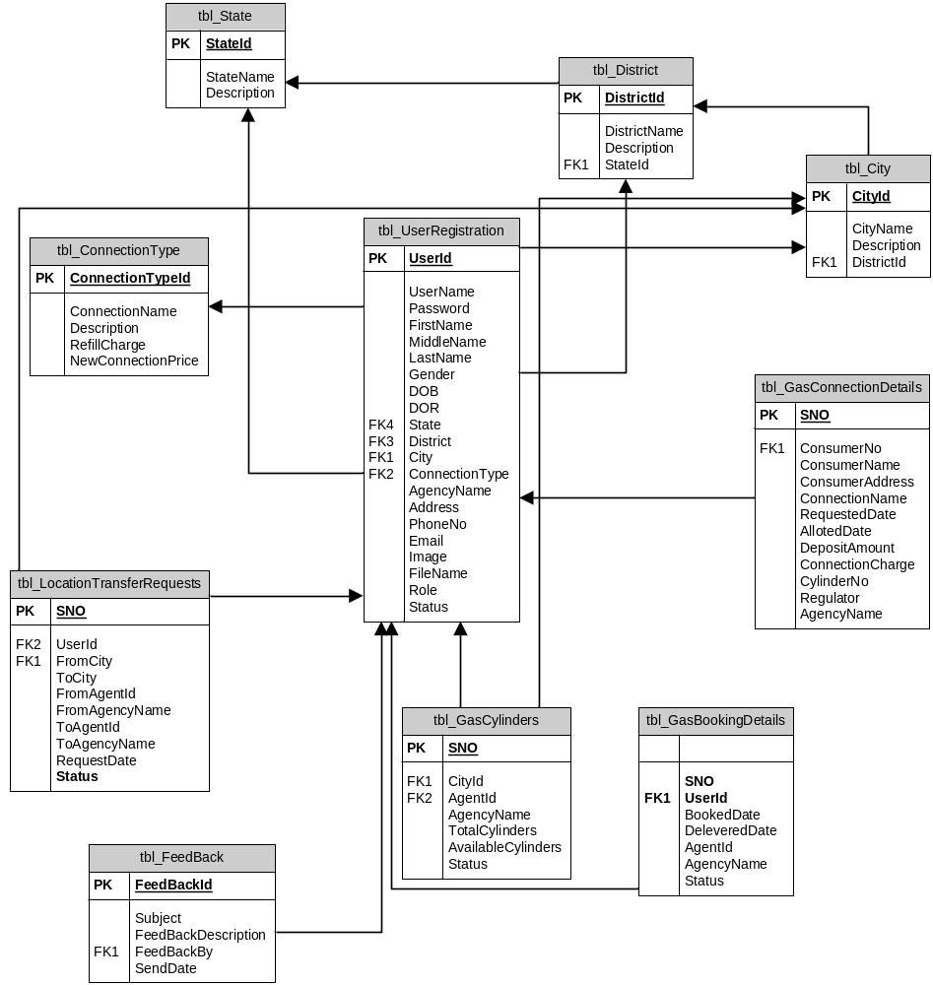

5.4. DATA FLOW DIAGRAMS

A data flow diagram is graphical tool used to describe and analyze movement of data through a system. These are the central tool and the basis from which the other components are developed. The transformation of data from input to output, through processed, may be described logically and independently of physical components associated with the system. These are known as the logical data flow diagrams. The physical data flow diagrams show the actual implements and movement of data between people, departments and workstations. A full description of a system actually consists of a set of data flow diagrams. Using two familiar notations Yourdon, Gane and Sarson notation develops the data flow diagrams. Each component in a DFD is labeled with a descriptive name. Process is further identified with a number that will be used for identification purpose. The development of DFD’S is done in several levels. Each process in lower level diagrams can be broken down into a more detailed DFD in the next level. The lop-level diagram is often called context diagram. It consists a single process bit, which plays vital role in studying the current system. The process in the context level diagram is exploded into other process at the first level DFD.
The idea behind the explosion of a process into more process is that understanding at one level of detail is exploded into greater detail at the next level. This is done until further explosion is necessary and an adequate amount of detail is described for analyst to understand the process.
Larry Constantine first developed the DFD as a way of expressing system requirements in a graphical from, this lead to the modular design.
A DFD is also known as a “bubble Chart” has the purpose of clarifying system requirements and identifying major transformations that will become programs in system design. So it is the starting point of the design to the lowest level of detail. A DFD consists of a series of bubbles joined by data flows in the system.

DFD SYMBOLS:
In the DFD, there are four symbols
- A square defines a source(originator) or destination of system data
- An arrow identifies data flow. It is the pipeline through which the information flows
- A circle or a bubble represents a process that transforms incoming data flow into outgoing data flows.
- An open rectangle is a data store, data at rest or a temporary repository of data

Process that transforms data flow.

Source or Destination of data
Data flow

Data Store

CONSTRUCTING A DFD:
Several rules of thumb are used in drawing DFD’S:

- Process should be named and numbered for an easy reference. Each name should be representative of the process.
- The direction of flow is from top to bottom and from left to right. Data traditionally flow from source to the destination although they may flow back to the source. One way to indicate this is to draw long flow line back to a source. An alternative way is to repeat the source symbol as a destination. Since it is used more than once in the DFD it is marked with a short diagonal.
- When a process is exploded into lower level details, they are numbered.
- The names of data stores and destinations are written in capital letters. Process and dataflow names have the first letter of each work capitalized

A DFD typically shows the minimum contents of data store. Each data store should contain all the data elements that flow in and out.
Questionnaires should contain all the data elements that flow in and out. Missing interfaces redundancies and like is then accounted for often through interviews.

SAILENT FEATURES OF DFD’S
- The DFD shows flow of data, not of control loops and decision are controlled considerations do not appear on a DFD.
- The DFD does not indicate the time factor involved in any process whether the dataflow take place daily, weekly, monthly or yearly.
- The sequence of events is not brought out on the DFD.

TYPES OF DATA FLOW DIAGRAMS
- Current Physical
- Current Logical
- New Logical
- New Physical

CURRENT PHYSICAL:
In Current Physical DFD process label include the name of people or their positions or the names of computer systems that might provide some of the overall system-processing label includes an identification of the technology used to process the data. Similarly data flows and data stores are often labels with the names of the actual physical media on which data are stored such as file folders, computer files, business forms or computer tapes.

CURRENT LOGICAL:
The physical aspects at the system are removed as mush as possible so that the current system is reduced to its essence to the data and the processors that transforms them regardless of actual physical form.

NEW LOGICAL:
This is exactly like a current logical model if the user were completely happy with he user were completely happy with the functionality of the current system but had problems with how it was implemented typically through the new logical model will differ from current logical model while having additional functions, absolute function removal and inefficient flows recognized.

NEW PHYSICAL:
The new physical represents only the physical implementation of the new system.

RULES GOVERNING THE DFD’S

PROCESS
- No process can have only outputs.
- No process can have only inputs. If an object has only inputs than it must be a sink.
- A process has a verb phrase label.

DATA STORE
- Data cannot move directly from one data store to another data store, a process must move data.
- Data cannot move directly from an outside source to a data store, a process, which receives, must move data from the source and place the data into data store
- A data store has a noun phrase label.

SOURCE OR SINK
The origin and / or destination of data.

- Data cannot move direly from a source to sink it must be moved by a process
- A source and /or sink has a noun phrase land

DATA FLOW
- A Data Flow has only one direction of flow between symbols. It may flow in both directions between a process and a data store to show a read before an update. The later is usually indicated however by two separate arrows since these happen at different type.
- A join in DFD means that exactly the same data comes from any of two or more different processes data store or sink to a common location.
- A data flow cannot go directly back to the same process it leads. There must be atleast one other process that handles the data flow produce some other data flow returns the original data into the beginning process.
- A Data flow to a data store means update (delete or change).
- A data Flow from a data store means retrieve or use.

A data flow has a noun phrase label more than one data flow noun phrase can appear on a single arrow as long as all of the flows on the same arrow move together as one package.
Context Level (0th Level Diagram)

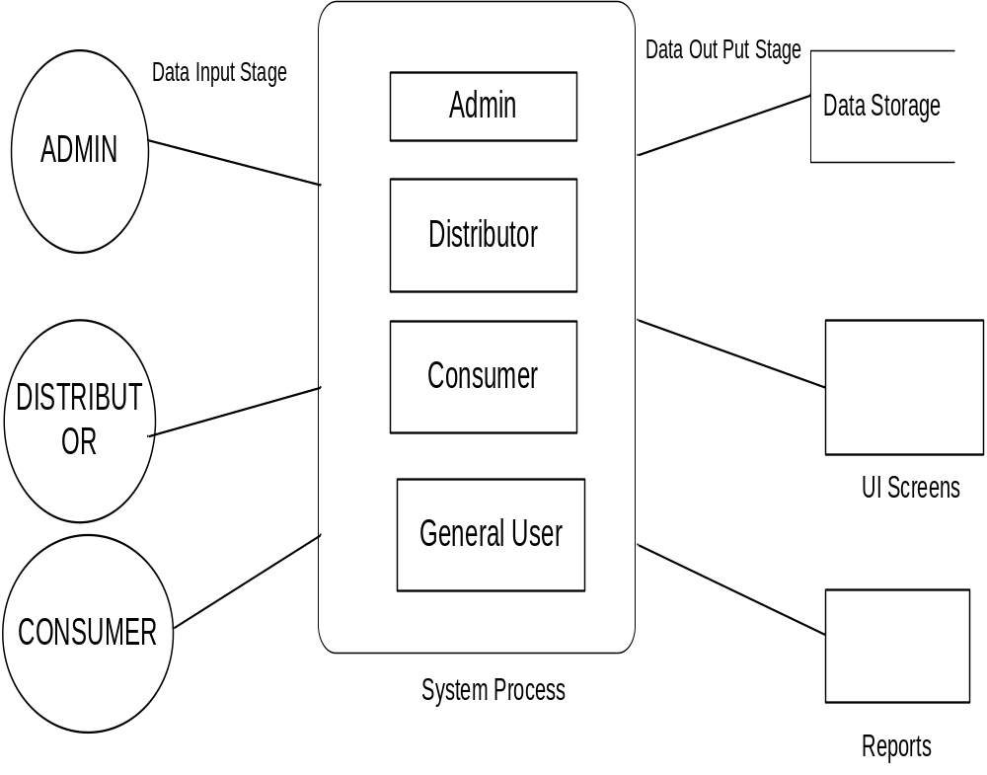

Login DFD Diagram:
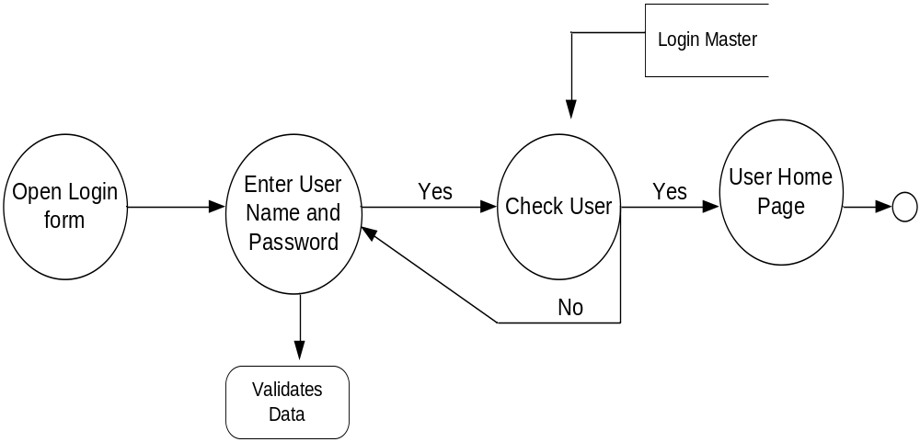

Admin Details Data Flow
1st Level DFD
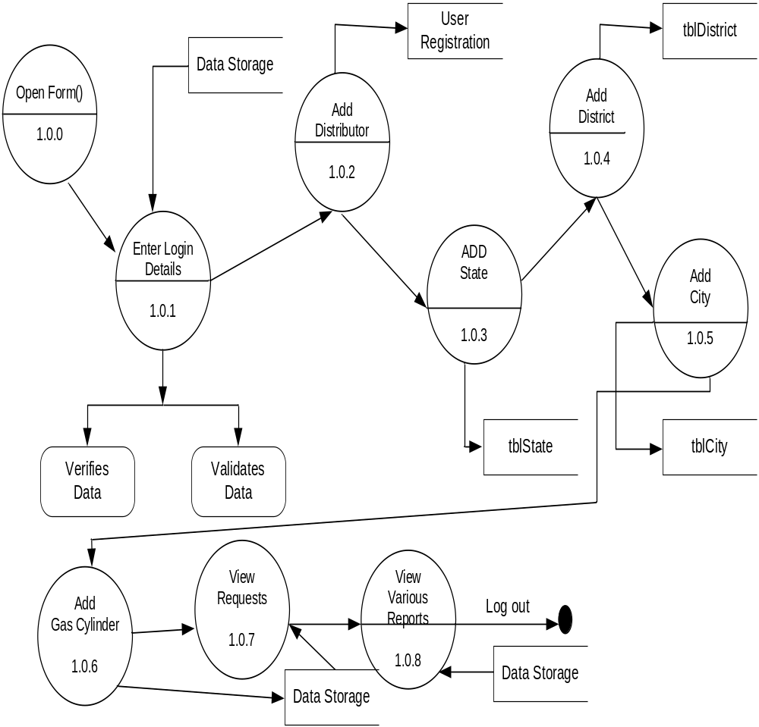

Distributor Details Dataflow Diagram:
1st Level DFD diagram:
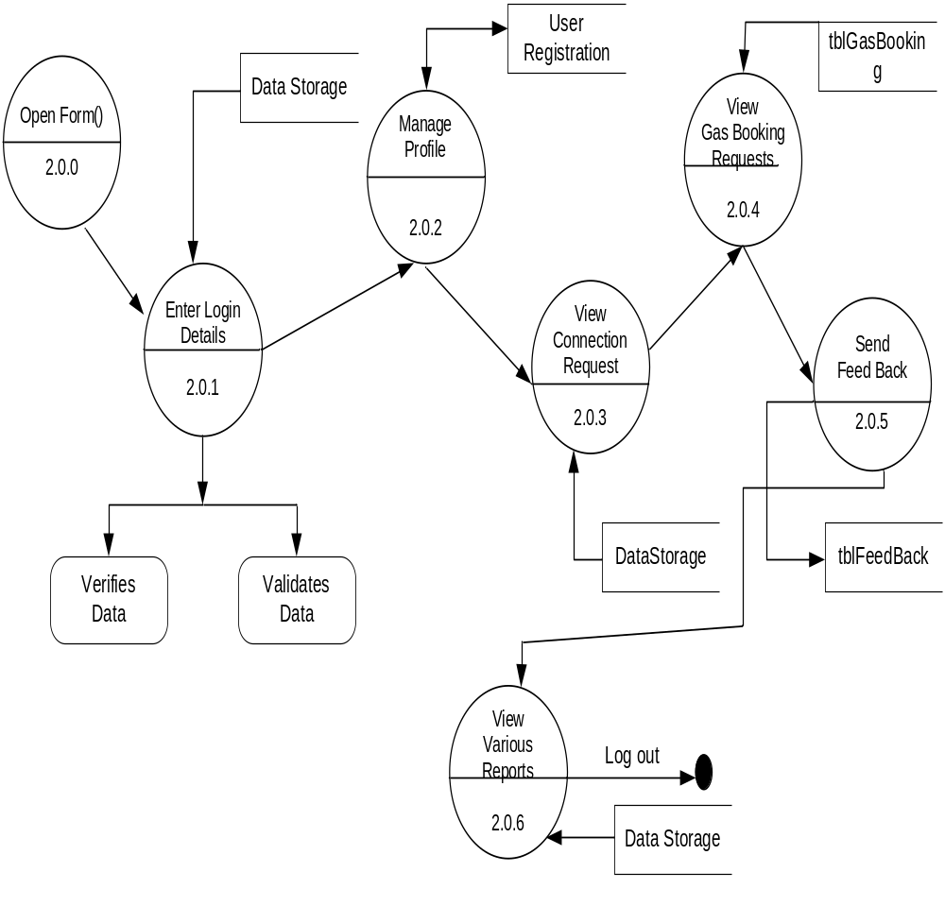

Consumer Details Data Flow Diagram:
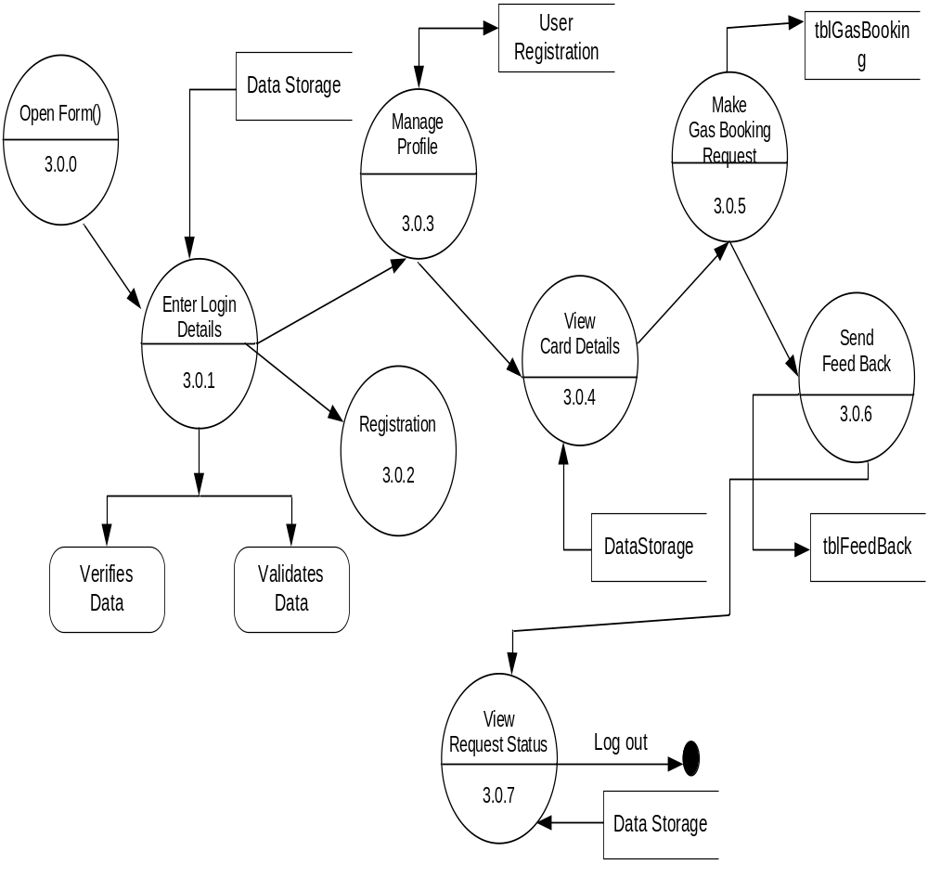
2nd Level DFD
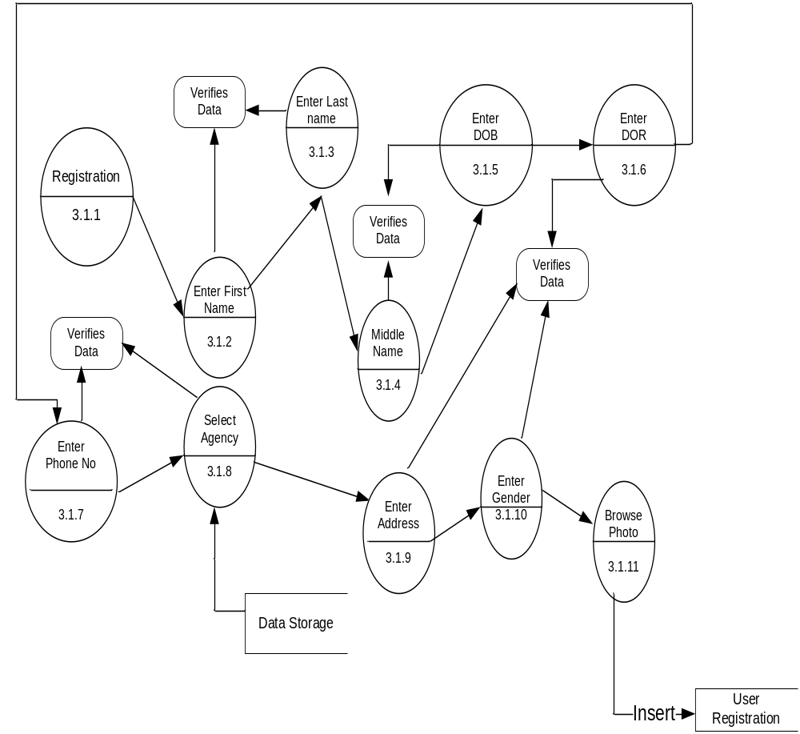

5.5. UML DIAGRAMS
The Unified Modeling Language (UML) is used to specify, visualize, modify, construct and document the artifacts of an object-oriented software intensive system under development. UML offers a standard way to visualize a system's architectural blueprints, including elements such as:
- actors
- business processes
- (logical) components
- activities
- programming language statements
- database schemas, and
- Reusable software components.

UML combines best techniques from data modeling (entity relationship diagrams), business modeling (work flows), object modeling, and component modeling. It can be used with all processes, throughout the software development life cycle, and across different implementation technologies. UML has synthesized the notations of the Booch method, the Object-modeling technique (OMT) and Object-oriented software engineering (OOSE) by fusing them into a single, common and widely usable modeling language. UML aims to be a standard modeling language which can model concurrent and distributed systems.
Use Case Diagram:
Over View Use Case Diagram:

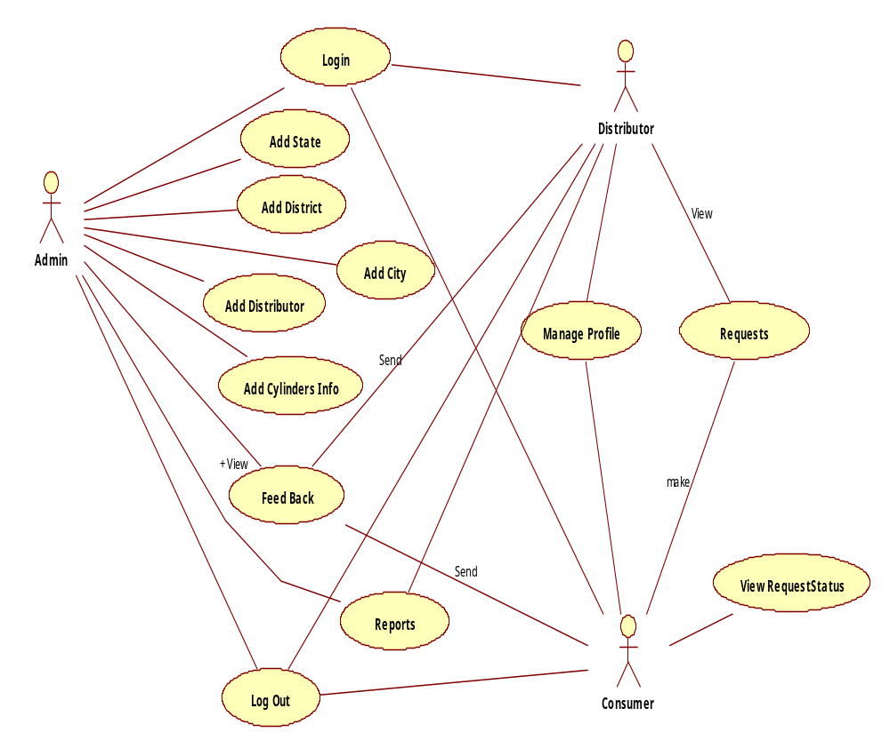
Admin Use Case Diagram:
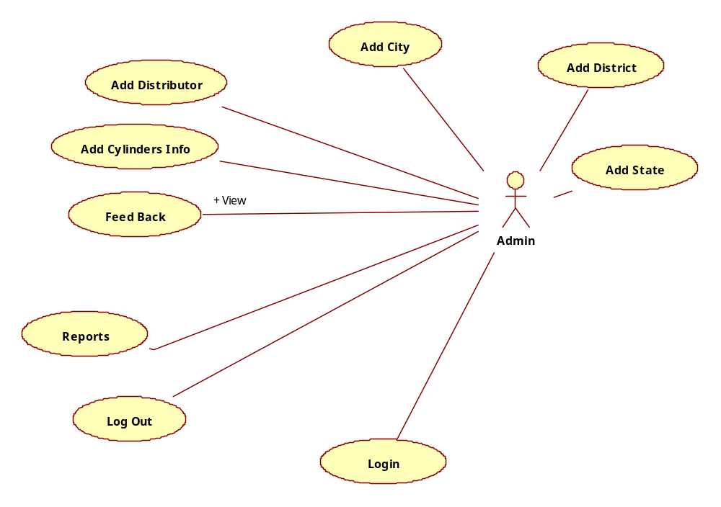
Distributor Use Case Diagram:
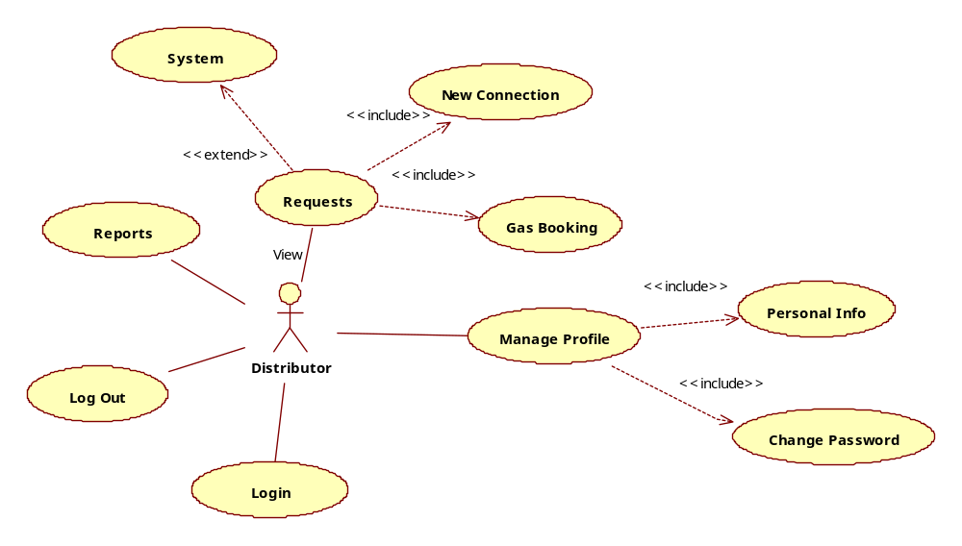
Consumer Use Case Diagram:

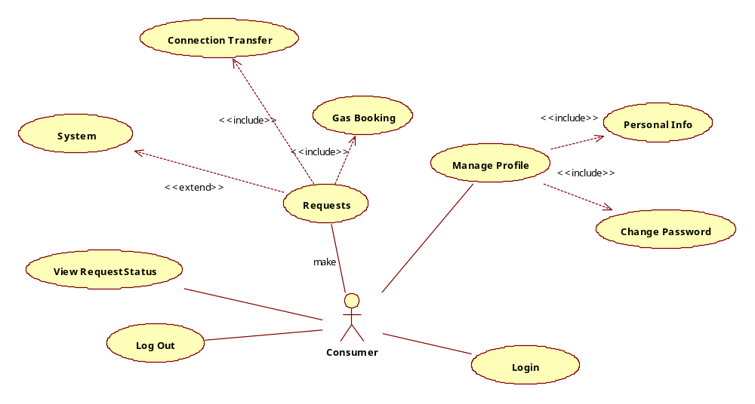

Sequence Diagrams Represent the objects participating the interaction horizontally and time vertically. A Use Case is a kind of behavioral classifier that represents a declaration of an offered behavior. Each use case specifies some behavior, possibly including variants that the subject can perform in collaboration with one or more actors. Use cases define the offered behavior of the subject without reference to its internal structure. These behaviors, involving interactions between the actor and the subject, may result in changes to the state of the subject and communications with its environment. A use case can include possible variations of its basic behavior, including exceptional behavior and error handling.

Admin Login Sequence Diagram:

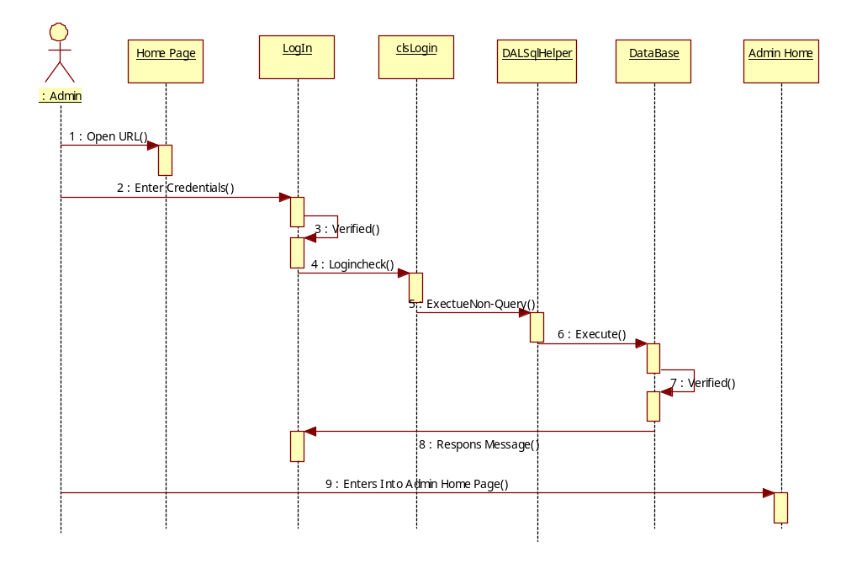
: Admin
LogIn
Admin Home
Add State
clsState
Dal SqlHelper
Database
1 : Enter Credentials()
2 : Verified()
3 : Enters Into Admin Home Page()
4 : Enters State Details()
5 : Add State()
6 : Execute NonQuery()
7 : Execute()
8 : Response Message()
Add District Details:

: Admin
LogIn
Admin Home
Add District
clsState
Dal SqlHelper
Database
1 : Enter Credentials()
2 : Verified()
3 : Enters Into Admin Home Page()
4 : Enters District Details()
5 : Add District()
6 : Execute NonQuery()
7 : Execute()
8 : Response Message()

Add City Sequence Diagram:
: Admin
LogIn
Admin Home
Add City
clsState
Dal SqlHelper
Database
1 : Enter Credentials()
2 : Verified()
3 : Enters Into Admin Home Page()
4 : Enters City Details()
5 : Add City()
6 : Execute NonQuery()
7 : Execute()
8 : Response Message()

Add Distributor Sequence Diagram:
: Admin
LogIn
Admin Home
Add Distributor
clsUser
Dal SqlHelper
Database
1 : Enter Credentials()
2 : Verified()
3 : Enters Into Admin Home Page()
4 : Enters Distributor Details()
5 : Add User()
6 : Execute NonQuery()
7 : Execute()
8 : Response Message()
Add Gas Cylinders Sequence Diagram:
: Admin
LogIn
Admin Home
Add Cylinders
clsAdmin
Dal SqlHelper
Database
1 : Enter Credentials()
2 : Verified()
3 : Enters Into Admin Home Page()
4 : Enters Cylinders Details()
5 : Add Cylinders()
6 : Execute NonQuery()
7 : Execute()
8 : Response Message()

Add View Reports Sequence Diagram:
: Admin
LogIn
Admin Home
View Reports
clsAdmin
Dal SqlHelper
Database
1 : Enter Credentials()
2 : Verified()
3 : Enters Into Admin Home Page()
4 : Select Report()
5 : ShowDitributor()
6 : ExecuteDataset()
7 : Execute()
8 : View Reports()

Distributor View User Request :
LogIn
Home
View New connection
clsUser
Dal SqlHelper
Database
: Distributor
1 : Enter Login Details()
2 : Verified()
3 : Get Home Page()
4 : Select User Request Details()
5 : ShowUserConnection()
6 : ExecuteDataset()
7 : Execute()
8 : Verified()
9 : View Requests()

LogIn
Home
View connection transfer request

clsUser
Dal SqlHelper
Database
: Distributor
1 : Enter Login Details()
2 : Verified()
3 : Get Home Page()
4 : Select Transfer Request
5 : ShowTrasnfer()
6 : ExecuteDataset()
7 : Execute()
8 : Verified()
9 : View Requests()

Consumer Sequence Diagram:

: Consumer
LogIn
Consumer
Home
clsUser
Dal SqlHelper
Database
1 : Enter Credentials()
2 : Verified()
3 : Enters Into Consumer Home Page()
4 : Enters Gas Booking Details()
5 : AddGasBooking()
6 : Execute NonQuery()
7 : Execute()
8 : Response Message()
Booking Request

Collaboration Diagram:
Admin Login Collaboration Diagram:
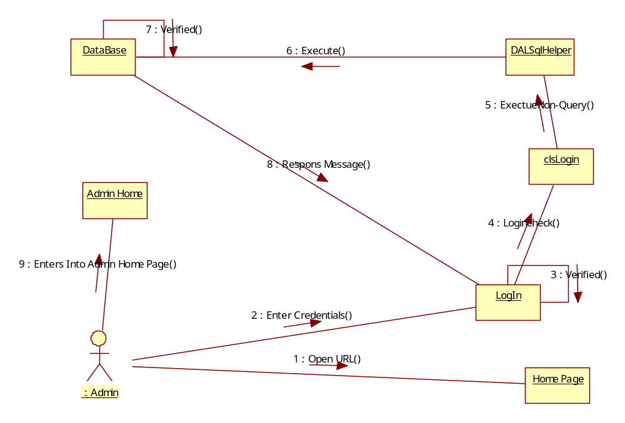
Add State Collaboration Diagram:
: Admin
LogIn
Admin Home
Add State
clsState
Dal SqlHelper
Database
1 : Enter Credentials()
2 : Verified()
3 : Enters Into Admin Home Page()
4 : Enters state Details()
5 : Add state()
6 : Execute NonQuery()
7 : Execute()
8 : Response Message()

Add District Details Collaboration Diagram:
: Admin
LogIn
Admin Home
Add District
clsState
Dal SqlHelper
Database
1 : Enter Credentials()
2 : Verified()
3 : Enters Into Admin Home Page()
4 : Enters District Details()
5 : Add Floor()
6 : Execute NonQuery()
7 : Execute()
8 : Response Message()

City Collaboration Diagram:
: Admin
LogIn
Admin Home
Add City
clsCity
Dal SqlHelper
Database
1 : Enter Credentials()
2 : Verified()
3 : Enters Into Admin Home Page()
4 : Enters City Details()
5 : Add Asset()
6 : Execute NonQuery()
7 : Execute()
8 : Response Message()

Add Distributor Collaboration Diagram:
: Admin
LogIn
Admin Home
Add Distributor
clsUser
Dal SqlHelper
Database
1 : Enter Credentials()
2 : Verified()
3 : Enters Into Admin Home Page()
4 : Enters Distributor Details()
5 : Add Invoice()
6 : Execute NonQuery()
7 : Execute()
8 : Response Message()

Distributor View User Requests Collaboration Diagram:
LogIn
Home
View requests
clsUser
Dal SqlHelper
Database
: Distributor
1 : Enter Login Details()
2 : Verified()
3 : Get Home Page()
4 : Select Connection Request()
5 : Show connection Request()
6 : ExecuteDataset()
7 : Execute()
8 : Verified()
9 : View Reports()
: Admin
LogIn
Admin Home
Add Gas cylinders
clsAdmin
Dal SqlHelper
Database
1 : Enter Credentials()
2 : Verified()
3 : Enters Into Admin Home Page()
4 : Enters Gas Cylinders Details()
5 : Add Cylinders()
6 : Execute NonQuery()
7 : Execute()
8 : Response Message()

Admin View Reports:
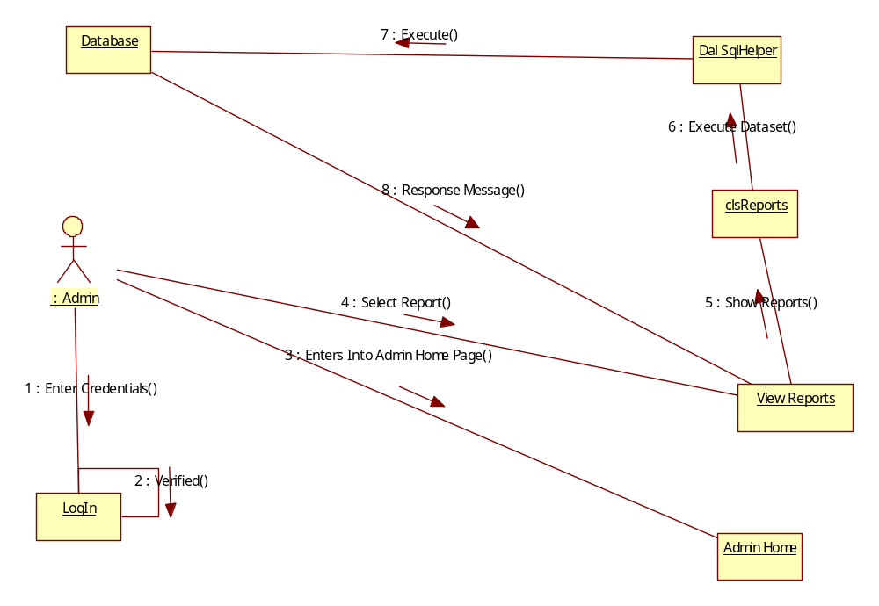

Activity Diagrams:

Login Activity Diagram:
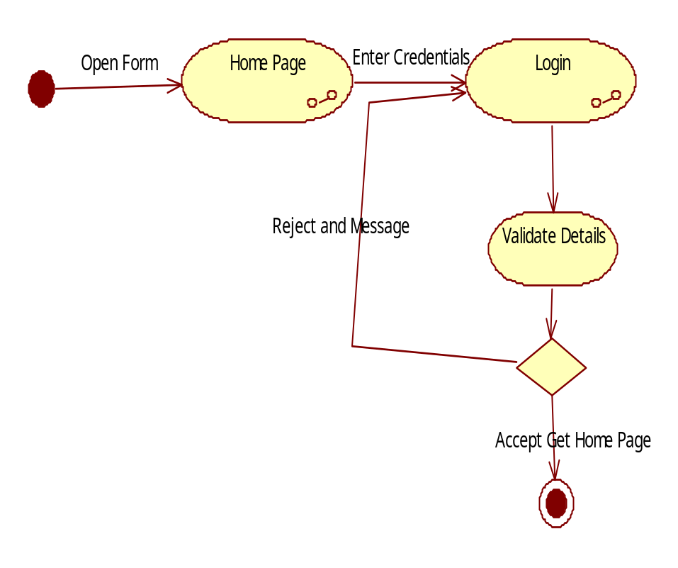

Admin activity Diagram:
Home Page
Login
Enter Credentials
Validate Details
NO
Yes
Add State
Add District
Add City
Add Distributors
Add Cylinders
View feedback, Reports
View Requests

Distributor Activity Diagram:
Home Page
Login
Enter Credentials
Validate Details
NO
Yes
Update Profile
View User New Connection Request
View Gas Booking Requests
Send Feed Back
View Reports

Consumer Activity Diagram:
Home Page
Login
Enter Credentials
Validate Details
NO
Yes
Update Profile
View Gas Card Details

Make Online Gas Booking Requests
View Request Status
Send Feedback

Class Diagram:

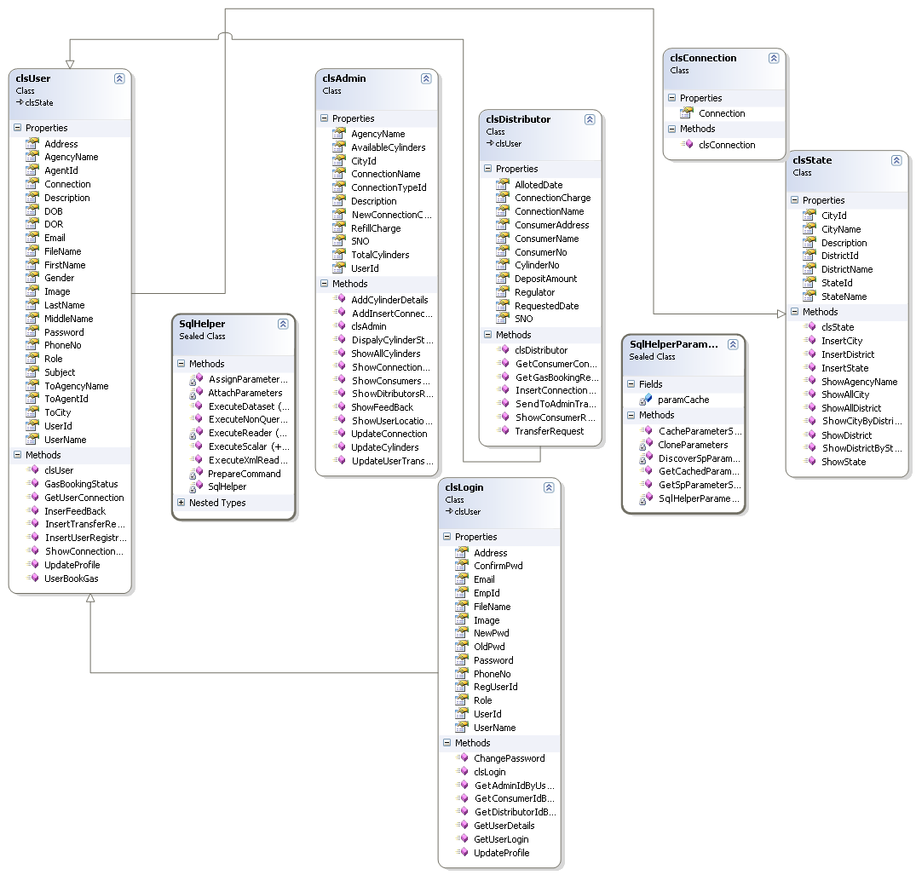

5.6. DATA DICTONARY
After carefully understanding the requirements of the client the the entire data storage requirements are divided into tables. The below tables are normalized to avoid any anomalies during the course of data entry.

User Registration Table:
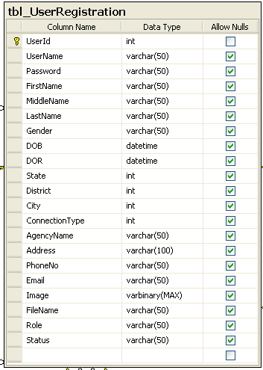
Connection Type Table:
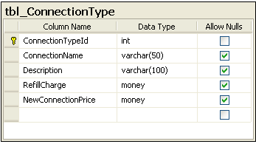
Gas Cylinders Table:
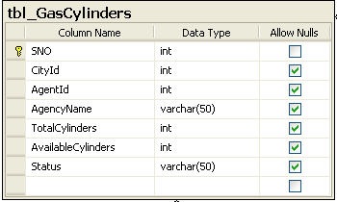
State Table:
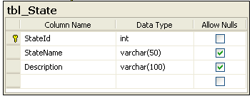
District Table:
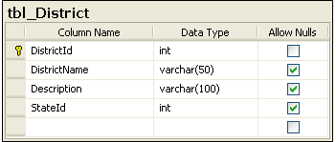
City Table:
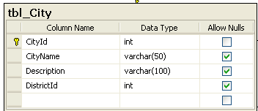

Gas Connection Table
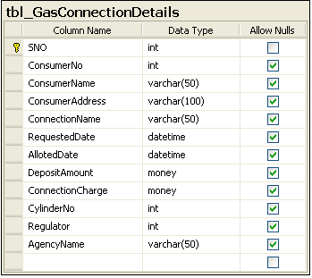
Gas Booking Table:
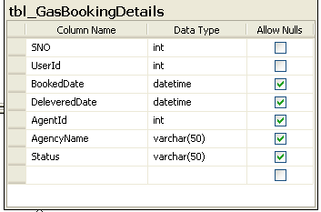
Location Transfer Table:
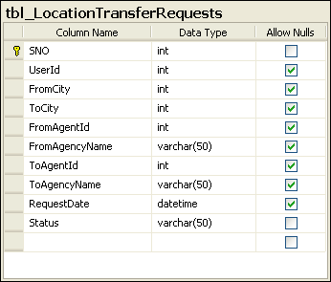
Feed Back Table:
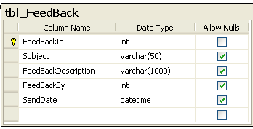

Output Screens
Chapter - 6

Out Put Screens:

Paste output Screens Here

System Testing and Implementation
Chapter - 7

7.1 INTRODUCTION TO TESTING

Software testing is a critical element of software quality assurance and represents the ultimate review of specification, design and coding. The increasing visibility of software as a system element and attendant costs associated with a software failure are motivating factors for we planned, through testing. Testing is the process of executing a program with the intent of finding an error. The design of tests for software and other engineered products can be as challenging as the initial design of the product itself.
There of basically two types of testing approaches.
One is Black-Box testing – the specified function that a product has been designed to perform, tests can be conducted that demonstrate each function is fully operated.
The other is White-Box testing – knowing the internal workings of the product ,tests can be conducted to ensure that the internal operation of the product performs according to specifications and all internal components have been adequately exercised.
White box and Black box testing methods have been used to test this package. The entire loop constructs have been tested for their boundary and intermediate conditions. The test data was designed with a view to check for all the conditions and logical decisions. Error handling has been taken care of by the use of exception handlers.

7.2 TESTING STRATEGIES:
Testing is a set of activities that can be planned in advanced and conducted systematically. A strategy for software testing must accommodation low-level tests that are necessary to verify that a small source code segment has been correctly implemented as well as high-level tests that validate major system functions against customer requirements.
Software testing is one element of verification and validation. Verification refers to the set of activities that ensure that software correctly implements as specific function. Validation refers to a different set of activities that ensure that the software that has been built is traceable to customer requirements.
The main objective of software is testing to uncover errors. To fulfill this objective, a series of test steps unit, integration, validation and system tests are planned and executed. Each test step is accomplished through a series of systematic test technique that assist in the design of test cases. With each testing step, the level of abstraction with which software is considered is broadened.

Testing is the only way to assure the quality of software and it is an umbrella activity rather than a separate phase. This is an activity to be preformed in parallel with the software effort and one that consists of its own phases of analysis, design, implementation, execution and maintenance.

UNIT TESTING:
This testing method considers a module as single unit and checks the unit at interfaces and communicates with other modules rather than getting into details at statement level. Here the module will be treated as a black box, which will take some input and generate output. Outputs for a given set of input combination are pre-calculated and are generated by the module.
SYSTEM TESTING:
Here all the pre tested individual modules will be assembled to create the larger system and tests are carried out at system level to make sure that all modules are working in synchronous with each other. This testing methodology helps in making sure that all modules which are running perfectly when checked individually are also running in cohesion with other modules. For this testing we create test cases to check all modules once and then generated test combinations of test paths through out the system to make sure that no path is making its way into chaos.

INTEGRATED TESTING
Testing is a major quality control measure employed during software development. Its basic function is to detect errors. Sub functions when combined may not produce than it is desired. Global data structures can represent the problems. Integrated testing is a systematic technique for constructing the program structure while conducting the tests. To uncover errors that are associated with interfacing the objective is to make unit test modules and built a program structure that has been detected by design. In a non - incremental integration all the modules are combined in advance and the program is tested as a whole. Here errors will appear in an end less loop function. In incremental testing the program is constructed and tested in small segments where the errors are isolated and corrected.
Different incremental integration strategies are top – down integration, bottom – up integration, regression testing.
TOP-DOWN INTEGRATION TEST
Modules are integrated by moving downwards through the control hierarchy beginning with main program. The subordinate modules are incorporated into structure in either a breadth first manner or depth first manner. This process is done in five steps:
- Main control module is used as a test driver and steps are substituted or all modules directly to main program.
- Depending on the integration approach selected subordinate is replaced at a time with actual modules.
- Tests are conducted.
- On completion of each set of tests another stub is replaced with the real module
- Regression testing may be conducted to ensure trha5t new errors have not been introduced.
This process continuous from step 2 until entire program structure is reached. In top down integration strategy decision making occurs at upper levels in the hierarchy and is encountered first. If major control problems do exists early recognitions is essential.
If depth first integration is selected a complete function of the software may be implemented and demonstrated.
Some problems occur when processing at low levels in hierarchy is required to adequately test upper level steps to replace low-level modules at the beginning of the top down testing. So no data flows upward in the program structure.
BOTTOM-UP INTEGRATION TEST
Begins construction and testing with atomic modules. As modules are integrated from the bottom up, processing requirement for modules subordinate to a given level is always available and need for stubs is eliminated. The following steps implements this strategy.
- Low-level modules are combined in to clusters that perform a specific software sub function.
- A driver is written to coordinate test case input and output.
- Cluster is tested.
- Drivers are removed and moving upward in program structure combines clusters.
Integration moves upward, the need for separate test driver’s lesions.

If the top levels of program structures are integrated top down, the number of drivers can be reduced substantially and integration of clusters is greatly simplified.

REGRESSION TESTING
Each time a new module is added as a part of integration as the software changes. Regression testing is an actually that helps to ensure changes that do not introduce unintended behavior as additional errors.
Regression testing maybe conducted manually by executing a subset of all test cases or using automated capture play back tools enables the software engineer to capture the test case and results for subsequent playback and compression. The regression suit contains different classes of test cases.
A representative sample to tests that will exercise all software functions.
Additional tests that focus on software functions that are likely to be affected by the change.

7.3 IMPLEMENTATION
Implementation is the process of converting a new or revised system design into operational one. There are three types of Implementation:
- Implementation of a computer system to replace a manual system. The problems encountered are converting files, training users, and verifying printouts for integrity.
- Implementation of a new computer system to replace an existing one. This is usually a difficult conversion. If not properly planned there can be many problems.
- Implementation of a modified application to replace an existing one using the same computer. This type of conversion is relatively easy to handle, provided there are no major changes in the files.
Implementation in Generic tool project is done in all modules. In the first module User level identification is done. In this module every user is identified whether they are genuine one or not to access the database and also generates the session for the user. Illegal use of any form is strictly avoided.
In the Table creation module, the tables are created with user specified fields and user can create many table at a time. They may specify conditions, constraints and calculations in creation of tables. The Generic code maintain the user requirements through out the project.
In Updating module user can update or delete or Insert the new record into the database. This is very important module in Generic code project. User has to specify the filed value in the form then the Generic tool automatically gives whole filed values for that particular record.
In Reporting module user can get the reports from the database in 2Dimentional or 3Dimensional view. User has to select the table and specify the condition then the report will be generated for the user.

System Security
Chapter - 8

9.1. INTRODUCTION
The protection of computer based resources that includes hardware, software, data, procedures and people against unauthorized use or natural
Disaster is known as System Security.

System Security can be divided into four related issues:
- Security
- Integrity
- Privacy
- Confidentiality

SYSTEM SECURITY refers to the technical innovations and procedures applied to the hardware and operation systems to protect against deliberate or accidental damage from a defined threat.

DATA SECURITY is the protection of data from loss, disclosure, modification and destruction.

SYSTEM INTEGRITY refers to the power functioning of hardware and programs, appropriate physical security and safety against external threats such as eavesdropping and wiretapping.

PRIVACY defines the rights of the user or organizations to determine what information they are willing to share with or accept from others and how the organization can be protected against unwelcome, unfair or excessive dissemination of information about it.

CONFIDENTIALITY is a special status given to sensitive information in a database to minimize the possible invasion of privacy. It is an attribute of information that characterizes its need for protection.

9.2. SECURITY IN SOFTWARE

System security refers to various validations on data in form of checks and controls to avoid the system from failing. It is always important to ensure that only valid data is entered and only valid operations are performed on the system. The system employees two types of checks and controls:
CLIENT SIDE VALIDATION
Various client side validations are used to ensure on the client side that only valid data is entered. Client side validation saves server time and load to handle invalid data. Some checks imposed are:
- JavaScript in used to ensure those required fields are filled with suitable data only. Maximum lengths of the fields of the forms are appropriately defined.
- Forms cannot be submitted without filling up the mandatory data so that manual mistakes of submitting empty fields that are mandatory can be sorted out at the client side to save the server time and load.
- Tab-indexes are set according to the need and taking into account the ease of user while working with the system.

SERVER SIDE VALIDATION
Some checks cannot be applied at client side. Server side checks are necessary to save the system from failing and intimating the user that some invalid operation has been performed or the performed operation is restricted. Some of the server side checks imposed is:
- Server side constraint has been imposed to check for the validity of primary key and foreign key. A primary key value cannot be duplicated. Any attempt to duplicate the primary value results into a message intimating the user about those values through the forms using foreign key can be updated only of the existing foreign key values.
- User is intimating through appropriate messages about the successful operations or exceptions occurring at server side.
- Various Access Control Mechanisms have been built so that one user may not agitate upon another. Access permissions to various types of users are controlled according to the organizational structure. Only permitted users can log on to the system and can have access according to their category. User- name, passwords and permissions are controlled o the server side.
- Using server side validation, constraints on several restricted operations are imposed.

Conclusion
Chapter - 9

It has been a great pleasure for me to work on this exciting and challenging project. This project proved good for me as it provided practical knowledge of not only programming in ASP.NET and C#.NET web based application and no some extent Windows Application and SQL Server, but also about all handling procedure related with “Gas Agency System”. It also provides knowledge about the latest technology used in developing web enabled application and client server technology that will be great demand in future. This will provide better opportunities and guidance in future in developing projects independently.
BENEFITS:
The project is identified by the merits of the system offered to the user. The merits of this project are as follows: -
- It’s a web-enabled project.
- This project offers user to enter the data through simple and interactive forms. This is very helpful for the client to enter the desired information through so much simplicity.
- The user is mainly more concerned about the validity of the data, whatever he is entering. There are checks on every stages of any new creation, data entry or updation so that the user cannot enter the invalid data, which can create problems at later date.
- Sometimes the user finds in the later stages of using project that he needs to update some of the information that he entered earlier. There are options for him by which he can update the records. Moreover there is restriction for his that he cannot change the primary data field. This keeps the validity of the data to longer extent.
- User is provided the option of monitoring the records he entered earlier. He can see the desired records with the variety of options provided by him.
- From every part of the project the user is provided with the links through framing so that he can go from one option of the project to other as per the requirement. This is bound to be simple and very friendly as per the user is concerned. That is, we can sat that the project is user friendly which is one of the primary concerns of any good project.
- Data storage and retrieval will become faster and easier to maintain because data is stored in a systematic manner and in a single database.
- Decision making process would be greatly enhanced because of faster processing of information since data collection from information available on computer takes much less time then manual system.
- Allocating of sample results becomes much faster because at a time the user can see the records of last years.
- Easier and faster data transfer through latest technology associated with the computer and communication.
- Through these features it will increase the efficiency, accuracy and transparency,

LIMITATIONS:
- The size of the database increases day-by-day, increasing the load on the database back up and data maintenance activity.
- Training for simple computer operations is necessary for the users working on the system.

Future Scope
Chapter - 10

- This System being web-based and an undertaking of Cyber Security Division, needs to be thoroughly tested to find out any security gaps.

- A console for the data centre may be made available to allow the personnel to monitor on the sites which were cleared for hosting during a particular period.

- Moreover, it is just a beginning; further the system may be utilized in various other types of auditing operation viz. Network auditing or similar process/workflow based applications...

Bibliography
Chapter - 11

- FOR .NET INSTALLATION
www.support.mircosoft.com
- FOR DEPLOYMENT AND PACKING ON SERVER
www.developer.com
www.15seconds.com
- FOR SQL
www.msdn.microsoft.com
- FOR ASP.NET
www.msdn.microsoft.com/net/quickstart/aspplus/default.com
www.asp.net
www.fmexpense.com/quickstart/aspplus/default.com
www.asptoday.com
www.aspfree.com
www.4guysfromrolla.com/index.aspx
- System Analysis and Design
Senn
- Database System Design
Elmasree
Korth
- Software Engineering Concepts
Robert Pressman

