SYSTEM REQUIRMENT SPECIFICATIONS
FOR
GAS AGENCY SYSTEM

PURPOSE OF THE SYSTEM

The Gas Agency system is providing facility to the users from that the user can make online gas booking easily. If the user (Consumer) has no gas connection, the system is providing facility that user can make a request for new connection. And also providing the facility like he can make a request for transfer gas connection from one location to another.
Features:

  - The system keeps the track of Agency Details
  - The system keeps the track of All Consumers Agency wise
  - The system will displays statically data about Gas Cylinders
  - Providing Online gas Booking Facility
  - Providing Online Transfer request facility from one location to another

EXISTING SYSTEM

Through this existing consumer unable to make online gas booking. For gas booking he has to make a cal to distributor and book the gas on. Data has located in single system. Making online request is not possible in existing system. Online requests are like gas booking request and connection transfer request. For maintain the large data not possible with the existing system. More physical interaction needed.

PROPOSED SYSTEM

By considering the existing system the new proposed system providing the facility like that the consumer can make on line gas books as well as connection transfer request. Data has located as centralized. That data can be accessed by authorized persons. By this new system general user can know that statical data about gas cylinders in particular gas agency. The System also providing Online Registration for new connection.

STUDY OF THE SYSTEM

In the flexibility of the uses the interface has been developed a graphics concept in mind, associated through a browses interface. The GUI’S at the top level have been categorized as
- Administrative user interface
- The operational or generic user interface(Distributor, Consumer, User)

The administrative user interface concentrates on the consistent information that is practically, part of the organizational activities and which needs proper authentication for the data collection. The interfaces help the administrations with all the transactional states like Data insertion, and Date updating along with the extensive data search capabilities.

The operational or generic user interface helps the users upon the system in Transactions through the existing data and required services. The operational user interface also helps the ordinary users in managing their Personal information helps the ordinary users in managing their own information

NUMBER OF MODULES

  - Administration
  - Customer (User)
  - Distributor
  - Registration
  - Reports
  - Authentication
Users:
Distributor
Consumer
Administrator
Administration:
This is the module under this various tasks will takes place. That task are like Managing the States, District, City details. In this module distributors registration will be done. Statical data can be entered for gas cylinders on agency wise. Consumers transfer requests will be accepted in this module. And generates various reports in this module.
Registration:
Under this module various users registration will takes places. Distributors registration, User (Consumer) registration will be done through this module. At the time of registration that the user should provide the all information and also providing the facility the user can upload the image also.
Reports:
This module is comes under admin module as sub module as well as in distributor. In this module various reports will be generated. The system will generate reports like Consumers reports, Distributors reports, Feedback reports etc.
All these can view by the admin only. The distributor can view only his consumers reports.

Authentication Module:

This module contains all the information about the authenticated users. User without his username and password can’t enter into the login if he is only the authenticated user then he can enter to his login and then he will have authorization based upon their roles.
Distributor:
The distributor authenticate through system. Then he will get his home page. In this the distributor having facility like that he can modify his personal information.
He can view the online gas connection requests from the consumers. That Request will send to Admin. And also he can view the gas booking requests. Along with he will receive transfer requests from one location to other location. For further verification and decisions purpose these requests send to Admin. The distributor can send feed back to the admin. He can view the reports how many consumers are under his agency.
Consumer:
Consumer is the registered user. He can login in to the system. After that he can modify his profile if needed. Through this he can book the gas. And also he can make a request for transferring connection from one location to another. He can view the Status of his requests
Admin:
Admin is super user of this application. He is owner of this application. The admin will authenticate through system. After that he will perform his functionalities. He will add the New Agency Details; view the transfer requests send by distributor,
Update the gas cylinders information agency wise. That it displays home page of system. He can view the feedback send by consumer as well as distributor. And also he can view the various reports generated by system like consumers, distributor etc.

Inputs and Outputs
The following some are the projects inputs and outputs.
Inputs:
Admin enters his credentials.
Admin registers Agency (Distributors) details.
Admin enters State, District, and City Details into system
Admin select consumer requests send by Distributor
Distributor enters his credentials
Distributor enters feedback Details
Distributor enters personal info for updation.
Distributor selects Users Requests.
User (Consumers) enters personal data
Consumer enters credentials.
Consumer enters data for making gas booking.
Consumer enters data for making connection transfer request.
Consumer enters feedback details
Out Puts:
Admin will get his home page.
Registration details will be stored in centralized database.
Admin can view feedback details
Consumer requests will be stored in centralized database.
Users (Consumer,Ditributor) will get their home page.
Distributor information will be update in database.
Consumer can view the status on his request.
Admin view the various reports.

SDLC METHODOLOGY USED
Software Development Life Cycle (SDLC)

The Software Development Lifecycle (SDLC) for small to medium database application development efforts.

This project uses iterative development lifecycle, where components of the application are developed through a series of tight iteration. The first iteration focus on very basic functionality, with subsequent iterations adding new functionality to the previous work and or correcting errors identified for the components in production.
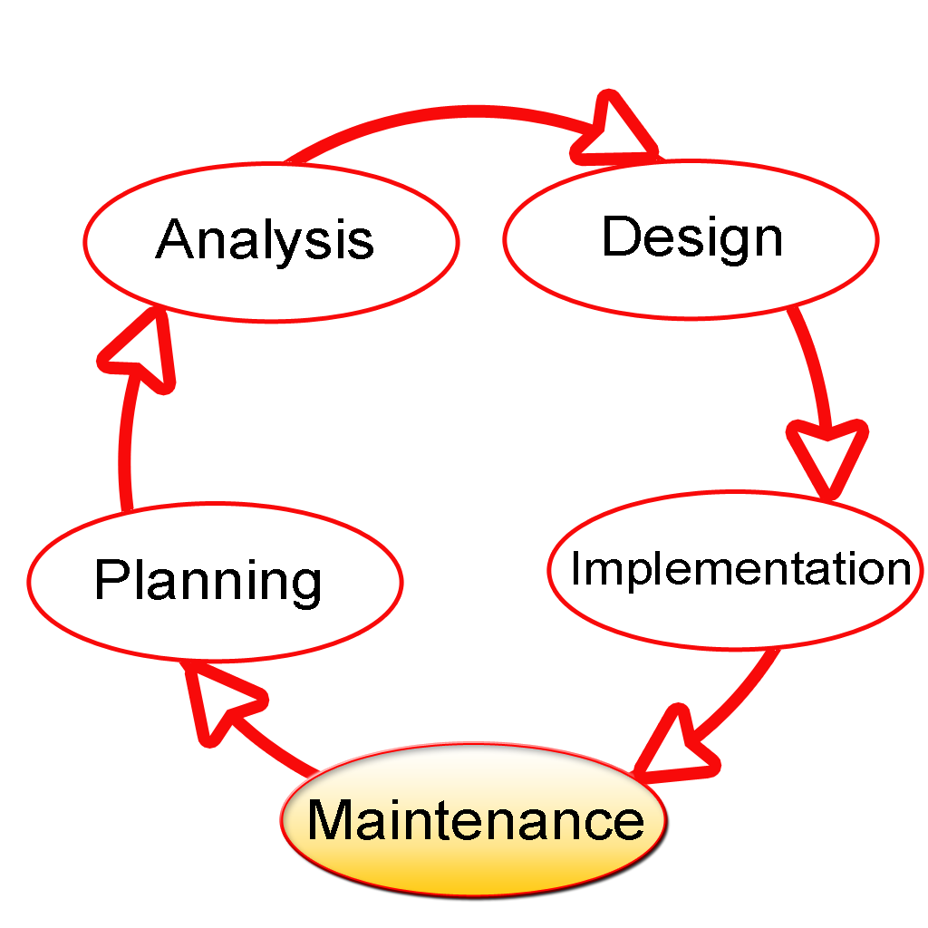

The six stages of the SDLC are designed to build on one another, taking outputs from the previous stage, adding additional effort, and producing results that leverage the previous effort and are directly traceable to the previous stages. During each stage, additional information is gathered or developed, combined with the inputs, and used to produce the stage deliverables. It is important to not that the additional information is restricted in scope, new ideas that would take the project in directions not anticipated by the initial set of high-level requirements or features that are out-of-scope are preserved for later consideration
.
Too many software development efforts go awry when development team and customer personnel get caught up in the possibilities of automation. Instead of focusing on high priority features, the team can become mired in a sea of nice to have features that are not essential to solve the problem, but in themselves are highly attractive. This is the root cause of large percentage of failed and or abandoned development efforts and is the primary reason the development team utilizes the iterative model.

INPUT DESIGN

Input design is a part of overall system design. The main objective during the input design is as given below:
- To produce a cost-effective method of input.
- To achieve the highest possible level of accuracy.
- To ensure that the input is acceptable and understood by the user.

INPUT STAGES:
The main input stages before the information gets stored in the database media:
Ex: In this project voter either existing or new user data will be stored in database as the inputs given by users….
- Data recording ,Data transcription, Data conversion, Data verification
- Data control, Data transmission, Data validation, Data correction

OUTPUT DESIGN

Outputs from computer systems are required primarily to communicate the results of processing to users. They are also used to provide a permanent copy of the results for later consultation. The various types of outputs in general are:
- External Outputs, whose destination is outside the organization,
- Internal Outputs whose destination is with in organization and they are the
    - User’s main interface with the computer.
- Operational outputs whose use is purely with in the computer department.
- Interface outputs, which involve the user in communicating directly with

The outputs were needed to be generated as a hard copy and as well as queries to be viewed on the screen. Keeping in view these outputs, the format for the output is taken from the outputs, which are currently being obtained after manual processing. The standard printer is to be used as output media for hard copies.
Project Architecture Flow
The current application is being developed by taking the 3-tier architecture as a prototype. In a three-tier architecture (also known as a multi-tier architecture), there are three or more interacting tiers, each with its own specific responsibilities:
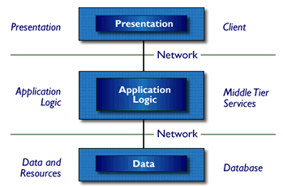
Three-Tier Architecture
- Tier 1: the client contains the presentation logic, including simple control and user input validation. This application is also known as a thin client. The client interface is developed using ASP.Net Server Controls and HTML controls in some occasions
- Tier 2: the middle tier is also known as the application server, which provides the business processes logic and the data access. The business logic/ business rules can be written either with C#.Net or VB.Net languages. These business runes will be deployed as DLL’s in IIS web server.
- Tier 3: the data server provides the business data. MS-SQL server acts as Tier-3, which is the database layer.
These are some of the advantages of three-tier architecture:
- It is easier to modify or replace any tier without affecting the other tiers.
- Separating the application and database functionality means better load balancing.
- Adequate security policies can be enforced within the server tiers without hindering the clients.
The proposed system can be designed perfectly with the three tier model, as all layers are perfectly getting set as part of the project. In the future, while expanding the system, in order to implement integration touch points and to provide enhanced user interfaces, the n-tier architecture can be used.

Context Level DFD

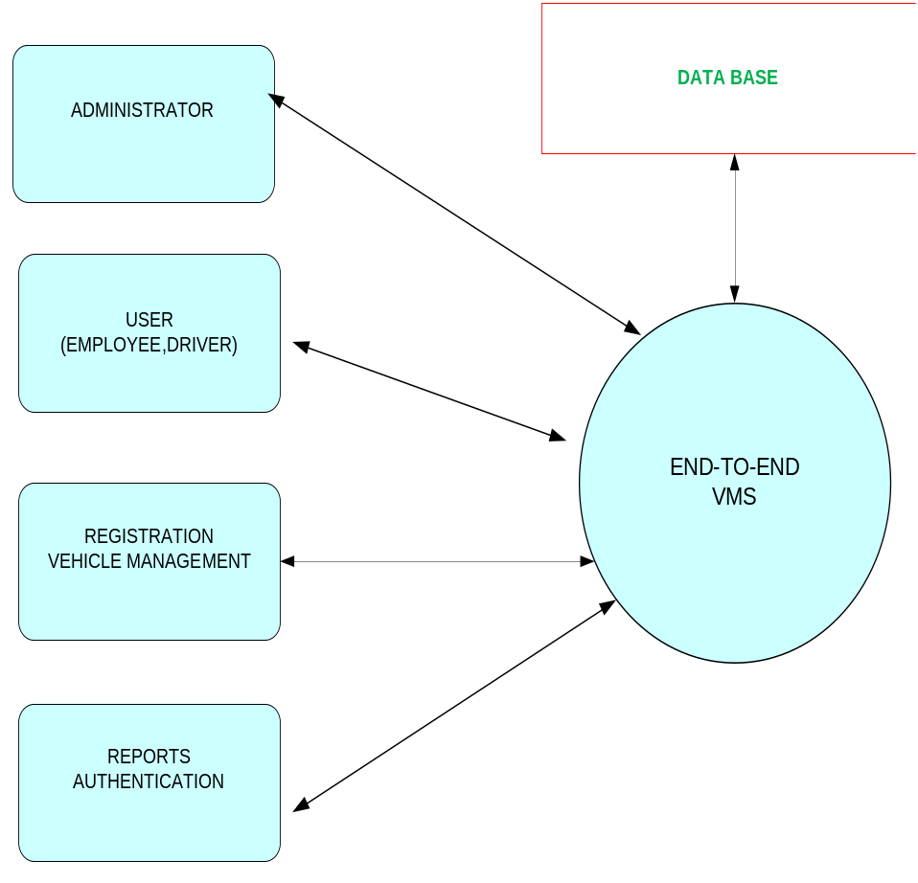

FEASIBILITY STUDY:

Preliminary investigation examine project feasibility, the likelihood the system will be useful to the organization. The main objective of the feasibility study is to test the Technical, Operational and Economical feasibility for adding new modules and debugging old running system. All system is feasible if they are unlimited resources and infinite time. There are aspects in the feasibility study portion of the preliminary investigation:

- Technical Feasibility
- Economical Feasibility
- Operation Feasibility
Technical Feasibility:
In the feasibility study first step is that the organization or company has to decide that what technologies are suitable to develop by considering existing system.
Here in this application used the technologies like Visual Studio 2008 and SqlServer 2005. These are free software that would be downloaded from web.
Visual Studio 2008 –it is tool or technology.

Determining Economic Feasibility

Assessing the economic feasibility of an implementation by performing a cost/benefit analysis, which as its name suggests compares the full/real costs of the application to its full/real financial benefits. The alternatives should be evaluated on the basis of their contribution to net cash flow, the amount by which the benefits exceed the costs, because the primary objective of all investments is to improve overall organizational performance.

Type | Potential Costs | Potential Benefits
Quantitative | - Hardware/software upgrades  - Fully-burdened cost of labor (salary + benefits)  - Support costs for the application  - Expected operational costs  - Training costs for users to learn the application  - Training costs to train developers in new/updated technologies | - Reduced operating costs  - Reduced personnel costs from a reduction in staff  - Increased revenue from additional sales of your organizations products/services
Qualitative | - Increased employee dissatisfaction from fear of change | - Improved decisions as the result of access to accurate and timely information  - Raising of existing, or introduction of a new, barrier to entry within your industry to keep competition out of your market  - Positive public perception that your organization is an innovator
The table includes both qualitative factors, costs or benefits that are subjective in nature, and quantitative factors, costs or benefits for which monetary values can easily be identified. I will discuss the need to take both kinds of factors into account when performing a cost/benefit analysis.
Operational Feasibility
Not only must an application make economic and technical sense, it must also make operational sense.
Issues to consider when determining the operational feasibility of a project.
Operations Issues | Support Issues
- What tools are needed to support operations?  - What skills will operators need to be trained in?  - What processes need to be created and/or updated?  - What documentation does operations need? | - What documentation will users be given?  - What training will users be given?  - How will change requests be managed?
Very often you will need to improve the existing operations, maintenance, and support infrastructure to support the operation of the new application that you intend to develop. To determine what the impact will be you will need to understand both the current operations and support infrastructure of your organization and the operations and support characteristics of your new application.
To operate this application END-TO-END VMS. The user no need to require any technical knowledge that we are used to develop this project is Asp.net ,C#.net. That the application providing rich user interface by user can do the operation in flexible manner.

