**Facial Emotion Recognition Using Convolutional Neural Networks**

**1. Name:**

Gattu Sai Lakshmi

**2. Topic: Problem Definition:**

The project revolves around the development of a Convolutional Neural Network (CNN) for Facial Emotion Recognition.

**3. Project Completion Status:**

The implementation of the CNN for facial emotion recognition using the CK+ dataset has been completed.

**4. Data Set:**

The dataset utilized in this project is the CK+ (Extended Cohn-Kanade) dataset. This dataset consists of facial expression images with labeled emotions. The CK+ dataset can be accessed from Kaggle.

**5. Description of Your System:**

***5.1 Data Preprocessing:***

Loaded and explored the CK+ dataset in a Pandas DataFrame.

Checked and displayed basic information about the dataset using the info() method.

Converted pixel strings to NumPy arrays and resized images to a standard size (48x48 pixels).

Normalized pixel values to the range [0, 1].

Determined the number of classes dynamically and split the dataset into features and labels.

***5.2 Model Architecture:***

Defined a CNN architecture using the Keras framework.

Utilized convolutional layers with ReLU activation and max-pooling to capture spatial features.

Flattened the output and added fully connected layers.

Compiled the model using the Adam optimizer, categorical cross entropy loss, and accuracy as the evaluation metric.

***5.3 Training:***

Split the dataset into training and testing sets using sci-kit-learn's train_test_split.

Implemented data augmentation using the ImageDataGenerator to enhance model generalization.

Trained the model with data augmentation for multiple epochs.

Adjusted hyperparameters, including the learning rate, to optimize training.

**6. Results and Conclusions:**

Monitored the training and validation accuracy over epochs using Matplotlib.

Evaluated the model on the test set and reported test accuracy.

Extended training for additional epochs with adjusted learning rate.

Visualized the training and validation accuracy over the extended training period.

After performing a little bit of tunning with 20 epochs

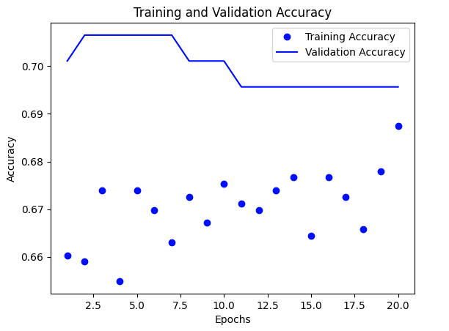

***7. Further Considerations:***

The model achieved 70% accuracy on the test set, demonstrating its effectiveness in recognizing facial expressions.

Considerations for future work include exploring additional architectures, fine-tuning hyperparameters, and experimenting with more advanced data augmentation techniques.