Introduction

Notes and remarks taken while preparing a test suite for autosaint.
These notes provide some suggestion on how to improve the radio-nuclide environment from the software engineering point of view.

Database Comments
To test autosaint, it was required to setup a separate environment copying the environment used on idcdev. The first step was to recreate the necessary tables on a local oracle database installed on a workstation. The database schema has been recreated from Tim and Gertrud’s schemas and crossed-checked with the request performed by autosaint. Below are comments and possible suggestions for improvements.

Bidirectional references (synonyms) in RMSAUTO and RMSMAN
RMSAUTO is referencing tables (with the synonym keyword) from RMSMAN and RMSMAN is referencing tables from RMSAUTO. The two tables are highly coupled and interdependent and therefore it is difficult to maintain, backup and migrate these tables. In order to simplify the users and administrators life, it would be better to have one schema pointing to another one and no bidirectional references.

RMSMAN contains some relatively static data which are referenced by RMSAUTO and the logic of data referenced by RMSMAN from RMSAUTO remains unclear. Indeed my understanding was that the dynamic data (sample data) which can be modified during the manual process should be copied by triggers to RMSMAN from RMSAUTO

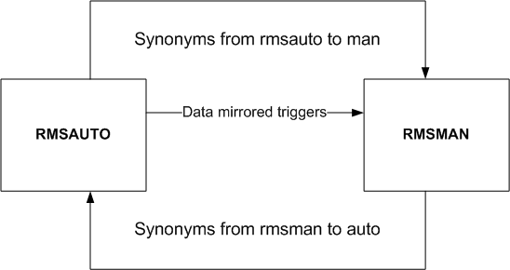
current dependencies between RMSAUTO and RMSMAN

In order to organise the database all the static tables should be identified and regrouped under another schema which would reference both (for instanceRMSSTATIC). All the data coming from RMSAUTO which could be used in RMSMAN should be copied by trigger. Hopefully and if not mistaken the automatic process being run before the manual process RMSAUTO at the end should not have any dependencies with RMSAUTO only RMSSTATIC.

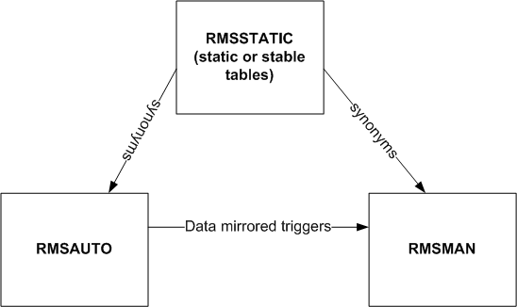
new dependencies

If it is difficult to create a RMSSTATIC schema a first step could be to regroup all the static information in RMSMAN.

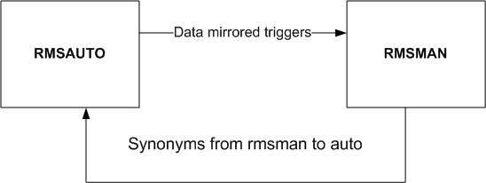
temporary solution

Note that Gertrud is building a graphical map of the database for RMSMAN and RMSAUTO and an analysis will be performed from this starting point in order to provide some advices and guidelines on how to improve the database environment.

Absolute file path in the database
The table FILEPRODUCT contains some file information related to the IDC product. Amongst them are the file name (DFILE), the offset (FOFF), the size (DSIZE) and the absolute directory (DIR) containing the data file. Having an absolute directory in the database makes migrations, backup and maintenance more difficult as you might have to modify the database content when you redeploy it on another machine. For example, it is difficult to deploy a separate test environment on another database as you need to exactly recreate the same directory structure.

A common practice is to store some relative directory and file information in the database, use a home directory for the data and use these two pieces of information to rebuild the absolute directory. For example the database would contain DIR=spectrum/08_jan_14 DFILE=sep63_002_153716g.s and DATA_HOME=/home/misc/rmsops/data. DATA_HOME could be defined as an env variable or passed as a command line argument. The advantage with this solution is that the database can be dumped and deployed on another machine without being touched at all.
In order to introduce this kind of modifications, all new programs should use a relative directory approach, a Directory type (DTYPE=ABS or REL) could be introduced and a little library could be written to adapt to both situations. The library could support a way to define rules which could be applied in special cases in order to create the final directory location from the relative DATA_HOME and part of the static path. For example if DATA_HOME=/usr/data and DIR= /home/misc/rmsops/data/spectrum/08_jan_14, the rules could be expressed to ignore the beginning of the absolute directory and obtain /usr/data/spectrum/08_jan_14. At the end when all the tools will be based on the relative directory system, all the rules will be removed.

Test and Development Environment
.In general we should try to develop the tools in order to have them as much decoupled as possible from the IDC specificities (the database, the IDC directory structure, …). We should provide to the contractor an environment for developing the software. This work will pay when the IDC environment is modified and adaptations are needed as the software produced should be more flexible.

Provide test plan and test cases to the contractor
A test plan and real test cases should be provided to the contractor in order to validate the software. The test plan should cover a large part of the possible cases. At the moment the contractor is blind and validates the tool only against a very limited number of tests. Part of the tests cases should include failures due to common errors like: data missing, table missing, database non available, file system full, inconsistent data provided …

If necessary a little mock-up prototype mimicking the tool behaviour should be developed prior to the contractor development.

These tests should contains a setup tool in order to create the necessary database schema and database environment, import the input data into the database and provide the necessary data files.

Some of the tests should check the results obtained against previous results identified as valid.

This test suite should be kept with the tested tool and reused in order to validate the tool every time it has been modified. If necessary the test suite should also be enriched.

Compilation Environment
In the current case, autosaint is using IDC libraries in order to access the database and perform some computations. Most of these libraries have been packaged using the Autotools which provide a way to compile this library on several platforms. The contractor should be advised to use this environment from the beginning to develop its tool. He should be advised to also modify it in order to generate the compilation env for the currently developed tools.
If a test suite with mock-up objects is developed a configure will be used to create and deploy these tests and this configure could be used as a starting point for developing the new tool.

Getrud is going to implement the autotools on autosaint.

Annex Data

Synonyms of RMSAUTO in RMSMAN

SQL> select synonym_name from user_synonyms where TABLE_OWNER='RMSAUTO';
SYNONYM_NAME
--------------------------------------------------------------------------------
GARDS_ALERTS
GARDS_DATA_LOG
GARDS_HISTOGRAM
GARDS_MET_DATA
GARDS_RLR
GARDS_SAMPLE_CERT
GARDS_SAMPLE_CERT_LINES
GARDS_SAMPLE_AUX
GARDS_RECEIPT_LOG
GARDS_INTERVAL
GARDS_ENVIRONMENT
GARDS_SPECTRUM
GARDS_SOH_NUM_DATA
GARDS_SAMPLE_DESCRIPTION
GARDS_SOH_CHAR_DATA
GARDS_SOH_HEADER
GARDS_BG_DETECTOR_STD_SPECTRA
GARDS_BG_STD_SPECTRA
GARDS_RLR_RESULTS
GARDS_RLR_OBJECTIVE
GARDS_RLR_CONCLUSIONS
GARDS_RLR_RATIOS
GARDS_RLR_SSREB
GARDS_SOH_SENSOR_DATA
24 rows selected.
Synonyms from RMSMAN in RMSAUTO
SQL> select synonym_name from user_synonyms where TABLE_OWNER='RMSMAN';
SYNONYM_NAME
--------------------------------------------------------------------------------
GARDS_BG_CONFIG_PARAMS
GARDS_AUX_LIB
GARDS_AUX_LINES_LIB
GARDS_CODES
GARDS_COMMENTS_DEFS
GARDS_DIST_SAMPLE_QUEUE
GARDS_MDAS2REPORT
GARDS_DETECTORS
GARDS_NIC_INIT
GARDS_PROC_PARAMS_TEMPLATE
GARDS_QCTARGETS
SYNONYM_NAME
--------------------------------------------------------------------------------
GARDS_QCPARAMS
GARDS_POC
GARDS_NUCL2QUANTIFY
GARDS_NUCL_LIB
GARDS_NUCL_LINES_LIB
GARDS_PERMISSIONS
GARDS_CAT_TEMPLATE
GARDS_ROLES_PERMISSIONS
GARDS_READ_SAMPLE_CAT
GARDS_REFLINE_MASTER
GARDS_RELEVANT_NUCLIDES
SYNONYM_NAME
--------------------------------------------------------------------------------
GARDS_ROLES
GARDS_ROI_LIB
GARDS_SOH_CODE
GARDS_USERENV
GARDS_UPDATE_REFLINES
GARDS_STADET
GARDS_STATIONS
GARDS_STATIONS_SCHEDULE
GARDS_UPDATE_PARAMS_TEMPLATE
GARDS_STATION_ASSIGNMENTS
GARDS_CSC_MODCOEFF_LIB
SYNONYM_NAME
--------------------------------------------------------------------------------
GARDS_USERS_ROLES
GARDS_XE_NUCL_LIB
GARDS_XE_NUCL_LINES_LIB
GARDS_XE_PROC_PARAMS_TEMPLATE
GARDS_USERS
GARDS_READ_SAMPLE_STATUS
GARDS_CAT_CRITERIA_TESTS
GARDS_STATUS_HISTORY
GARDS_QAT_CONFIG
GARDS_PRODUCT_TYPE
GARDS_PRODUCT
SYNONYM_NAME
--------------------------------------------------------------------------------
GARDS_PROCESSING_ERRORS
GARDS_PERM_ID_SEQ
GARDS_METHOD_ID_SEQ
GARDS_GRANT_ID_SEQ
GARDS_FPID_SEQ
GARDS_COMMENTS_SEQ
GARDS_QAT_QUERY_FILTER
GARDS_QAT_NOTIFY
GARDS_DL_ID_SEQ
GARDS_DETECTOR_ID
GARDS_DBROLE_OWNER
SYNONYM_NAME
--------------------------------------------------------------------------------
GARDS_RLR_SEQ
GARDS_SAMPLE_ID_SEQ
GARDS_STATION_ID
UPDATECATRECORD
GARDS_USER_ID_SEQ
GARDS_SOH_ID_SEQ
GARDS_ROLE_ID_SEQ
GARDS_QVIEWER_SEQ
GARDS_POCID_SEQ
GARDS_LAB_CATEGORY_DESCRIPTION
GARDS_IRF
66 rows selected.
SQL>

