MAE 598: Finite Element Methods in Engineering

Project 01

Project Report

By

Gaurav Borgaonkar

INDEX

1. Problem Statement
2. Analytical Solutions for the displacement field and strain field
3. MATLAB Solution
   1. Plot of the displacement field for linear element solution
   2. Plot of the strain field for linear element solution
   3. Plot of the displacement field for quadratic element solution
   4. Plot of the strain field for quadratic element solution
   5. Comparison of times
   6. Plot of L2 displacement error norm vs element size and computed rate of convergence using linear elements
   7. Plot of L2 displacement error norm vs element size and computed rate of convergence using quadratic elements
   8. Plot of energy error norm vs element size and computed rate of convergence using linear elements
   9. Plot of energy error norm vs element size and computed rate of convergence using quadratic elements
4. ABAQUS Solution
   1. Plot of the displacement and strains field for linear element solution
   2. Plot of the displacement and strains field for linear element solution
5. Convergence of all Solutions
6. Problem Statement

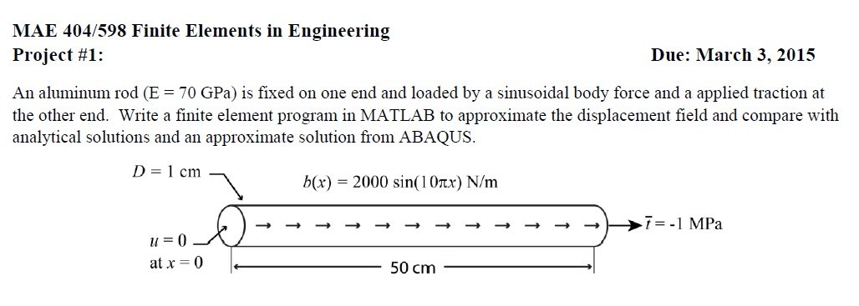An Aluminium rod (E=70GPa) is fixed on one end and loaded by a sinusoidal force and an applied traction at the other end. Write a finite element program in MATLAB to approximate the displacement field and compare with analytical solutions and an approximate solution from Abaqus.

1. Analytical Solution

We know that, the strong form for 1D stress analysis is given by,

These three equations form the basis of our analytical solution. From equation (i), we have,

On substituting the value of body force, we get the expression,

Integrating on both the sides, we get

(Where c₁ is constant of integration)

Substituting first boundary condition, natural boundary condition, at x=0.5, we get,

And diving throughout by AE,

This is the expression obtained for strain at a distance x from origin.

Integrating the above equation again, we get

(Where c₂ is the constant of integration)

Now, applying second boundary condition, at u=0 x=0, we get

→ c₂ = 0

This is the expression for calculating the value of displacement at a distance x from origin.

We will be using the following two expressions to calculate and plot the displacement and strain fields.

1. Plot of Analytical Solutions

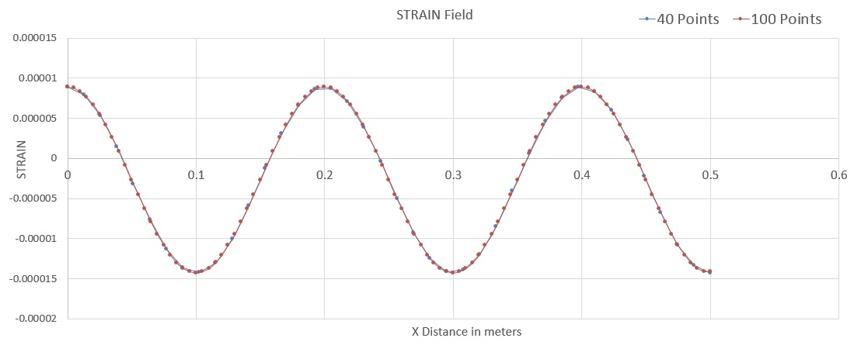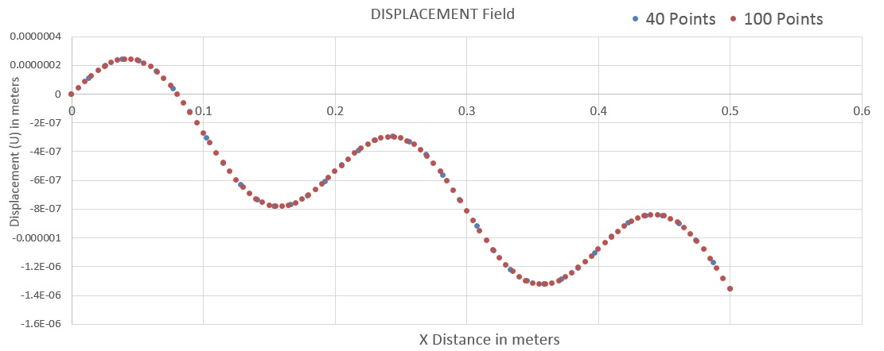Using a MATLAB code, we will plot the exact solutions for 40 and 100 calculation points.

1. MATLAB Solutions

3.1 Plot of the Displacement Field for Linear Element for two element sizes

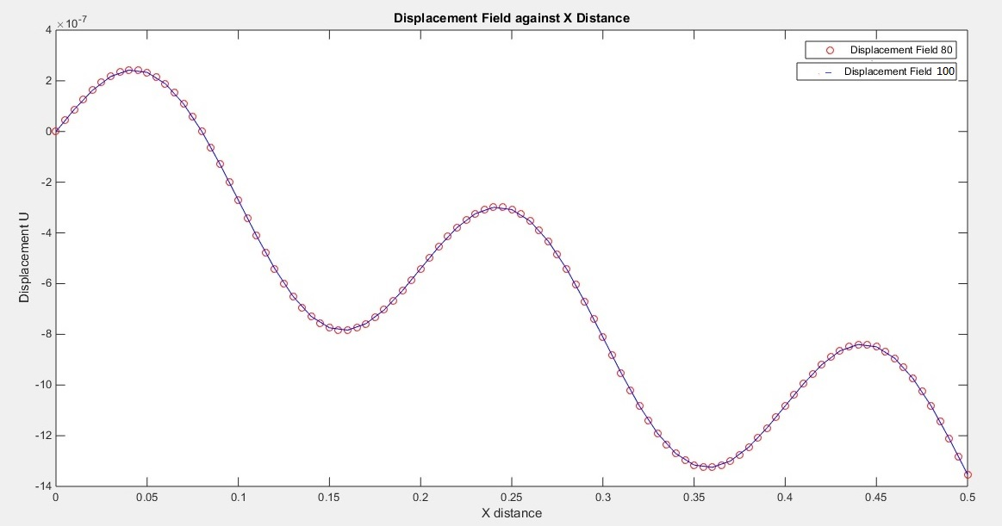

3.2 Plot of the Strain Field for Linear Element for two element sizes

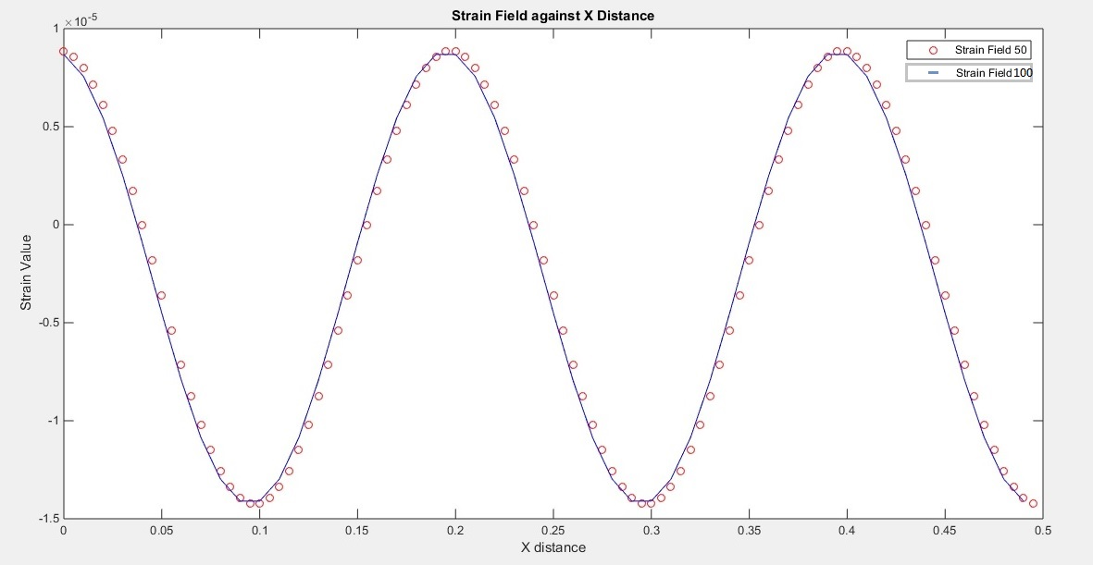

The above graphs show the variation of displacement and strain values with respect to X distance for 100 and 50 elements respectively.

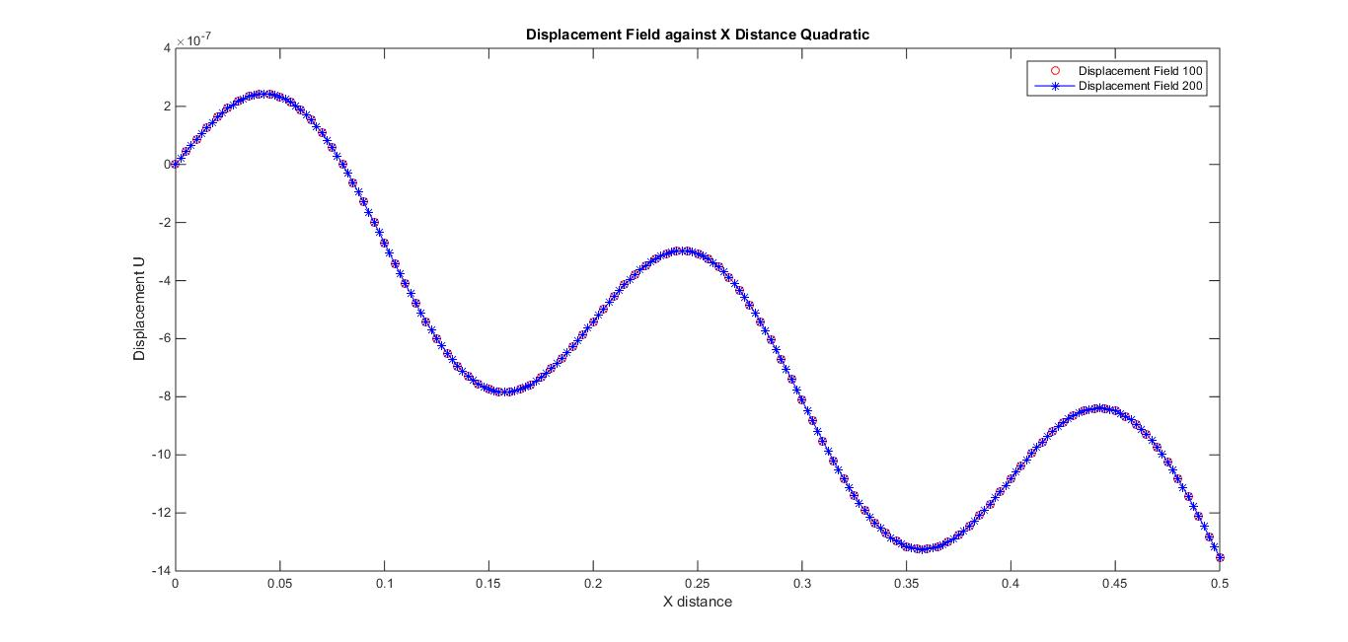3.3 Plot of the Displacement Field for Quadratic Element for two element sizes

3.4 Plot of the Strain Field for Quadratic Element for two element sizes

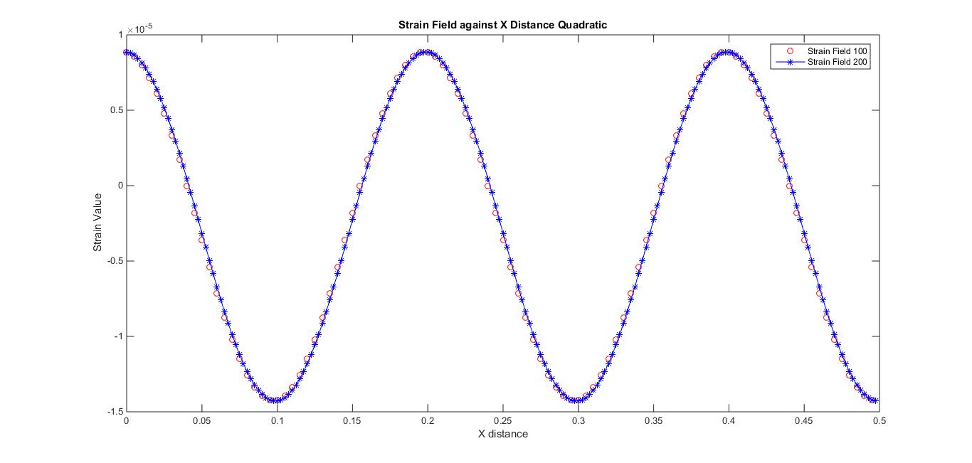

3.5 Comparison of times required for storage and solving the system of equations with 1000 elements

For Linear Elements:

Time required for matrix assembly = Elapsed time is 0.002881 seconds.

Time required for solving the system of equations = Elapsed time is 0.057297 seconds.

For Quadratic Elements:

Time required for matrix assembly = Elapsed time is 0.007293 seconds.

Time required for solving the system of equations = Elapsed time is 0.042705 seconds.

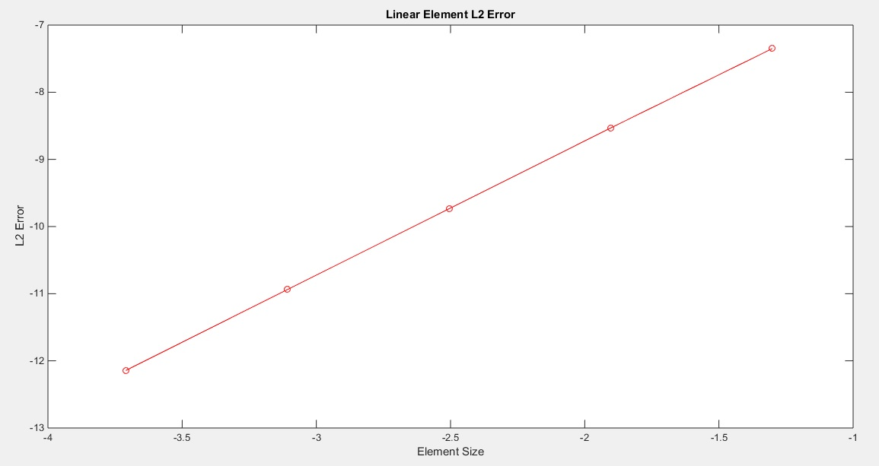3.6 Plot of L2 displacement error norm vs element size and computed rate of convergence using linear elements

Computed Rate of Convergence for Displacement Error = 1.9998

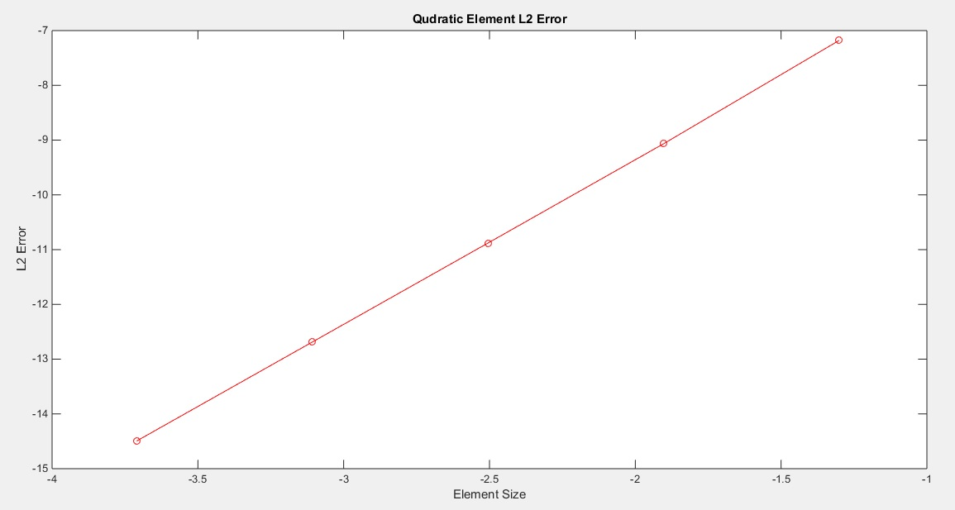3.7 Plot of L2 displacement error norm vs element size and computed rate of convergence using Quadratic elements

Computed Rate of Convergence = 3.00063

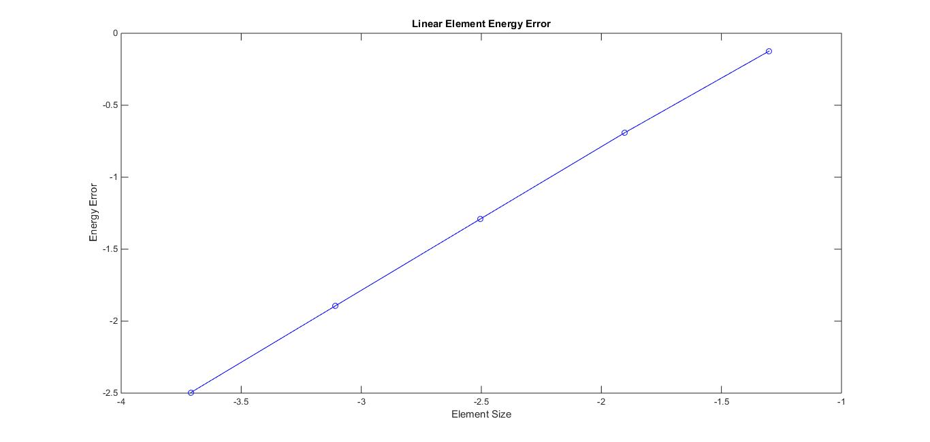3.8 Plot of energy error norm vs element size and computed rate of convergence using linear elements

Computed Rate of Convergence for Energy Error = 0.9998

3.9 Plot of energy error norm vs element size and computed rate of convergence using Quadratic elements

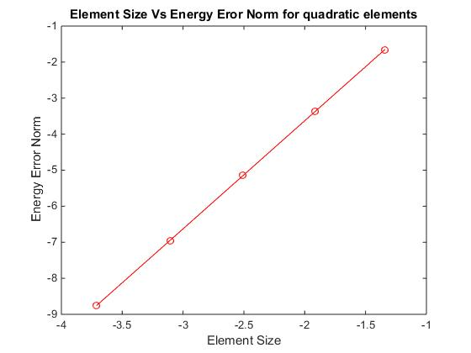

Computed Rate of Convergence for Energy Error = 2.0001108

**Abaqus Solution**

The system was modelled using 2d planar wire elements of beam type. The system was modelled using linear and quadratic elements respectively. The boundary condition, at x=0; u=0; is applied in both cases. The following loads are applied on the system-

1. At, x=L, the traction loading condition is applied (in the form of concentrated force = stress × area = -7.853982e-05m². (negative sign indicates that load is in negative X axis and hence compressive)
2. Body fore per unit volume, b(x) = 2000 sin (10πx) ÷ Area = 25464790.98 sin (10πx) N/m³ on all the elements.

Following this, field outputs were requested for Displacement (U), Strain (E), and stress (S).

For the quadratic case, total number of elements were 476 elements with 954 nodes. For the linear case, total number of elements were 504 elements and 505 nodes.

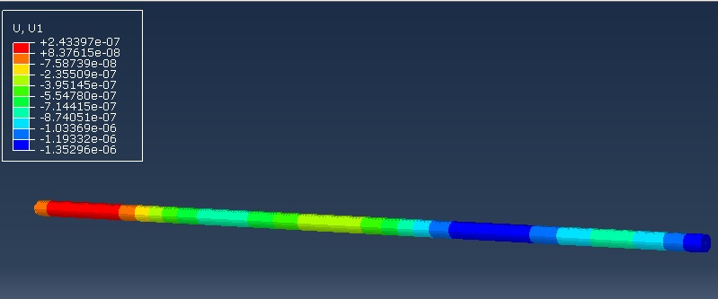Following images show the displacement and strain contours for linear elements respectively.

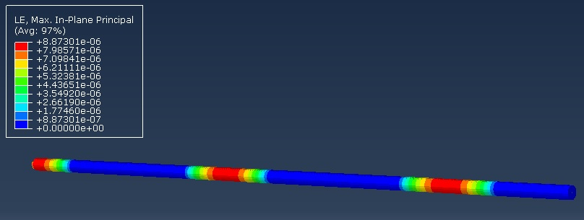

4.1 Displacement and Strain Graphs for Linear Elements

(Displacement and Distance along X are both in meters.)

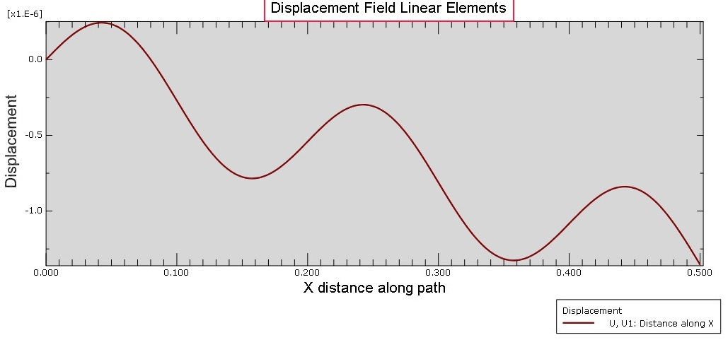

Displacement field plot for linear element

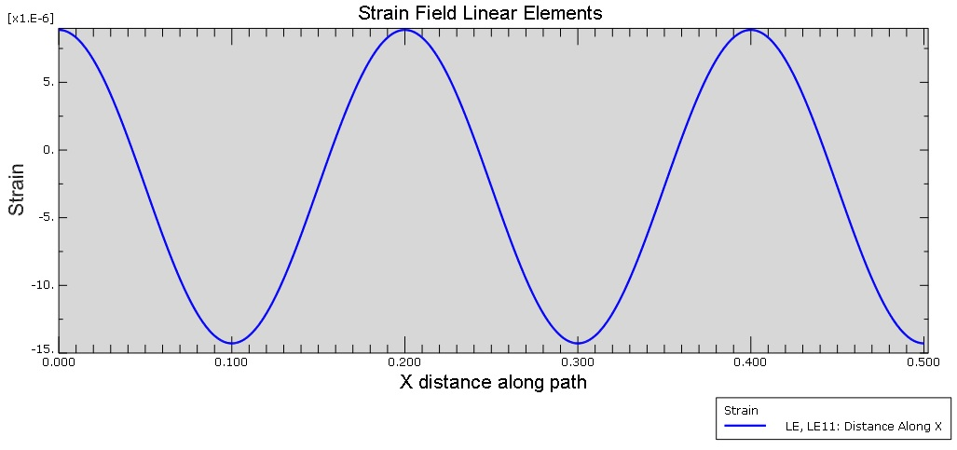

Strain Field plot for linear element

4.2 Displacement and Strain Field Plots for Quadratic Elements

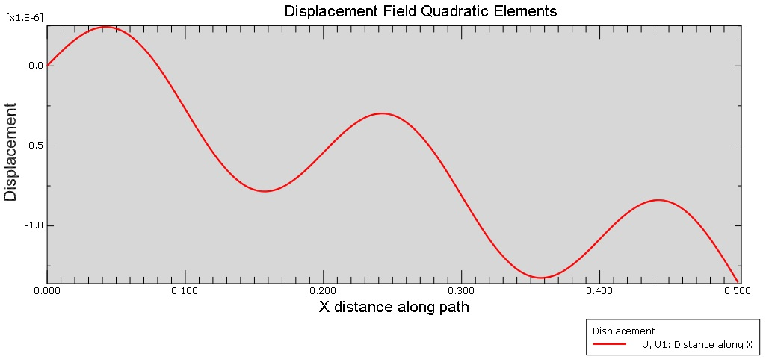(Displacement and X distance are both in meters.)

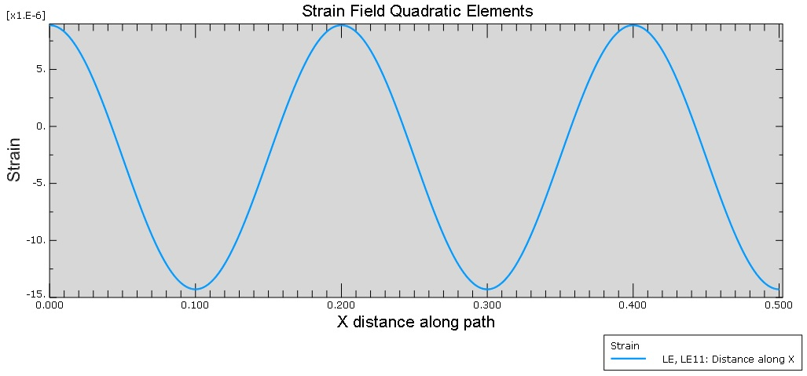Displacement Field for Quadratic Elements

Strain Field for Quadratic Elements

5. Convergence of all Solutions

The following two graphs show the convergence of all the methods for solving the given problem and it can be seen how closely the solutions match.

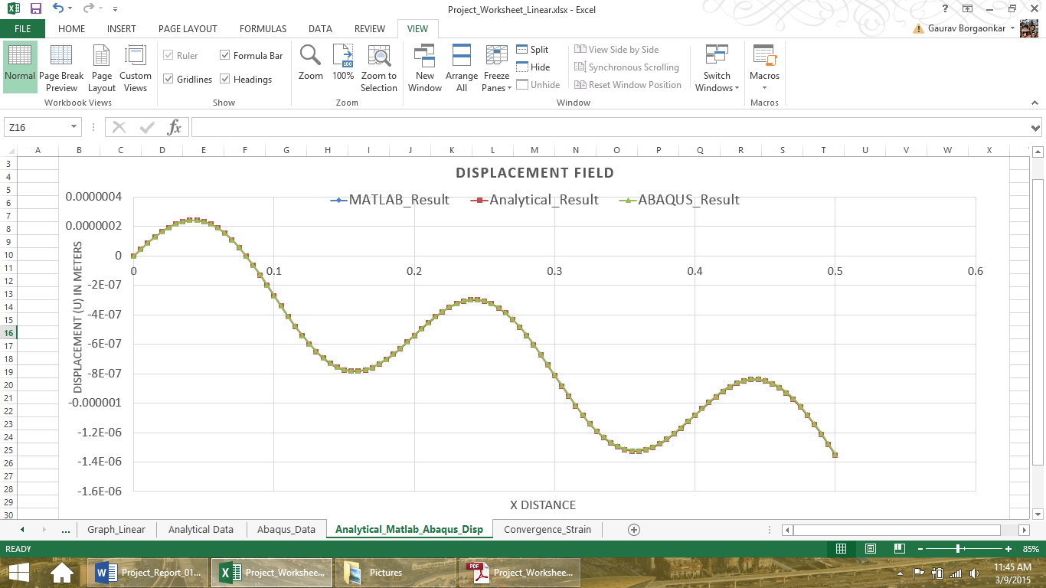

It can be seen from above, that the displacement field graphs for analytical, Abaqus and Matlab solutions match almost exactly with each other and hence the solutions converge almost perfectly even for 80 elements in case of Abaqus, 100 for Matlab and 100 calculation points for analytical solution. Although the graphs are there, they are barely visible as there is very little margin between the three of them.

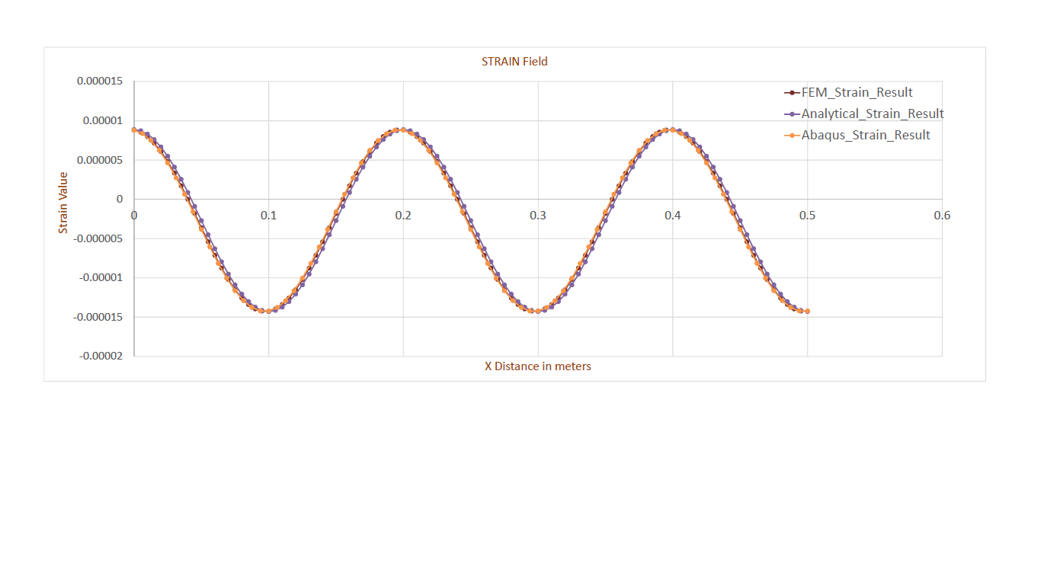

The graph above, in this case shows the convergence of strain for different solution methods. As it can be seen, strain takes slightly more iterations to converge perfectly with each other. The error margin is slightly higher in the case of strain than in the case of displacement.