Plot of Temperature Fields for two different element sizes

Plot of Temperature contours for finer mesh:

For the coarser mesh conditions, the plate was meshed with global element size of 0.12m. The total number of elements generated were 220 with 254 nodes.

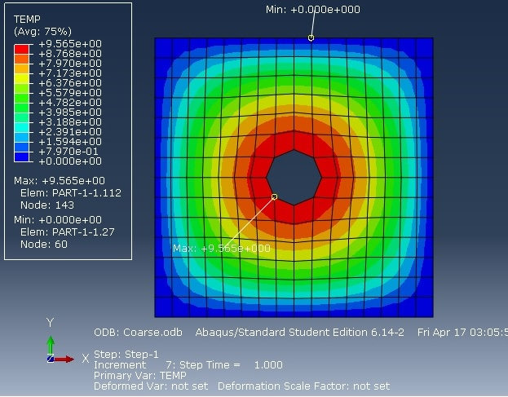The solution is found to converge to a fair degree of accuracy (with maximum temperature being shown as 9.565°C at the hole edges) with the analytical solution in this case.

Plot of Temperature contours for finer mesh:

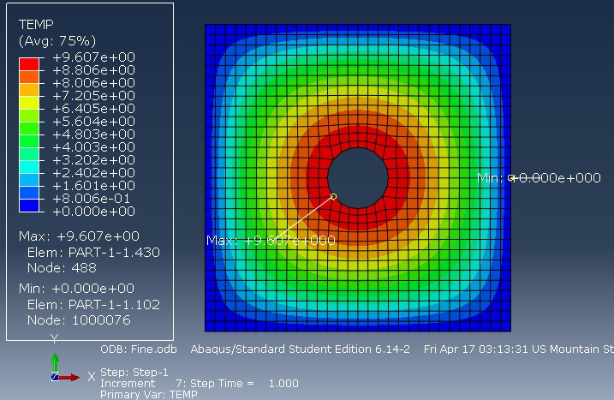For the finer mesh conditions, the plate was meshed with global element size of 0.06m. The total number of elements generated were 876 with 976 nodes.

The solution is found to converge perfectly with the analytical solution in this case.

Comparison of solutions between linear and quadratic elements

In order to compare solutions with different types of elements to check which elements yield better results for same number of elements, we need to mesh the model using the exactly the same mesh pattern with same no. of elements, however in the first case as 1st order elements (linear) while in the second case as 2nd order elements (quadratic). The following images show the results.

1st Order (Linear) Elements:

In the first case, the model was meshed with 280 elements and 380 nodes quadrilateral elements. A heat source term given in the analytical solution was applied over the entire body. The boundary conditions were heat flux term on the inner boundary of the plate and 0°C at the outer boundary.

The following image shows the temperature contours obtained. As expected, the maximum temperature is found at the inner boundary and minimum temperature at the outer boundary. The linear elements give a perfect solution even for 280 elements. Hence, the linear elements give a very good solution even for a very basic no. of elements.

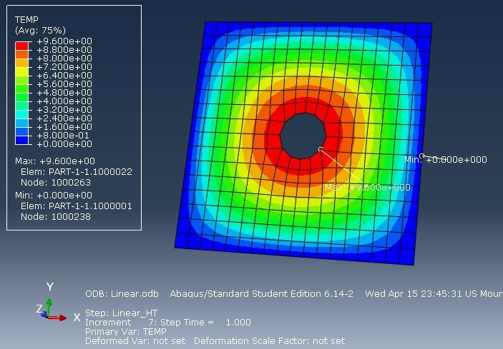

2nd order (Quadratic) Elements:

In the second case, the model was meshed maintaining the same mesh pattern with 280 no of elements and 920 no. of nodes. A heat source term given in the analytical solution was applied over the entire body. The boundary conditions were heat flux term on the inner boundary of the plate and 0°C at the outer boundary.

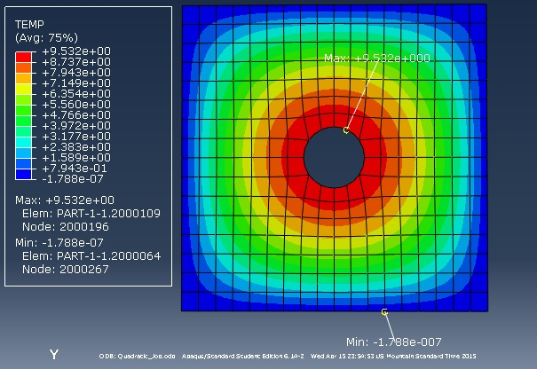The following image shows the temperature contours obtained. As expected, the maximum temperature is found at the inner boundary and minimum temperature at the outer boundary. However, in this case, solution does not converge perfectly and the maximum temperature found at the inner boundary is only about 9.532°C. This leaves an error margin of 0.7% in the solution.

Conclusion:

For same no. of elements, solutions using linear elements took about 0.30 seconds to complete while solution using quadratic elements took about 0.44 seconds to complete. Also, the linear element mesh performs better in case of convergence compared to the quadratic element.

This leads us to conclude that given the limitation of number of elements, linear elements should be preferred over quadratic because of better convergence rate and for reduced solution time (about 25% reduction in solution time).

Justification for Abaqus Solution:

The following points justify that the Abaqus solution is reasonable.

1. The Abaqus solution converges perfectly with our analytical and Matlab FEM solutions. The maximum and minimum temperature locations are captured perfectly by Abaqus.
2. So, a node path along X axis was created in Abaqus in order to plot temperature variations as shown below. The temperature variations along X on the plate are plotted along this nodal path.

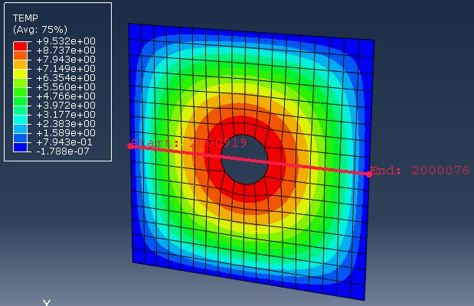

The following graph shows the variation of temperature along the nodal path (along X axis) between co-ordinates (-1, 1). As expected, temperature varies along a parabola (because of the x² term in source) expression from (-1, -0.2) until hole (-0.2, 0.2) where it encounters a discontinuity in the values and then again from (0.2, 1), it varies as a parabola. Similar graph is obtained in the Y direction for temperature variations.

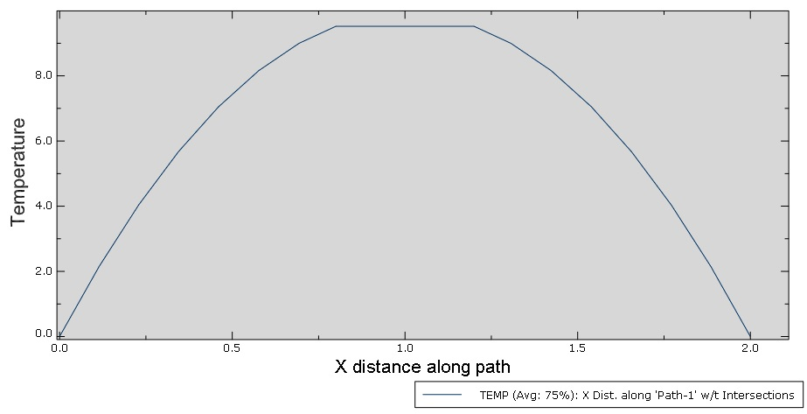

1. We will also compare the temperatures obtained by analytical solution and Abaqus solutions at an intermediate location on the plate.

Consider the location: (0.661, 0.503) – nodal co-ordinates for any random node

Temperature obtained by analytical solution: 4.206°C

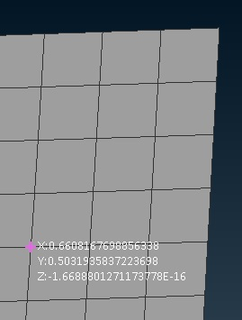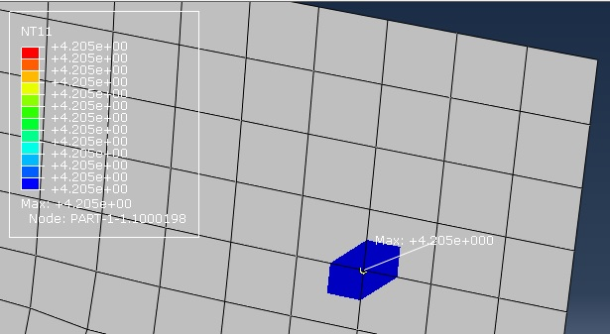Temperature obtained by Abaqus solution: 4.205°C (as shown below)