*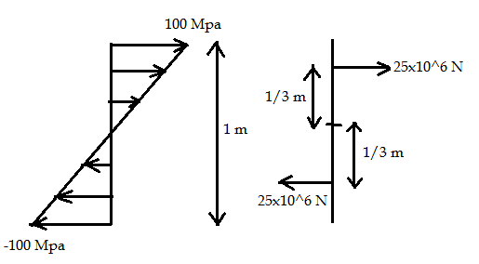*

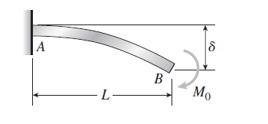Moment can be calculated from above diagram as



 Nm



Maximum bending stress occurs at upper filament.

Thus maximum bending stress = 

  Pa.

This is the analytical stress value.