MAE 598

Project 3

Salil Rabade (Grad Student)

ASU ID-1207888418

**Problem Statement**

Analyze the following stress problem in a 2D beam with a center hole, shown below. The beam has a cantilever support on the left end. Moment is applied via an applied traction as shown in following figure. The maximum traction is 100 MPa. Beam thickness is 1m.



**ANALYTICAL SOLUTION**

The uniformly varying load applied on the beam forms a couple, giving rise to a bending moment. This Bending moment is given as

M = Force x distance

=0.5 x 100 x 106 x (x 0.5)

M=16.667 x 106 Nm.

The theoretical maximum deflection for a continuous beam without the hole is given as

δ=

L=length of beam=3m

E=Young’s Modulus=69GPa

I=Moment of Inertia

I=( 1x13-1x0.43)

I=0.078m4

δ=

**δ=0.01393m**

**Plane Stress and Plane Strain**

Plane stress is a condition where σz along with the shear stresses τxz and τyz are assumed to be zero. Plane strain is a condition where the strains εz along with shear strains γ xz  and γyz  are zero.

**MATLAB SOLUTION**

We plot displacement field for plane stress and plane strain model with ey=20 as input

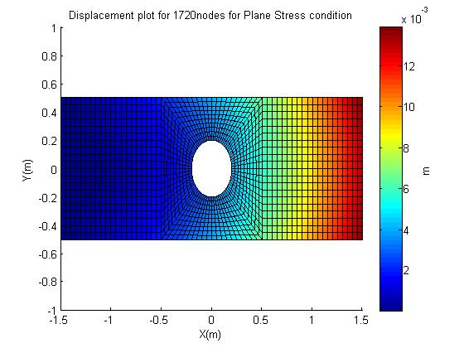

|  |  |  |
| --- | --- | --- |
| Ey (Matlab Input) | Max Plane Stress model Displacement (resultant of x and y components ) | Max Plane Strain Model Displacement(resultant of x and y components ) |
| 10 | 0.0138 m | 0.0122 m |
|  |  |  |
| 20 | 0.0139 m | 0.0123 m |

We see that Plane stress model gives a much more accurate displacement field compared to the plane strain model.

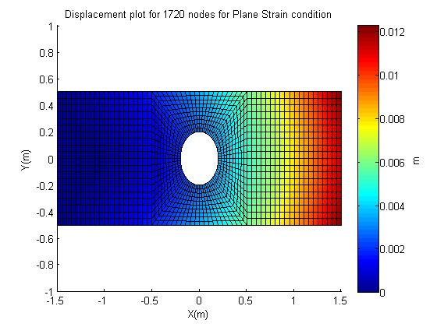

**Plot of Maximum uy**

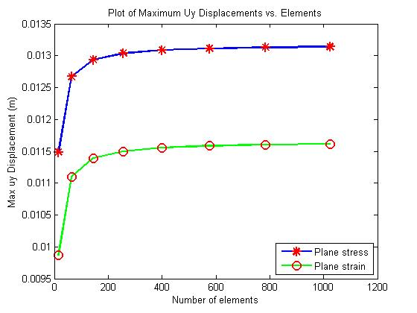

**Contour Plot of stress field**

We plot the stress fields for a ey value of 20.

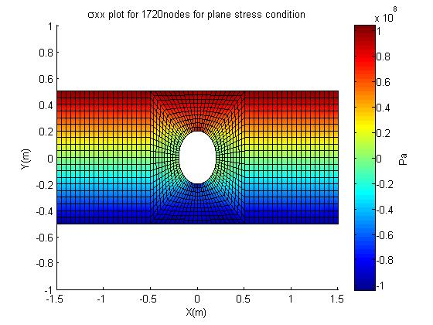

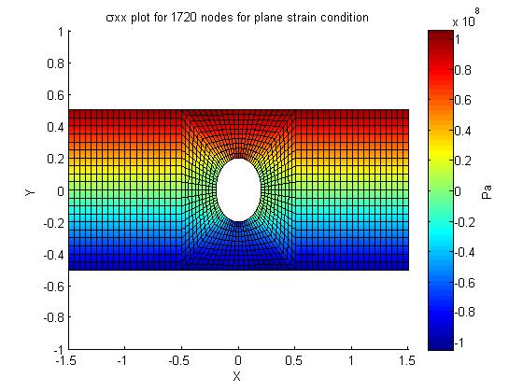

Analytically, using flexure formula,

σxx=

Where y=0.5m

σxx=

**σxx=106.839e6 Pa**

|  |  |  |
| --- | --- | --- |
| Analytical Max Stress | Plane Stress Model(for ey=20) | Plane Strain Model(for ey=20) |
|  |  |  |
| 1.06839e8 Pa | 1.0425e8 Pa | 1.0546e8 Pa |

The analytical and matlab stress results are in good agreement with each other. This proves that the stress field is correct.

**Plot of stress along line AA’**

We again plot for ey=20. The discontinuities in the graph are present due to the hole in the beam. The stresses above and below the hole are symmetric to each other. This is expected as the applied traction is symmetrical. 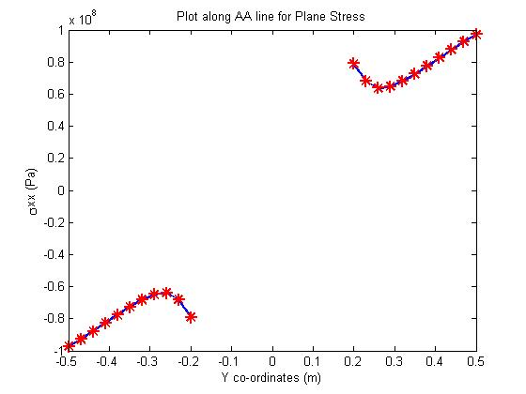

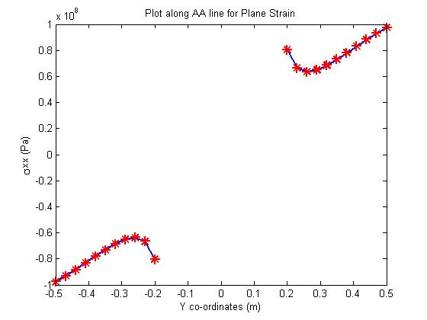

**Location of Failure**

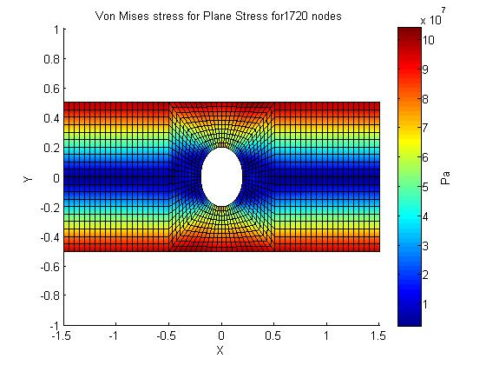

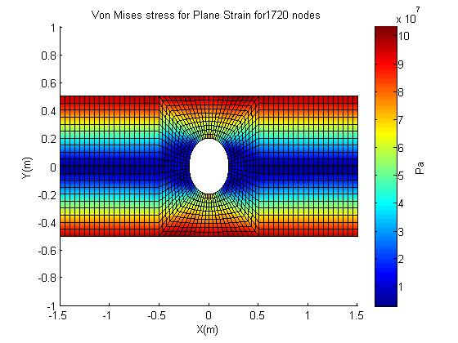

|  |  |  |  |  |  |
| --- | --- | --- | --- | --- | --- |
|  | Ey (Matlab Input) | Max Von Mises stress | Node Number | Node Co-ordinates | |
|  |  |  |  | X | Y |
| Plane Stress | 20 | 1.0357e08 Pa | 15 | 0.3000 | 0.5000 |
|  |  |  |  |  |  |
| Plane Strain | 20 | 1.0320e08 Pa | 15 | 0.3000 | 0.5000 |

The failure criteria of a structure depends on its geometry and material properties. We notice that the location of maximum Von Mises stress remains the same irrespective of plane stress and plane strain condition. As failure is most likely to occur at the point with maximum stress, *we can conclude that failure does* ***not*** *depend on the plane stress and plane strain model*. *The failure is most likely to occur near the hole due to stress concentration around the hole*. This is confirmed by the location of the node with maximum Von Mises stress .

**ABAQUS SOLUTION**

We compare the abaqus solutions for the displacement field and stress field for a fine and quadratic mesh. We also plot the Von Mises stress field and *not* the σxx field.

**Displacement field**

We first plot a linear fine mesh field.

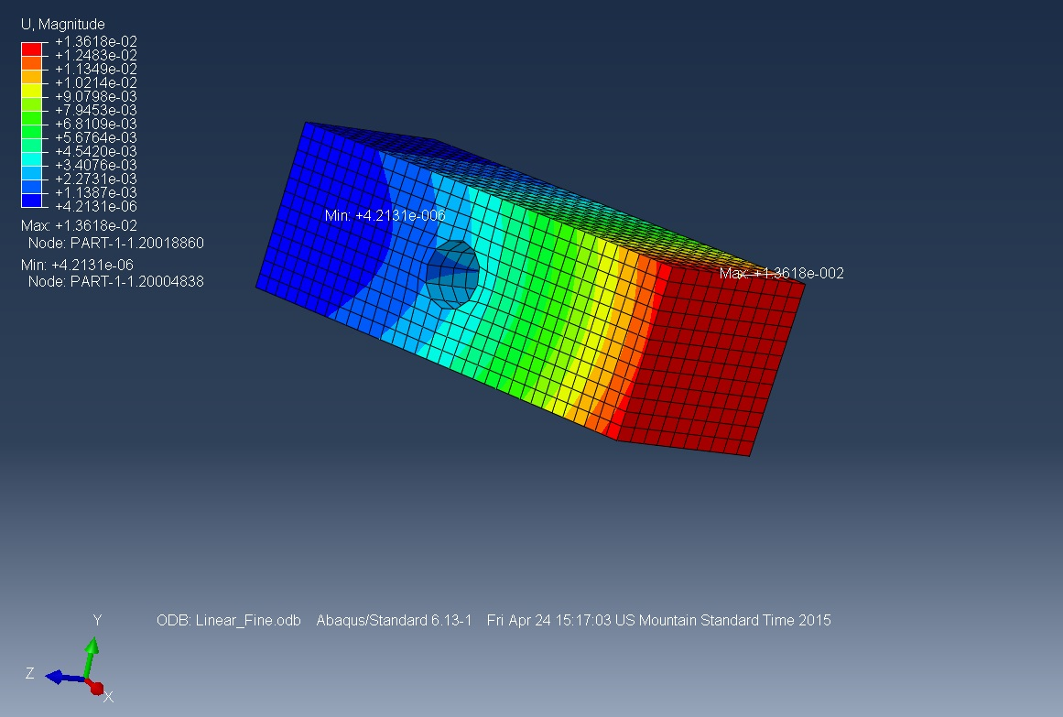

(*This figure uses linear elements*)

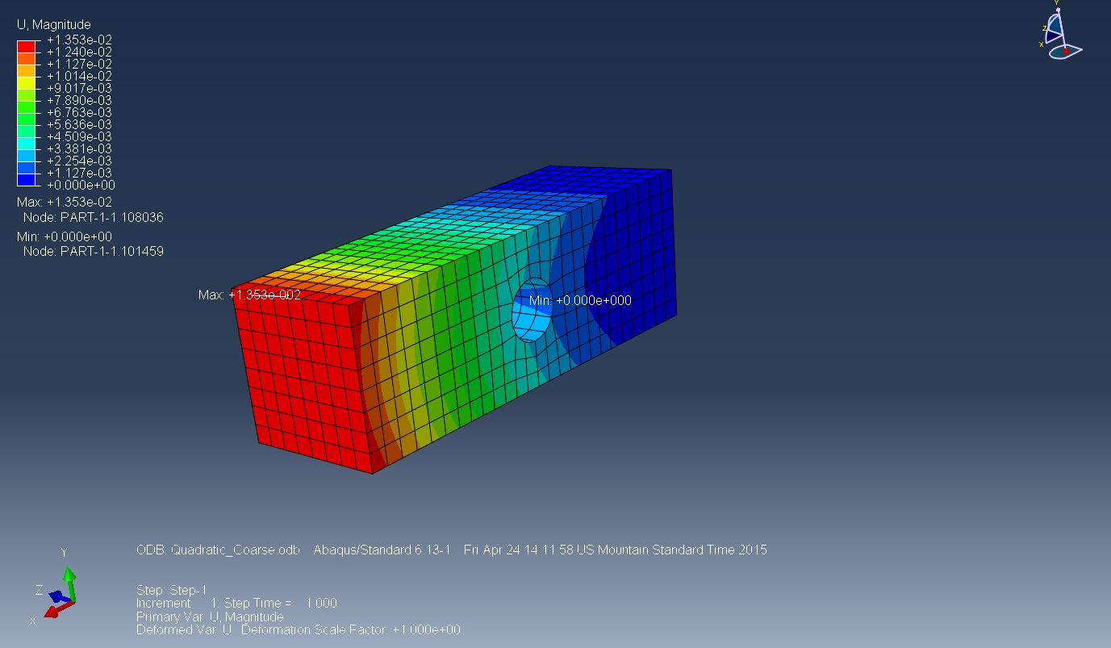

*(This figure uses quadratic elements coarse mesh)*

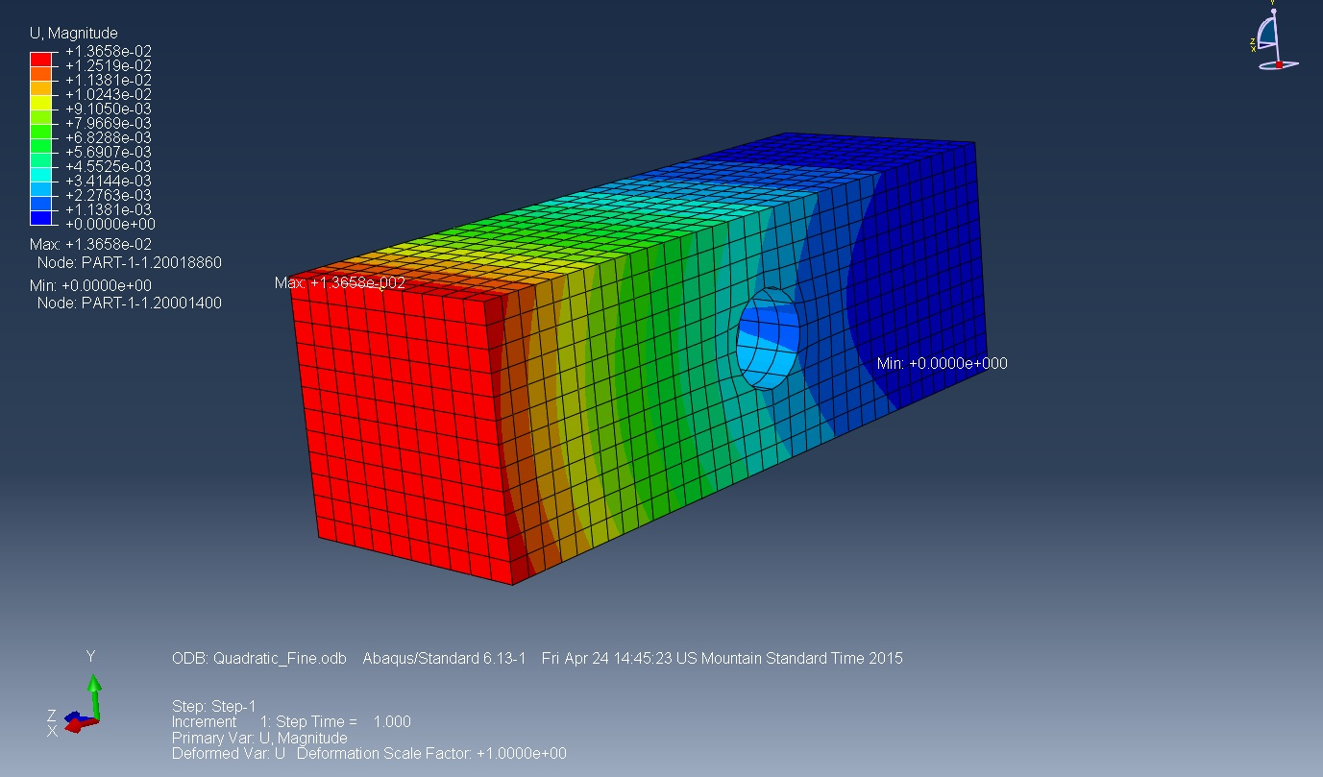

*(This figure uses quadratic elements with fine mesh)*

|  |  |  |  |
| --- | --- | --- | --- |
| Max Analytical displacement | Linear Fine | Quadratic Coarse | Quadratic Fine |
|  |  |  |  |
| 0.01393 m | 0.013618 m | 0.01353 m | 0.013658 m |

Given the limited number of elements, we see that fine quadratic mesh is closest to the theoretical maximum displacement. Hence we say that for displacement, quadratic elements are better. Similarly for stress field quadratic elements give us a better accuracy.

**Stress Field**

We plot the Van Mises stress field.

|  |  |  |  |
| --- | --- | --- | --- |
| Max FEM Van Mises stress (ey=20)(Plane Stress model) | Linear Fine | Linear Coarse | Quadratic Fine |
|  |  |  |  |
| 1.0425e08 | 1.078e08 | 1.031e08 Pa | 1.043e08 |

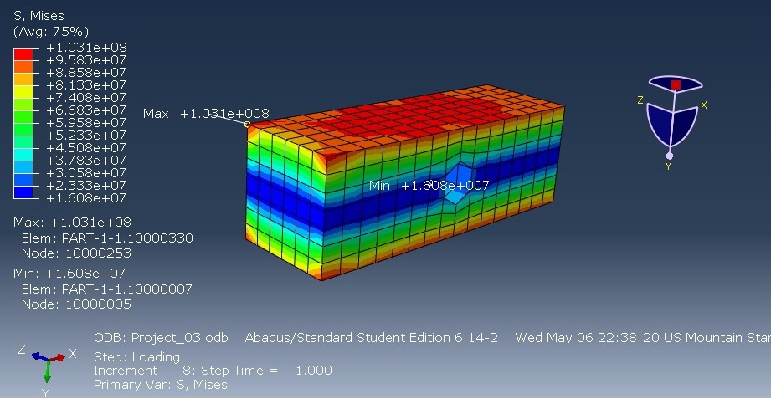(*This figure uses coarse mesh with linear elements*)

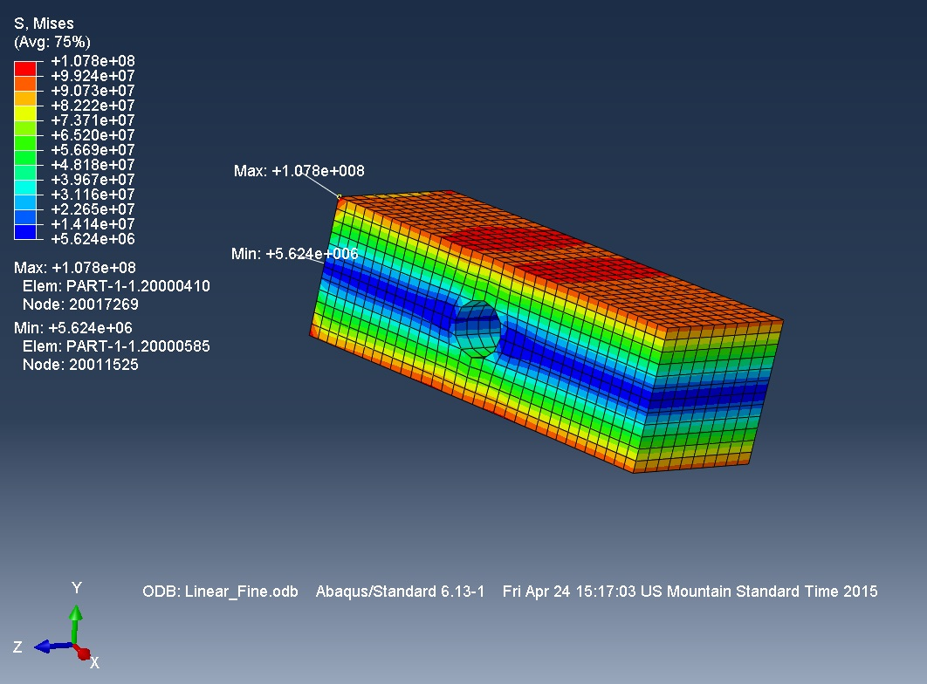

*(This figure uses fine mesh with linear elements*)

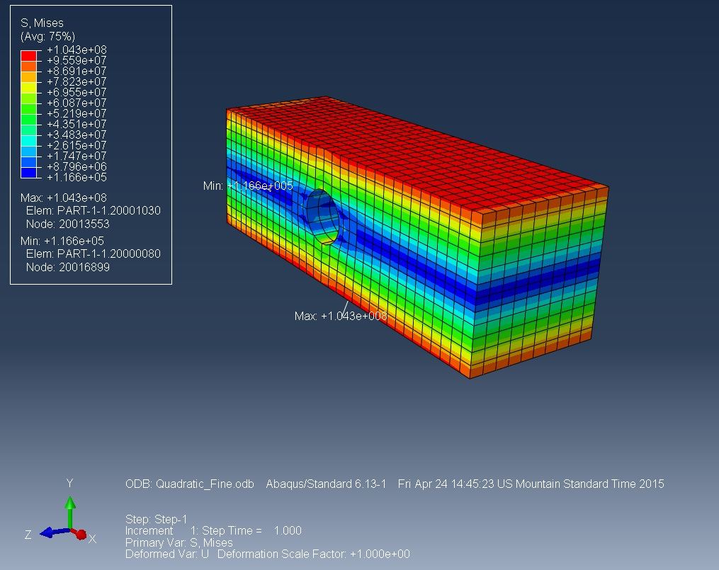*(This figure uses fine mesh with quadratic elements*)

**JUSTIFICATION OF SOLUTION**

Both the displacement field and Van Mises stress field are in good agreement with analytical and FEM solution.

The displacement field for quadratic fine mesh gives us an error of 1.9%. This error can be further reduced by using more number of quadratic elements and creating a finer mesh.

The Van Mises stress calculated by the matlab solution is in very good agreement with abaqus solution. An error of only 0.004% is observed. The reason we calculate with respect to matlab solution is analytically it might be impossible to always to find the stress in a structure with complicated geometry. In that case we might need to use a matlab solution to justify the correctness of the answer.