MAE 598: Finite Element Methods in Engineering

Project 03

Project Report

By

Gaurav Borgaonkar

INDEX

1. Problem Statement
2. MATLAB Solution
   1. Contour plot of approximated displacement field under fine mesh using both plane strain and plane stress model
   2. Plot of maximum || versus the number of elements using both plane strain and plane stress model in the same figure
   3. Contour plot of using plane stress and plane strain model
   4. Explanation for the results. Reasoning (comparison of numerical stress fields with analytical solution for beam)
   5. Plot of along line AA’ using plane stress and plane strain mode
   6. Discussion of failure location? Explanation for plane stress/plain strain cases
3. ABAQUS Solution
   1. Plots of two displacements for two different element sizes
   2. Plots of stresses for two different element sizes
   3. Comparison of solution between linear and quadratic elements, explanation over performance of elements
   4. Justification for Abaqus Solution
4. Appendix: MATLAB Codes
5. **Problem Statement**

Analyze the following stress problem in a 2D beam with a center hole shown below. The beam has a cantilever support at the left end. Moment is applied at via an applied traction as shown in the fig. The maximum traction is 100 MPa. Beam thickness is 1m.



The material properties are:

Young’s Modulus E = 69GPa

Poisson’s ratio

1. **MATLAB SOLUTION**

2.1) Contour plot of approximated displacement field under fine mesh

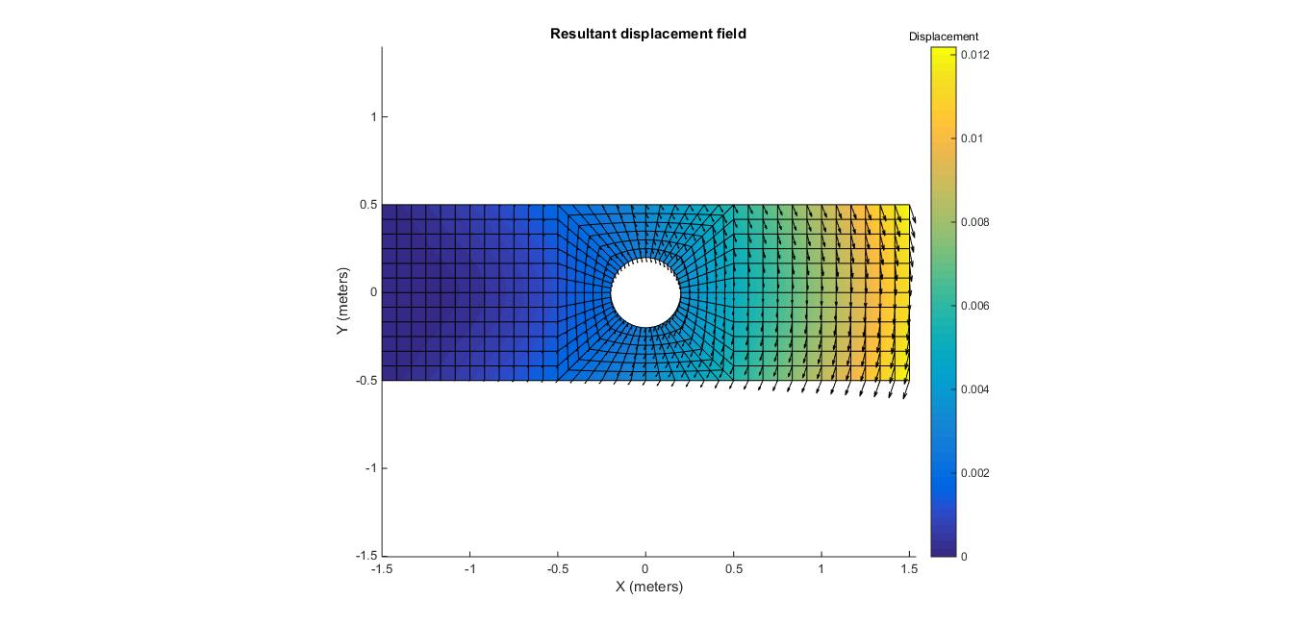

PLANE STRAIN MODEL: Maximum displacement = 11.9mm

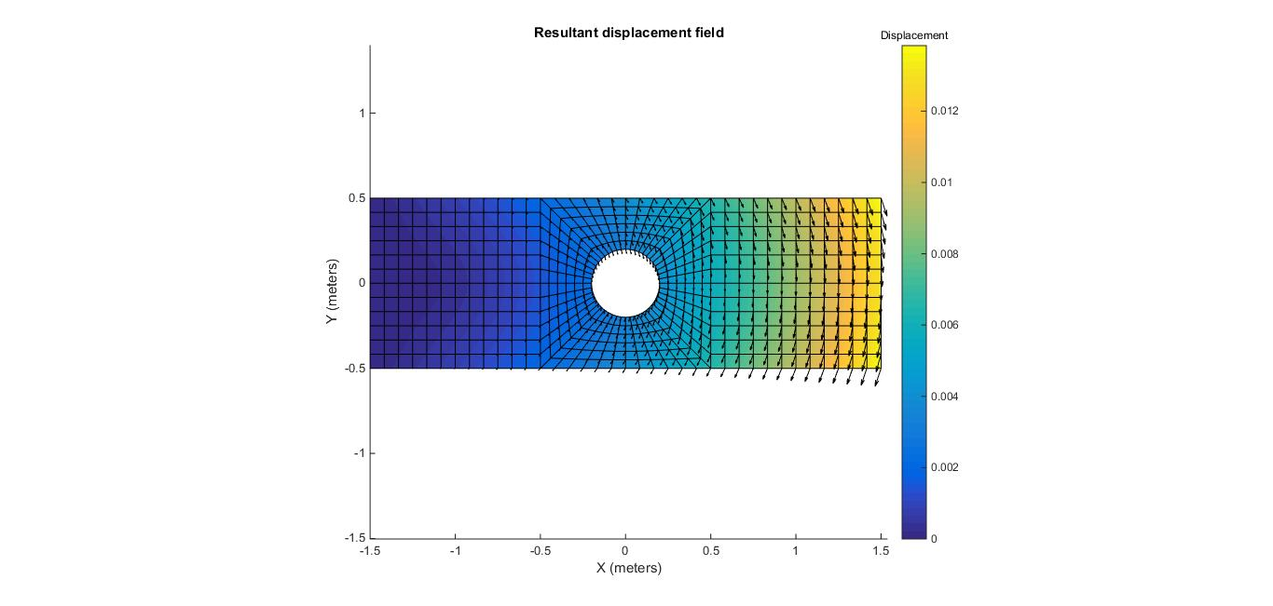

PLANE STRESS MODEL: Maximum Stress Field = 13.8mm

* 1. ) Plot of maximum || versus the number of elements using both plane strain and plane stress model in the same figure

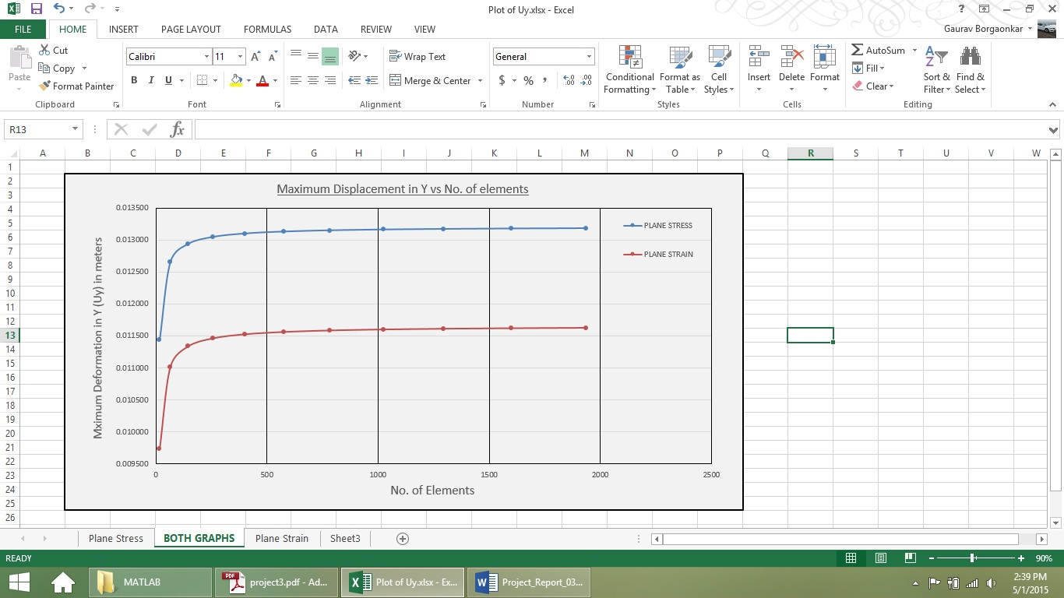

* 1. ) Contour plot of using plane stress and plane strain model

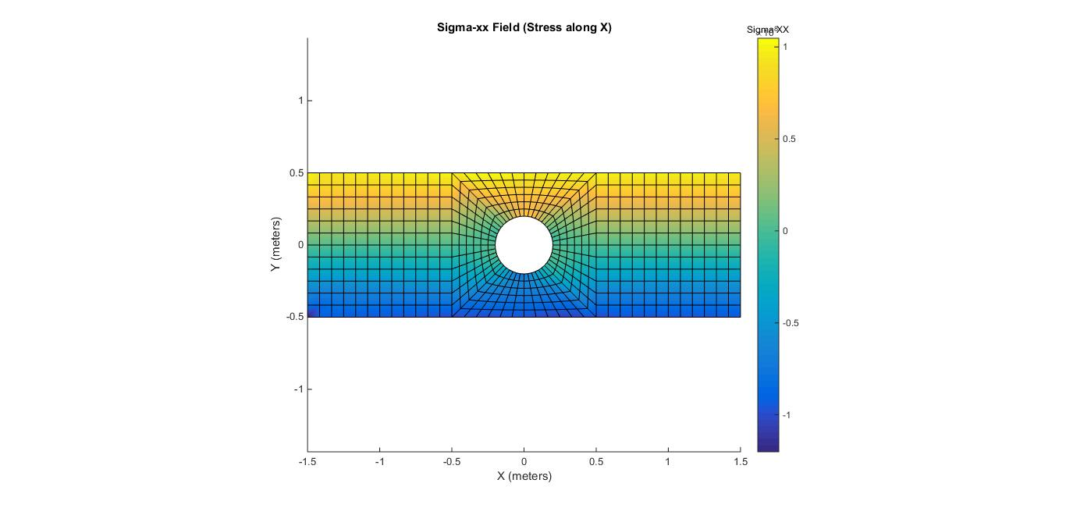PLANE STRAIN MODEL:





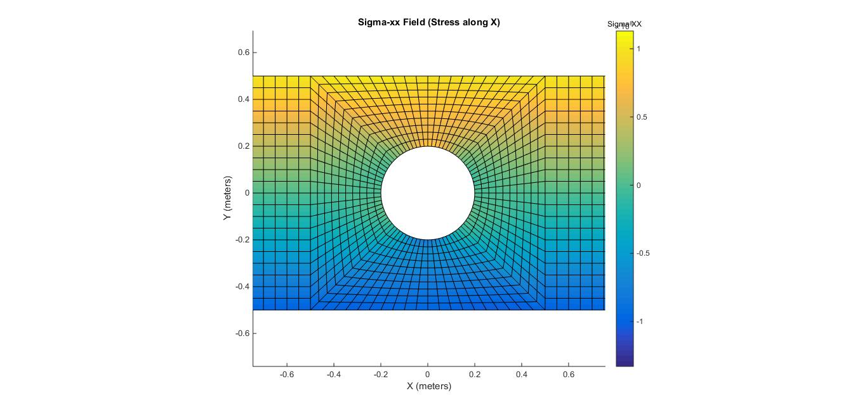

PLANE STRESS MODEL: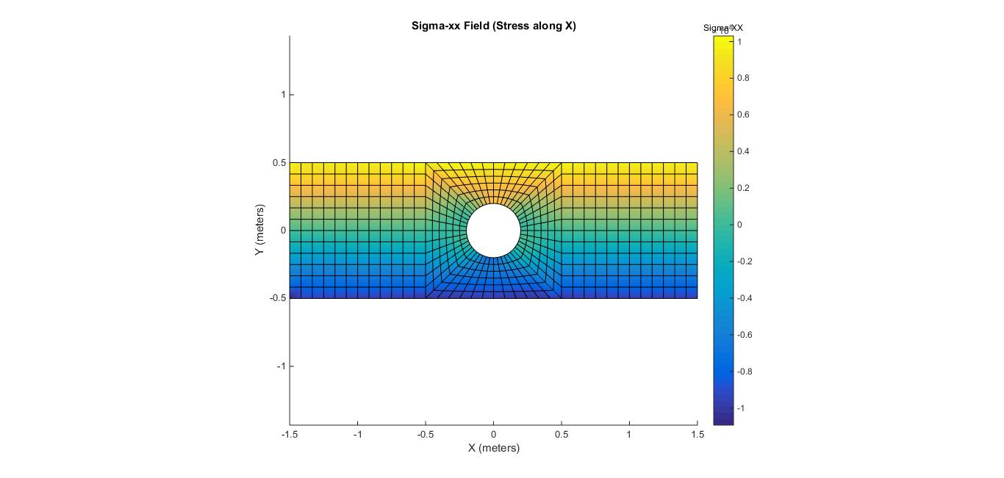

Explanation for the results:

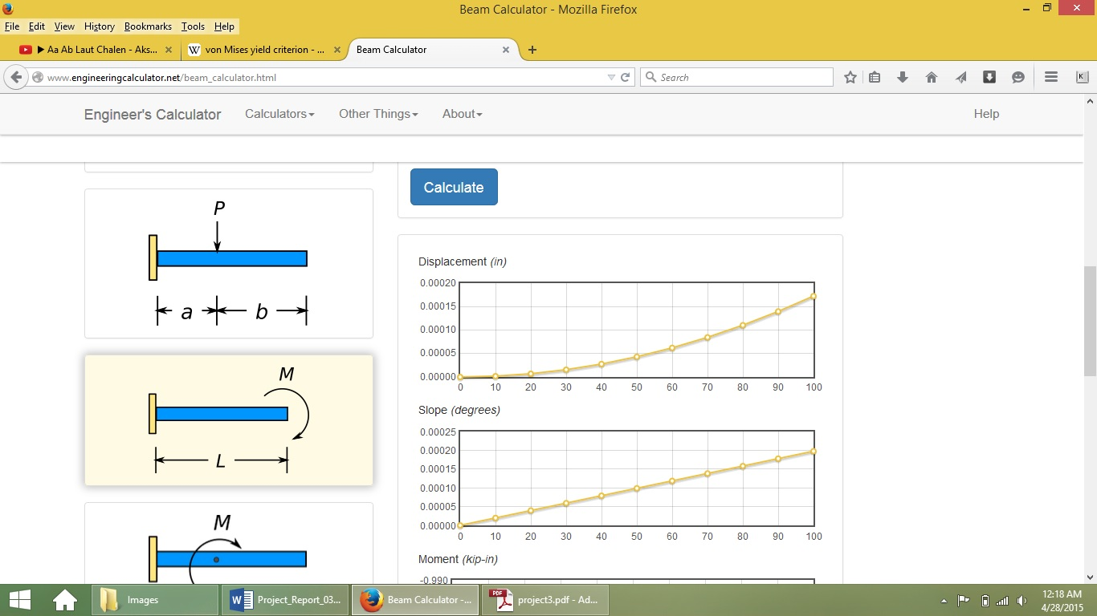

The problem is similar to a cantilever beam with an end moment applied to it to some extent. However, this is NOT SUPPOSED to give us the exact solution to our problem as we have slightly different loading conditions. In our problem, we are having a uniformly varying pressure applied to the beam cross section surface. The symmetry of pressure application will ultimately bring about a moment to the beam at the endpoint. Again, we are only relating the symmetry of this problem to a similar problem of cantilever beam with end moment.

The moment applied is given by,

M = 50e9 × = 16,666,666.67 N-m

The moment of area of the beam about the Z axis is given by,

Moment of Area =

The maximum deformation in the beam is given by,

This value is fairly close to our Matlab and Abaqus solution of maximum displacement in Y direction (U₂) which is equal to 13.22 mm.

This deformation will be in Y direction at the end of the beam. Also, if we compare the overall pattern of deformation in the beam, it is given by a parabolic pattern because of the term in the beam deflection equation.

Explanation for Stresses:

* 1. ) Plot along AA´ line using plane stress and plane strain model

These plots are done using 18 elements along the vertical.

PLANE STRAIN MODEL:

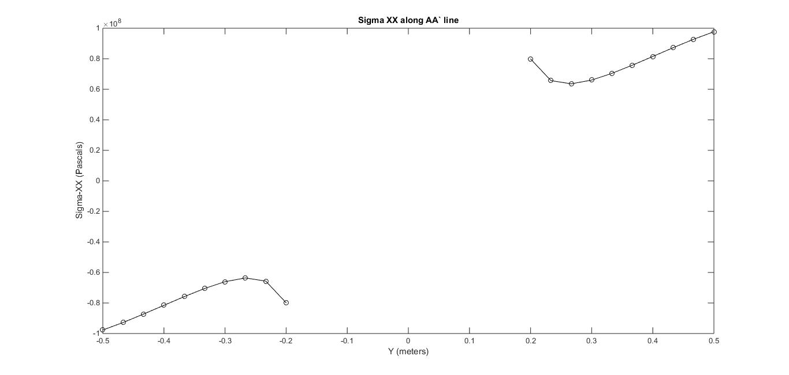

PLANE STRESS MODEL:

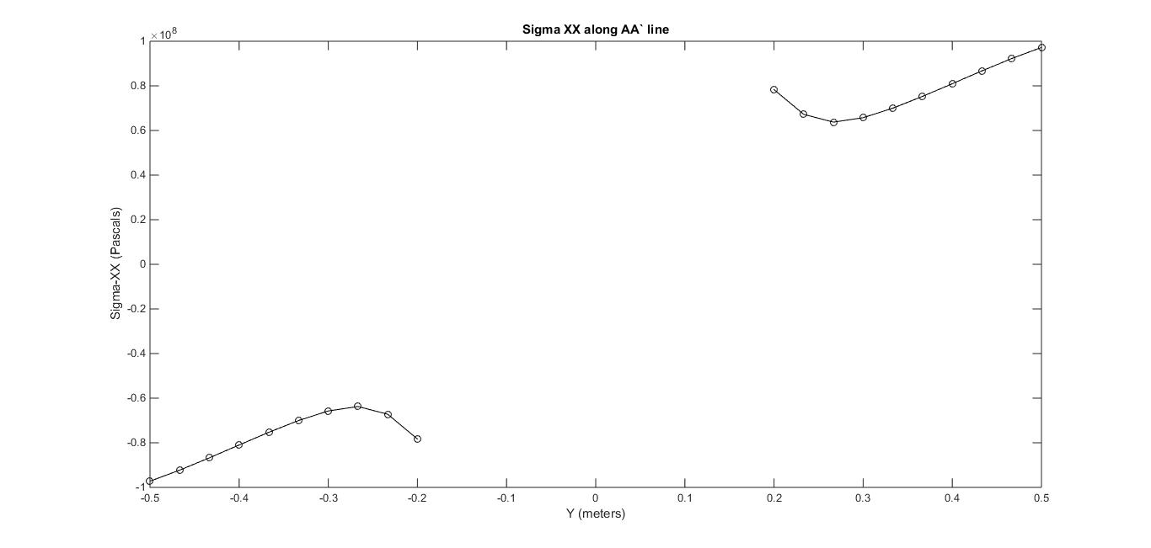

* 1. Where is the most likely location for failure if the material is ductile? Does the predicted failure depend on the assumption of plain stress or plain strain?

We will take the help of contour plots taken in Abaqus for better depiction of stress values. In case of ductile materials, VonMises failure theory (which is an adaptation from Distortion Energy Theory) is used to predict failure location.

The region with the maximum values of the Von-Mises Stresses is likely to fail first.

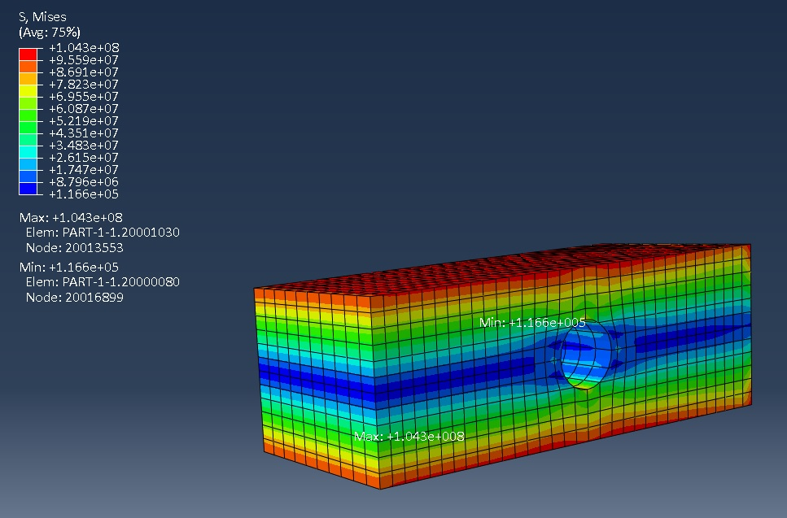

As it can be seen from the images, the regions which develop the highest VonMises stresses are above and below the hole.

1. ABAQUS Solution
   1. Plots of the displacements for two different element sizes

In the first case, the geometry is meshed with only 960 nodes and 144 hexahedron 2nd order elements. For any type of stress analysis problem, it is always better to use 2nd order elements as they yield much better results compared to 1st order elements.

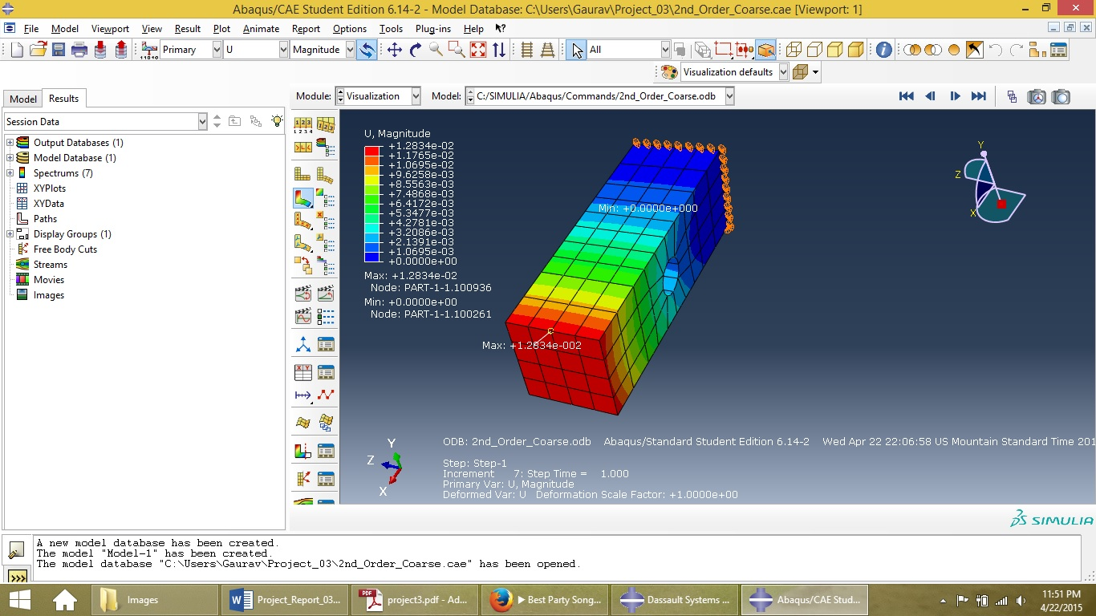Maximum displacement for coarse mesh: 12.83mm

For the second case, the geometry is meshed with 4160 elements and 19860 nodes for 2nd order hexahedral elements. Maximum displacement is found at the same location.

Magnitude for maximum displacement = 13.528mm

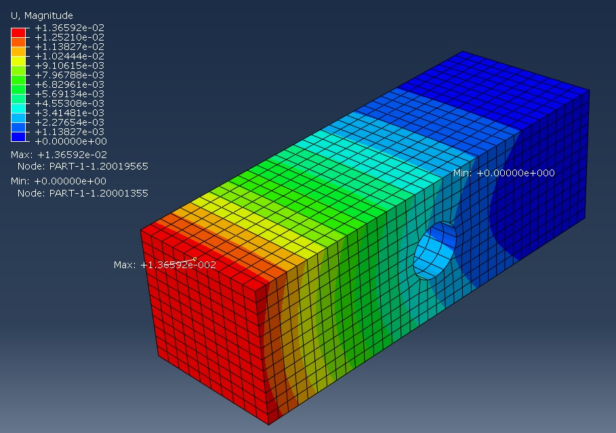

* 1. Plots of the stresses for two different element sizes

Von Mises Stresses for Quadratic Fine Mesh Size

Maximum Von Mises Stress = 1.0406e+08 N/m²

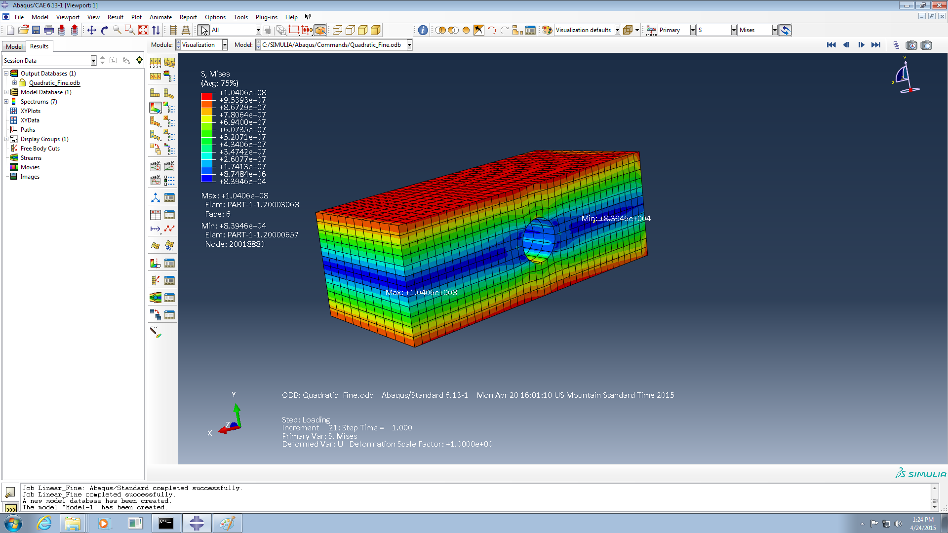

Von Mises Stresses for Quadratic Coarse Mesh Size

Maximum Von Mises Stress = 1.0301e+08 N/m²

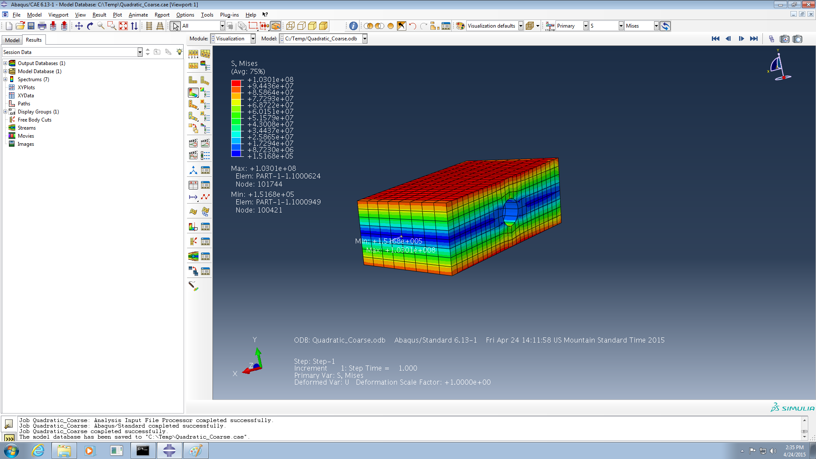

3.3 Comparison of solutions between linear and quadratic elements

In order to compare solutions with different types of elements to check which elements yield better results for same number of elements, we need to mesh the model using the exactly the same mesh pattern with same no. of elements, however in the first case as 1st order elements (linear) while in the second case as 2nd order elements (quadratic). The following images show the results.

For hexahedral elements, even linear elements yield fairly good results. However, in case of a restriction on number of elements, we should always prefer 2nd order (quadratic) elements because of their higher accuracy in analyzing stress analysis problems.

There is one more point I will make here. If we compare the results using tetrahedral elements, we find that the quadratic tetra elements give a far better result compared with linear tetra elements. However, linear tetrahedral elements don’t give a very reliable result and lack the accuary.

1st Order (Linear) Elements:

In the first case, the model was meshed with 4160 hexahedral 1st order elements having a total of 5192 nodes. The load traction was applied in the form of pressure normal to the surface and varying as t = 200y, with maximum values of 100Mpa and -100Mpa at y=0.5 and y=-0.5 respectively. The boundary conditions fixed support at y = -0.5 on the left edge and roller supports on the YZ plane above the fixed supports so that these nodes are free to move in y direction.

The following image shows the displacement contours obtained.

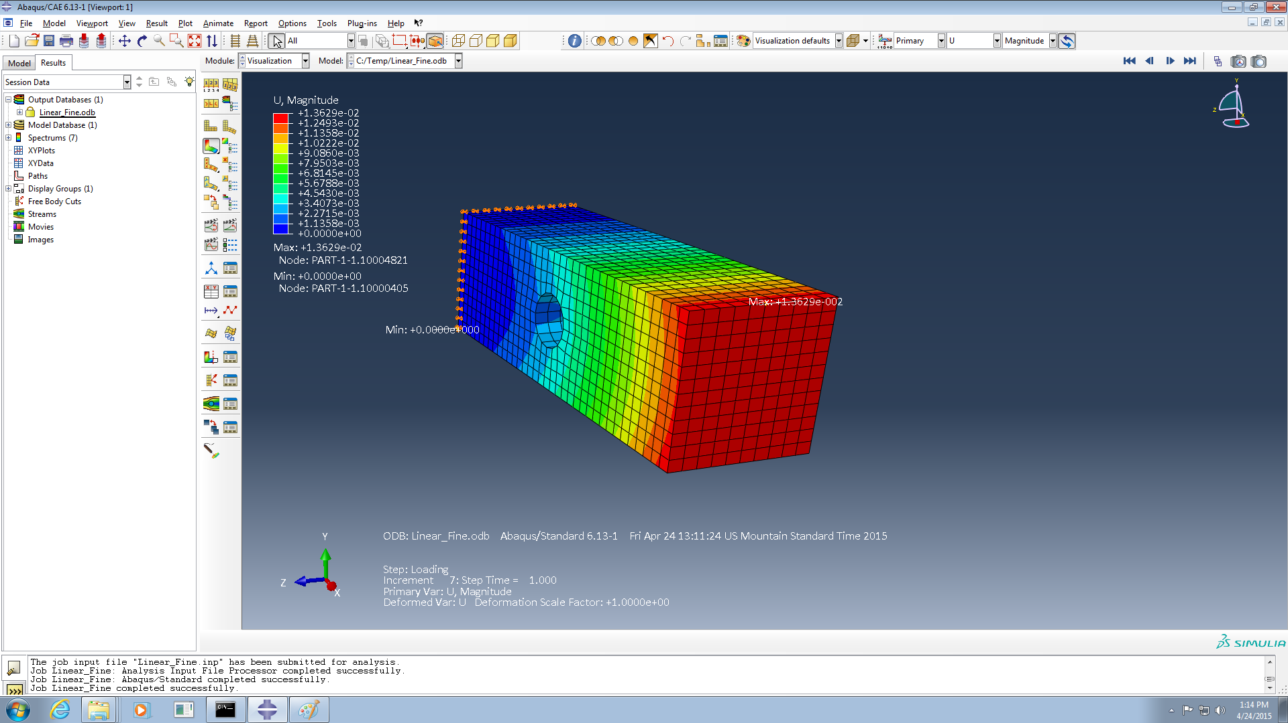

Maximum displacement for linear hexa elements = 1.3629e-02 m = 13.62 mm

The maximum displacement obtained for linear hexa elements is 13.62 mm which is fairly accurate. However, the stresses obtained for the linear hexa elements are very much off the actual values as it can be seen on the next page.

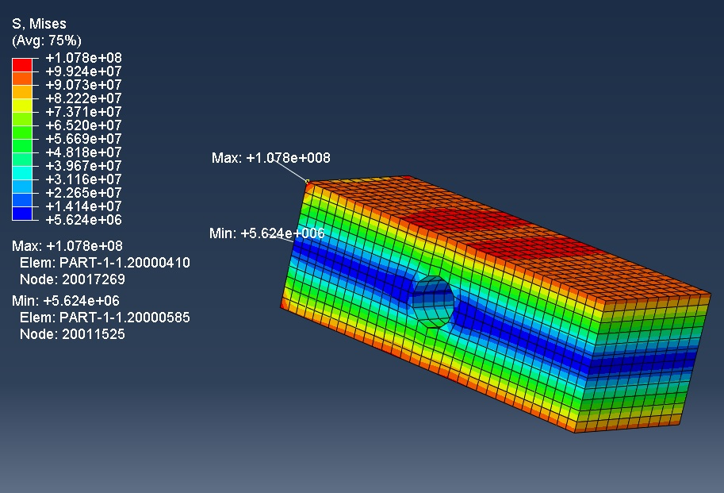2nd Order (Quadratic) Elements:

In the 2nd case, the model was meshed with 4160 hexahedral 2nd order elements having a total of 19680 nodes.

It can be seen that the Quadratic solution converges faster than linear solution and provides more accurate results than linear solution. Quadratic solution should always be preferred in case of geometries with curvatures because of their higher rate of convergence than linear elements because geometry can be captured in a much better way.

3.4 Abaqus Solution Justification

1. The maximum displacement shown by the Abaqus solution is 13.62 mm. This value of displacement converges perfectly with both Analytical and Matlab solutions.
2. The problem is similar to that of cantilever beam with moment applied at the end point and the solution of displacement can be expected in the parabolic form along the length of the beam.

The following plot shows the variation of displacement along the length of the beam. It can be seen that the graph follows the parabolic curve exactly and hence this justifies our solution.

