Vietnam National University Ho Chi Minh City

Ho Chi Minh City of Technology

Computer Science and Engineering Faculty



SOFTWARE ENGINEERING

ASSIGNMENT 1

Professor: Bui Hoang Thang

Student: Tran Thi Ngoc Diep – 1827005 – Class B01

Group 4

09/2019

Contents

1. Introduction (Group work) 5

1.1. Purposes 5

1.2. Definitions 5

1.3. Overview 5

2. Overall Description (Group work) 5

2.1. System Use Case Diagram 5

2.2. System Context Diagram 8

3. Functional Requirement Specifications (Group work) 8

3.1. Room Information and Schedule 8

3.1.1. Search room for information 8

3.1.2. Search room for booking 8

3.1.3. Book room 8

3.1.4. Cancel room 9

3.1.5. Modify room 9

3.1.6. Review booking 9

3.1.7. Confirm by email 9

3.1.8. Remind by email 9

3.1.9. Campus map 9

3.1.10. Recommend room 9

3.1.11. Search Lecturer 9

3.1.12. Borrow Babratory 9

3.2. Electrical Automation System 10

3.2.1. Turn on automatically 10

3.2.2. Turn off automatically 10

3.2.3. Alert not functional 10

3.2.4. Alarm automatically 10

3.3. Security Staff 10

3.3.1. Search for electrical devices 10

3.3.2. Search for active room 10

3.3.3. Control electrical devices remotely 10

3.3.4. Control electrical devices in-person 10

3.3.5. Monitor camera 10

3.3.6. Enter the campus 11

3.4. Sensor and Camera System 11

3.4.1. Check number of people 11

3.4.2. Automatically control the light 11

3.4.3. Alert detecting human 11

3.4.4. Detect fire 11

3.5. SOS Alert 11

3.6. Statistical and Reporting System 11

3.6.1. View electrical usage 11

3.6.2. View room usage 11

3.6.3. Automatically send report 11

3.6.4. User feedback 12

4. Non-Functional Requirements Specification (Group and Individual work) 12

4.1. Group work - Non-Functional Requirements Specification 12

4.1.1. Efficiency requirements 12

4.1.2. Regulatory 13

4.1.3. Usability 13

4.1.4. Reliability 13

4.1.5. Confidentiality 13

4.1.6. Survivalbility 14

4.2. Individual - Other Non-Functional Requirements 15

4.2.1. Efficiency requirements 15

4.2.2. Regulatory 15

4.2.3. Usability 15

5. Use-case in detailed (Individual work) 16

5.1. Search Room Information 16

5.1.1. Context Model 16

5.1.2. Use-case Diagram 16

5.1.3. Use-case Scenario Tabular 17

5.1.4. Non-functional Requirements 18

5.2. Search Room for Booking 18

5.2.1. Context Model 18

5.2.2. Use-case Diagram 18

5.2.3. Use-case Scenario Tabular 19

5.2.4. Non-functional Requirements 20

5.3. Cancel Booking 21

5.3.1. Context Model 21

5.3.2. Use-case Diagram 21

5.3.3. Use-case Scenario Tabular 22

5.3.4. Non-functional Requirements 22

5.4. Modify Booking 23

5.4.1. Context Model 23

5.4.2. Use-case Diagram 23

5.4.3. Use-case Scenario Tabular 24

5.4.4. Non-functional Requirements 25

6. Other non-interactive functional requirement (individual) 26

7. Conclusions 26

8. Group list 26

# 1. Introduction (Group work)

## 1.1. Purposes

The purpose of this report is specifying a Smart Campus System (SCAMS) in detail including system design, features, methods and operation of the system and how the system interacts with variety range of users such as lecturers, students, security staffs,guesses. The system is expected to make the university smart.

## 1.2. Definitions

SCAMS: Smart Campus System

## 1.3. Overview

* Section 1: Group work - Introduction to the SCAMS
* Section 2: Group work - Overall description of the SCAMS
* Section 3: Group work and individual work - Functional requirements
* Section 4: Group work and individual work - Non-Functional requirements
* Section 5: Individual - Use-case detail/scenario for use-case the student is in-charged
* Section 6: Individual - Non-interactive functional requirements
* Section 7: Individual – Conclusion
* Section 8: Group list

# 2. Overall Description (Group work)

## 2.1. System Use Case Diagram

The SCAMS system includes/connects to the following components:

* **Room Information and Schedule**: connects Room Management Service (ROMS) of the university to fetch room data, book and modify room for different purposes.
* **IoT system**: connects to the IoT system of the university to view information, control electrical devices.
* **User Database System**: connects to the User Database System of the university to fetch user information and verify user.
* **Infrastructure Database**: connects to the Infrastructure Database of the university to fetch infrastructure and facility information .
* **AI service**: connects to the external AI service for detecting human.
* **Emailing System**: connects to the external email service to send email automatically to users and other stakeholders.
* **End User Interface System**: includes a system of interfaces for end user on different platforms.
* **Statistics and Reports System**: includes a systems of statistics and reports for different purposes.

End-users of SCAMS system:

* *Lecturers*
* *Security Staffs*
* *Office Staffs*
* *Students*
* *Guests*
* *Board of Rectors*
* *System Administrators*

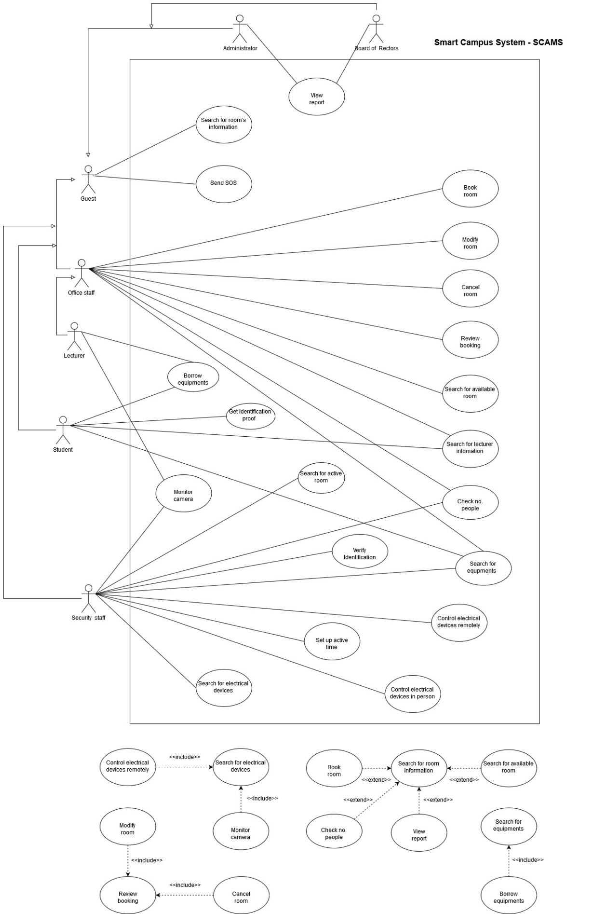

*Figure 2.1: System Use-case Diagram For Smart Campus System (SCAMS)*

## 2.2. System Context Diagram

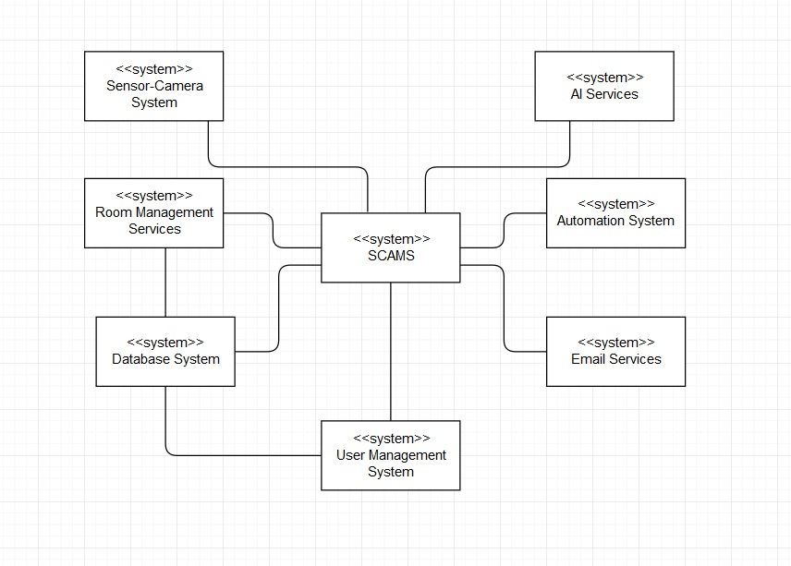

*Figure 2.2: Context-model Diagram*

# 3. Functional Requirement Specifications (Group work)

## 3.1. Room Information and Schedule

### 3.1.1. Search room for information

All users can search for room information (available or not, capacity, current lecture/event information, direction to the room) using date, building, room number.

### 3.1.2. Search room for booking

Lecturers and office staff can search room to see its information (available or not, capacity) for booking purpose, using search criteria: date, building, room number.

### 3.1.3. Book room

Lecturers and office staff can book a room in one or more class periods for different purposes (teaching, event).

### 3.1.4. Cancel room

Lecturers and office staff can cancel a room they booked if they change their schedule.

### 3.1.5. Modify room

Lecturers and office staff can modify a room they booked if they change their schedule.

### 3.1.6. Review booking

Lecturers and office staff can review all of their booked rooms on the application

### 3.1.7. Confirm by email

Email will be sent to the lecturer/office staff email address when he/she finished booking/modify/canceling room.

### 3.1.8. Remind by email

User (lecturer & office staff) will receive a reminder of his/her booked room's information & schedule before the lecture.

### 3.1.9. Campus map

User can open the whole campus map on the application.

### 3.1.10. Recommend room

The system recommend lecturer the suitable room for them.

### 3.1.11. Search Lecturer

Lecturers, Students, Office Staff and Security Staff can search for lecturers information.

### 3.1.12. Borrow Babratory

User can register for borrowing laboratory equipment.

## 3.2. Electrical Automation System

### 3.2.1. Turn on automatically

The doors and its electrical (lights, fans) devices will be turned on automatically before the lecture if they are off.

### 3.2.2. Turn off automatically

Electrical devices will be turned off and doors will be closed after the end of lecture & after the last person left the room if there are no next lecture in the same room.

### 3.2.3. Alert not functional

An alert will be sent to the security staff if doors the automation system is function properly (not on or of as it has to be).

### 3.2.4. Alarm automatically

The sound will be alarmed at if there is still some person in the room after the closed hour of the university.

## 3.3. Security Staff

### 3.3.1. Search for electrical devices

Security staff can search for electrical devices by room's ID, building's ID.

### 3.3.2. Search for active room

Security can search for rooms in the campus which is still in active after the closed hour.

### 3.3.3. Control electrical devices remotely

Security staff can control electrical devices using the application.

### 3.3.4. Control electrical devices in-person

Security staff use code on the system to access control panel attached on each room, corridor, building to control in-person.

### 3.3.5. Monitor camera

User (security staff) can monitor rooms, corridor and building using camera.

### 3.3.6. Enter the campus

User can use the changeable QR code provided by the system to verify identification in order to enter the campus instead of using the ID card

## 3.4. Sensor and Camera System

### 3.4.1. Check number of people

User can check for the number of people in the classroom currently.

### 3.4.2. Automatically control the light

The lights in corridors can be turned on/off automatically based on human detecting system.

### 3.4.3. Alert detecting human

The system can send an alert to the security staff in case of detecting human.

### 3.4.4. Detect fire

The system is able to detect fire based on a system of sensor detecting smoke and fire.

## 3.5. SOS Alert

User can send SOS alert to every user in the campus if he/she is in danger.

## 3.6. Statistical and Reporting System

### 3.6.1. View electrical usage

System Administrators and Board of Rectors can view reports on the usage of electrical devices.

### 3.6.2. View room usage

System Administrators and Board of Rectors can view reports on the usage of electrical devices in a period of time.

### 3.6.3. Automatically send report

A monthly report will be generated and sent automatically to the System Administrators and the Board of Rectors via email.

### 3.6.4. User feedback

Any user can provide information and suggestions about the use of electrical devices to the System Administrators using the reporting box.

# 4. Non-Functional Requirements Specification (Group and Individual work)

## 4.1. Group work - Non-Functional Requirements Specification

### 4.1.1. Efficiency requirements

* Response Time:
* The maximum start up time of the system is 2 seconds
* The maximum react time of the system for a particular job is 2 seconds.
* The maximum receiving search result time is 4 seconds.
* The doors and its electrical (lights, fans) devices will be turned on automatically 15 minutes before the lecture if they are off.
* Electrical devices will be turned off and doors will be closed immediately after the end of lecture & after the last person left the room if there are no next lecture in the same room.
* Report for System Administrator and Board of Rectors will be generated before 5pm on the last working day of the month.
* The maximum interaction for each activity (searching, booking, cancelling, modifying, monitoring, SOS messaging, report retrieving) is 2.
* Space:
* At least 20 percent of the processor capacity and storage space available to the system shall be unused at normal load seasonal periods.
* Performance:
* At least 80 percent of the request must be successful in 1 minute.

### 4.1.2. Regulatory

* The system shall not affect other system while using shared resources.

### 4.1.3. Usability

* User Interface:
* The interface must be available in English and Vietnamese.
* The theme color of interface shall be blue (Color Hex #1384d4).
* Learnability:
* The product shall be able to used by adult members (age 18 to 60) without training.
* The product shall be self-explanatory for whom encounter it the first time.

### 4.1.4. Reliability

* Readiness:
* The system shall be at least 99 percent available everyday, maintenance is not included.
* Unless the system is non‐operational, the system shall send a user an email informing them that the system is unavailable.
* Fault tolerance:
* The system should ensure operation in case of errors.
* Resilience:
* The system should recover operation in at most 3 hours in case of incidents.

### 4.1.5. Confidentiality

* Security:
* The system should provide multi-layer security for accessing management tools.
* Integrity:
* Username and password of users should be encrypted.
* Authentication:
* The system should provide two-factor authentication.
* The system should authenticate by a sequence of 4 numbers (PIN) besides password.

### 4.1.6. Survivalbility

* Analytical ability:
* The system should be able to identify issues itself and provide reports.
* Modifiability:
* In source code, function calls shall not be nested more than two levels deep.
* A junior developer who has at least 6 months of experience programming should be able to add a new feature, including code modifications and testing.
* Adaptation ability:
* The system can operate on several platforms: web and mobile.
* The system should display on different resolution based on devices.
* The system must be able to interface with any HTML (HyperText Markup Language) browser.
* Installability:
* The system should be installed easily and automatically.
* The installation time must be within 5 minutes.
* When a new version of the main system is released, it shall be possible to upgrade to it from any previous version.

## **4.2. Individual - Other Non-Functional Requirements**

### 4.2.1. Efficiency requirements

* User (lecturer) will receive a reminder of his/her booked room's information & schedule before 5pm the previous day.
* Email will be sent to the user's email address when he/she finished booking/modify/canceling room within 5 seconds.
* The response time of electrical devices for automatically or manually command is less than 2 seconds.
* The system must be able to accommodate up to 400 simultaneous users during the peak load period.
* The system must process a notification (SOS message, alert, fire detection) in maximum 1 second, and up to 100 notifications in no more than 15 seconds.

### 4.2.2. Regulatory

* The system must guarantee that external systems access such as ROMS shall not be overlap.

### 4.2.3. Usability

* The theme color of interface shall be blue (Color Hex #1384d4).
* The product shall be self-explanatory for whom encounter it the first time.

# 5. Use-case in detailed (Individual work)

## 5.1. Search Room Information

### 5.1.1. Context Model

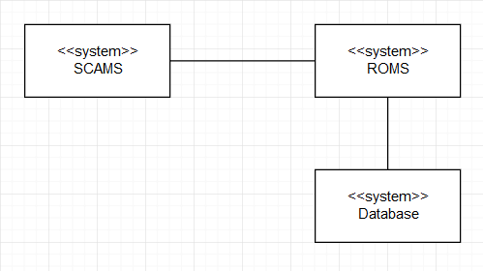

*Figure 5.1: Context Model for Search Room Information Use-case*

### 5.1.2. Use-case Diagram

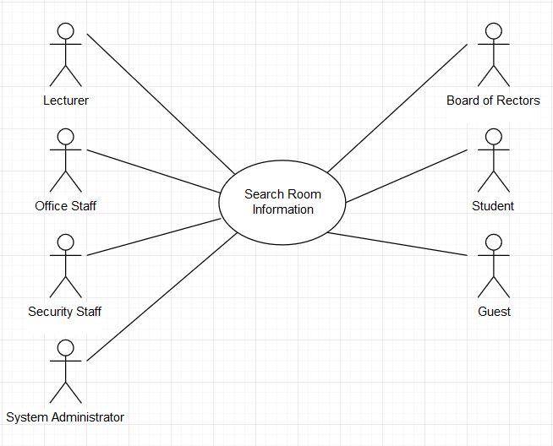

*Figure 5.2: Use-case Diagram for Search Room Information*

### 5.1.3. Use-case Scenario Tabular

|  |  |
| --- | --- |
| **Use case name** | **Search Room Information** |
| Actor | User (Security Staff, Lecturer, Office Staff, System Administrator, Board of Rectors, Student, Guest) |
| Description | User can search for room information |
| Preconditions | User logged in into SCAMS application |
| Triggers | None |
| Normal Flow | 1. User selects “Search” on SCAMS home page 2. System represents a search panel with multiple filters (date) and (building, room number). Date and building must be filled 3. User selects date, building and room number filters 4. System represents a page with the room’s usage timetable and capacity 5. User chooses each lecture/event 6. System represent a pop up box giving the lecture/event’s information: lecturer/speaker, subject/event’s name 7. User choose to quit the view 8. User choose to quit the search |
| Exception | *Exception at step 4. Cannot find the room number*  4a. The system represents a pop up box saying that user should use other search criteria (Alternative 3a)  *Exception at step 4. System failed to connects with the ROMS system to fetch information.*  4b. A pop-up box will explain the situation: “This service is not available” |
| Alternative Flows | *Alternative 1: at step 3*  3a. User selects date and building  3b. System represent a list of room in that building and it’s usage timetable, capacity  3c. User select on a particular room to see its usage timetable, move to step 4  *Alternative 2: at step 5*  5a. User chooses “Room information”  5b. System represents the room’s capacity, facilities and direction to that room |

### 5.1.4. Non-functional Requirements

|  |  |  |  |
| --- | --- | --- | --- |
| **Category** | **Requirement** | **Unit** | **Maximum value** |
| Efficiency | Receive search result | second | 4 |
| Number of interactions | interactions | 4 |
| Usability | User shall learn to use easily | minute | 5 |
| Available 24/7 |  | 24/7 |
| Adaptability | The system shall operate on multiple platforms |  |  |

## 5.2. Search Room for Booking

### 5.2.1. Context Model

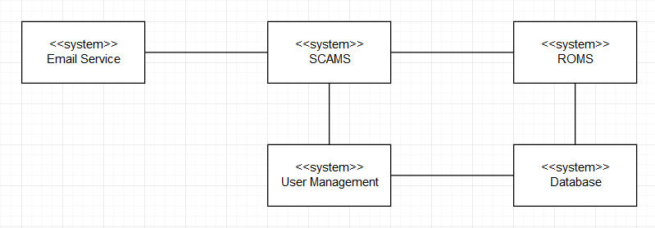

*Figure 5.3: Context Model for Search Room for Booking Use-case*

### 5.2.2. Use-case Diagram

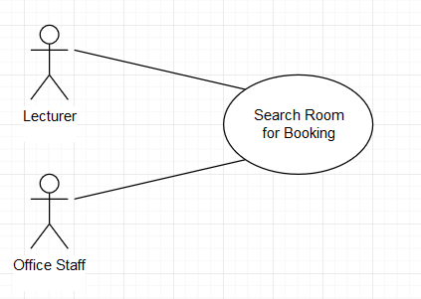

*Figure 5.4: Use-case Diagram for Search Room for Booking Use-case*

### 5.2.3. Use-case Scenario Tabular

|  |  |
| --- | --- |
| **Use case name** | **Search Room for Booking** |
| Actor | User (Lecturer, Office Staff) |
| Description | User can search for available room and book |
| Preconditions | User logged in into SCAMS application |
| Triggers | None |
| Normal Flow | 1. User selects “Search” on SCAMS home page 2. System represents a search panel with multiple filters (date) and (building, room number). Date and building must be filled 3. User selects date, building and room number filters 4. System represents a page with the room’s usage timetable and capacity 5. User chooses “Book” button on the room 6. System represent a pop up list of available class period in that day of that room 7. User choose the time he/she willing to book 8. System shows a form where user must fill in the class/event information.  * If user is a lecturer, a dropdown list of his/her active classes will be shown and he/she can choose which class it is for this room. He/she can also book room for other purpose, which will be explained in “Other” box. * If user is an office staff, he/she will describe the event in “Event” box and fill in the “Speaker” information.  1. User select “Confirm” 2. System shows a pop-up announces that the room is booked successfully, the user is now back to the search result screen 3. An email is sent immediately to the user’s email address confirm that the booking is successful 4. User choose to quit the search |
| Exception | *Exception at step 4. Cannot find the room number*  4a. The system represents a pop up box saying that user should use other search criteria (Alternative 3a)  *Exception at step 4. System failed to connects with the ROMS system to fetch information.*  4b. A pop-up box will explain the situation: “This service is not available”  *Exception at step 4. The room full at that time*  Alternative 2 |
| Alternative Flows | *Alternative 1: at step 3*  3a. User selects date and building  3b. System represent a list of room in that building and their usage timetable, capacity  3c. User select on a particular room to see its usage timetable, move to step 4  *Alternative 2: at step 4*  4a. User quit the search result  4b. User chooses another date or another room |

### 5.2.4. Non-functional Requirements

|  |  |  |  |
| --- | --- | --- | --- |
| **Category** | **Requirement** | **Unit** | **Maximum value** |
| Efficiency | Receive search result | second | 4 |
| Number of interactions | interactions | 6 |
| Email shall be sent immediately after the booking is confirmed | second | 1 |
| Usability | User shall learn to use easily | minute | 10 |
| Available 24/7 |  | 24/7 |
| Adaptability | The system shall operate on multiple platforms |  |  |

## 5.3. Cancel Booking

This use-case is a continuous of use-case “Review booking”, where user (lecturer, office staff) can review all of his/her booking. Then if user selects on a particular booking, he/she will see the modify and cancel booking options. **This use-case does not focus on the Review Booking use-case, but only on the cancel room booking process.**

### 5.3.1. Context Model



*Figure 5.5: Context Model for Cancel Room Use-case*

### 5.3.2. Use-case Diagram

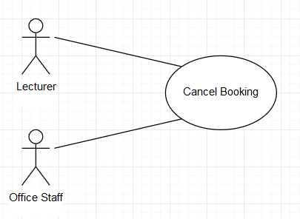

*Figure 5.6: Use-case Diagram for Cancel Room Use-case*

### 5.3.3. Use-case Scenario Tabular

|  |  |
| --- | --- |
| **Use case name** | **Cancel Room** |
| Actor | User (Lecturer, Office Staff) |
| Description | User can cancel his/her booked room |
| Preconditions | User logged in into SCAMS application |
| Triggers | None |
| Normal Flow | 1. User selects “Manage Booking” on menu from home screen 2. System represents a list of his/her booked room 3. User selects filter (Class/Event or Date) to filter and find the booking he/she is looking for 4. System represents the list of room(s) booking on search result 5. User selects on the room booking want to cancel 6. System represents the booking information and options “Modify” and “Cancel” 7. User chooses “Cancel” 8. System shows a pop-up box announces that the cancel process is done successfully. 9. An email is sent immediately to the user’s email address 10. User choose to quit the manage booking section |
| Exception | *Exception at step 2. System failed to connects with ROMS*  2a. A pop-up box will explain the situation: “This service is not available at the moment” |
| Alternative Flows |  |

### 5.3.4. Non-functional Requirements

|  |  |  |  |
| --- | --- | --- | --- |
| **Category** | **Requirement** | **Unit** | **Maximum value** |
| Efficiency | Receive search result | second | 4 |
| Number of interactions | interactions | 4 |
| Email shall be sent immediately after the booking is canceled | second | 1 |
| Usability | User shall learn to use easily | minute | 10 |
| Available 24/7 |  | 24/7 |
| Adaptability | The system shall operate on multiple platforms |  |  |

## 5.4. Modify Booking

This use-case is a continuous of use-case “Review booking”, where user (lecturer, office staff) can review all of his/her booking. Then if user selects on a particular booking, he/she will see the modify and cancel booking options. **This use-case does not focus on the Review Booking use-case, but only on the modify room booking process.**

### 5.4.1. Context Model



*Figure 5.7: Context Model for Modify Room Use-case*

### 5.4.2. Use-case Diagram

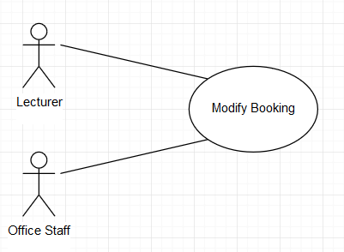

*Figure 5.8: Use-case Diagram for Modify Room Use-case*

### 5.4.3. Use-case Scenario Tabular

|  |  |
| --- | --- |
| **Use case name** | **Modify Room** |
| Actor | User (Lecturer, Office Staff) |
| Description | User can modify his/her booked room |
| Preconditions | User logged in into SCAMS application |
| Triggers | None |
| Normal Flow | 1. User selects “Manage Booking” on menu from home screen 2. System represents a list of his/her booked room 3. User selects filter (Class/Event or Date) to filter and find the booking he/she is looking for 4. System represents the list of room(s) booking on search result 5. User selects on the room booking want to modify 6. System represents the booking information and options “Modify” and “Cancel” 7. User chooses “Modify” 8. System represents a search panel with multiple filters (date) and (building, room number). Date and building must be filled 9. User selects date, building and room number filters 10. System represents a page with the room’s usage timetable and capacity 11. User chooses “Select” button on the room 12. System represent a pop up list of available class period in that day of that room 13. User choose the time he/she willing to book 14. User select “Confirm” 15. System shows a pop-up announces that the booking is modified successfully, the user is now back to the manage booking screen 16. An email is sent immediately to the user’s email address confirm that the booking modify process is successful 17. User choose to quit the manage booking section |
| Exception | *Exception at step 2. System failed to connects with the ROMS system to fetch information.*  2b. A pop-up box will explain the situation: “This service is not available”  *Exception at step 12. The room full at that time*  Alternative 2 |
| Alternative Flows | *Alternative 1: at step 10*  10a. User selects date and building  10b. System represent a list of room in that building and their usage timetable, capacity  10c. User select on a particular room to see its usage timetable, move to step 12  *Alternative 2: at step 12*  12a. User chooses another date/room and continue the modify process  *Alternative 3: at step 12*  *12b. User choose to quit the searching new date/room and cancel the modify process, continue in step 17* |

### 5.4.4. Non-functional Requirements

|  |  |  |  |
| --- | --- | --- | --- |
| **Category** | **Requirement** | **Unit** | **Maximum value** |
| Efficiency | Receive search result | second | 4 |
| Number of interactions | interactions | 6 |
| Email shall be sent immediately after the booking is modified | second | 1 |
| Usability | User shall learn to use easily | minute | 10 |
| Available 24/7 |  | 24/7 |
| Adaptability | The system shall operate on multiple platforms |  |  |

# 6. Other non-interactive functional requirement (individual)

* An email will be sent to all student of that class the lecturer book/modify/cancel room automatically
* A message will be automatically sent to System Administrator if there is any error in connecting with other systems

# 7. Conclusions

This document describes all the requirements of the SCAMS system, including non-functional and functional requirements.

4 use-cases is described in detailed, these use-cases descriptions take an important role in building program structure, data flow, interfaces, etc.

# 8. Group list

|  |  |
| --- | --- |
| **Student ID** | **Full Name** |
| 1827005 | Tran Thi Ngoc Diep |
| 1820047 | Luong Thanh Nhan |
| 1820034 | Nguyen Dang Khoa |
| 1820031 | Pham Tran Anh Huy |
| 1827030 | Ngo Hoang Ngoc Thanh |