**jQuery Ajax() Jsp 연습1**

[결과]

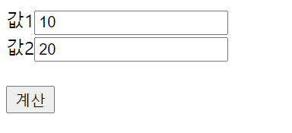 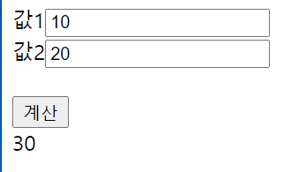

[jQ_ajax_1.html ]

|  |
| --- |
|  |

[calc.jsp]

|  |
| --- |
|  |