[입력]

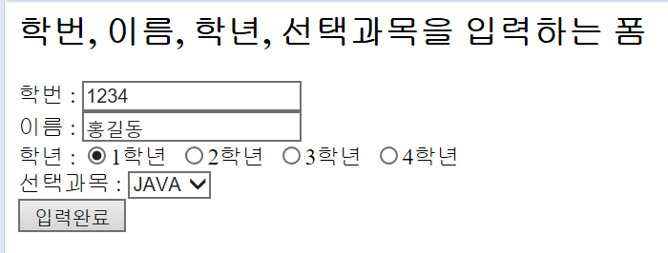

[결과]

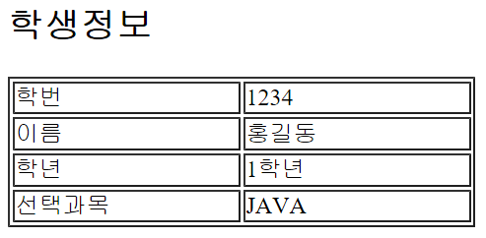

|  |
| --- |
| <%@ page language=*"java"* contentType=*"text/html; charset=UTF-8"*  pageEncoding=*"UTF-8"*%>  <html>  <head>  <title>Request 내장객체 예제</title>  </head>  <body>    </body>  </html> |

|  |
| --- |
| <%@ page language=*"java"* contentType=*"text/html; charset=UTF-8"*  pageEncoding=*"UTF-8"*%> |