**forward:: 로그인 사용자/관리자**

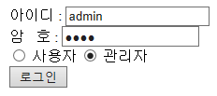

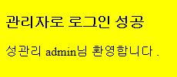

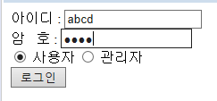

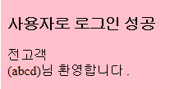

[actionTestForm.jsp]

|  |
| --- |
| <%@ page language=*"java"* contentType=*"text/html; charset=UTF-8"*  pageEncoding=*"UTF-8"*%>  <!DOCTYPE html>  <html>  <head>  <meta charset=*"UTF-8"*>  <title>Insert title here</title>  </head>  <body>  <form action=*"actionTest.jsp"*>  </form>  </body>  </html> |

[actionTest.jsp]

|  |
| --- |
| <%@page import=*"java.net.URLEncoder"*%>  <%@ page language=*"java"* contentType=*"text/html; charset=UTF-8"*  pageEncoding=*"UTF-8"*%> |

[managerMain.jsp]

|  |
| --- |
| <%@page import=*"java.net.URLDecoder"*%>  <%@ page language=*"java"* contentType=*"text/html; charset=UTF-8"*  pageEncoding=*"UTF-8"*%>  <!DOCTYPE>  <html>  <head>  <meta *charset="UTF-8"*>  <title>Insert title here</title>  </head>  </html> |

[userMainjsp]

|  |
| --- |
| %@page import=*"java.net.URLDecoder"*%>  <%@ page language=*"java"* contentType=*"text/html; charset=UTF-8"*  pageEncoding=*"UTF-8"*%>  <!DOCTYPE>  <html>  <head>  <meta *charset="UTF-8"*>  <title>Insert title here</title>  </head>  </html> |