JavaBean Servlet

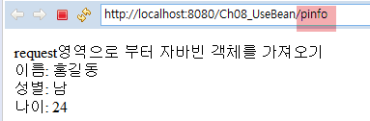

[personalInfo.java]

|  |
| --- |
| **public** **class** PersonalInfo {  **private** String name;  **private** **char** gender;  **private** **int** age;      } |

[web.xml]

|  |
| --- |
|  |

[personalInfoServlet.java]

|  |
| --- |
| **import** javax.servlet.http.*;  **import** javax.servlet.*;  **import** java.io.*;  **public** **class** PersonalInfoServlet **extends** HttpServlet {    **private** **static** **final** **long** ***serialVersionUID*** = 1L;  **public** **void** doGet(HttpServletRequest request, HttpServletResponse response)  **throws** IOException, ServletException {  }  } |

[customerInfoViewer.jsp]

|  |
| --- |
|  |