**Servlet을 이용한 Cookie 처리**

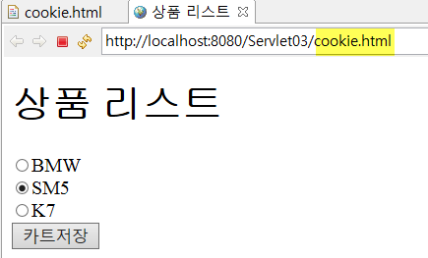

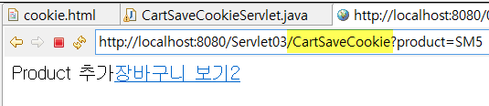

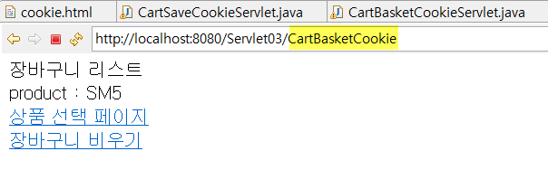

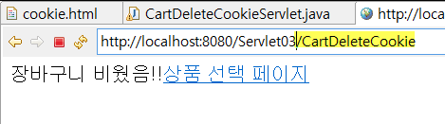

[ cookie.html]

|  |
| --- |
| <!DOCTYPE html>  <html>  <head>  <meta charset=*"utf-8"*>  <title>상품 리스트</title>  </head>  <body>  </body>  </html> |

[CartSaveCookieServlet ]

|  |
| --- |
| **package** com.controller;  **import** java.io.IOException;  **import** java.io.PrintWriter;  **import** javax.servlet.ServletException;  **import** javax.servlet.annotation.WebServlet;  **import** javax.servlet.http.Cookie;  **import** javax.servlet.http.HttpServlet;  **import** javax.servlet.http.HttpServletRequest;  **import** javax.servlet.http.HttpServletResponse;  @WebServlet("/CartSaveCookie")  **public** **class** CartSaveCookieServlet **extends** HttpServlet {  **protected** **void** doGet(HttpServletRequest request, HttpServletResponse response) **throws** ServletException, IOException {  doPost(request, response);  }  **protected** **void** doPost(HttpServletRequest request, HttpServletResponse response) **throws** ServletException, IOException {    }  } |

[CartBasketCookieServlet.java ]

|  |
| --- |
| **package** com.controller;  **import** java.io.IOException;  **import** java.io.PrintWriter;  **import** javax.servlet.ServletException;  **import** javax.servlet.annotation.WebServlet;  **import** javax.servlet.http.Cookie;  **import** javax.servlet.http.HttpServlet;  **import** javax.servlet.http.HttpServletRequest;  **import** javax.servlet.http.HttpServletResponse;  @WebServlet("/CartBasketCookie")  **public** **class** CartBasketCookieServlet **extends** HttpServlet {  **protected** **void** doGet(HttpServletRequest request, HttpServletResponse response) **throws** ServletException, IOException {  doPost(request, response);  }  **protected** **void** doPost(HttpServletRequest request, HttpServletResponse response) **throws** ServletException, IOException {    }  } |

[CartDeleteCookieServlet.java ]

|  |
| --- |
| **package** com.controller;  **import** java.io.IOException;  **import** java.io.PrintWriter;  **import** javax.servlet.ServletException;  **import** javax.servlet.annotation.WebServlet;  **import** javax.servlet.http.Cookie;  **import** javax.servlet.http.HttpServlet;  **import** javax.servlet.http.HttpServletRequest;  **import** javax.servlet.http.HttpServletResponse;  @WebServlet("/CartDeleteCookie")  **public** **class** CartDeleteCookieServlet **extends** HttpServlet {  **protected** **void** doGet(HttpServletRequest request, HttpServletResponse response) **throws** ServletException, IOException {  doPost(request, response);  }  **protected** **void** doPost(HttpServletRequest request, HttpServletResponse response) **throws** ServletException, IOException {    }  } |

[product.html] :: 상품 선택페이지