**URL Mapping 연습**

**형태1**

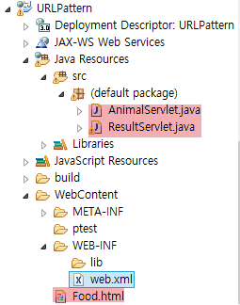

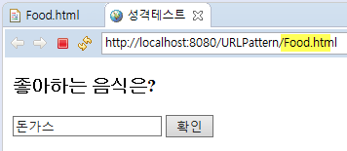

[web.xml]

|  |
| --- |
|  |

[FOOD.html]

|  |
| --- |
| </html> |

[AnimalServlet.java]

|  |
| --- |
| **import** javax.servlet.*;  **import** javax.servlet.http.*;  **import** java.io.*;  **public** **class** AnimalServlet **extends** HttpServlet {  } |

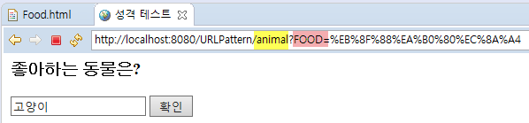

[ResultServlet.java]

|  |
| --- |
| **import** javax.servlet.*;  **import** javax.servlet.http.*;  **import** java.io.*;  **public** **class** ResultServlet **extends** HttpServlet {  } |

[최종결과]

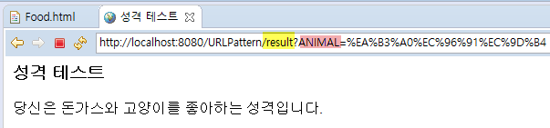

**형태2**

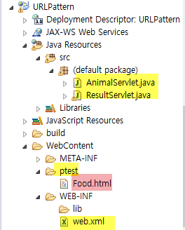

[web.xml]

|  |
| --- |
|  |

