**Session 연습하기 (Login)**

**1. 파일 만들기**

http://localhost:8080/Ch10_Session/LoginTest/sessionLogin.jsp

sessionLogin2.jsp

sessionLogout.jsp

**2. 조건**

sessionLogout 종료 : removeAttribute( ) 사용

**3. 실행**

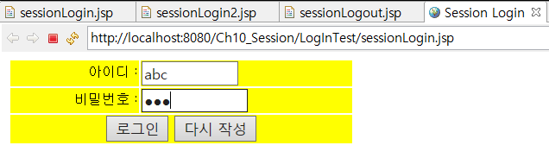

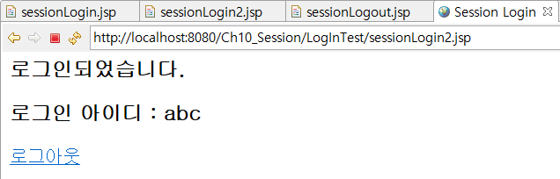

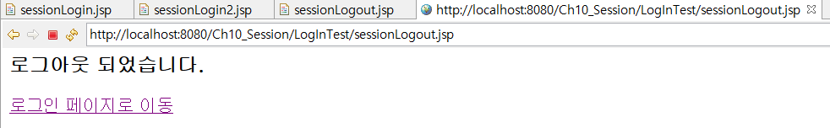

[sessionLogin.jsp]

|  |
| --- |
| <%@ page language=*"java"* contentType=*"text/html; charset=utf-8"*%> |

[sessionLogin2.jsp]

|  |
| --- |
| <%@ page language=*"java"* contentType=*"text/html; charset=utf-8"*%> |

[sessionLogout.jsp]

|  |
| --- |
| <%@ page language=*"java"* contentType=*"text/html; charset=utf-8"*%> |