**request.getSession(false)**

request.getSession(true); // request에 대한 새로운 세션을 생성후 리턴

request.getSession(false); // 현재 세션이 존재하면 기존 세션 리턴, 없으면 null값 리턴

request.getSession(); //현재 세션이 존재하면 기존 세션 리턴, 없으면 새로생성한 세션 리턴

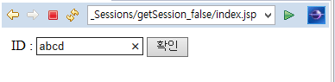

[index.jsp]

|  |
| --- |
| <%@ page language=*"java"* contentType=*"text/html; charset=UTF-8"*  pageEncoding=*"UTF-8"*%>  <!DOCTYPE html PUBLIC "-//W3C//DTD HTML 4.01 Transitional//EN" "http://www.w3.org/TR/html4/loose.dtd">  <html>  <head>  <meta http-equiv=*"Content-Type"* content=*"text/html; charset=UTF-8"*>  <title>Insert title here</title>  <script>      </script>  </head>  <body>  <!-- Header -->  <form name=*"idForm"* method=*"post"*>  <table width=*"100%"*>  <tr>  <td>ID : <input type=*"text"* name=*"id"* size=*"15"*>  <input type=*"button"* value=*"확인"* onClick="idSubmit()">  </td>  </tr>  </table>  </form>  </body>  </html> |

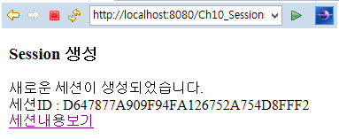

[test1.jsp]

|  |
| --- |
| <%@ page language=*"java"* contentType=*"text/html; charset=UTF-8"*  pageEncoding=*"UTF-8"*%>  <!DOCTYPE html PUBLIC "-//W3C//DTD HTML 4.01 Transitional//EN" "http://www.w3.org/TR/html4/loose.dtd">  <html>  <head>  <meta http-equiv=*"Content-Type"* content=*"text/html; charset=UTF-8"*>  <title>Insert title here</title>  </head>  <body>  <h3>Session 생성 </h3>  새로운 세션이 생성되었습니다.<BR>  </body>  </html> |

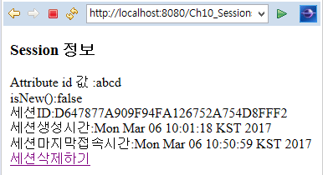

[test2.jsp]

|  |
| --- |
| <%@ page language=*"java"* contentType=*"text/html; charset=UTF-8"*  pageEncoding=*"UTF-8"*%>  <!DOCTYPE html PUBLIC "-//W3C//DTD HTML 4.01 Transitional//EN" "http://www.w3.org/TR/html4/loose.dtd">  <html>  <head>  <meta http-equiv=*"Content-Type"* content=*"text/html; charset=UTF-8"*>  <title>Insert title here</title>  </head>  <body>  <h3>Session 정보 </h3>  </body>  </html> |

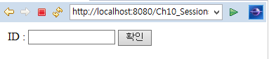

[test3.jsp]

|  |
| --- |
| <%@ page language=*"java"* contentType=*"text/html; charset=UTF-8"*  pageEncoding=*"UTF-8"*%> |