**Session Servlet 연습**

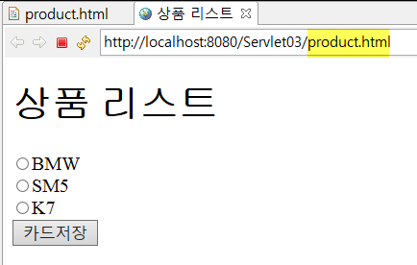

[product.html]

|  |
| --- |
| <!DOCTYPE html>  <html>  <head>  <meta charset=*"utf-8"*>  <title>상품 리스트</title>  </head>  <body>  <h1>상품 리스트</h1>  <form action=*"CartSave"* method=*"GET"*>  <input type=*"radio"* name=*"product"* value=*"BMW"*>BMW<br>  <input type=*"radio"* name=*"product"* value=*"SM5"*>SM5<br>  <input type=*"radio"* name=*"product"* value=*"K7"*>K7<br>  <input type=*"submit"* value=*"카드저장"*>  </form>  </body>  </html> |

[CartSaveServlet.java ] 선택한 물품 저장

|  |
| --- |
|  |

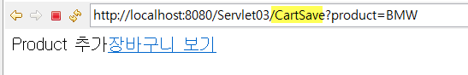

[CartBaskeServlet.java ] 장바구니 리스트

|  |
| --- |
|  |

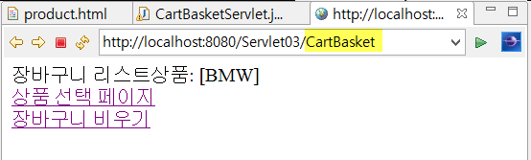

[ CartDeleteServlet.java] 장바구니 리스트 비우기

|  |
| --- |
|  |

