**JSTL - Core Tag**

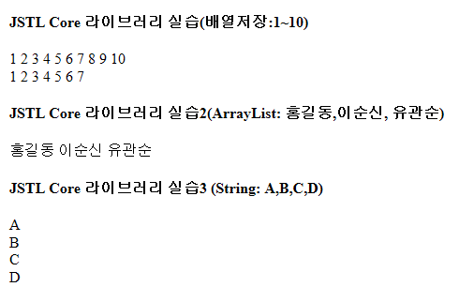

|  |
| --- |
| <%@page import=*"java.util.ArrayList"*%>  <%@ page language=*"java"* contentType=*"text/html; charset=utf-8"*  pageEncoding=*"utf-8"*%> |